# 4.24 Discoursing With Dolphins

Learning Objectives: • Understand how scientists determine the sequence, age, and nature of biological events using observations of the structure and composition of biological materials and an understanding of biological processes. Also, understand how molecular clocks work. • Identify what biological materials like body parts, genes, fossils, and fossil traces record about present and past organisms. • Understand how rocks and fossils record information about the environmental conditions that existed when they formed. • Identify how a past biological event like extinction or speciation might be recorded for modern observers.



Dr. Dan Moore and Dr. Alan Holyoak, Geology and Biology Departments, BYU-Idaho

The facts of nature are what they are. ―Stephen Jay Gould

## Learning Objectives:

* Understand how scientists determine the sequence, age, and nature of biological events using observations of the structure and composition of biological materials and an understanding of biological processes. Also, understand how molecular clocks work.
* Identify what biological materials like body parts, genes, fossils, and fossil traces record about present and past organisms.
* Understand how rocks and fossils record information about the environmental conditions that existed when they formed.
* Identify how a past biological event like extinction or speciation might be recorded for modern observers.

The history of Life on Earth consists of the events associated with the origin and development of all organisms. To understand this history, scientists must establish the sequence, age, and nature of past biological events. Scientists determine the sequence of biological events using the principles of relative dating, establish the age of biological events using radiometric and molecular clocks, and discover the nature of biological events by interpreting the structure and composition of biological materials. Like the Universe and Earth, discovering how Life developed is both exciting and rewarding.

## Basic Biological Materials and Processes

The bodies of all living things are made of the same biological molecules—carbohydrates, lipids, proteins, and nucleic acids (**Figure 4.16**). Of course, living things also use materials such as water, salts, and trace metals. Some biological materials can directly enter bodies and require little processing. The remainder must be built by organisms. The diversity, composition, and structure of biological molecules are vital to the health and success of all living things.

Carbohydrates like glucose and cellulose are used for energy and structural support. Lipids are made with the help of protein enzymes and can be used for long-term storage of excess energy (fats and oils), as structural components of cell membranes (phospholipids), protective materials (waxes), and as molecules that carry signals within and between cells (steroid hormones). Proteins are long strings of amino acids that fold into shapes that determine their function. These functions include facilitating chemical reactions and regulating gene expression. Nucleic acids, which include DNA and RNA, carry genetic instructions for making proteins. **Figure 4.17** shows how genes produce proteins.

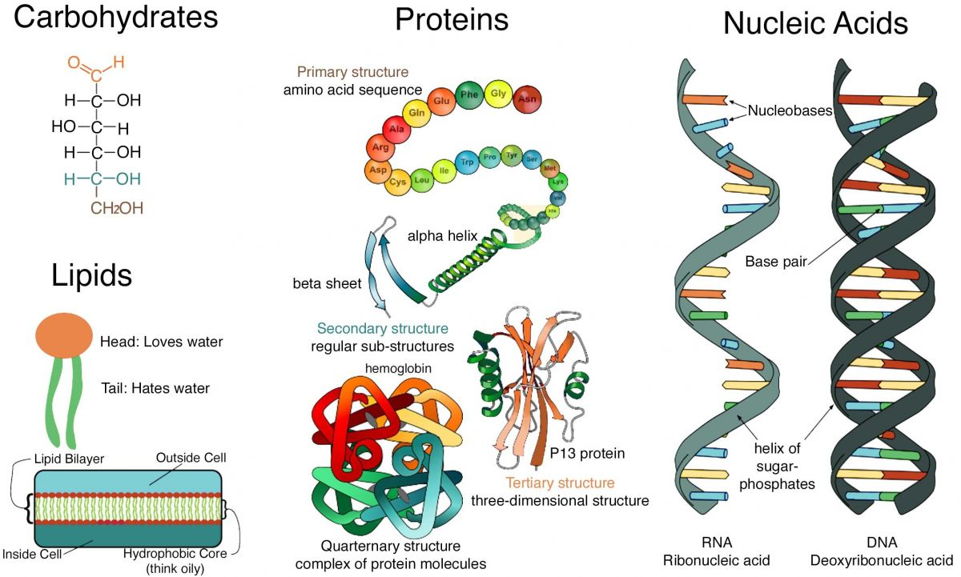

**Figure 4.16**. Illustrations of basic types of biological molecules. Organisms use these molecules for energy, structure, signaling, information storage, and so on.

(Biomolecules, Author illustration, created as a work for hire by Eden Platt using these images: Carbohydrates, ClockworkSoul, https://bit.ly/3Lab7kB, public domain, recolored; Lipids, Bradleyhintze, https://bit.ly/3wi IDRD, CC-BY-SA-3.0, recolored; Proteins, LadyofHats, https://bit.ly/37EPvPs, public domain; Nucleic Acids, Guku235, https://bit.ly/3ytuO4a, CC-BY-SA-4.0. Licensed as CC-BY-SA-3.0.)

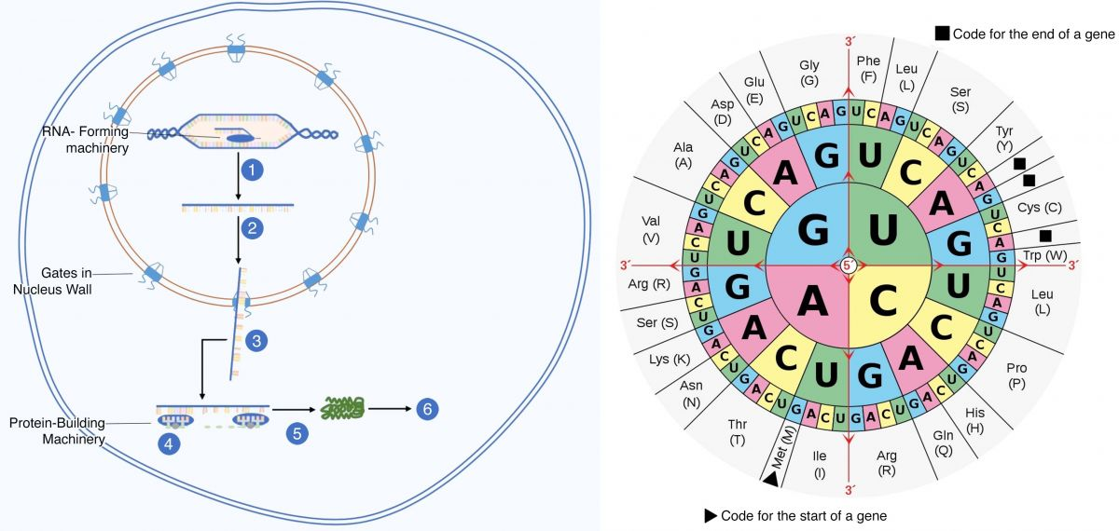

**Figure 4.17**. **Left**: Illustration of the protein synthesis process: 1- Gene transcription produces messenger-RNA (mRNA), with complementary ‘genetic letters’ (nucleobases). 2- mRNA is modiﬁed before leaving the nucleus. 3- mRNA leaves the nucleus, enters the cytoplasm, and encounters a ribosome. 4- The ribosome translates mRNA by connecting each three-letter mRNA word (codon) with an amino acid. In this way, successive ‘train cars’ of amino acids are connected to form a protein ‘train’. 5- Once produced, proteins fold into speciﬁc shapes. 6- Interactions after translation determines the ﬁnal shapes of proteins. These shapes determine protein function. **Right**: Illustration of the universal genetic code (read from the inside, out) showing the ‘genetic words’ (codons) that correspond to particular amino acids (outer circle). ‘Start’ and ‘stop’ codons initiate or end proteins.

(Protein synthesis, Author illustration, created as a work for hire by Eden Platt using these images: Protein synthesis, Kep17, https://bit.ly/39kdWl W, CC-BY-SA-4.0, relabeled; Genetic code, Mouagip, https://bit.ly/3LnMSQ9, public domain. Licensed as CC-BY-SA-3.0.)

As organisms grow and develop, the basic molecules of life self-assemble to produce larger-scale biological materials like tissues. Speciﬁc combinations of tissues make familiar body parts called organs. These include the heart, eyes, and bones.

After death, organisms can no longer maintain their bodies, which begin to decay. Body components like oils, sugars, and muscles readily decompose. Other components such as tendons, ligaments, bone, and wood take longer to break down. Biological materials that persist long enough to be buried in layers of sediment can become fossils. As such, durable materials such as shells and teeth most easily form **fossils**. Likewise, organisms that live where sediment is readily deposited (as on the ocean ﬂoor) are much more commonly preserved as fossils.

Once buried, the long-term processes that form rock from sediment can produce fossils from biological remains. Fossilization can preserve many of the properties of the original organism.

## Interpreting Biological Materials

Recall that understanding the history of life requires determining the sequence, age, and nature of biological events. This involves using an understanding of biological processes to interpret the structure and composition of biological materials. Scientists use the principles of relative dating to determine the order in which things happened in Earth’s history, the patterns of fossil appearance and disappearance found in successive layers of sedimentary rock to discover the history of life and to correlate bodies of sedimentary rock separated by large distances, and radiometric (absolute) dating to determine the age of a past Earth and Life events. Using these approaches humanity has been able to discover how life developed through time.

In addition to the fossil record, the genes of living organisms provide important information about the timing and nature of events in the history of life. For example, so-called molecular clocks measure the time elapsed since species diverged using the rate at which genetic diﬀerences appear. In this way, ages provided by molecular clocks represent the lengths of time (numbers of generations) that species have been reproductively isolated from each other. As an example, comparing human and ape DNA indicates that our last common ancestor lived ~7 Mya.

Humanity’s modern understanding of the nature of biological events results primarily from studying the structure and composition of biological materials. The structure of biological materials includes their shape and arrangement, which determines their function at all scales. The composition of biological materials includes the molecules, elements, and isotopes that comprise them and the relative abundances of characteristics in populations and ecosystems. By understanding the natural processes that form and modify biological materials, scientists can interpret the structure and composition of biological materials to understand the origins of those materials. **Table 4.6** provides important examples of what humanity can learn from materials that record biological and climate events.

**Table 4.6**. What Biological Materials Records

|  |  |
| --- | --- |
| **Biological Materials**  (Observations) | **What We Can Learn**  (Interpretations) |
| **Fossils** | **Nature of the organism**  , its development through time and  **originations**  and  **extinction**  ages |
| Fossil Body Parts | **Lifestyle**  of the organism |
| Fossil Traces | **Behavior**  of the organism |
| **Biomolecules** | **Source**  of the atoms/molecules and the  **processes**  that modified them |
| Genes | **Descendancy**  relationships and  **relatedness** |
| **Climate Records** | **Habitat**  of an organism(s) |

## How Organisms Change through Time

The properties of living and fossil organisms indicate that successive generations of a population changes when individuals with beneﬁcial attributes survive to reproduce more commonly than their peers. Thus, diﬀerential survival can cause successive generations of a population to change. These changes include variations in the way genes are used. For example, populations change when the duration or location of gene expression changes— without any change to the genes being expressed.

In this way, signiﬁcant changes to bodies result from how genes are applied. Said another way, many diﬀerences between organisms do not require new genes. Instead, the changes result from diﬀerences in how the same genes are applied. For example, all organisms with bones produce their skeletal elements using the same (homologous) genetic toolkit. In these organisms, the diﬀerences in bone shape and size result from how bone-producing genes are used—not from new genes.

Genetic mutations can also cause populations of organisms to change through time. These mutations result from natural processes such as radiation, gene sharing, and faulty replication. Although most mutations are detrimental and cause miscarriage or cancerous growth, mutations can also produce beneﬁcial attributes. Mutations that are passed to successive generations cause populations to change through time.

A prominent example of a deleterious human mutation is the single-genetic-letter deletion that broke the process that produces vitamin-C in primates. This damaging error was allowed to persist in early primate populations because, at the time, the abundant vitamin C provided by their fruity diets masked the genetic deﬁciency. By the time human ancestors left fruit-ﬁlled forests for emerging vitamin-C-deﬁcient grasslands, the genetic machinery that makes vitamin C was pervasively broken. In this same way, the eventually-deleterious mutations that lead to loss of sight and pigmentation in cave-dwelling organisms are masked. Outside the cave, these mutations are deleterious, but inside where there is no light sight and pigmentation do not improve survival. Thus, eventually-damaging mutations can creep into populations during periods when their eﬀects on reproduction are neutral.

Some beneﬁcial mutations involve the duplication of entire genes or sets of genes. Mutations of this type have produced important plants like those from which we harvest wheat, potatoes, peanuts, and bananas. Duplications of this kind have also produced animals with repeated body segments—like the replicated thorax segments of millipedes and snakes.

Interestingly, some mutations can be simultaneously beneﬁcial and detrimental. An example involves the single-genetic-letter substitution that produces sickle cell anemia in humans. This mutation produces abnormally shaped red blood cells that have diminished capacity to carry oxygen and enhanced ability to resist malaria. These sickle-shaped cells are life-threating to individuals that only produce abnormal cells, but they are beneﬁcial to individuals that produce both normal and abnormal cells. Unsurprisingly, this mutation persists in human populations that have been constantly exposed to malaria.

In short, the traits of populations change through time when the relative abundance of genes in populations shift. These shifts result from changes in how genes are used and from deleterious, neutral, and beneﬁcial mutations. Signiﬁcantly, without the ability to change across generations species would be unable to adapt to the constantly changing environments they inhabit, and they would eventually go extinct. Thus, the abundance and diversity of present Earth life is a powerful witness to the reality of life’s ability to change through time, to evolve. Indeed, it is this very process—adaptation across generations—that has produced the unity and diversity of life.

## Learning from Ötzi

Not only do observations of biological materials allow humanity to interpret broad-scale patterns in the history of life, but they also allow us to learn a great deal about speciﬁc individual organisms. Ötzi the Iceman provides a fun example of the latter. Hikers found Ötzi in 1991 in glacial ice of the Italian Alps near the Austrian border—as illustrated in **Figure 4.18**.

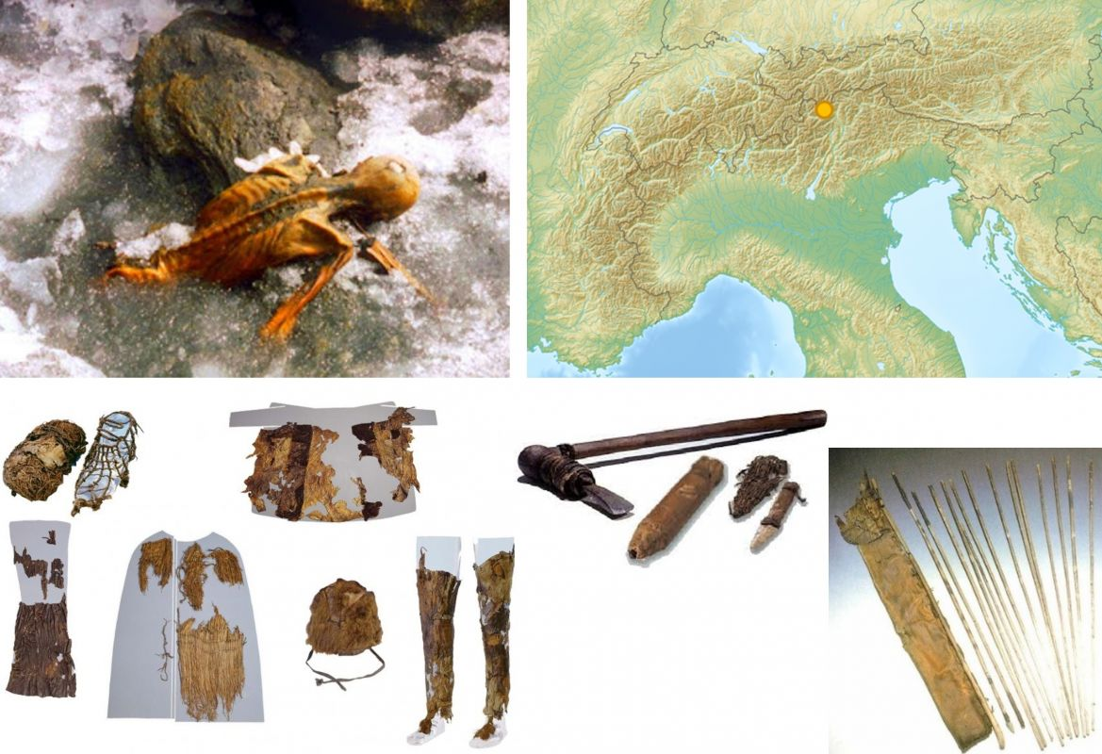

**Figure 4.18**. **Top**: Ötzi before he was removed from the ice and the location of his discovery. **Bottom**: Some of the clothing and weapons found with him.

(Ötzi, Author illustration, created as a work for hire by Eden Platt and Jordan Barton using these images: Map, Lencer, https://bit.ly/3Nt0R8L, CC-BY-SA-3.0; Body, 120, https://bit.ly/39hwCmn, CC-BY-SA-3.0; Reconstruction, Melotzi, https://bit.ly/3w6ekxh, CC-BY-SA-4.0. Licensed as CC-BY-SA-3.0.)

After Ötzi’s discovery, oﬃcials carefully liberated his body and associated artifacts from the ice and moved him to a University in Italy where these materials were studied with great intensity by numerous scientists from around the world. **Table 4.7** lists what humanity has learned thus far about Ötzi (organized by observation type), and **Figure 4.19** shows a reconstruction of this fascinating individual. Before proceeding, investigate what humanity has been able to learn about Ötzi from biological remains and artifacts.

**Table 4.7**. What observations of Ötzi and associated artifacts have taught humanity.

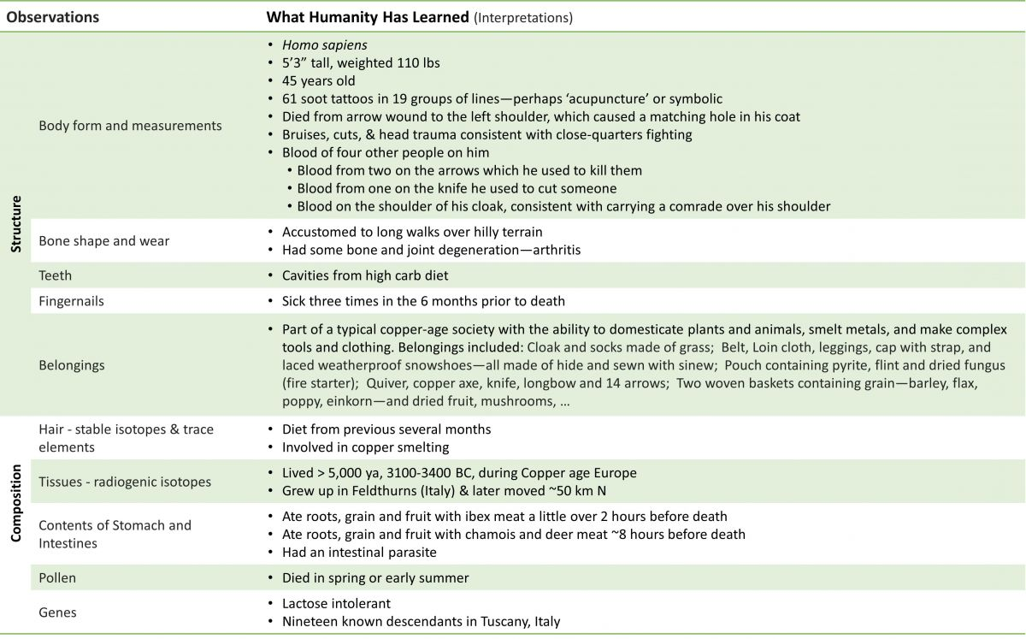

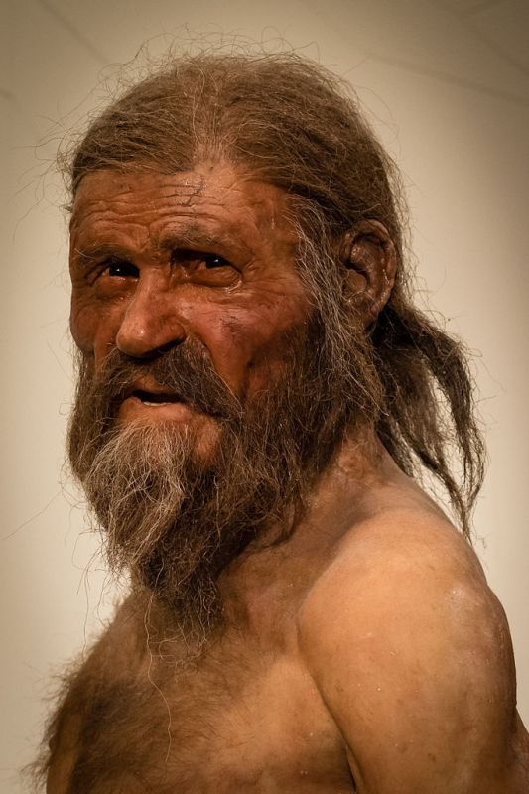

**Figure 4.19**. Reconstruction of Ötzi the Iceman.

(Ötzi, Zigres, https://shutr.bz/3PbIEhz, Shutterstock royalty-free license.)

As you can see, the attributes of biological materials allow humanity to discover the nature of living and fossil organisms and to understand the development of life (illustrated in **Figure 4.20**).

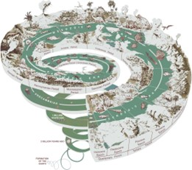

**Figure 4.20**. Illustration of the history of Earth life. (USGS, recolored and simpliﬁed)

As a last thought, recall that any true explanation of the development of Life must be consistent with observations of biological and Earth materials—all of which are important records of God’s creative works. If you ﬁnd that you react skeptically to scientiﬁc explanations of the history of life, we invite you to consider what leads you to mistrust the natural scripture upon which these interpretations are founded.

Read this online at <https://books.byui.edu/from_atoms_to_humans/424_discoursing_with>