# 4.27 Nurturing Nature

Learning Objectives: • Understand and be able to identify each of the following: genes, biological evolution, population, species, microevolution, macroevolution, extinction, artiﬁcial and natural selection, population isolation, speciation, and the theory of evolution. • Explain evolution as observation and theory, using the terms listed above. • Explain how microevolution can produce macroevolution, using the terms listed above.

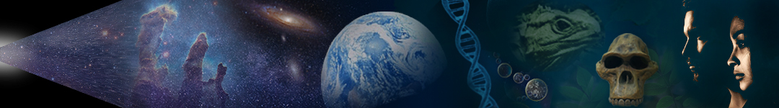

Dr. Dan Moore and Dr. Alan Holyoak, Geology and Biology Departments, BYU-Idaho

Nothing in biology makes sense except in the light of evolution. —Theodosius Dobzhansky

## Learning Objectives:

* Understand and be able to identify each of the following: genes, biological evolution, population, species, microevolution, macroevolution, extinction, artiﬁcial and natural selection, population isolation, speciation, and the theory of evolution.
* Explain evolution as observation and theory, using the terms listed above.
* Explain how microevolution can produce macroevolution, using the terms listed above.

Before humanity learned to use ‘things as they are’ as the arbiter of truth about the physical world, the western world believed in ‘special creation’. This notion asserts that in the recent past God directly created every type of organism as separate, perfect, unchanging, and unchangeable entities. Although many aspects of this notion seemed to match written scripture, the idea directly contradicts natural scripture. Instead of the attributes predicted by special creation, living entities are related, imperfect, and ever-changing. In the late 1700s, Georges Cuvier made the ﬁrst of numerous observations that falsify special creation by demonstrating the reality of extinction, the termination of entire groups of organisms.

Unfortunately, more than a century passed before humanity discovered an explanation for the nature and development of living things capable of explaining life ‘as it is’. This revolution resulted from a fusion of key discoveries. These included Charles Darwin’s ~1860 hypothesis of evolution by natural selection, the ~1900 rediscovery of Gregor Mendel’s work on inheritance, the early 1950s discovery of DNA as the molecular basis for inheritance, the establishment of the principles of ecology by the 1970s, and the ~1980s identiﬁcation of the mechanisms by which gene regulation builds and rebuilds bodies.

With the fusion of Darwin and Mendel’s hypotheses in the early 1900s, humanity began in earnest to explore whether evolution could explain the attributes of living things. Since that time, a network of discoveries has provided abundant and powerful tests of biological evolution. What’s more, the vigorous opposition of religious fundamentalists has intensiﬁed scrutiny of the scientiﬁc theory of evolution. As a result, the theory of evolution has been exposed to more strenuous and intensive testing than nearly any other scientiﬁc theory. Signiﬁcantly, the theory of evolution has withstood and been strengthened by this testing.

Today, those who consider that truth is ‘knowledge of things as they were, are, and will be’ acknowledge that the theory of evolution stands alone as humanity’s most successful tool for explaining the nature and development of life. Sadly, there is much confusion regarding the ‘e’ word (evolution). For example, relatively few people can accurately deﬁne biological evolution.

## What Is Evolution?

Biological evolution, which we’ll simply call evolution, refers to changes in the relative abundance of characteristics in a population or species from generation to generation. As you know, these changing characteristics are coded for by genes (alleles), the basic units of heredity. So, evolution results when the proportion of genes (alleles) changes across generations. For our purposes, a population is a group of interbreeding organisms that live in the same place at the same time, and a species is a population that produces fertile oﬀspring. Even so, there is no deﬁnition of species that applies well in every situation, in part because the diﬀerences between ‘species’ is often more gradational than discrete.

Thus, evolution occurs when successive generations of interbreeding organisms change in any way—as when coloration or size changes in descendant populations. Large-scale evolutionary changes often occur when a population splits and the isolated groups change suﬃciently that inter-group breeding becomes impossible. This forms two species from one. In these ways, evolution occurs both within and between species.

Microevolution refers to evolution within a species, and macroevolution describes evolution between species. Macroevolution involves changes in the relative proportions of species over relatively long periods and includes the formation and extinction of species. Microevolution is observational, and macroevolution is a scientiﬁc explanation that is consistent with numerous observations. The theory of evolution encompasses both microevolution and macroevolution. Thus, the theory of evolutionis the extensively tested scientiﬁc explanation that describes how the hereditable characteristics of populations change through time, including how new species arise and existing species become extinct. The theory of evolution explains that the unity of life results from descendancy and the diversity of life results from adaptation. It further explains that accrued microevolutionary changes generate the adaptations that produce macroevolutionary change—as in the formation of new species.

## Microevolution

Microevolution involves relatively small, generation-to-generation shifts in characteristics within a species, usually over short periods. **Selection** is the process by which traits that enhance survival and reproduction become more common in successive generations of a population. Thus, microevolution occurs when natural or artiﬁcial factors cause selection. It also results from genetic innovation or drift, which we’ll explore later.

Artificial selectionoccurs when humans breed organisms like cows and corn for speciﬁc traits, like the larger size. Similarly, natural selectionoccurs when environmental factors like climate change select for or against speciﬁc traits. No matter its source, selection acts on variability in existing traits, does not require genetic innovation, and is an important cause of evolution.

Examples of artiﬁcial selection abound. **Figure 4.34** shows the microevolutionary eﬀects of human breeding on maize and wolves. Humans began domesticating the grass plant teosinte by ~9 kya in the highlands southwest of Mexico City. A teosinte ‘ear’ is about as long as your ﬁnger and has less than a dozen diﬃcult-to-digest kernels. In contrast, modern corn/maize has a 12- inch ear with hundreds of easily digestible kernels. Like maize, human selection of wolf attributes has produced tremendous variability. Modern dogs are so diverse that they stretch the biological species concept described above. For example, natural mating between a 3-foot-tall (1 m) Great Dane and a 6-inch-tall (15 cm) Chihuahua is almost impossible. Wolf domestication began in Siberia no later than ~15 kya.

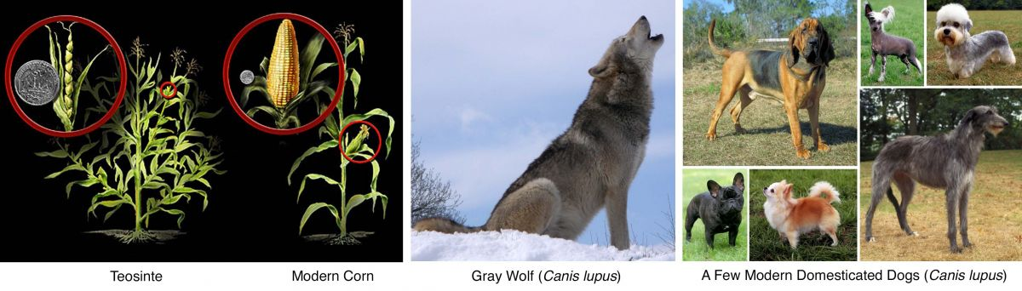

**Figure 4.34**. Examples of microevolution by artiﬁcial selection in maize and wolf. As you can see, humans selected variants of corn that produced more food, and artiﬁcial selections have produced tremendous variability in modern dogs.

(Microevolution 1, Author illustration, created as a work for hire by Eden Platt using these images: Corn, NSF, https://bit.ly/39e114S, public domain; Wolf, Retron, https://bit.ly/3ytxSgG, public domain; Dogs, Mary Bloom, https://bit.ly/3L808rN, CC-BY-SA-4.0. Licensed as CC-BY-SA-3.0.)

All populations display examples of microevolutionary change resulting from natural selection, as illustrated in **Figure 4.35**. A simple example involves the change in beak size in a population of seed-eating birds (Medium Ground Finches on the island of Daphne Major in the Galapagos Islands) before and after the drought of 1976-1978. During the drought, researchers observed that plants with larger seeds became more abundant than those with smaller seeds (**Figure 4.35**). As the availability of smaller seeds dropped, smaller-beaked birds in the population struggled to survive and reproduce. As a result, the drought caused beak size in the population to increase. Can you see how natural selection produces microevolution?

Like ﬁnch beak size during a drought, the proportion of light- and dark-colored Pepper Moths in the British Isles changed when pollution altered individual ability to hide from natural predators. Before the industrial revolution of the late 1700s, light-colored moths comprised ~99% of the local moth population because birds easily spotted and ate dark-colored variants. As industrial activities covered trees in soot, dark-colored moths were favored. By 1959, dark-colored moths comprised ~90% of the population. Then, after environmental reforms in the 1970s allowed trees to once again achieve their natural color, light-colored individuals once again rose to dominate the population. Thus, changing environmental conditions selected body color in the moths and pushed the population ﬁrst one way and then back.

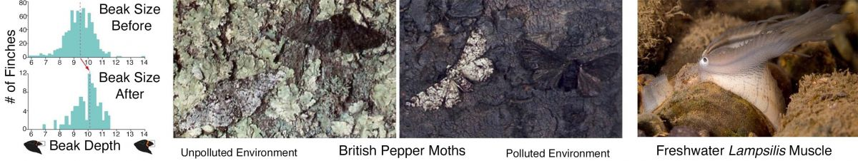

**Figure 4.35**. Examples of microevolution resulting from natural selection in Galapagos Finches, British Pepper Moths, and American Lampsilis mussels.

(Microevolution 2, Author illustration, created as a work for hire by Eden Platt using these images: Beaks, Charles Mallory/U. of Miami, CC-BY-SA-4.0; Moths, IUPUI Biology, used with permission; Lamsilis, USFWS, https://bit.ly/3wmuyRH, public domain; Licensed as CC-BY-SA-3.0.)

As a third example, microevolution in the freshwater Limpsilis mussel has molded the peripheral tissue into a ‘ﬁsh lure’. Note that what appears in **Figure 4.35** to be a small ﬁsh, a favorite prey of bass, is a disguised extension of mussel ﬂesh that enhances mussel reproduction. If these mussels release their young directly into the rivers they inhabit, the larvae are washed out to sea, and the population would eventually die out. Instead, numerous generations of mussels have selected for individuals with ﬂeshy extensions that mimic bass food. Then, when a bass strikes, the mussel blasts a pulse of larvae directly into its mouth—where the larvae clamp onto whatever bit of bass they ﬁrst touch. Then, once developing mussels reach suﬃcient size, they release from the bass, ﬂoat to the river bottom, and begin living the ﬁlter-feeding lifestyle of adult mussels.

As you can see, many examples of microevolution are observed scientiﬁc facts, and other examples involve scientiﬁc interpretation. Signiﬁcantly, microevolution produces the ‘lawful body molding’ that ensures that populations remain ﬁnely-tuned to their environments. Without microevolution, constantly changing environments species would go extinct. What’s more, microevolutionary adaptations produced many of the larger-scale macroevolutionary changes that characterize the history of Earth life and generated the diversity of life observed today. So beautiful, so cool, and so well-described by the scriptural analogy of forming organisms by molding clay!

## Macroevolution

In contrast to microevolution, macroevolution refers to larger-scale changes between species over longer periods. Macroevolution occurs when the relative proportion of interacting species changes. These changes include relatively small variations, such as when decreasing numbers of wolves increase deer abundance. They also include large changes to the composition of an ecosystem, such as the rise and demise of species. Speciation is the origin of a new population of organisms with characteristics that are persistently distinct from other populations. Microevolution over long periods of time can produce new species.

Macroevolution is more challenging to directly observe than microevolution because it typically occurs over periods that extend far beyond human lifespans. As a result, macroevolutionary explanations involve more interpretation. Even so, some speciation events can be directly observed.

For example, plants can form new species from one generation to the next—by duplicating chromosomes during sex cell formation (polyploidy) or by combining genomes from distinct species (hybridization). In the laboratory, researchers have formed new species like the ‘radicole’ (raddish + cabbage) in this way. What’s more, genetic studies indicate that ~80% of modern plant species formed in these ways—including many food plants like oats, cotton, potatoes, wheat, and bananas. Humanity can also directly observe speciation in single-celled organisms like bacteria and short-lived animals like fruit ﬂies.

In addition to directly observing speciation, humanity has used an overwhelming body of empirical observations to test the validity of macroevolutionary interpretations like the emergence of new species from an existing species. To date, these observations are unable to falsify the theory of evolution, which indicates that the theory contains abundant truth. Observations of macroevolution include data from genetic, embryological, ecological, and fossil sources.

Most commonly, speciation involves the reproductive isolation of subpopulations. Such isolation can result from the formation of geographic barriers like a mountain range or sand sea. No matter the source, isolating mechanisms divide initially-interbreeding population. Once split, genetic innovation and microevolutionary adaptations to distinct environments can produce populations that no longer interbreed. When this occurs, the new populations represent distinct species. As a result, the theory of evolution predicts that humanity should observe populations at varying stages of reproductive isolation, from partial to complete speciation.

Natural examples of partial speciation are abundant. For example, Mallards and Gadwall represent persistently distinct populations of ducks. However, these ducks can breed, and their oﬀspring (Brewer’s ducks) are fertile. As such, these duck populations represent a small degree of species separation. In contrast, horses and donkeys illustrate greater species separation. When these populations breed they produce mules, which are infertile.

Similarly, examples of gradational speciation provide compelling examples of populations ‘caught in the act’ of forming new species through evolution. This kind of ‘in process’ speciation occurs when a chain of reproducing populations have end-member groups that cannot reproduce. **Figure 4.36** shows three examples of these so-called ‘ring species’—in populations of birds and salamanders. To be clear, the populations on the ‘closed’ portion of each ‘ring’ represent a single species, but the populations that lie at the ‘open’ portion of each ring are separate species.

Ring species typically develop as the ranges of interbreeding populations expand around a geographical barrier over many generations. During expansion, isolated populations change. For example, exposure to diﬀerent selection pressures molds bodies in diﬀerent ways. This eventually produces populations that, although adjacent, cannot interbreed and are thus separate species. In this way, ring species allow humanity to observe in space (geography) the descendancy relationships and microevolution that occurred through time, as populations spread around a barrier. These and other ring species are profoundly powerful conﬁrmations of the reality of micro and macroevolution.

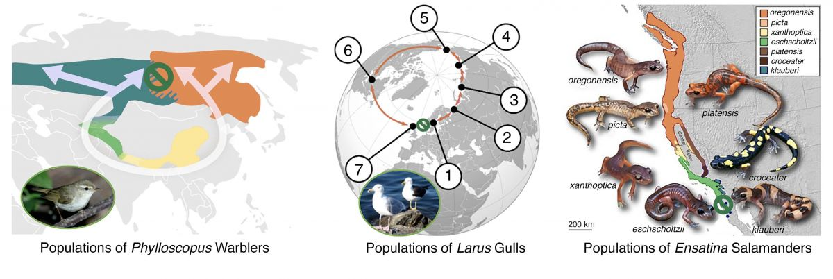

**Figure 4.36**. Illustration showing groups of interbreeding populations whose end-members cannot reproduce. The green ‘not allowed’ symbol lies between the populations that cannot reproduce and are thus separate species. The geographic barriers in these examples are, respectively, the Himalayas, Arctic Ocean, and Central Valley of California.

(Speciation, Author illustration, created as a work for hire by Eden Platt using these images: Warbler Map, Esculapio, https://bit.ly/3w9Bi Uc, public domain; Warbler, Vishnevskiy Vasil y, https://shutr.bz/ 3lbEN64, Shutterstock royalty-free license; Gull map, Frédéric Michel,https://bit.ly/3wpCxNV, CC-BY-SA-3.0; Gulls, Tomasz Sienicki, https://bit.ly/3wrfQJm, CC-BY-SA-3.0; Salamanders, Thomas J. Devitt and others, https://bit.ly/3l 8ESrg, CC-BY-SA-2.0; Licensed as CC-BY-SA-3.0.)

Notably, every modern species is part of a speciation story. As a result, examples of speciation are nearly innumerable and include both modern and fossil organisms. Some examples are based entirely on modern observations and others include fossil organisms. **Figure 4.37** illustrates the nearly-complete speciation of Grand Canyon squirrels and the complete speciation of Central American Porkﬁsh.

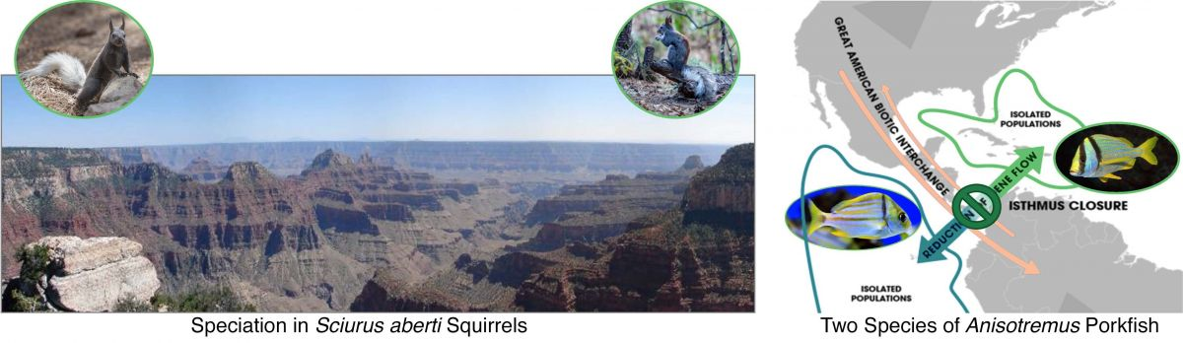

**Figure 4.37**. Illustrations showing speciation in Grand Canyon squirrels and Central American Porkﬁsh.

(Macroevolution, Author illustration, created as a work for hire by Eden Platt using these images: Grand Canyon, author photograph; Northern squirrel, Azhikerdude, https://bit.ly/3yzQMCt, CC-BY-SA-3.0; Southern squirrel, Dennis Swena, https://shutr.bz/3l 4divt, Shutterstock royalty-free license; Porkﬁsh map, Andrew Colvin, https://bit.ly/3sx0rGl, CC-BY-SA-4.0; Western ﬁsh, Karelj, https://bit.ly/3l 6QfA0, CC-BY-SA-3.0; Eastern ﬁsh, aquapix, https://shutr.bz/3MdDEaj, Shutterstock royalty-free license. Licensed as CC- BY-SA-3.0.)

In the area of the Grand Canyon, climate warming at the end of the last glacial period isolated stands of Ponderosa Pine on the cooler, wetter North Rim and on the warmer, drier South Rim. Climate diﬀerences between these isolated forests caused a once-interbreeding population of squirrels to diverge down separate microevolutionary paths. Today, the speciation of North and South Rim squirrels is nearly complete.

Geographic isolation also produced diverging populations of Porkﬁsh, after being isolated by the formation of Central America ~3.5 Mya. Today, Paciﬁc and Carribean Porkﬁsh are completely separate species. Of course, this explanation is testable—for the Mesoamerican land bridge predicts the isolation of many marine species and the mixing of many terrestrial species. Observations conﬁrm both sets of predictions.

In addition to modern examples, the attributes of fossil organisms through time mark clear descendancy paths from early to modern organisms (see [**Figure 4.14**](https://books.byui.edu/content_images/from_atoms_to_humans/Figure_4_14.jpg)). Researchers illustrate both ﬁne- and broad-scale descendancy relationships in diagrams called phylogenetic trees. **Figure 4.38** shows two broad-scale examples of such descendancy trees. One illustrates major transitions in the development of modern whales, dolphins, and hippopotami from a lineage of early terrestrial mammals. The other illustrates the lawful body molding that produced dinosaurs, including the modern ﬂying dinosaurs known as birds.

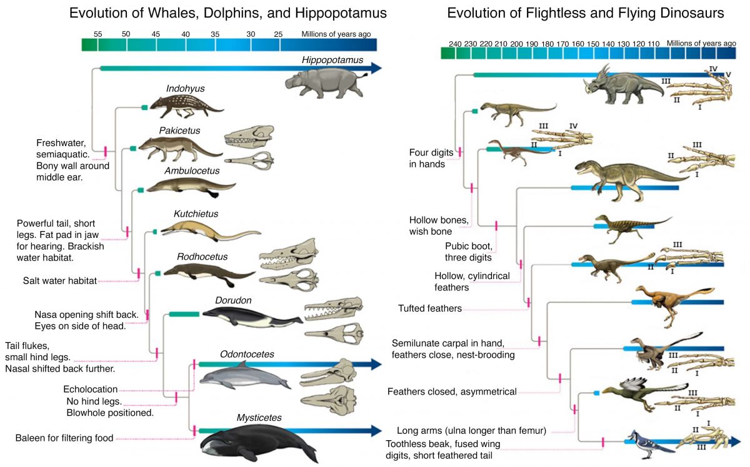

**Figure 4.38**. Illustrations of descendancy relationships and emerging attributes among fossil and modern groups of aquatic mammals (left) and dinosaurs (right). Note that most major groups of aquatic mammals and all ﬂightless dinosaurs are now extinct.

(Molding whales and dinosaurs, Author illustration, created as a work for hire by Jordan Barton using these images: add image ci tations. Licensed as CC-BY-SA-3.0.)

Both descendancy diagrams identify attributes that mark developmental transitions. The emergence of novel attributes such as these can be a stumbling block for individuals who know little about evolution. Often, these individuals assume that evolution asserts that these emerging attributes ‘appear out of nowhere’. Evolution suggests no such thing. Instead, the theory of evolution recognizes that these ‘new’ attributes are molded versions of preexisting features.

What’s more, evolutionary relationships based on fossil observations are independently established by abundant additional natural witnesses, including observations from genetics and embryology. For example, did you know that the nostril in dolphin embryos forms at the front of the face and then migrates to the top of the head before birth? Or that dolphin embryos form hind limbs that then usually resorb before birth? Or that birds have inactive fossil genes for building teeth but lack the control gene to turn them on? Or so many, many, many other witnesses of the descendancy relationships that produced modern organisms. Signiﬁcantly, descendancy trees such as these, together with similar supporting evidence, exist for all living organisms—including humans.

At its core, the theory of evolution explains that the development and nature of living things results from descent with adaptation through time. This assertion is supported by an extensive web of biological and other observations. Said diﬀerently, numerous interrelated observations of living things fail to falsify the theory of evolution. For this reason, biological evolution is not a whimsical idea about what might or could happen. Instead, it provides humanity with ‘knowledge of life as it is, as it was, and as it will be’. Today, the theory of evolution informs and provides the unifying principle for all ﬁelds of biology—genetics, medicine, ecology, embryology, and so on.

As a result, it’s diﬃcult to understand the meaning of individuals who declare that they don’t believe in or accept evolution. In our experience these individuals typically don’t mean that they are opposed to observed microevolution, extinction, and speciation; or that they reject the relatedness of all living things; or that they don’t believe in the principles of genetics, ecology, or medicine; or that they don’t accept the lawful nature of embryological development; or …. Instead, as we’ve mentioned in other contexts, our experience indicates that individuals who proclaim opposition to evolution aren’t typically trying to say anything at all about evolution. Instead, they are trying to assert that God created all living things. We agree with their assertion, and we witness that life developed according to natural evolutionary processes.

To be clear, our message is not, “You’re a bozo if you don’t acknowledge the abundant truth contained in the theory of evolution.” Instead, we are trying to impress upon the consistency of evolutionary explanations with the explanations derived from written scripture. What’s more, we are trying to help you understand the implications of disavowing the tremendous explanatory power of this scientiﬁc theory. Rejecting the theory of evolution requires also disavowing most scientiﬁc knowledge because this theory is one of humanity’s most extensively tested scientiﬁc explanations. Whatever your present perspective, we wish you our very best as you continue your personal search for truth. May you continue to enjoy and be abundantly blessed in that pursuit.

Read this online at <https://books.byui.edu/from_atoms_to_humans/427_nurturing_nature>