# Co-Create Spiritually

### Objectives

* Why is it important to create spiritually?
* How do I create spiritually?

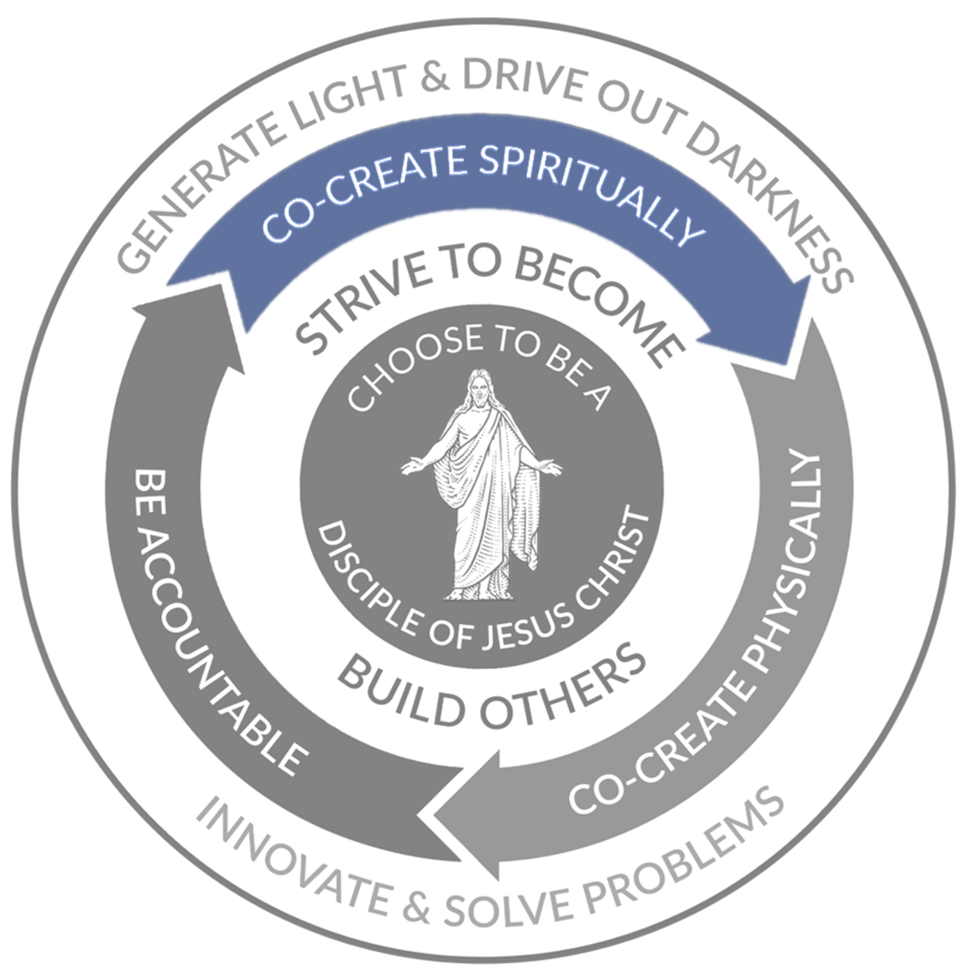

Go to Mini-Case: Hey Joe Show

In the scriptures, we find a pattern by which Heavenly Father and Jesus Christ created the universe and our planet.

“For I, the Lord God, created all things, of which I have spoken, spiritually, before they were naturally upon the face of the earth….”

Moses 3:5

As a leader, it is important to accomplish the work and get things done. You will be learning the same pattern that the very earth was created. The first step of that pattern is to create spiritually or, in other words, to create a plan, strategy, or mission.  **In this spiritual creation, seek the guidance of our Heavenly Father and Jesus Christ.  You are partnered with Them, and that is why it is referred to as "co-create."** Don't create the plan or strategy alone.

## Why is It Important to Create Spiritually?

Benjamin Franklin said, “If You Fail to Plan, You Are Planning to Fail.”  He was correct; if we don't prepare, we will lead ourselves to failure.  Having a plan, strategy, or mission for our organization is the first step to success.

Read the following articles and reflect on the following questions:

* [Moses 3:5-9](https://www.churchofjesuschrist.org/study/scriptures/pgp/moses/3?lang=eng&amp;id=p5-p9#p5) Creation of the Earth
* [Luke 14:28-30](https://www.churchofjesuschrist.org/study/scriptures/nt/luke/14?lang=eng&amp;id=p28-p30#p40) Jesus is speaking to His disciples
* [“Revelation for the Church, Revelation for Our Lives”](https://www.churchofjesuschrist.org/study/general-conference/2018/04/revelation-for-the-church-revelation-for-our-lives?lang=eng) Russell M. Nelson

How can you make sure you "have sufficient to finish" a project? (Note: Your responses will not save)

How can you, as a leader, include revelation as you create a plan, strategy, or mission?

(Note: Your responses will not save)

|  |
| --- |
| Example of Christ: Jesus Declares He is the Messiah |
| WATCH [Jesus Declares He is the Messiah](https://youtu.be/h9M2mprzCF8) or READ [Luke 4:15-30](https://www.churchofjesuschrist.org/study/scriptures/nt/luke/4?lang=eng&amp;id=p15-p30), then consider the following questions:   * + Why do you believe Jesus quoted the words of Isaiah to declare His mission?   + Knowing that the people of Nazareth would reject His declaration that He was the promised Messiah, why do you think He chose to declare His mission in the synagogue that day? Why was he unafraid to do so?   + What does Jesus’ firm commitment to His mission teach us about the importance of discovering, clarifying, and sharing our own personal mission(s)? |

## How do I Create Spiritually

As you read The 7 Habits this week, Covey will refer to spiritual creation with phrases like "first creation" and "mental creation."

### Habit 2: Begin with the End in Mind

Watch and read the following from the 7 Habits of Highly Effective People:

1. Read the first part of [Habit 2: Begin with the End in Mind](https://ebookcentral.proquest.com/lib/byupw/reader.action?docID=3565195&amp;ppg=112&amp;c=RVBVQg#) chapter (from pages 92–100).
   * Take notes as you read.
2. Watch this video, ["80th Birthday" as it relates to a Personal Mission Statement](https://youtu.be/1z7iHB24Oqg).
3. Continue reading starting at the heading, ["A Personal Mission Statement."](https://ebookcentral.proquest.com/lib/byupw/reader.action?docID=3565195&amp;ppg=121) (pages 121–137)Think about this quote by Viktor Frankl, "We detect rather than invent our missions in life.”

### Habit 3: Put First Things First

1. Watch this video, [**The Time Matrix**](https://youtu.be/Z459cW8C3i0).

(4:42 The 4 Quadrant Week Plan Transcript)

1. Read the first part of the [Habit 3: Put First Things First](https://ebookcentral.proquest.com/lib/byupw/reader.action?docID=3565195&amp;ppg=128) (pages 150-141)
   1. Remember to take notes as you read.
2. Watch this video,

(4:01,

[Big Rocks](https://docs.google.com/document/d/e/2PACX-1vRlhEY4vg_mtyypBE5eIZpMLLJmeIErjrERIq5ihWT9FgfKphKmoNds_AsOm2cM1_6xHOeOuneJYSt_/pub)

Transcript)

1. Watch this video, [**Weekly Planning**](https://youtu.be/7yMh2QNRc_M).

(7:11,

[Weekly Planning](https://docs.google.com/document/d/e/2PACX-1vQE7djeegClrrKICsQwid5ZvOSRP4fFBWhxnTvySBLUiAmdP9R9H-FdD1OTpr9nOtwd_iaeJ7c8my1c/pub)

Transcript)

1. Continue reading starting at the heading, ["Becoming a Quadrant II Self-Manager."](https://ebookcentral.proquest.com/lib/byupw/reader.action?docID=3565195&amp;ppg=163) (pages 163–175)
2. You will apply these concepts in future assignments.

### Habit 2

* **Principle**: Mental creation precedes physical creation
* **Ineffective Paradigm**: I live by default.
* **Effective Paradigm**: I live by design.

"Would you tell me please which way I ought to go from here?"

"That depends a good deal on where you want to get to," said the Cat.

"I don't much care where," said Alice.

"Then it doesn't matter which way you go," said the Cat.

- From Alice's Adventures in Wonderland.

### Habit 3

* **Principle**: Effectiveness requires the integrity to act on your priorities.
* **Ineffective Paradigm**: I live by default.
* **Effective Paradigm**: I live by design.

Habit 3 is the habit of execution and integrity.

"Things which matter most must never be at the mercy of things which matter least."

- Johann Goethe

"To live more fully each hour and to glean the most from each day is wisdom. How unwise we are to waste our todays when they determine the significance of our tomorrows. We should wisely live a day at a time because that is all that we have."

- Marvin J. Ashton

## How can I create and clearly communicate mission, vision, and values for the people I lead?

There are many great books, websites, and other sources that can help us learn the principles of creating and communicating a clear vision. For our purposes in this course, we will seek to understand the differences between Mission, Vision, Values, Strategy, Goals, and Priorities.

### Mission

We addressed personal mission statements in the last chapter. Whether you are creating or discovering your personal mission or the mission of an organization of which you are a part, the simplest way to define your mission is to ask yourself why you or your organization exist; what is your purpose?

The following video with Simon Sinek, “Start with Why,” can help us determine the “why,” or the purpose of the organizations we lead:

* Start with Why by Simon Sinek

(18:01,

[Start with Why](https://docs.google.com/document/d/e/2PACX-1vRvFZ_9Rl01TGB2QjWp3SMRCwQvGu7gjl6pNo_VOQ2D1up_FzezlB48p6QOcFNxifVMfWKgVX07APMU/pub)

Transcript)

As we ponder Simon Sinek’s explanation of the “why” of an organization, we might also ask ourselves whether the idea of “starting with why” is based on eternal, timeless principles. Does our Heavenly Father have a “why” or a mission?

In Moses 1:39, the Lord states his purpose or mission in these simple words: “For behold, this is my work and my glory—to bring to pass the immortality and eternal life of man.” [emphasis added]

In other words, although the Lord does an infinite number of things to accomplish his work, His actions are always aligned with His mission: “to bring to pass the immortality and eternal life of man.”

In John 10:10-11, we find one of many statements of the Savior’s purpose: “I am come that they might have life, and that they might have it more abundantly. I am the good shepherd: the good shepherd giveth his life for the sheep.”

Similarly, in alignment with our Heavenly Father’s and the Savior’s purposes, the Church explains our mission as: “The mission of The Church of Jesus Christ of Latter-day Saints is to help all of God’s children come to Jesus Christ through learning about His gospel, making and keeping promises with God (covenants), and practicing Christlike love and service.” [Mission of the Church](https://www.churchofjesuschrist.org/learn/about-us?lang=eng)

BYU-Idaho, a university created by and sponsored by the Church, explains our mission as: “Brigham Young University-Idaho was founded and is supported and guided by The Church of Jesus Christ of Latter-day Saints. Its mission is to develop disciples of Jesus Christ who are leaders in their homes, the Church, and their communities.”

In each case, the Savior, His Church, and BYU-Idaho all pursue missions in support of our Heavenly Father’s mission “to bring to pass the immortality and eternal life of man.”

As a disciple-leader in your own life, in your home, in the Church, at work, and in the community, you will often have the responsibility of setting and communicating the mission of the people you serve. At times, that mission will have already been set by other leaders in the organization. At other times, you will need to seek inspiration from Heaven, from scriptures and good books, from other members of the organization, and from other sources of truth to “spiritually create” and define your common purpose and mission.

### Mission vs. Vision

In some circles, mission and vision are spoken of as synonyms. However, for our purposes, your mission is the “why” and the vision is “a clear picture of where you want to go.”

For example, Cotopaxi (a well-known outdoor gear brand started by Davis Smith, a Latter-day Saint who spent several years of his youth in Latin America and who wanted to start a company with a noble purpose of helping alleviate poverty) has the following mission statement: “Adventure inspires us to see the world and make it better. That’s why we build gear that fuels both outdoor experiences and global change. To achieve our mission, we dedicate at least 1% of our revenue to nonprofits that help communities experiencing poverty.”

([Click here](https://blog.hubspot.com/marketing/inspiring-company-mission-statements) if you’d like to explore more examples of compelling mission statements.)

Mission statements are usually externally facing as they give employees, customers, and investors a clear picture of why the company exists. By contrast, vision statements are often aspirational, internally facing statements intended to let employees and investors know where the company plans to go over time.

To illustrate the difference between mission and vision, consider the following statements from LinkedIn: LinkedIn’s vision statement is to “Create economic opportunity for every member of the global workforce,” and their mission statement is- to “connect the world’s professionals to make them more productive and successful.” In simple terms, “creating economic opportunity for every member of the global workforce” is a picture of the end of the journey LinkedIn is pursuing. Their mission, “to connect the world’s professionals and make them more productive and successful” is the reason [LinkedIn](https://about.linkedin.com/) is pursuing the journey.

### Values

The values of the organization are an expression of the principles a company holds most dear and upon which they intend to build their culture. Just as it can be difficult for us as individuals to always live up to our values, companies and other organizations may also aspire to live a certain set of values that are not always honored by every employee. This is one of the reasons that stating your values can be so important.

For example, if we return to the previous example of [Cotopaxi](https://www.cotopaxi.com/pages/about-us), their values are “Reduce Inequality, People and Planet, and Force for Good.

Here are several additional examples of organizations’ values statements:

* [Patagonia](https://www.patagonia.com/core-values/) (outdoor clothing company)
* [BYU Marriott School of Business](https://marriott.byu.edu/our-story/mission/)
* [Huntsman Cancer Institute](https://healthcare.utah.edu/huntsmancancerinstitute/about-us)
* [Microsoft](https://www.microsoft.com/en-us/about/corporate-values)

While most organizations base their values on good, timeless principles, you have a unique opportunity as a disciple of Jesus Christ to seek to base your values, the values of your family and the other organizations of which you are a part on principles of righteousness, light, and truth.

Consider the following questions as you consider your family or future family:

* What is our mission? Why do we do what we do?
* What is our vision? What do we want our family to become over time?
* What are our values? What core principles will we base our decisions and actions upon throughout our lifetime together?

## What is strategy and how can I create an effective strategy with and for the people I lead?

Strategy is another word that can have several meanings in organizational leadership. Many people consider “strategy” as the plan for “how” you will accomplish your vision. Michael Porter of Harvard Business School offers a more-specific definition:

Competitive strategy is about being different. It means deliberately choosing a different set of activities to deliver a unique mix of value.

[Southwest Airlines Company](https://hbr.org/1996/11/what-is-strategy), for example, offers short-haul, low-cost, point-to-point service between midsize cities and secondary airports in large cities. Southwest avoids large airports and does not fly great distances. Its customers include business travelers, families, and students. Southwest’s frequent departures and low fares attract price-sensitive customers who otherwise would travel by bus or car, and convenience-oriented travelers who would choose a full-service airline on other routes.

By this definition and example, your strategy is what sets you apart from others, the “unique mix of value” that you or your organization offer to the world. Your strategy is also a guide to help you determine what you will and will not do to maintain your unique competitive advantage.

See the following video for a summary of Michael Porter’s famous article on strategy:

Watch the following video:

Summary of Michael Porter's ["What is Strategy?"](https://youtu.be/VpRNZFuJ_VU)

(12:10,

["What is Strategy?"](https://docs.google.com/document/d/e/2PACX-1vSMkl7l_QMzNdopJz5DsfluNRKBCUXddgfA-vkERedfeDXWchZSVKRb41_FKY3Ez5GOxnjP4CgdSGTY/pub)

Transcript)

For example, as we discussed the [Church’s mission](https://www.churchofjesuschrist.org/learn/about-us?lang=eng) in the previous section, it can be helpful to consider the unique set of activities (the strategy) the Church follows to accomplish their mission.

1. Living the gospel of Jesus Christ
2. Caring for those in need
3. Inviting all to receive the gospel
4. Uniting families for eternity

This unique set of activities serve as both a guide of the actions we choose to pursue as a Church and also as a guide of the actions we should say “no” to when deciding the courses of actions we pursue. If a certain plan does not support one of these four strategic activities, while it may seem interesting and exciting, it will likely be forgone to make room for activities that match our strategy.

Similarly, while BYU, BYU-Hawaii, Ensign College, BYU-Idaho, and Pathway all have very similar missions, the unique set of activities they pursue to accomplish their unique roles in that mission can be quite different. For example, BYU-Idaho was created with a unique strategy in mind, as expressed in the second half of our mission statement:

The university does this by:

1. Building testimonies of the restored gospel of Jesus Christ and fostering its principles in a wholesome academic, cultural, and social environment.
2. Providing a high-quality education that prepares students of diverse interests and abilities for lifelong learning and employment.
3. Serving as many students as possible within resource constraints.
4. Delivering education that is affordable for students and the Church.

The following mini-case shares an example of a singing group based out of BYU who, due to their unique strategy, found remarkable and unlikely success amongst the Cebuano people of the Philippines:

### Mini-Case: The Hey Joe Show

WATCH the following story about BYU students who became famous in the Philippines. As you watch, think about Michael Porter’s definition of strategy,

[Hey Joe! BYU students' secret life as Filipino video stars](https://youtu.be/DGwifXqVug0)

(6:16,

[Hey Joe!](https://docs.google.com/document/d/e/2PACX-1vQUyfiiPKa-wB35vLYnI4EkiSBTWGQ5GGr3sDkFSuXmgh1tVCXFmSwhg-n3d8TJJBS4vws-rKLYIeFk/pub)

Transcript)

Hey Joe Show’s description on the About page of their website describes elements of their [mission and strategy](http://www.heyjoeshow.com/about.html):

The Hey Joe Show is a multi-platform social media group dedicated to celebrating and exposing Filipino culture to a global audience. The members of Hey Joe Show are committed to providing clean, wholesome entertainment predominantly in the Visayan language. Sumner, Connor, Davis, Tylan and Jake learned the rich and diverse Filipino culture while living in the Philippines for two years. In an effort to stay connected with the country they grew to love, they created the Hey Joe Show upon returning to the United States. Ranging in acts from American takes on Filipino customs to popular songs translated into Bisaya, the Hey Joe Show has done all they can to make Filipinos smile.

* What is the strategy of the Hey Joe Show?
* What principles from Michael Porter’s explanation of strategy helps explain why these young BYU students rose to stardom so quickly in the Philippines?
* What eternally true principles help explain why Hey Joe! Show’s strategy helped them succeed in the Philippines?

Read this online at <https://books.byui.edu/leadership_toolkit/create_spiritually>