# Atoms. The Building Blocks of Matter



Dr. Brian Tonks & Dr. Dan Moore, Physics & Geology Departments, BYU-Idaho

This brief essay reviews the basic nature of matter and humanity’s discovery of atoms.

## ATOMS, ELEMENTS, & ISOTOPES

As you know, all matter is made of **atoms**, and atoms are the smallest pieces of chemical **elements**. In other words, an atom is the smallest particle that displays all the properties of a chemical element. Hydrogen, oxygen, and gold are all examples of elements. Atoms consist of a nucleus and an electron cloud, as illustrated in **Figure 1**. The nucleus is the small region at the center of an atom that contains most of the atom’s mass. Atomic nuclei consist of positively charged subatomic particles called protons and neutrally charged particles called neutrons. The electrons, small negatively charged particles that have little mass, move rapidly around the nucleus in a region called the electron cloud. The electron cloud of an atom is ~100,000(!) times larger than the diameter of the atom’s nucleus.

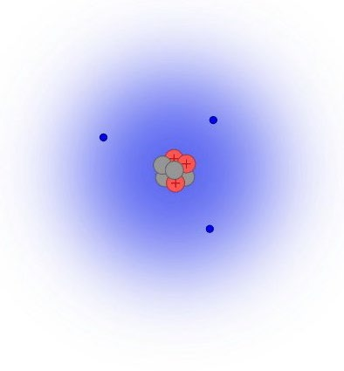

In atoms, the number of electrons is the same as the number of protons. Since electrons and protons have equal but opposite electric charges, this means that neutral atoms have the same numbers of protons and electrons—yielding a net electric charge of zero. Atoms that are not electrically neutral are called ions. Positively charged ions called cations have lost electrons, and negatively charged anions have gained electrons. Atoms of opposite charge can bind together to form matter. More on this later.

Figure 1. An illustration of an atom (not to scale). The protons and neutrons (red and gray) are bound together in the nucleus, which lies at the center and is surrounded by electrons (blue dots) that move rapidly and form the electron cloud (blue haze). (Credit. BYU-Idaho)

Atoms are characterized by the number of protons found in their nuclei. The number of protons in the nucleus is referred to as the atomic number, and this number identifies the element. For example, all atoms with six protons are carbon (C) atoms, and all atoms with 79 protons are gold (Au) atoms. U Different elements have different atomic numbers. However, it is the number of electrons—not the number of protons—that determines the chemical properties of the atom. For example, all atoms of hydrogen (atomic number = 1) have the same range of chemical properties, as do all the atoms of oxygen (atomic number = 8). **Figure 2** shows the periodic table of the elements, which organizes the elements that comprise the Universe according to their chemical properties. On the table, atomic number grows across rows, from upper left to lower right.

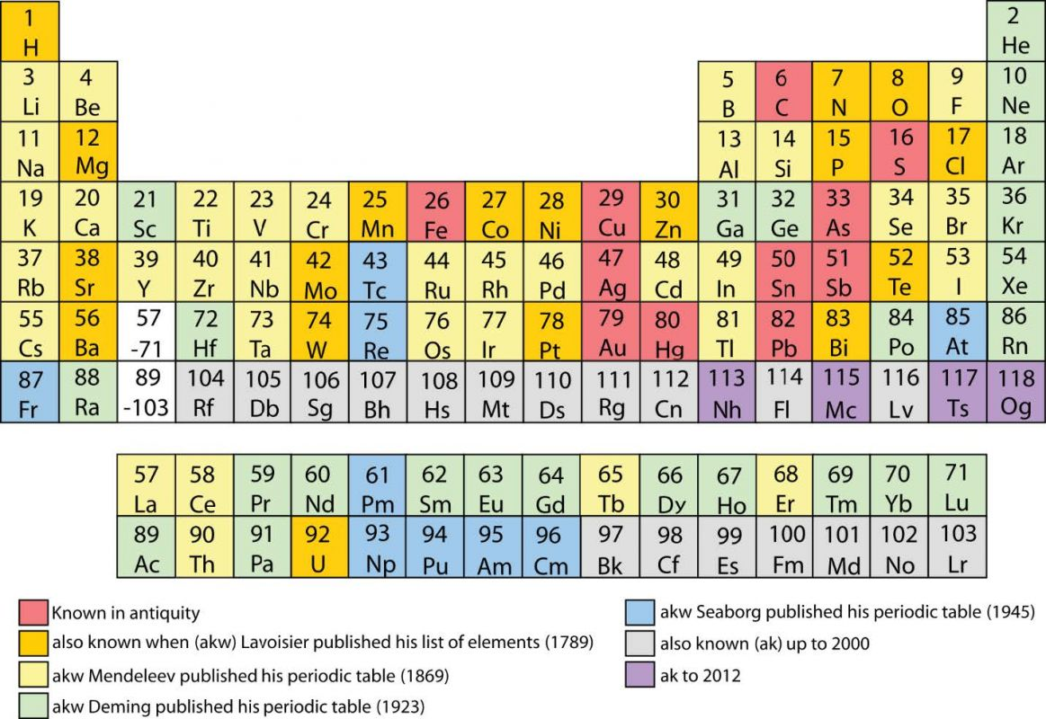

**Figure 2**. The Periodic Table of the Elements. Colors shown above indicate approximately when humanity discovered each element. (Credit. Wikimedia) Use this [interactive periodic table](https://ptable.com/?lang=en&amp;Properties) to match the atomic numbers and element symbols found above to the names of each element.

The total number of protons and neutrons (nucleons) in an atom is the mass number of that atom— emphasizing that essentially all the mass lies in the nucleus. Atoms with the same number of protons (atomic number), but differing numbers of neutrons (mass number) are called **isotopes**. Said differently, isotopes are atoms of a particular element with differing numbers of neutrons. For example, the element carbon—shown as ‘C’ on the periodic table in **Figure 2**—has three common isotopes. All three have six protons, but each has different numbers of neutrons: one has six, one has seven, and one has eight neutrons. A useful shorthand for isotopes consists of the chemical symbol for an element, preceded by a superscripted number indicating the mass number. Note that specifying the number of protons in this notation is unnecessary because all carbon atoms have six protons. Using this notation, the three common isotopes of carbon are 12C, 13C, and 14C. This [interactive chart](https://www-nds.iaea.org/relnsd/vcharthtml/VChartHTML.html) shows all of the isotopes that humanity has discovered—many only in the laboratory. Most of these isotopes are radioactive. Only those shown on the chart in black are stable.

Although the number of protons determines element and the number of electrons determines chemical behavior, it is the number of neutrons in an atom that determines the stability of its nucleus. Atoms with stable nuclei are called **stable isotopes**, and those with unstable nuclei are called **radioactive isotopes**. During radioactive decay, unstable isotopes of one element become isotopes of another element. For example, both 12C and 13C are stable isotopes, but 14C is unstable. And the decay of radioactive 14C atoms (6 protons and 8 neutrons) yields stable atoms of 14N (nitrogen atoms with 7 protons and 7 neutrons).

## CHEMICAL BONDS

As noted above, atoms bind together because opposite charges attract. To develop your intuition about chemical bonds, recall how magnets work. (Incidentally, as a child didn’t you find magnetics magically fascinating?!) Try as one might, pushing like magnetic poles together is nearly impossible—for the repelling force grows as the magnets approach each other. Similarly, it seemed like magic that opposite poles pulled magnets together. Like magnetic poles, the charges of atoms bind matter together: the opposite charges of positively and negatively charged atoms/molecules bind them together in different types of matter. Sometimes the charge imbalance responsible for atoms persists, but sometimes it only is transient or oscillates.

Before we describe different chemical bonds, let’s consider what happens when two uncharged atoms are brought together, slowly. As these atoms approach each other, it is the negatively charged electron clouds—not the positively charged nucleus—that first interact. And, of course, the electron clouds repel each other. This thought experiment emphasizes an essential point: atoms interact with each other through their electron clouds. This important reality underlies another essential point: the electrons of atoms determine their chemical behavior—the way that they bind with other atoms.

This thought experiment also illustrates why material objects like your body and a wall appear to be ‘full of matter’. As you already know, atoms are mostly empty space. In fact, the matter in everyday objects accounts for far less than 0.00001% of the space they occupy. Seriously!!! So, if your body and a wall consist mostly of empty space, why can’t you walk through the wall? Material objects such as people and walls cannot pass through each other because they are full of something, just not matter. Material objects are completely full of ‘charge’ (quantum fields), not matter. In other words, it is the repulsion of electron clouds that keeps objects from passing through each other. In this sense, you have never touched any matter in your entire life—not ever! What you thought of as ‘touching’ matter was actually the atoms in your body and those in the object repelling each other. So, the next time you sit down, remember that your butt is not touching the chair; instead, your butt is hovering a small distance above the chair! Isn’t scientific discovery fascinating?! How can anyone who is interested in truth—in understanding ‘things as they actually are’—not be interested in scientific discovery?! So cool!

Okay, back to chemical bonding. When atoms are charged—even if only for an instant—the electron cloud of the negatively charged atom is attracted to the positively charged nucleus of the other atom, and vice-versa. Thus, chemical bonds are caused and maintained by attraction between opposite charges.

Bond types are distinguished by the different ways that electrons interact to produce attracting charges. In so-called ionic bonds, the attraction results from electrons that completely leave one atom and take up residence in the electron cloud of another atom. In contrast, other bond types result when electron clouds share electrons. In covalent bonds, electron sharing persists between adjacent atoms, and in metallic bonds, electron sharing is communal across many atoms. The weakest chemical bonds (Van der Waals bonds) result from instantaneous charge imbalances in neutral atoms. These imbalances stem from shifts in the electron density of adjacent electron clouds—for example, when the electron density on one side of an electron cloud is high, that side will have a slight negative charge and the opposite side will have a slight negative charge.

A comprehensive discussion of bonding is far beyond the scope of our course. Unsurprisingly, understanding bonding at a deeper level is quite a bit more complex. Even so, the descriptions above are sufficient to build a usefully-accurate mental model for nonscientists.

## HOW HUMANITY DISCOVERED ATOMS

Humanity’s path to understanding the basic nature of matter required many thousands of years. Can you believe it took so long?! Humanity did not discover the nature of matter until the early 1900s. We will track Western Civilization’s journey of discovery beginning with the ancient Greeks, who were profoundly interested in the nature of the physical world. Greeks thinkers developed three different concepts of matter. One group of thinkers, known as atomists, developed the foundations of modern concepts of matter. This hypothesized that matter consists of tiny particles called atoms that could move around in empty space. (In Greek, atomic means indivisible.) For them, objects grow when atoms combine, and they shrink when atoms dissipate. Although their ideas contained some truth, the atomists weren’t clear about what made one type of atom different from another or what caused atoms to combine or separate. And, of course, their ideas cannot be considered scientific, because their explanations lacked a mechanism and extensive testing. In the 1600s, scientists were still using this ambiguous atomic view of matter in their scientific work. These scientists—like Descartes and Newton—considered that atoms were too small to affect large-scale objects like wagon wheels and planets. And they were partially, but not completely, correct.

Later, in the late 1700s and early 1800s, scientists like John Dalton began recognizing that different types of matter consisted of mixtures of atoms, and these atoms combined in fixed proportions. For example, when water is split it produces twice as much hydrogen gas as oxygen gas. As a result, Dalton hypothesized that water consists of two hydrogen atoms and one oxygen atom (i.e., H20). Following Dalton, other scientists recognized that some substances could not be broken down, but they could mix with other indivisible substances. They called these fundamental substances elements and compiled lists of their chemical properties. This led to the recognition of groups of elements that possess similar properties. For example, sodium and potassium are both highly reactive metals—so reactive that if you expose these pure metals to water, they burst into flames!

A Russian scientist named Dmitri Mendeleev organized the groups of elements with similar properties into a table, cleverly called the Periodic Table of the Elements. In the table—shown in **Figure 2**, elements in the same column share similar properties while those in the same row have different characteristics. Significantly, when Mendeleev created the Periodic Table many elements had not yet been discovered by humanity. In this way, the hypothesized principles that guided the creation of the Periodic Table predicted the existence of as-yet-undiscovered forms of matter. The subsequent discovery of these predicted elements failed to falsify The Atomic Theory of Matter—which, of course, provided powerful confirmation of the truth content of this scientific theory.

In the latest 1800s, a British physicist named J. J. Thomson conducted experiments with previously discovered ‘cathode rays’ that demonstrated that the rays were beams of electrons. Further, Thomson demonstrated that all atoms contained these electrons. What a discovery! Previously, humanity had considered atoms indivisible, but Thompson had proven that atoms were in fact made of even smaller particles! Based on his experiments, Thomson proposed that atoms were like plum pudding, where the pudding held a positive charge, and the plums were negatively charged electrons. Although short-lived, the plum pudding model of atoms was humanity’s first concrete description of the nature of atoms.

The next step in the journey—the discovery of atomic nuclei consisting of protons and neutrons—was made by the New Zealand-born British scientist Ernest Rutherford, and his students. Rutherford’s experimental work was designed to identify the nature of radioactivity, which Marie Curie had discovered in 1897. Rutherford refined humanity’s understanding of radiation by identifying its principal types— alpha, beta, and gamma, and by demonstrating that alpha radiation consists of fast-moving helium atoms. Rutherford’s most famous discovery resulted from shooting alpha particles at a thin sheet of gold atoms. [This video](https://video.byui.edu/media/t/1_7gq8geie) (47 sec) illustrates his 1910 experiments. Based on the plum pudding model, Rutherford predicted that the speeding alpha particles would blast straight through the thin metal foil. Although many alpha particles behaved in just this way, some ‘bounced off’ the foil as if they had hit something extremely massive. Rutherford famously declared that this astounding result was as surprising as shooting a gun at a piece of tissue paper and having the bullet ricochet off the paper, instead of blasting through it.

Rutherford’s astounding discovery falsified Thomson’s plum-pudding model and replaced it with a mostly- modern view of atoms—in which atoms consist of tiny, positively-charged nuclei (that contain nearly all of the atom’s mass) surrounded by orbiting, negatively-charged electrons, as shown in **Figure 1**. Discrepancies between atomic mass and charge led scientists to predict the existence of protons and neutrons. With the addition of the 1913 proposal of Niels Bohr (that electrons can ‘orbit’ the nucleus only at highly specific, quantized, energies), humanity’s journey of discovery had yielded a basic understanding of the nature of atoms. Other discoveries in the early-to-mid 1900s fleshed out these basic notions and produced our present, robust understanding of matter.

## A FINAL WORD

All matter consists of atoms, and the wide varieties of matter result from combining different atoms together in different ways. The properties of matter result from both elemental composition (types of atoms) and atomic structure (configuration). For example, both graphite (the soft black substance in pencils) and diamond (Earth’s hardest mineral) consist entirely of carbon atoms—but the atoms are configured differently. Despite consisting of the same type of matter, graphite and diamond have very different properties. Similarly, the atoms in the minerals halite (table salt) and sylvite shares are arranged identically, but halite consists of sodium and chlorine atoms, and sylvite consists of potassium and sodium atoms. Despite identical atomic configurations, halite and sylvite taste quite differently. Thus, changing either atomic structure or composition changes the properties of matter.

In our journey From Atoms to Humans, we’ll encounter many different types of matter: the familiar gas carbon dioxide [CO2], common liquid water [H2O], and the many iron-magnesium-silicon-oxygen solids that comprise the bulk of solid Earth [such as olivine, (Mg,Fe)2SiO4]. We’ll also learn more about the carbon-based compounds critical to life—such as proteins, carbohydrates, lipids, and nucleic acids.

Read this online at <https://books.byui.edu/from_atoms_to_humans/atoms>