# Plate Tectonics. How Earth Works

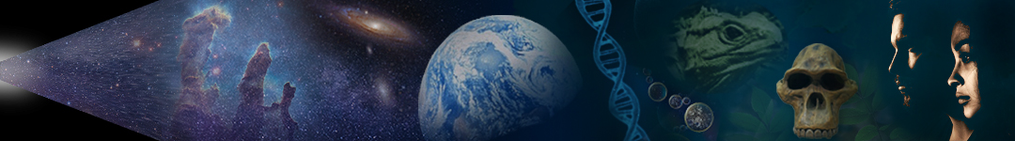

by Dr. Dan Moore & Dr. Brian Tonks, Geology & Physics Departments, BYU-Idaho

## INTRODUCTION

Craters form when space debris impacts a planet. The Moon and Mercury remain heavily cratered from the bombardment that all planets received early in the evolution of the Solar System. And yet there are almost no craters today on Earth. Why is that? Every year billions of tons of sediment are carried into the ocean basins by rivers, glaciers, and wind, and yet the oceans are not full of sediment. How can that be? Each year there are several million earthquakes. What causes them? The answers to these questions rest on the single most important characteristic of our planet: Earth is an active planet, which causes Earth's surface to constantly change.

The energy provided by the Sun fuels many important processes on Earth. However, these are largely confined to Earth’s surface. The temperature in Earth’s core is about 7,000oC (12,500oF), or about 25 times hotter than the maximum temperature of your home oven. The temperature of space is about - 270oC (-450oF). From this perspective, Earth is a very hot object in an incredibly cold freezer. Most of the heat in the Earth originates from its initial formation and from the ongoing decay of radioactive atoms in its interior. Earth's heat leaves the planet slowly because rocks are good insulators—like the blankets you use to slow the release of body heat while sleeping. Imagine being insulated by many hundreds of miles of rock, and you start to understand why heat leaves our planet so slowly.

The heat inside Earth moves to the surface via conduction (heat transfer by physical contact between materials) and convection (the slow flow and overturning of a planet's mantle as deep hot rock rises to the surface, cools, and sinks back toward the planet's interior). At Earth’s surface, convection is expressed as the movement of pieces of rigid rock called tectonic plates. Many of Earth's active processes, like seismic and volcanic activity, are caused by the movement of tectonic plates near Earth’s surface (which in turn is caused by the convection of solid rock in Earth’s mantle). Once interior heat has reached Earth’s surface, it radiated as infrared light into space. At Earth’s surface, tectonic produces (produced by the release of deep heat) interact with surface processes (generated by energy absorbed from the Sun) to produce and continually modify Earth’s surface landforms and features.

In contrast to Earth, the Moon and Mercury are small, so they had only enough heat to cause planetary convection early in their histories. As such, these planetary bodies have been tectonically ‘dead’ for a very, very long time. Mars is larger and was therefore active longer, but it too has been dead for a long time. Venus is about the same size as Earth and, as such, remains tectonically active today. …So, back to our original question: why isn’t Earth covered by craters, like the Moon and Mercury? As you’ve no doubt already surmised, the craters formed early in Earth’s history have long since been erased by interactions between Earth’s tectonic and surface processes. In addition to erasing early craters, these processes produced the surface conditions required for life to form and adapt.

Of course, most Earth change occurs over long timescales. As such, the geologic changes that accumulate during one human lifetime can be almost imperceptible.

## THE ORIGIN OF PLATE TECTONICS

The development of the Theory of Plate Tectonics is a great example of the scientific method at work. The early development of the theory began in the 1600's and extended into the early 1800's. A number of early individuals—including Sir Francis Bacon and Benjamin Franklin—suggested that the coasts of Africa and South America appeared to parallel each other and therefore might have been connected in the past. For example, Benjamin Franklin suggested that our planet might be much like a cracked shell, whose pieces are floating on a dense fluid (which, incredibly, is not far from the truth!). Unfortunately, humanity did not develop the technology necessary to make the relevant observations until the mid-1900s. As such, these early hypotheses remained essentially untested (and, therefore, outside science) until the 1950s.

Alfred Wegener, a German meteorologist shown in **Figure 1**, was also intrigued by the idea that the continents had once been connected. However, Wegener extended earlier ideas by making specific predictions—of specific aspects of nature that should be observed if his idea of ‘continental drift’ was true. These predictions included the distribution of rock bodies and fossils across now-separated continents—for example across the hypothesized connection between Africa and South America shown in **Figure 2**. In time, these and other observations failed to falsify Wegener’s continental drift hypothesis. For example, he noticed that the rocks in the Appalachian Mountains of the eastern United States are almost identical to the northern mountains of Ireland and Scandinavia. Wegener’s notion of continental drift suggested that continental crust is capable of moving thousands of kilometers across Earth’s surface and that Earth’s current continents had once been part of a supercontinent that Wegener called Pangaea.

Even though the continental drift hypothesis had substantial supporting evidence and would eventually prove true, it was not immediately accepted by geologists and other scientists. Why? The biggest problem with Wegener's hypothesis was the complete lack of a mechanism for moving the continents. And as you know, scientific explanations require mechanisms. Initially, physicists and others assumed that moving the continents required ‘shoving them through’ dense oceanic crust. These scientists quickly showed that no known force could accomplish this feat—which seemed to falsify Wegener’s hypothesis. In addition, Wegener was a meteorologist—so the movement of continents lay outside his area of expertise. In time, humanity’s ability to observe Earth’s crust improved. And these observations began to illuminate the mechanism of continental drift.



**Figure 1**. Photo of Alfred Wegener (1880-1930) taken while on an expedition in Greenland in 1930. He died soon after this picture was taken as he was traveling back to his base camp. (Credit. Wikimedia)

By the late 1930's, humanity had learned to use radio and sound waves to ‘see’ great distances through air and water. These tools (radar & sonar) allowed nations to protect themselves against submarine and aerial attacks. They also allowed humanity to investigate the shape (topography) of ocean basins for the first time. During the mid-1900s, other technological advances were improving radiometric dating, measurements of local magnetization and gravitation, and other ways of observing the nature and history of Earth. Together, these developments set the stage for the emergence of the Plate Tectonics Theory.

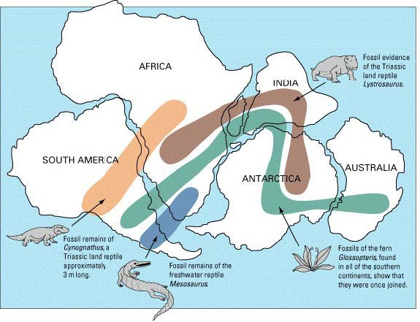

**Figure 2**. Distribution of fossil record across ocean basins. (Credit. USGS)

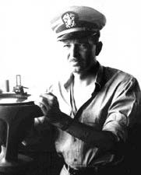

**Figure 3**. A photo of Harry Hess (1906-1969) as a captain of the ship USS Cape Johnson, during World War II. (Credit. Wikimedia)

Before and after World War II, Harold Hess (shown in **Figure 3**) was a professor at Princeton University involved in research of Earth’s ocean basins. During World War II, Hess captained an attack transport ship known as the USS Cape Johnson which was equipped with sonar. During his travels across the Pacific, used sonar equipment to begin mapping the topography of the ocean floor. Hess discovered many interesting (and previously unknown) features of Earth’s ocean basins, including deep oceanic trenches that parallel volcanic arcs like the Aleutians and Andes, large mountain ranges (ridges) located near the centers of individual ocean basins, and long linear chains of islands and seamounts (underwater mountains). In the Atlantic Ocean, scientists observed that the mid-oceanic ridge paralleled the shapes of the continents. As groups of scientists made these topographic observations, other scientists used radiometric dating to discover that the age of the ocean floor increased with distance from these ocean ridges, to a maximum of ~180 My.

Based on these and other observations, Hess hypothesized that mid-ocean ridges marked places where new oceanic formed and that, once formed, it was continually split apart—an idea that came to be known as seafloor spreading. In essence, Hess hypothesized that the seafloor was a vast conveyor belt for oceanic crust: the crust forms at mid-ocean ridges, ages as it moves across the ocean floor, and then is recycled into Earth’s interior at subduction zones. In this way, Hess’s ideas explained important characteristics of ocean basins such as their topography and patterns of magnetization and crustal age.

Importantly, Hess’s seafloor spreading provided the mechanism that Wegener's continental drift lacked. Namely, seafloor spreading explained that tectonic plates—including continents—move because of convection in Earth’s interior. Thus, instead of needing to move through oceanic crust, as Wegener’s model had suggested, Hess’s model had continents moving with seafloor—as it is created and recycled. Sadly, Wegener never saw the acceptance of his idea within the scientific community. He froze to death during an arctic expedition in Greenland in 1930, thirty-two years before Hess proposed seafloor spreading. Today, we refer to the synthesis of observations and explanations associated with the motion of Earth’s rigid outermost plates as the Theory of Plate Tectonics. This scientific theory describes the development and interactions of Earth’s tectonic plates, which include oceanic crust, continental crust, and the uppermost rigid mantle. Through the years, additional observations have failed to falsify the Theory of Plate Tectonics. These observations include the distribution of earthquakes, volcanoes, and mountain ranges around the world; patterns of paleomagnetic reversals in the seafloor; direct observations of plate movement from GPS measurements over time; and the progression of the ages of the seafloor and hot spot tracks (i.e. Hawaii and Yellowstone). Today, after more than a half-century of intensive testing, the Theory of Plate Tectonics remains unfalsified and is among the most extensively tested scientific theories.

## PLATE TECTONICS: FEATURES & FUNCTIONS

Convection drives tectonic change on Earth. Although you may not have thought of it as such, you have experience with convection. For example, you know that hot air balloons rise because the air in them is less dense than the air outside them. In other words, they rise because of convection. You also know that convection occurs when you heat soup or oatmeal: the hot material in the pot rises to the surface, cools as it moves along the surface, and then descends back into the liquid. Convection is based on the principle that materials tend to expand and become less dense as they are heated, and that lower-density matter rises as higher-density matter sinks. On Earth, exposure to the low temperatures of the atmosphere cause mantle rocks near the surface become denser and sink into Earth. Similarly, hot rocks at the base of the mantle become less dense and rise toward the surface.

Most people understand that the cool rocks found near Earth’s surface break when they are stressed. However, many people are surprised to discover that hot rocks in Earth’s interior flow (instead of breaking). Thus, convection in Earth’s mantle results from the ductile flow of solid(!) rock. If the flow of solids surprises you, thinking about ice may help you extend your intuition. If you drop an ice cube on cement it will break, but if you put ice under pressure it will flow—as happens inside glaciers. Under the right conditions, all solid materials can flow, including Earth's deep rocks.

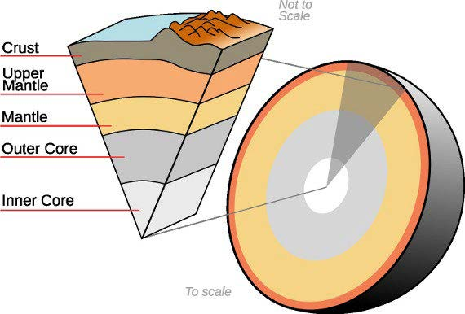

**Figure 4**. A simplified representation of Earth’s interior. Note that Earth’s core and mantle each consist of two layers. The inner core is solid metal, and the outer core is liquid metal. Ease of flow distinguish the upper and lower mantle. The upper mantle flows more readily than the lower mantle. (Credit: BYU-Idaho)

The Earth consists of three layers: crust, mantle, and core—as illustrated in **Figure 4**. Each layer is made of a different kind of material: the crust consists of relatively low-density rocks (like granite and basalt), the mantle is made of more dense rock, and the core consists of iron. There are two kinds of crust:

oceanic and continental. Oceanic crust is somewhat more dense than continental crust. This difference causes oceanic crust to ‘ride lower’ in Earth’s mantle and form the basins that contain the oceans. These differing densities also cause continents to ‘ride higher’ on the mantle and lie mostly above sea level.

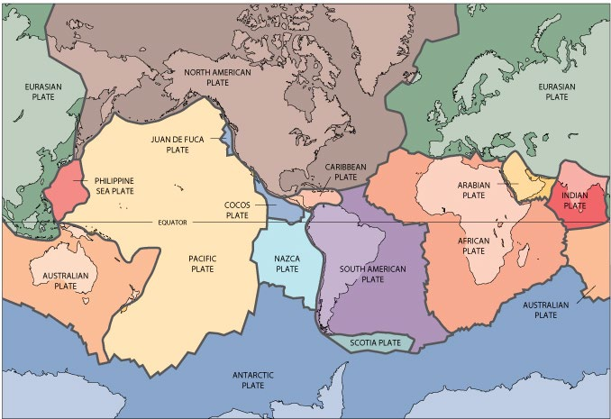

**Figure 5**. Earth's major tectonic plates. (Credit. USGS)

**Figure 5** shows Earth’s major tectonic plates. Convection causes these plates to move about Earth’s surface. Tectonic plates move quite slowly: about as fast as your fingernails grow (up to ~10 cm per year). The Theory of Plate Tectonics explains the causes and nature of plate motions and interactions.

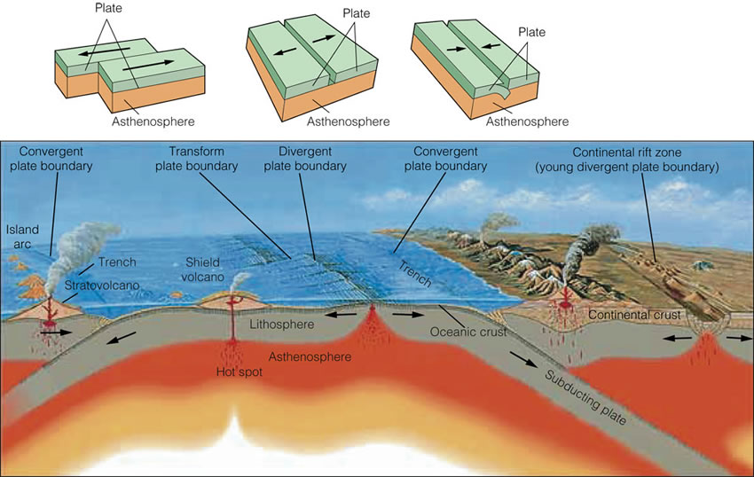

**Figure 6**. Illustrations showing transform, divergent, and convergent plate boundaries. Can you identify the tectonic causes of ocean ridges, ocean trenches, and ocean islands? (Credit USGS)

Earth’s tectonic plates interact in one of three ways: 1) plates slide past one another at transform boundaries like the San Andreas fault, 2) they move away from each other at divergent boundaries like mid-ocean ridges, or 3) plates collide at convergent boundaries like the western edge of South America. **Figure 6** illustrates these plate boundaries and associated tectonic features. Most tectonic change on Earth occurs within about a hundred kilometers of a plate margin, which is why most earthquakes and volcanoes are located near plate boundaries.

**Convergent Plate Boundaries.** Convergence can occur between two continental plates, two oceanic plates, or an oceanic plate and a continental plate. These collisions cause the crust in the overriding plate to thicken, which can produce mountain ranges. For example, the Himalayas and Alps are mountain ranges caused by the active convergence of two continental plates include. In contrast, the continent-continent convergence that produced the Appalachian and Ural mountain ranges occurred long ago (in the Paleozoic), during the formation of Pangea.

As noted, convergence can also involve oceanic plates. Where this happens, one of the plates overrides the other (down-going) oceanic plate. The overriding plate develops a thickened crust and a volcanic arc, and the lower (subducting) plate is recycled into the mantle. Oceanic trenches mark the surface expression of convergent boundaries that involve a subducting oceanic plate, as shown in **Figure 6**. The Andes and Cascades are both examples of oceanic plates subducting beneath a continent, and the Aleutian, Tonga, and Marianas Islands are examples of oceanic plates subducting beneath another oceanic plate—producing features known as island arcs (**Fig. 6)**.

**Divergent Plate Boundaries.** As with convergent boundaries, divergent plate margins can occur within the oceanic or continental portions of plates. Divergence between oceanic plates produces ocean-spreading ridges (mid-ocean ridges), where magma from the mantle rises to create new oceanic crust (**Fig. 6**). These ocean ridges extend through all of Earth’s ocean basins and form the longest mountain chains on Earth. The thinness of oceanic plates near ocean ridges exposes abundant mantle heat (**Fig. 6**). This heat is responsible for the mountainous character of ocean ridges—because the heat lowers the density of the overlying oceanic plate, causing it to ‘ride higher’ on the mantle. The splitting of oceanic plates at ocean ridges produces a central rift valley that lies atop these tall, broad oceanic mountain chains.

Continental rift zones form where divergence occurs in continental crust (**Fig. 6**). As for oceanic crust, these rift zones are marked by a chain of mountains with a rift basin at its center. Continued rifting of continents eventually separates the continental fragments and begins forming oceanic crust. The East African Rift and the Basin & Range Province of Western North America are both examples of continental rifting. And the Red Sea and the Gulf of California are examples of rifting that has generated narrow, recently formed ocean basins. The widening of these basins produces larger ocean basins. For example, rifting in the supercontinent Pangea separated North & South America from Europe & Africa and created the Atlantic Ocean, which continues growing today. Eventually, the cooling oceanic plates in the Atlantic will become sufficiently dense and subduct. This has already begun in the Caribbean and between South America & Antarctica. Thus, rifting opens ocean basins and subduction closes them—which causes continents to split and merge through time. Fascinating stuff isn’t it?!

**Transform boundaries.** Transform boundaries—where portions of plates slide past each other— accommodate convert and divergent plate motion. The example in **Figure 6** shows two segments of a spreading ridge connected by a short transform boundary. Can you see, in this example, how seafloor spreading causes ‘sliding’ along the transform margin? The most famous example of a transform boundary is the San Andreas Fault, which connects a spreading ridge in the Gulf of California with another spreading ridge in the Pacific, northwest of San Francisco.

**Hot Spots.** Subducting oceanic plates return surface material to the deep mantle. The back-flow of deep mantle material to the surface occurs in features called mantle plumes—tubes in which hot deep-mantle rock flows towards the surface. Near Earth’s surface, where a mantle plume encounters a tectonic plate, heat from a plume creates a ‘hot spot’. In addition to heat, the solid rock in mantle plumes partially melts and produces magma which rises into and through the overriding plate—forming oceanic islands, as illustrated in **Figure 6**. The Hawaiian Islands are formed in this way. In contrast, continental hot spots produce supervolcanoes like Yellowstone (which lies just a few tens of miles northeast of the BYU-Idaho campus).

## A FINAL THOUGHT

The Theory of Plate Tectonics explains the geologic processes that, together with surface processes, produce Earth’s features. In addition, it provides a context for understanding the history of Earth. For example, plate tectonics explains how now-separate land masses can share features that indicate that the continents were once connected. This theory also helps us understand why a single place on the Earth—like the area around BYU-Idaho—has been a seafloor, a beach, covered by volcanic rock, …, at different times in the past. In short, the Theory of Plate Tectonics explains why and how Earth changes.

Many aspects of plate tectonics have now been directly observed—moving them from theory to observation. For example, GPS measurements allow us to directly observe the movement of plates, and we can use sound waves to directly observe tectonic features deep inside Earth—such as subduction zones and mantle plumes. Even so, Plate Tectonics remains a scientific theory. In this role, it continues to fulfill the functions of scientific theories; namely, to explain how nature works, bring together otherwise unrelated observations, and guide future research. These research questions include the specific conditions that produced the different tectonics systems that have existed on Earth and do exist on other terrestrial planets (e.g., drip tectonics, stagnant lid tectonics, and plate tectonics). As research continues and new discoveries accumulate, humanity will continue refining Plate Tectonic Theory—which will continually expand its tremendous explanatory power.

Read this online at <https://books.byui.edu/from_atoms_to_humans/plate_tectonics_how_>