# Mechanical Properties in Solids (Elastic Behavior)

## 4.2.1. Types of Forces

        Whenever a force is applied to a solid material, that material will deform in response to the applied force. The most common types of force are a pulling force (called **tensile force**), a pressing or pushing force on the end of a columnar sample (called **compressive force**), a pressing or pushing force on the middle of a supported, long sample (called a bending or **flexural force**), a rotational or torsional force (called a **torsional force**), or a combination pushing force with a sliding force (called a **shear force**). These forces are illustrated in Figure 4.1. Tensile forces are often the easiest to visualize and will, therefore, be used to develop the concepts needed to understand mechanical properties. The other forces will be examined later in this chapter. Most of the concepts derived from a consideration of tensile forces are fundamental and will be directly applicable to the other forces, although in a slightly different form.

## 4.2.2. Elastic Behavior and Definitions

        If only small deformations are considered and the solid material will return to its original shape when the force is relieved, then the deformation is called elastic. In elastic deformations all of the mechanical energy that was put into the material by the applied force to cause the deformation is held within the material and is then used to cause the material to return to its original shape and position. A common example would be a spring that is deformed slightly, thus imparting potential energy to the spring, which is then available within the spring to cause it to return to its original shape. Another way of saying this is that energy is returned or recovered. Energy is always recovered in elastic deformations.

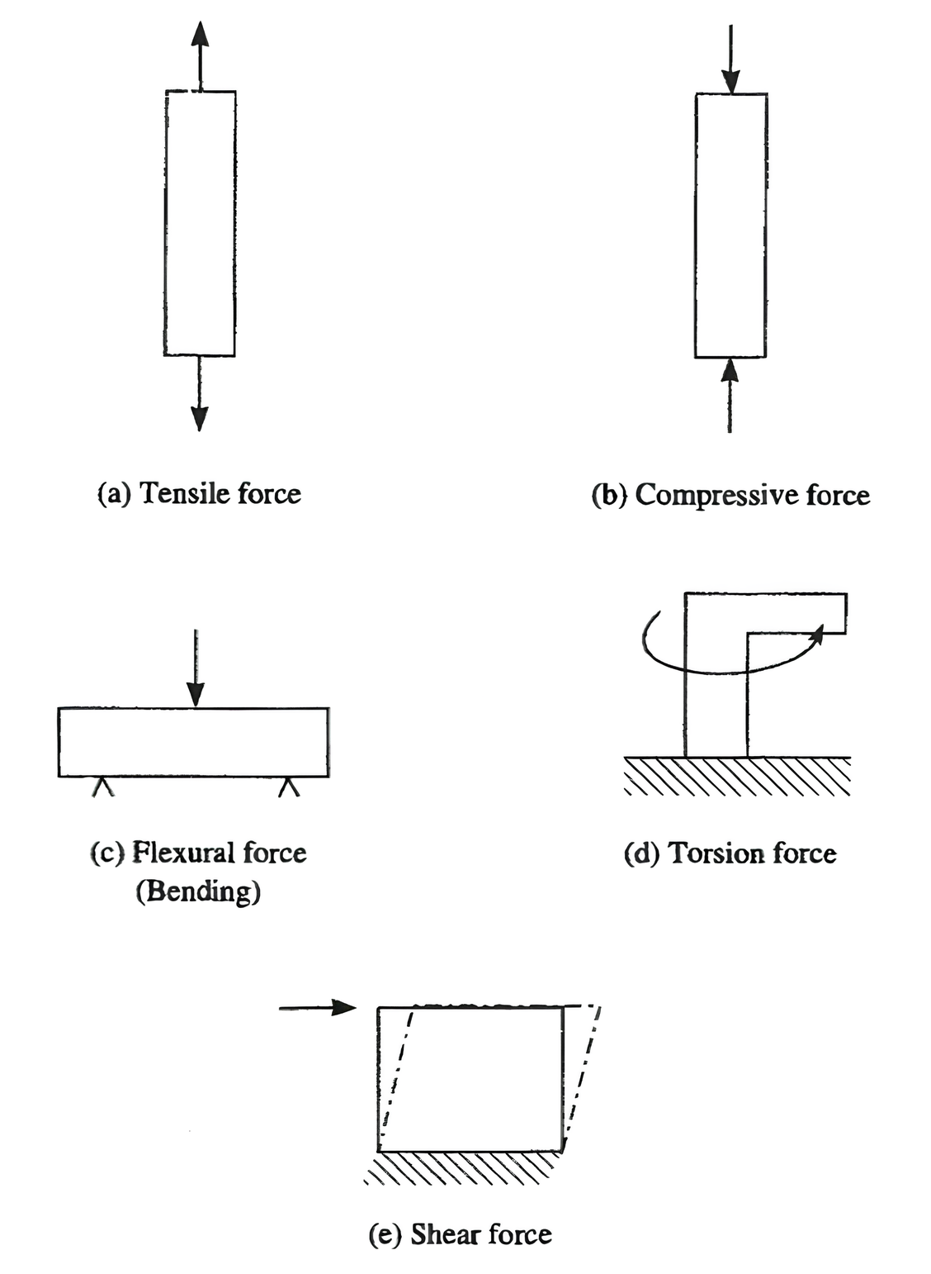

**Figure 4.1Types of forces.**

        So that materials of different sizes can be directly compared, the force is usually divided by the area of the sample to give units of pascals (newtons per square meter) or pounds per square inch. (The area is the width times the thickness. The length dimension is not important in this calculation because it is assumed that the applied force is evenly distributed over the entire length of the sample between the pulling forces.) The force divided by the area is called the **stress** (σ) and the units are force per area (typically, pascals or pounds per square inch). The displacement (movement) of the material is called the **strain** (ϵ). Normally the strain is given as the change in length (Δl) divided by the original length (l0 ); the units are dimensionless. The elongation is a measure of the strain when the force is tension. Elongation is usually expressed as a percentage increase in length compared to the original length of the test specimen. Plots of the stress versus the strain such as the type shown in Figure 4.2 are called stress-strain curves or stress-strain diagrams. The relationship between stress and strain can be given by an equation such as (4.1),

$$ {\dfrac{F}{A}} = \sigma = E\epsilon $$

where F is the force, A is the cross-sectional area, σ is the stress (force divided by area), ϵ is the strain, and E is the proportionality factor, which is called the **modulus**, sometimes referred to as **Young's modulus** for the tensile stress case. The modulus is the slope of the stress-strain curve. If the modulus is large (corresponding to a steep angle of the curve), the material resists deformation strongly. Such materials are said to be **stiff**.

        If the stress-strain curve is linear, regardless of its slope, the stress and strain are directly proportional and E is a constant over the elastic region (the straight portion of the curve). Such materials are said to follow Hooke's law and to be **Hookean**. Hooke's law applies to mechanical springs and can be written in the form:

$$ F = kx $$

where F is the force, x is the displacement, and k is the proportionality factor, which is called the spring stiffness and is constant for small displacements. This equation is similar to Equation (4.1) with only minor modifications for area and original length to fit normal forms of the two equations. Hence, the two equations are, in essence, the same.

        If the stress-strain curve is nonlinear, the material is said to be non-Hookean. The non-Hookean modulus is not constant and is defined only at specific points on the curve, using calculus, as the derivative of the stress to the strain. In both the linear and nonlinear cases, the material returns to its original shape and position when the force is relieved, so the material is elastic. Most metals and ceramics are Hookean solids.

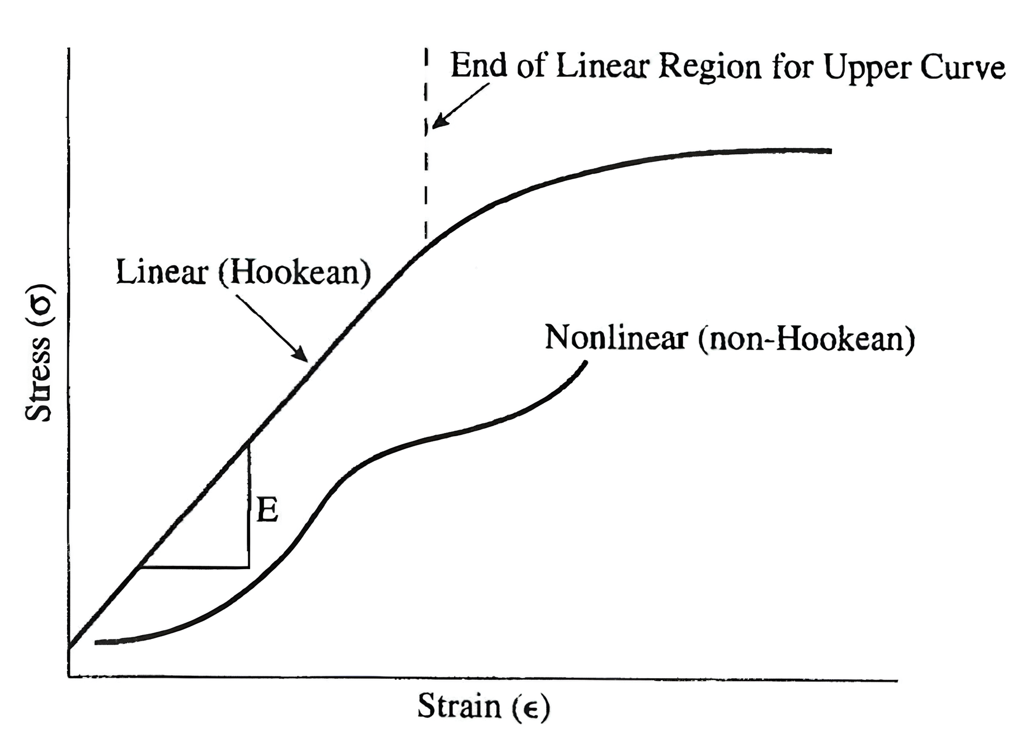

**Figure 4.2 Stress-strain relationships for elastic solids.**

Read this online at <https://books.byui.edu/plastics_materials_a/mechanical_propertieC>