# Viscoelastic Materials

## 4.4.1. Viscoelastic Behavior and Definitions

        Most polymer materials have some characteristics that are similar to viscous liquids and some that are similar to elastic solids. These materials are therefore known as viscoelastic. Viscoelastic materials can be either liquid or solid, although the distinction between liquids and solids in these materials is not a clear one. A representation of this continuum of properties between pure viscous liquid, viscoelastic liquid, viscoelastic solid, and elastic solid is given in Figure 4.6. This figure shows the simple mechanical devices previously used to describe viscous liquids (dashpot) and elastic solids (spring) with their appropriate equations. Because the viscoelastic materials are combinations of the viscous liquids and elastic solids, the two simple methods for combining the mechanical elements (in series and in parallel) are also shown. The series arrangement of the spring and dashpot elements behaves much like a viscoelastic liquid (**Maxwell model**), whereas the parallel arrangement is more like a viscoelastic solid (**Voigt** or **Kelvin model**). Both of these simple mechanics models can be useful for simple analysis and conceptual purposes but should be considered as approximations to actual systems. The different mathematical formulations derived from the expression of the models are what makes them useful. These formulations are beyond the scope of this text but may be used by the advanced student to understand, predict, and compare the behavior of the various materials.

        Plots of the responses of a typical solidlike material with elastic behavior, a liquid like material with viscous flow, and a viscoelastic material with plastic behavior to a given steady force are given in Figure 4.7.

        The plot of the applied force (stress) is shown in Figure 4.7a. The plot of response of the solidlike material (Figure 4.7b) indicates a direct and linear response to the applied force. The solidlike material moves (strains) instantaneously at the application of the constant force and continues at this position so long as the force is applied. At the moment the force is relieved, the solidlike material immediately returns to its original position. This behavior is like that of a spring that is instantaneously stretched and held in an elongated position. At the moment the force is relieved, the spring returns to its original, nonstretched shape.

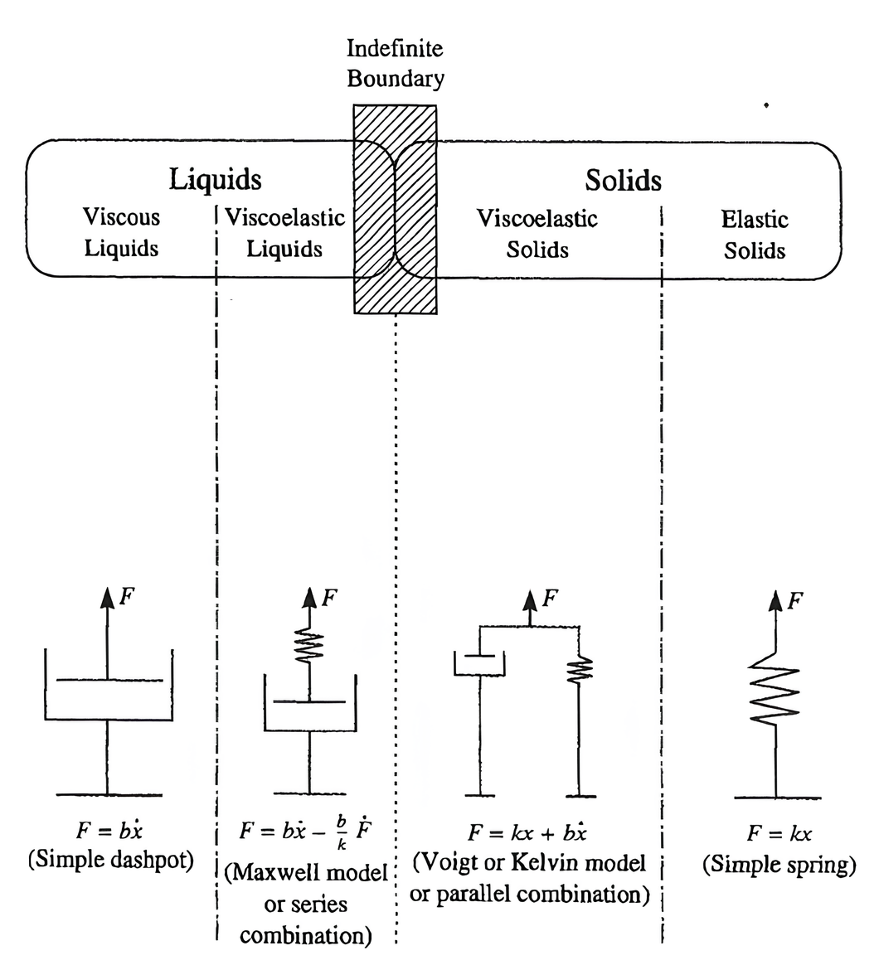

**Figure 4.6Continuum of viscoelastic properties and representations using simple mechanical devices.**

        The plot of the response of the liquidlike material possessing viscous flow is shown in Figure 4.7c. In this material the imposition of the steady force begins to deform the material, but the movement increases linearly as time proceeds. This movement will continue so long as the steady force is applied. This behavior is like honey being subjected to a block sliding against it: The honey will begin to flow when the force is first applied, and will continue to move as long as the force is applied. When the force is relieved, the honey will stop moving but will not return to the original position.

        The response of a viscoelastic material to an applied steady force is illustrated in Figure 4.7d. The viscoelastic material begins to move immediately upon application of the force, but not as much as the elastic material, although more than the viscous material. The response is, therefore, intermediate between the two other materials. The viscoelastic material will continue to move so long as the force is applied. When the force is stopped, the viscoelastic material will attempt to recover to the original position but will be slowed in this recovery. That slower recovery response is illustrated in the plot as a sloping, nonlinear curve that continues past the time the force is relieved. Hence, the viscoelastic material is like both a solid and a viscous liquid.

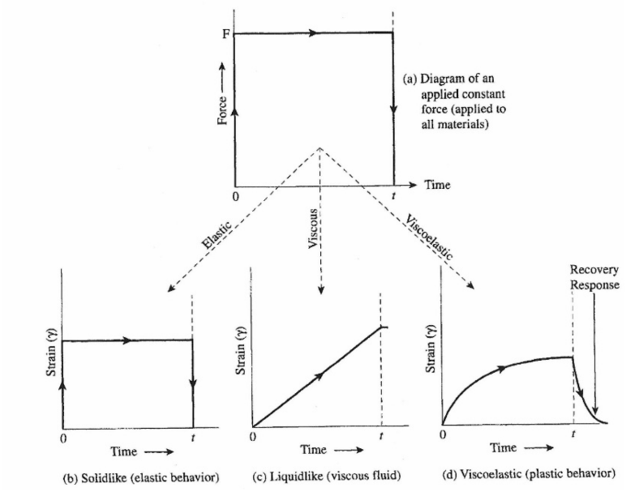

**Figure 4.7The mechanical response of liquidlike, solidlike, and viscoelastic materials to an imposed steady force.**

## 4.4.2. Time Dependence of Solid and Liquid Viscoelastic Materials

        The time dependence of viscoelastic materials is an important consideration that significantly affects their behavior. The shear rate (time) dependence of viscoelastic liquids has already been discussed. Most polymer viscoelastic liquids exhibit shear-thinning, and many are thixotropic.

        The time dependence of viscoelastic solids is illustrated in Figure 4.8, where the slope (viscosity) of the stress-strain curve is seen to rise with increasing shear rate. At the micro level, this time (rate) dependence can be understood in polymeric solids by noting that forces on polymericsystems are resisted by the substantial entanglement of the polymer chains and by secondary bonding. (Remember that these intermolecular forces are quite small in liquids and are mostly momentary entanglements that give rise to non-Newtonian behavior, as previously described and illustrated in Figure 4.4.) In solids, however, as energy is added through mechanical forces, the chains will gradually disentangle and the secondary bonds will eventually dissolve, thus allowing the molecules to translate (move) relative to each other to relieve the stress. However, this untangling and sliding takes time to accomplish. Therefore, at higher shear rates, the polymer molecules do not have as much time to move and the disentanglement is forced, resulting in a greater resistance to movement. The result is an apparently stiffer (higher-viscosity) material when sheared very quickly.

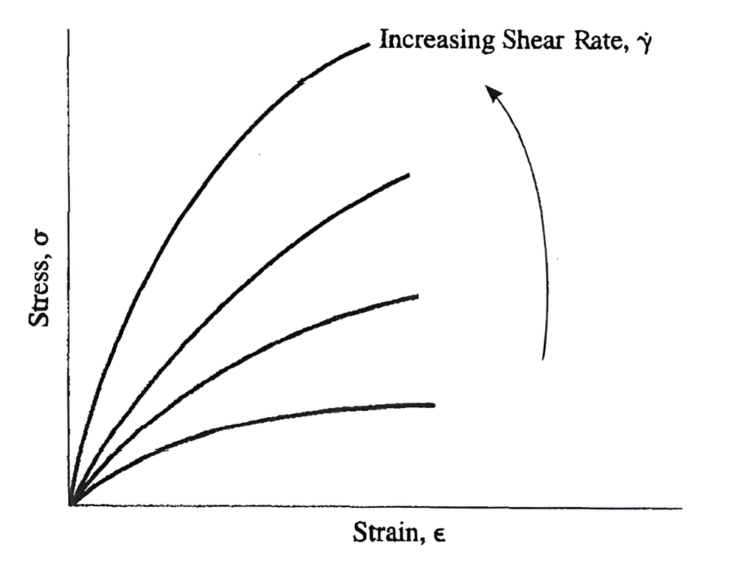

**Figure 4.8 Time dependence of viscoelastic (polymeric) materials showing the changes in stress-strain with shear rate.**

## 4.4.3. Glass Transition Temperature (Viscoelastic View)

        The glass transition was previously defined as the point (temperature) at which the energy in the system is sufficient to initiate long-range molecular motions, thus imparting a pliable and leathery nature to the solid material. These motions were considered from a thermal viewpoint, but they can also be understood from a viscoelastic viewpoint.

        As previously explained, solid viscoelastic materials can be thought of as having two behaviors viscous and elastic. The elastic behavior is typified by a relatively minor deformation of the solid when subjected to a force with a full return of the material to its original shape when the deformation force is stopped. The solid material remains hard and rigid. The energy put into the system is recovered completely when the force is removed. The mechanical analogy is a spring. Polymer molecules that behave like elastic solids can be thought of as many small springs. When they are stretched and then released, they return to their original positions. At the micro level, the small springs are the molecules themselves, which are stretched and bent but not displaced relative to their neighbors. No disentanglement occurs. This behavior occurs only if the movements are small. Hence, these are called **short-range movements**.

        The viscous nature of a polymer solid can be associated with **long-range movements**. The viscous material will move more freely than an elastic solid when a force is imposed, and all the energy input into the material may not be returned because of permanent deformations (such as disentanglement) or the creation of internal heating. The long- range movements require more energy to activate than do the short-range movements. Hence, above a certain level of internal energy, the behavior of the material will more likely be dominated by long-range movements, and below this characteristic energy level, the material will exhibit only short-range movements. The point where this occurs is, of course, the glass transition temperature (Tg ).

        The time required for the long-range movements to occur is also longer than the time required for short-range movements. Therefore, by subjecting the system to stresses over very short times, the long-range effects can be avoided. Hence, the long-term effects can be circumvented by either lower temperatures or shorter times. This is called the time-temperature superposition. The reverse of the experiments just explained is also true, that is, higher temperatures can be related to longer times. The earlier example of Silly Putty clearly reflects the time-temperature superposition phenomenon.

Read this online at <https://books.byui.edu/plastics_materials_a/viscoelastic_materia>