# Flammability

        Most untreated plastics will burn, a result of the chemical nature of the polymers (mostly carbons and hydrogens), which are readily oxidized (burned) to carbon dioxide and water vapor. The presence of other atoms besides carbon and hydrogen and insufficient heat or oxygen can result in additional by-products of the burning of polymers, but the basic tendency to burn remains to greater or lesser degree with only a few exceptions. These differences are, however, very important because some plastics burn readily under almost any environmental condition, whereas others burn only reluctantly in normal environments. It is these differences that allow some plastics to be used in situations where low flammability is required.

         Three components are required for any burning to take place: fuel, oxygen, and heat. If any of these three is eliminated or even reduced, flammability will be reduced. Therefore, efforts to reduce plastics flammability have attempted to reduce or remove one or more of these components that are required for burning. We can organize our discussion of plastics flammability by examining, in turn, the techniques that have been used to reduce the presence of the fuel, oxygen, and heat—the critical flammability components in plastics materials.

         Reducing the Fuel. Plastics are made from atoms, predominantly carbon and hydrogen, which have been arranged into long, chainlike molecules called polymers. As plastics are heated, the polymers break apart and small fragments volatilize. It is, generally, these small fragments that supply the initial fuel for the burning of the plastic. So long as the volatiles are present, the non-volatilized portions of the plastic might also burn, thus creating more volatiles and a continuation of the burning process.

         Some polymers are far less volatile than others and, therefore, have less fuel readily available for burning. Among those polymers that are low in volatility are the aromatic polymers, called aromatics. In general, the higher the ratio of aromatic to nonaromatic components in the polymer, the more resistant will be the plastic to the formation of volatiles. That means, of course, that the flammability will be reduced as the aromatic content increases. Some examples of varying flammability with aromatic content illustrate this point (Figure 5.5). Polyethylene, which has no aromatic content, ignites easily and burns readily even if the flame source is withdrawn from actual contact with the polymer. Polystyrene, which has some aromatic groups that are pendant (hanging) from the main backbone of the polymer, burns slower than polyethylene. Many epoxies, which can be made with benzene rings in the backbone itself, may sputter out when the flame source is withdrawn. In aramids (such as Kevlar®), the benzene rings make up the bulk of the backbone. This polymer is difficult to ignite and burns only if the flame source is held in contact, and even then the burning is erratic. If the flame source is withdrawn, the fire goes out. (Polymers, like aramids, that will not support combustion after the flame source is withdrawn, are called **self**-**extinguishing**.) Finally, if the aromatic components can form a three-dimensional structure such that the aromatic rings are interconnected and structural, the polymer may not burn at all, or if it burns, it will generally burn incompletely. Phenolics are the most common examples of this type of structure.

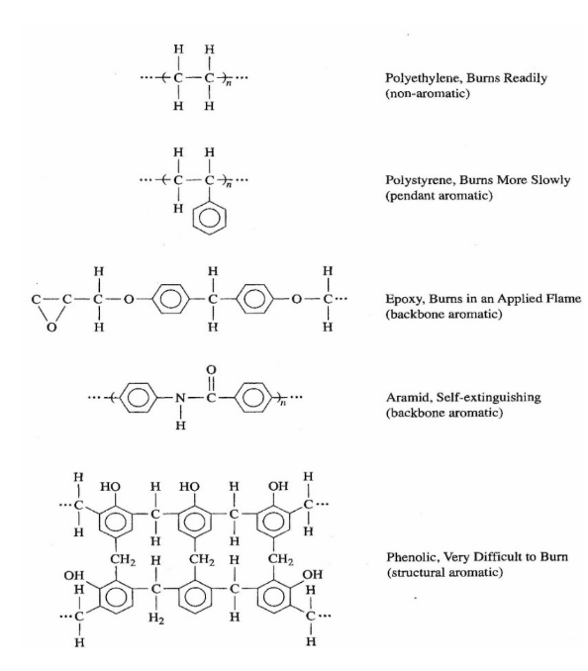

**Figure 5.5Flammability of polymers with varying aromatic content (some H's omitted for clarity).**

         Incomplete burning of a polymer usually produces a material that is called a **char**. This char is a largely organic material from which the volatiles have been extracted by the burning process. (Plastic char is roughly analogous to charcoal, which is created from wood by burning it under conditions of incomplete combustion.) Char burns only at higher temperatures than the original polymer and is harder to ignite than the original polymer. Chars are almost always self-extinguishing. Furthermore, chars are known to have very high resistance to thermal transport, thus making them excellent thermal insulators. The plastic handles on many cooking pans are made of phenolics because of their tendency to char instead of burn. Another interesting application for phenolics is the exhaust nozzles of rockets, where the thermal insulative properties of the char are critical to the rocket's performance. The fuel can also be removed from plastics by building the polymer from molecules other than carbon. The most important of these polymers are silicones. Silicones have silicon and oxygen atoms along the backbone with, generally, some carbon atoms pendant to the chain. These pendant carbon atoms can be either aromatic or not. Just the change from carbon atoms to silicon atoms along the backbone significantly reduces the flammability of the polymer. Further reductions can be obtained by using aromatics as the pendant groups.

         Reducing the Oxygen. The most effective method of excluding oxygen from the combustion zone is by creating a nonflammable and dense combustion product that will smother the flame by excluding the oxygen from the area around the polymer. The most common atoms that will accomplish this task are the **halogens**: fluorine (F), chlorine (CI), bromine (Br), and iodine (IHCl ). When polymers containing any of these elements are burned, one of the primary combustion products is a gas formed with the halogen atom and hydrogen. HCl is the gas formed when chlorine is present. All of these hydrogen-halogen gases are nonflammable and quite dense. Therefore, as they are created by the initial burning of the polymer, they accumulate in the vicinity of the flame front. That accumulation then simply excludes oxygen and, as a result, the flame goes out. Many of these halogen¬ containing gases are harmful (as discussed later in the section on smoke) and so caution should be taken when using halogens to reduce flammability.

         Several important polymers contain halogens as key atoms to determine critical polymer properties (besides flammability), see Figure 5.5. One of the most common of these is polyvinylchloride (PVC). It is self-extinguishing because of the high concentration of HCl that is produced when it begins to burn. Polytetrafluoroethylene (PTFE) or Teflon® has even a higher concentration of halogens in the polymer. Teflon will resist ignition so strongly that it is generally considered to be a nonflammable polymer. Some polymers that normally do not contain halogens can be modified by adding halogens. For instance, a halogenated epoxy can be made by building the epoxy molecule with aromatic rings to which four bromine atoms have been added. The resin companies sell these halogenated versions of regular polymers as special flame-retardant grades.

         Thermoset polyesters and vinyl esters are usually made flame retardant by the method just discussed for epoxies. However, these thermosets offer another method for the introduction of halogens into the polymer material. Thermoset polyesters and vinyl esters are crosslinked from a solution of the resin and a reactive solvent, usually styrene. Although rarely done, it is possible to use a halogenated solvent instead of styrene, thus incorporating the halogens into the crosslinks.

         Another method of adding halogens is with halogenated fillers. Almost any halogen¬ containing filler will work, although some particular types have been found to be especially useful. For instance, magnesium bromide and phosphorous pentachloride are solid inorganic powders that can be added to many plastic mixes to reduce the flammability of the mix. Halogenated organic fillers include compounds such as polybrominated diphenyl ethers (PBDE). Some of these halogenated organic fire retardants are suspected carcinogens or otherwise harmful chemicals and are increasingly coming under scrutiny and prohibition by state and federal regulations.

         The action of halogens can be enhanced if certain other elements are present. Some of these are phosphorous, bismuth, and antimony. Hence, some fillers may be combinations of halogens with these activating elements or the activating elements may be added separately. These non-halogenated fillers have some small fire-retardant benefit even if halogens are not present.

         Other materials besides halogens have the property of smothering the flame by the exclusion of oxygen. Perhaps the most common of these are compounds containing phosphorus. Others are those that produce carbon dioxide (CO2) when burned. Just as with halogens, these materials can be added to the plastic mix and can render the resultant plastic material self-extinguishing.

         Reducing the Heat. The third critical component of all combustion, heat, can also be reduced as a method of decreasing the flammability of plastics. Firemen have long realized that the addition of water to a fire will reduce the heat and help put out the fire. (The water may also help exclude the oxygen.) Water molecules are bound to some inorganic materials such as alumina (Al2O3), which are called **hydrated**. (Each alumina molecule can hold three water molecules and so the hydrated form of alumina is written as Al2O3 · 3H2O.) In this form it is usually called alumina trihydrate (ATH). When hydrated materials get hot, they lose these bonded water molecules, which are then evaporated and the area is cooled. An advantage of using hydrated materials to reduce flammability is that the gas liberated (water vapor) is not harmful, whereas the halogenated and phosphorous materials often are. The heat can also be reduced by the simple action of adding more mass of non-burning materials.

         The presence of these inert materials requires that they be heated along with the polymer. That heating requires additional energy and, therefore, the net amount of heat available for the flame is reduced by their presence. Many materials can serve as these inert fillers. Some, like fiberglass, are added to improve some other property of the plastic. Still other fillers (like calcium carbonate) are added simply to reduce the overall cost of the plastic part. Whatever the purpose of their addition, these fillers will reduce the flammability. Of course, some fillers are added for the express purpose of reducing flammability. In these cases, the presence of the filler may have some effects on other properties (such as toughness) and those that are important for the performance of the plastic should be monitored.

         Smoke. The nature of the gaseous by-product from burning plastic parts is dependent on both the polymer and the additives. Many additives and polymers can create toxic smoke or smoke that is so dense, black, and irritating that it causes visibility problems. Sadly, some of the modifications to plastics that are intended to reduce flammability worsen the harmful effects of the smoke that is generated. Of particular note in this regard are the halogens, especially when combined with antimony, phosphorous, or bismuth. The very gases that are formed by the halogens to exclude oxygen (such as HCl or HBr) are themselves toxic and irritating to mucous membranes. Research efforts are underway to identify methods of obtaining the same low flammability as the halogen-containing polymers without the presence of halogens. To help suppress the smoke, additives such as zinc borate, molybdenum trioxide, or ferrocene can be added to the plastic.

        The presence of aromatics, while not as detrimental as halogens, is also negative in the nature of the smoke that is generated. Smoke from aromatics is generally darker (more sooty) than when aromatics are not present. This can be a problem in applications where people must be able to see clearly to exit the area, such as in mass transport applications. In general, however, the presence of aromatics is acceptable so long as the smoke density is controlled by other formulating methods (such as the addition of inert fillers that lower flammability but do not increase smoke density).

         Testing. The following properties are usually those considered when examining the burning of plastics:

* Ease of ignition/flame resistance- How readily does the material ignite?
* Flame spread/fire retardancy/surface flammability- How rapidly does the fire spread? Is the spread different in different directions?
* Heat release rate-How much heat escapes from the material during combustion and at what rate?
* Fire endurance- How rapidly will fire penetrate a barrier of the specific material? What are the orientation effects on fire penetration?
* Ease of extermination- How easily will the fire go out?
* Smoke emission/toxicity-How much smoke is released? What is the rate of smoke release? Is the smoke toxic or corrosive?
* Physical characteristics-Does the material drip, droop, or sag as a result of burning?

        The most obvious and prevalent reasons for testing the flammability of plastic materials is to ensure the safety of the product and to satisfy the requirements of some agency that controls the specifications for the use of the product. Other reasons might include improvement of the product for some specific application, study of the nature of the combustion process, establishment of a specification, and assessment of overall design for fire safety.

         Flammability tests can be divided into three groups, generally reflecting the purpose for performing the test. These groups are "official tests," or those that are performed to meet some official requirement; "lab tests," or those that are usually done within a manufacturing facility for informal studies; and "full-scale" tests, which are used to simulate actual use conditions. Each of these groups of tests will be discussed separately.

*Official Tests*. For numerous reasons (including historical and performance) various market sectors have developed their own combustion requirements and tests. The test procedures have been carefully specified so that all parties performing the tests do them in precisely the same way. The agencies that control the specifications usually change the procedures only with considerable study and experimentation, thus guaranteeing continuity over time in interpreting the test results. The pro-cedures are also studied to ensure that variations from lab to lab are kept statistically small. In many cases, equipment used in the tests has also become standardized, often requiring the purchase of equipment from approved sources or that is guaranteed to be made according to specific design requirements. In light of these requirements and equipment restrictions, places where these tests can be run are usually limited to two groups-commercial testing laboratories and major research facilities (such as those owned by resin manufacturers and government labs).

         Note that each test procedure is designated by an alphanumeric code in which the agency controlling the test procedure is designated, such as ASTM (American Society for Testing and Materials), International Electrotechnical Commission (IEC), National Electrical Manufacturers Association (NEMA). American National Standards Institute (ANSI), IEEE, National Fire Protection Association (NFPA), NHTSA (National Highway Transportation Safety Administration), FMVSS (Motor Vehicle Safety Standard), FRA (Federal Railroad Administration), ISO (International Organization for Standardization), NBSIR (National Bureau of Standards, now the National Institute of Standards and Technology, NIST), and MIL-STD (Military Standard). Details about the tests can be obtained from these agencies.

         Space does not permit a detailed analysis of each of the tests used to investigate combustion of plastics, but a brief summary of the most important of these official tests follows.

* **Cone Calorimeter (ISO 5660/ASTM E-1354).** This test, which is only about 10 years old, appears to be the best possibility for a single, comprehensive test that might satisfy most of the marketing/use sectors. Several advantages of this test include modest sample size (4 x 4 x 1/4 inches) so that preparation costs are low, usually modest costs (in the $200 to $500 range at commercial labs), and a wide range of heater and ignition conditions for most of the fundamental combustion characteristics (ease of ignition, rate of heat release, weight of sample as it burns, temperature of sample as it burns, rate of weight loss, rate of smoke release, and yield of smoke). As a result of the vast amount of data available from this test, a model of the combustion of a material might be developed, thus enabling an estimation of the potential effects of a fire on surrounding areas and occupants. (See Figure 5.6.)
* **Radiant Panel Test (ASTM E-162).** The principal result of this test is a flame spread index. This index is the product of a flame spread factor and a heat evolution factor, which are determined as the material is subjected to a radiant heat source. The sample size is not large (6 X 18 inches) and the costs of the test are modest ($200 to$300). Furthermore, this test has been used extensively for many years and so much comparative data is available. However, results are often confusing, especially when different materials are compared, thus limiting the broad applicability of this test.

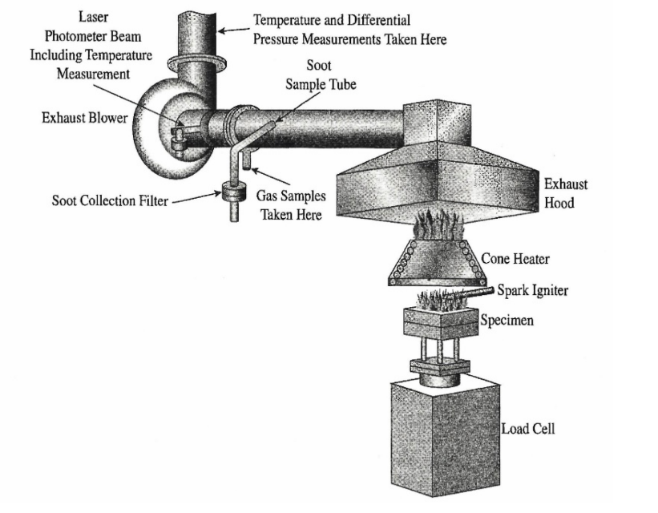

**Figure 5.6 Cone calorimeter test for flammability.**

* **Smoke Chamber Test (ASTM E-662)**. Combustion research has shown that many fire fatalities occur in rooms where the flames never reach. Hence, the nature of the smoke generated in a fire is very important. This test is designed to measure the density of the smoke generated as a function of time, under both flaming and smoldering conditions. Because this test was originally developed by the National Bureau of Standards (NBS), the test is sometimes referred to as the NBS smoke density test. The test apparatus is a closed box (smoke chamber), approximately 3 x 3 x 2 feet, that contains an optical light source and detector to measure the reduction of optical density from the smoke generated by the burning of a sample placed inside the chamber. The sample is small (3 X 3 x 1/4 inches, usually) and the cost is moderate ($300 to $500). Results are usually expressed as a smoke density, Ds, after 1.5 or 3.0 minutes.
* **Steiner Tunnel Test (ASTM E-84).** This test measures the flame spread and smoke generated by the burning of a sample within a large (25 x 2 foot) chamber. The principal use of the test is for building materials. The sample is attached to the top of the chamber and a fire is started at one end. The rate and extent of burning are reported. The cost of performing this test (about $500 per run) is relatively high, as is the cost of the materials because of the large sample size.
* **UL 94 Flammability Tests**. The Underwriters Laboratories has developed several burn tests that are all classed as UL 94 tests. These tests measure the burning characteristics of various materials in horizontal and vertical orientations. The tests establish various maximum burn distances and rates that must not be exceeded for a material to be in compliance with the particular UL standard.

         Lab Tests. Sometimes official tests are either too costly or too time-consuming to run. Such a case might occur when a company is trying to adjust the formula or design of a product The company might go to an outside testing agency (commercial lab or resin supplier) and have an official test run on a candidate formula or design and then use lab tests to monitor the effectiveness of changes. In this way, nearly immediate results can be assessed and, because the nature of the materials is usually similar, the lab tests will generally give the same ranking of materials as would be obtained in the official tests. Lab tests are not, however, as useful as official tests in ranking the combustion characteristics of widely different materials. Some of the most common of these lab tests are:

* **Limiting Oxygen Index, LOI (ASTM D-2863).** This test is probably the most accurate of the lab tests. In the LOI test a sample is suspended vertically inside a closed chamber (usually a glass or clear plastic enclosure). The chamber is equipped with oxygen and nitrogen gas inlets so that the atmosphere in the chamber can be controlled. The sample is ignited from the bottom and the atmosphere is adjusted to determine the minimum amount of oxygen to just sustain burning. This minimum oxygen content, expressed as a percentage of the oxygen/nitrogen atmosphere, is called the limiting oxygen index. Higher numbers are associated with decreased flammability. (See Figure 5.7.)
* **Vertical Burn Test (ASTM D-568 and D-3801).** The sample is suspended vertically so that it can be ignited at the bottom. After ignition, the ignition source (usually a Bunsen burner) is withdrawn and the length of burn of the sample in a set period of time (10 seconds) is measured. If the sample does not burn for the entire time, the time to extinguish is noted. Materials that burn while the ignition source is in contact but go out quickly when it is removed are termed self-extinguishing. This test is most useful in measuring the burning characteristics of similar materials. Dripping of the resin should be noted.
* **Horizontal Burn Test (ASTM D-635).** This test is similar to the vertical burn test except that the sample is supported vertically. This test is less stringent and is used when the vertical test cannot distinguish between materials. Only self-supporting materials should be tested in the horizontal test.

         Full-scale Tests. The major problem with all the official tests and the lab tests is that performance in oficial tests and the lab tests is that performance in actual combustion situations can only be guessed at. In fact, the standard procedures often caution against using the results of the test for any determination of performance in actual burning conditions. The best that can be hoped for in the official and lab tests is a correct ranking of materials as to their performance in real burning conditions. In most of the official and lab tests, failure is considered "bad,'' but passing cannot necessarily be extrapolated to being "good." Hence, a definitive performance under actual in-use conditions is usually required.

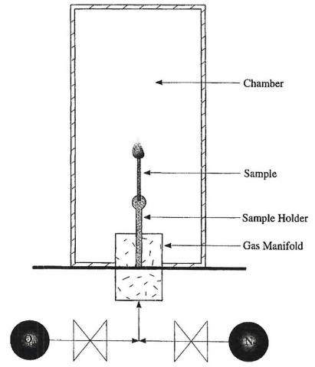

**Figure 5.7 Test apparatus for the limiting oxygen index (LOI) test.**

         These full-scale tests are only rarely controlled by standard test procedures. Therefore, the company or agency requiring the results is usually free to configure the test as it believes to be best (most realistic). Often, because of the complexity of combustion, companies will request assistance from private testing organizations (often the same people who run the official tests). Some of these testing organizations have even established full-scale test facilities (rooms, vehicles, etc.) that can be used as a framework on which the test materials can be attached.

         Full-scale tests often examine temperatures in and around the test enclosure, smoke generation in and leaking out of the enclosure, and heat generation in and around the chamber. Ignition often simulates a likely fire hazard, such as a burning wastebasket, or may be a controlled source, such as a gas burner or an assembly of wooden slats.

Read this online at <https://books.byui.edu/plastics_materials_a/flammability>