# Polystyrene (PS)

        The styrene monomer has a carbon-carbon double bond to which a benzene ring and three hydrogens are attached. This monomer is polymerized by the addition polymerization mechanism. The repeating unit for PS is represented in Figure 7.12. The size of the benzene pendant group is represented in Figure 7.11, where it is much larger than any of the other pendant groups (hydrogen, CH3, or Cl) associated with the other commodity resins. The benzene ring reduces the ability of the polymer chain to bend and interferes substantially with other parts of the molecule. These characteristics prevent crystallization. Therefore, PS is essentially 100% amorphous.

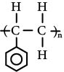

**Figure 7.12 Polystyrene (PS) polymer repeating unit.**

        Polystyrene is, perhaps, the foremost example of steric effects in polymers. The very large aromatic ring not only prevents crystallization but also significantly increases tensile strength. This effect might be surprising, because high tensile strength is normally associated with crystallinity (and high molecular weight). Polystyrene illustrates another cause of high tensile strength—steric (shape) effects. The type of steric effect present in polystyrene is interference by the pendant groups on one chain with the movement of pendant groups on another chain. In tension, as a pulling force is placed on the mass of molecules, the molecules attempt to disentangle and to slide past each other. If the pendant groups are large and bulky, they will inhibit both disentanglement and sliding. (Think of trying to pull some entangled strands out of a mass of barbed wire.) Although not always the case, certainly when comparing polystyrene with polyethylene, the steric (barbed-wire) effect results in a higher tensile strength than does the crystallinity effect.

        As might be expected from the high resistance to movement caused by large pendant groups, polystyrene does not easily move to accommodate sudden impacts. It is, therefore, quite brittle. Some methods of modifying the polymer to alleviate this brittleness are discussed later in this chapter.

        The amorphous nature of PS allows light to pass through the structure without significant refraction and so PS is transparent and clear. Pellets of PS have a certain glitter or sparkle, giving the name **crystal polystyrene** to this unfilled, clear grade of PS. The term refers to its appearance and not its crystallinity, which is near zero.

        The chemical properties of PS are dictated largely by the presence of the benzene ring. Any molecule containing the benzene ring is aromatic and has certain characteristic chemical properties. Among those properties are a sensitivity to aromatic and chlorinated solvents. Therefore, PS can be dissolved in these solvents and will swell in the presence of small amounts of both aromatic and chlorinated solvents. Solvent adhesives employing these solvents are effective in joining PS. However, PS is resistant to water and has been used extensively for applications, such as food packaging, where water resistance and clarity are important.

        PS will burn readily with a yellow flame and dark, sooty smoke. This type of burning is characteristic of polymers with aromatic pendant groups. (When aromatic groups are in the backbone of the molecule, flammability is reduced in comparison to pendant aromatic groups.) Therefore, flame-retardant additives must be added to PS to obtain slow burning or self-extinguishing properties. These flame-retardant additives usually make PS non-transparent and therefore eliminate one of its major advantages.

        Long-term, the clarity of PS does not remain good because of a tendency of the material to yellow with exposure to UV light and to oxygen. The material is also subject to environmental stress cracking, which further limits its long-term use. PS is therefore most appropriate for applications of short duration (such as packaging) and not for long-term use (such as for outdoor signs). The misuse of PS in the 1950s and 1960s was largely responsible for the bad image of "cheap plastics." Light covers that yellowed, appliance covers that burned easily, and outside panels that embrittled are all examples of the poor application of PS.

        Perhaps the most troublesome use of PS was in toys, which often broke easily because of PS's brittleness. Brittleness (low toughness) in PS is a result of the interference of the aromatic pendant groups with neighboring molecules, which prevents the molecules from sliding past each other. Today, the most important applications of crystal PS take advantage of the low cost and clarity of the material and are not negatively affected by the brittleness. Most of these applications do not require toughness. Examples include cosmetic bottles and packages, drinking cups (such as the clear cups used on airplanes), and thermoformed packaging, such as blister packs, where the rigidity and clarity are premium characteristics.

        The strength of PS is strongly determined by the molecular weight. Normal uses of PS do not usually depend upon high strength, and so the molecular weight is often kept at moderate levels to facilitate easy processing. Some examples of polystyrene products are shown in Photo 7.5. The wide range between the softening point of PS (212°F, 100°C) and its decomposition temperature (500°F, 250°C) allows the viscosity of PS to be reduced by increasing the temperature. PS should not be held at temperatures above 300°F (150°C) for long periods of time because some degradation can occur. However, simple processing is usually of a short duration, so the extent of this thermal degradation is rarely a problem. The noncrystalline nature of PS results in low mold shrinkage and minimal part warpage. All these properties simplify the processing of PS, so it is readily processed by all of the common thermoplastic processes.

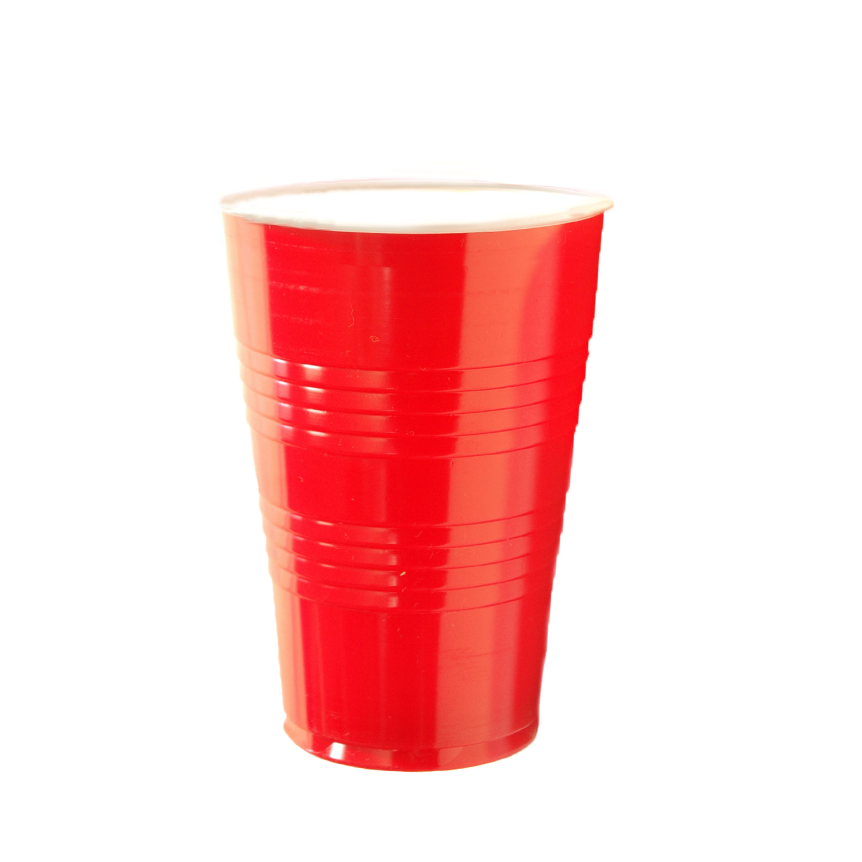

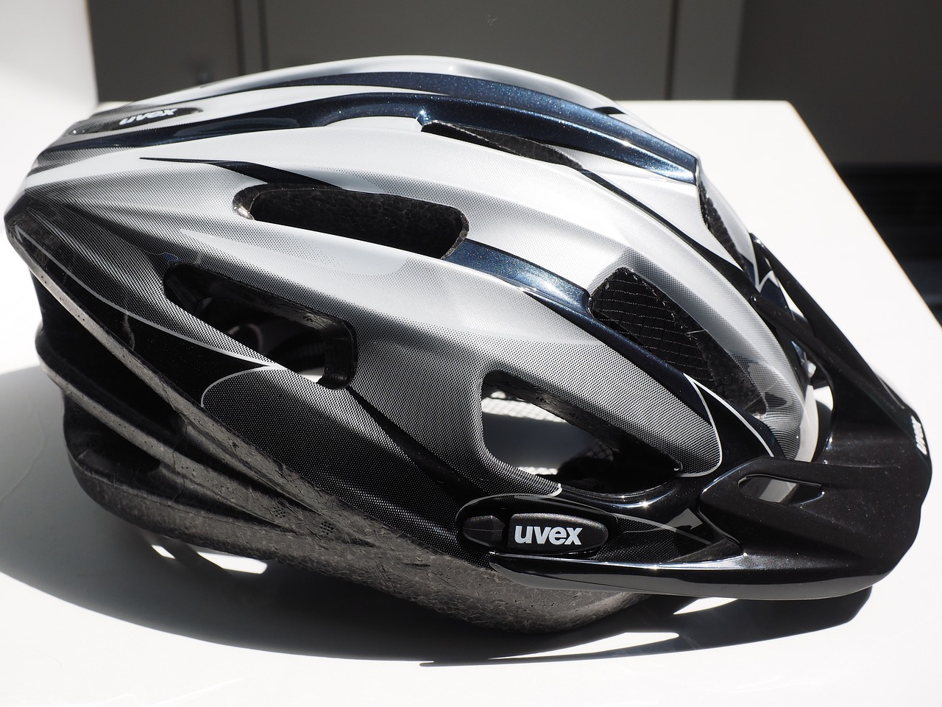

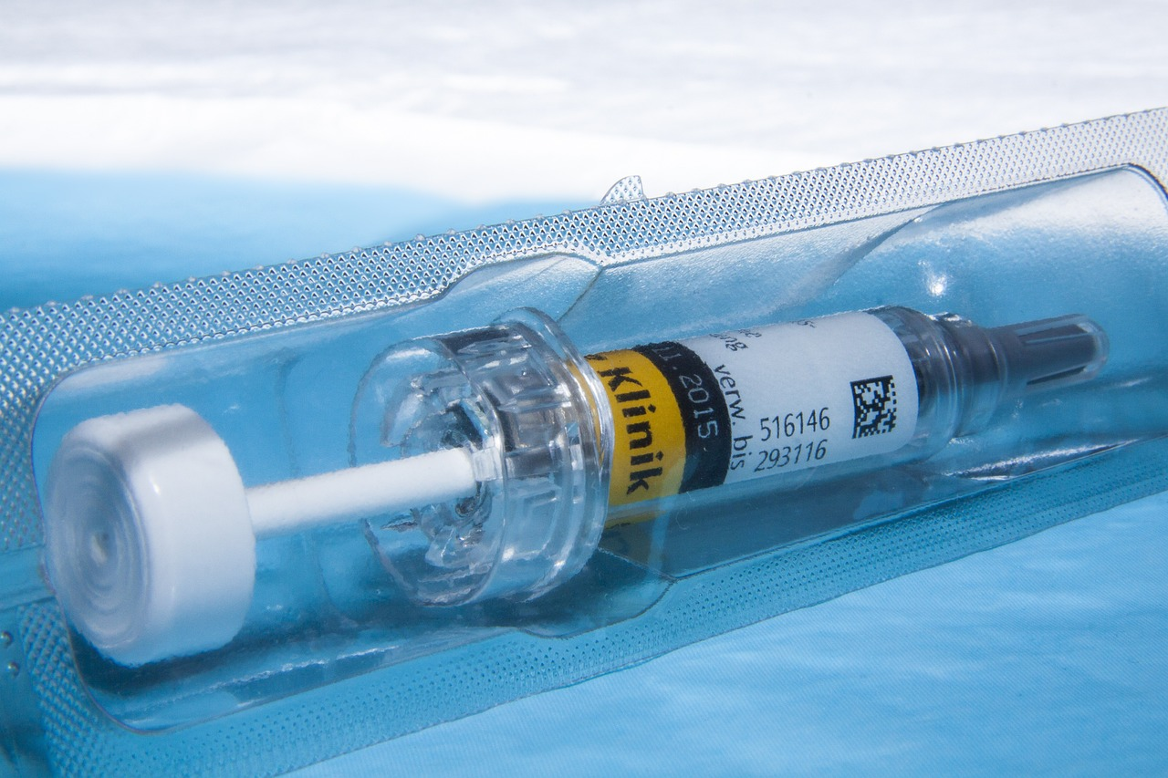

Photo 7.5 **Various polystyrene (PS) products. (a) Rigid cup. (b) Bicycle helmet. (c) Blister packs.**

        The development of catalysts that hold the monomer and the polymer chain in specific geometrical configurations during polymerization has resulted in the production of a PS with high crystallinity. The catalysts are part of a chemical family called metallocenes. These catalysts have been used to make geometrical isomers of several plastics called **constrained geometry polymers**, similar to the stereoisomers discussed in relation to PP except that the geometrical restraints using metallocene catalysts are even stronger than with the Ziegler-Natta catalysts. The result of using these new metallocene catalysts can be significant. Constrained geometry PS has a melting point of 520°F (270°C), which is 340°F (170°C) higher than that of amorphous PS. Significantly higher mechanical properties are also claimed for constrained geometry PS.

## 7.6.1. Expanded Polystyrene (Polystyrene Foam)

        One of the most important PS applications is as a foamed material. PS foam is widely used for disposable drinking cups, fast-food containers, picnic plates, wall insulation, packing material for delicate instruments, and numerous other applications. (A common brand of PS foam is Styrofoam™, a Dow Chemical trademark.) The widespread use of foamed PS has drawn criticism from environmentalists, who are concerned that the material is not being properly recycled, even though recycling of PS is very easy. The plastics industry is addressing these environmental concerns, and many of the steps being taken are outlined in Chapter 23. Despite the environmental concerns, the use of PS foam continues to increase, undoubtedly because of the superior performance of this material in comparison to other competitive materials and the environmental difficulties also present with almost any other material that might be used in place of the PS foam.

The advantages of PS foam over competitive materials include the following:

* Low thermal conductivity, making for good insulation.
* Good energy absorption for packaging delicate instruments and for other impact applications.
* High buoyancy.
* High stiffness-to-weight ratio, so parts made from the PS foam can be self-supporting and lightweight.
* Low cost per volume.

        The process for making foams will be discussed in detail in Chapter 17, but some general discussion here will assist in understanding how PS foam parts are made. The most common method involves the use of prefoamed PS beads. The resin manufacturer makes these beads by adding an inert gas, such as pentane, during the polymerization. Under the proper conditions, which usually involve a water suspension environment, polymerization occurs with the formation of small, internally foamed PS beads with the inert gas trapped inside. These beads are then shipped to the part molders. The part molders convey the beads from the shipping container to the mold by air pressure or vacuum. During this conveying step, the beads are often heated and will expand up to 20 times their original volume, but this is only a partial expansion. The beads are then heated, usually by passing steam through the mold. This heating causes the beads to further expand, often doubling in size over the partially expanded size, and to fuse together. The molds are then cooled and the parts removed. A close examination of many parts made from PS will permit identification of the individual beads that have been fused to form a continuous part. Some of these parts are shown in Photo 7.5.

        Foamed PS slabs are made by a different technique that is much more typical of other foamed plastics. These slabs are made by introducing a foaming agent into a PS solution or melt that is extruded to form a flat sheet. As the sheet leaves the end of the extruder, the pressure on the melt reduces, thus allowing the foaming agent to expand and foaming of the PS occurs. The dimensions of the slab are set by causing the foamed slab to pass between dimensioning belts or plates with a specified gap between them. The foamed PS slab is then cooled and cut to dimension.

Read this online at <https://books.byui.edu/plastics_materials_a/polystyrene_ps>