# Thermoset Polyesters or Un-saturated Polyesters (Up)

        Thermoplastic polyesters (PET and PBT), discussed in Chapter 8 (engineering plastics), are polymers formed by condensation polymerization with ester bonds linking the repeating units. The **thermoset polyesters** are also polymerized using condensation reactions to form ester bonds, but some significant differences allow these polyesters to crosslink and become thermoset. With thermoset polyesters, the polymerization is terminated much sooner so that the thermosets are short-chain, low molecular weight polymers. They are, therefore, viscous liquids or low-melting solids, allowing the thermosets to be shaped easily before crosslinking. (The crosslinking reactions that occur during molding cause an increase in the molecular weight and the corresponding increase in physical and mechanical properties needed for most applications.) The thermoset polyesters, therefore, must have active sites in each polymer repeating unit that allows crosslinking to occur. This active site is a carbon-carbon double bond.

## 9.6.1. Crosslinking Mechanism for Thermoset Polyesters

        The thermoset polyesters are able to form cross-links because each repeating unit contains an active carbon-carbon double bond that can react by the addition polymerization mechanism, as described in Chapter 2, and form a link to a carbon-carbon bond in another molecule. Because carbon-carbon bonds are **unsaturated bonds**, the thermoset polyesters containing these bonds are called **unsaturated polyesters**, which is another term for thermoset polyesters. The carbon-carbon double bonds in these crosslink reactions are not created by the condensation polymerization reaction, but, rather, are present in one of the monomers and simply go through the condensation polymerization reaction without being affected. The carbon-carbon bonds are therefore available for the crosslinking reactions after the polymer is formed. The separate crosslinking reaction involving the carbon-carbon double bonds is carried out when the polyester resins are molded. A polyester molecule containing a carbon-carbon double bond is shown in Figure 9.6a.

        Carbon-carbon double bonds react by the addition polymerization mechanism, which requires a free radical to attack the carbon-carbon double bond to initiate the reaction sequence. Typically, a heat-activated or time-activated peroxide or some other free radical source is added to the polyester to initiate the crosslinking process. The typical concentration of initiator is 1 to 2%. (Concentrations of initiator that are significantly higher or lower will result in incomplete crosslinking and parts with inferior properties.) The initiator reacts with a carbon-carbon double bond, forming a new bond with one of the carbons in the carbon-carbon double bond and creating another free radical on the other carbon. This new free radical can then react with another carbon-carbon double bond to form another new bond and another free radical. This process can be repeated in a chain-reaction fashion. If the carbon-carbon double bonds that are linked are on separate molecules, a crosslinked, thermoset structure is created. No condensation byproduct is formed during the crosslinking, thus making the molding of thermoset polyesters much less difficult than with phenolics or amino plastics.

**﻿**

**Figure 9.6 Unsaturated polyester showing (a) reactive carbon-carbon double bond and (b) crosslinking reaction. Note: New bonds are shown extended, but are really the same length as other C—C bonds.**

        Direct bonds between polyester molecules are difficult to form in practice because of the high viscosity of the polymers and the steric (shape) interferences that are often present. Therefore, solvents are often added to the polyesters. These solvents allow the polymer molecules to move freely, thus facilitating the crosslinking. Generally, the solvents chosen contain an active carbon-carbon double bond so that they can also participate in the crosslinking reaction. This further facilitates the process because the solvent molecules can serve as "bridges" between the polymer chains and make the bonding less hindered. Furthermore, the solvents can be completely used up, thus eliminating the need for solvent removal from the crosslinked plastic. A reaction illustrating the use of a solvent molecule is shown in Figure 9.6b. Almost all commercial unsaturated polyesters contain solvents that participate in the crosslinking (reactive diluents). The most common solvent is styrene but others occasionally used include vinyl toluene, diallyl phthalate, and methyl methacrylate.

        A high concentration of solvent vapors usually accompanies the molding of unsaturated polyesters. Most processes for molding or shaping thermoset polyesters allow the vapors to freely enter the workplace, thus causing a potentially flammable environment and, perhaps, unhealthy breathing conditions. Modern manufacturing methods seek to control these vapors, but the potential for problems is still present and needs to be carefully monitored.

## 9.6.2. Additives to Thermoset Polyesters

        Free radicals can be formed spontaneously by sunlight, heat, oxygen or contaminants even without the addition of an initiator. So most polyester resins, even those to which no initiator has been added, have a limited shelf life since eventually enough free radicals are formed to crosslink the material. To prevent this premature crosslinking, the materials are often stored at low temperatures. Chemicals that retard the formation of free radicals or that preferentially absorb free radicals can also be added to prolong the shelf life. These materials are called **inhibitors**.

         For some applications, the speed of the cross-linking reaction is too slow, either because the mixture has been inhibited or because the reaction is inherently too slow. Under these circumstances, chemicals can be added that speed the reaction. These chemicals, called **accelerators**, are usually based on a metal such as cobalt or manganese. Care must be taken that the accelerators and initiators are never mixed together in high concentrations. Each must be added separately to the polyester mixture. Any polyester mixture to which an accelerator and initiator have been added will have a very short shelf life and must be used immediately.

        When the molder is ready to form the part, the polyester material is shaped (usually but not always in a mold) and then the crosslinking reaction is allowed to proceed. If a heat-activated initiator is used, the material is heated. If a time-activated initiator is used (usually with an accelerator), the material is simply allowed to sit until the crosslinking reaction is complete.

         The unmodified, cured thermoset polyesters are generally hard, brittle materials that do not compete well with either the commodity thermoplastics (because of price) or with the engineering thermoplastics (because of performance). Therefore, thermoset polyesters are almost always modified with fillers and reinforcements to reduce costs and improve properties. If the resin is modified with fillers or reinforcements at the time of molding, the resin is a **laminating resin**. If the resin is modified before molding, generally by the resin manufacturer, and is later molded as a modified material, the resin is called a molding compound.

## 9.6.3. Laminating Resins

        Unsaturated polyester laminating resins or resins combined with a diluent are usually sold to the molder as **neat resins**, which means a resin containing nothing but the main polymer (and possibly the diluent), although minor additives such as inhibitors and antioxidants can be included. Initiators are not added to the neat resins or solutions until just prior to use. This procedure prolongs the shelf life of the resin and allows the user to choose the type of activation system most appropriate for the particular application. The shelf life for thermoset materials, even without initiators, is short (only a few weeks or months) compared to thermoplastics. Polyesters, for example, should generally be processed in less than 60 days.

        Unsaturated polyester resins are used extensively with fiber reinforcements; the purpose of the resin is to bind the fibers together and give shape to the part. Reinforcing fibers are saturated with the resin at the time of molding or shaping. The resin is then cured either by heat or time. The fibers significantly increase the strength of the polyester resin and allow these materials to compete effectively against engineering thermoplastics and metals, especially when low cost and light weight are important. Materials that combine resins with reinforcements are called **composites** and constitute an important class of materials.

        Another term for these combinations of resin and reinforcements is fiberglass reinforced plastics (FRP), which some use as a synonym for composites, but more frequently refers to a special type of composite where the resin is polyester and the reinforcement is fiberglass. FRP is the most common type of composite material. Many of the manufacturing methods used for making these fiber-reinforced plastics (which will be examined in detail in Chapter 19) are suitable for making very large parts. Therefore, common applications for FRP include boat hulls, spas (whirlpool baths), shower stalls, corrugated panels (such as carport roofs), electrical insulators, truck and automotive parts (such as the Corvette and now most cars), and architectural products (such as columns and decorations) (see Photo 9.4).

        In many FRP products a coating of unsaturated polyester is applied to the mold surface and allowed to partially cure before the wetted reinforcement is put in place. This coating provides a protective layer (called a **gel coat**) that can be colored so that painting is not necessary. (The term **gel** comes from the fact that the coating is allowed to partially cure or gel before the reinforcement layers are added.) The ability of unsaturated polyesters to form protective coatings has led to their widespread use as coatings for wood, metals, and various other materials. They can be applied as gel coats, which are then cured, or as solvent-based paints. Baked enamels are often based upon unsaturated polyesters.



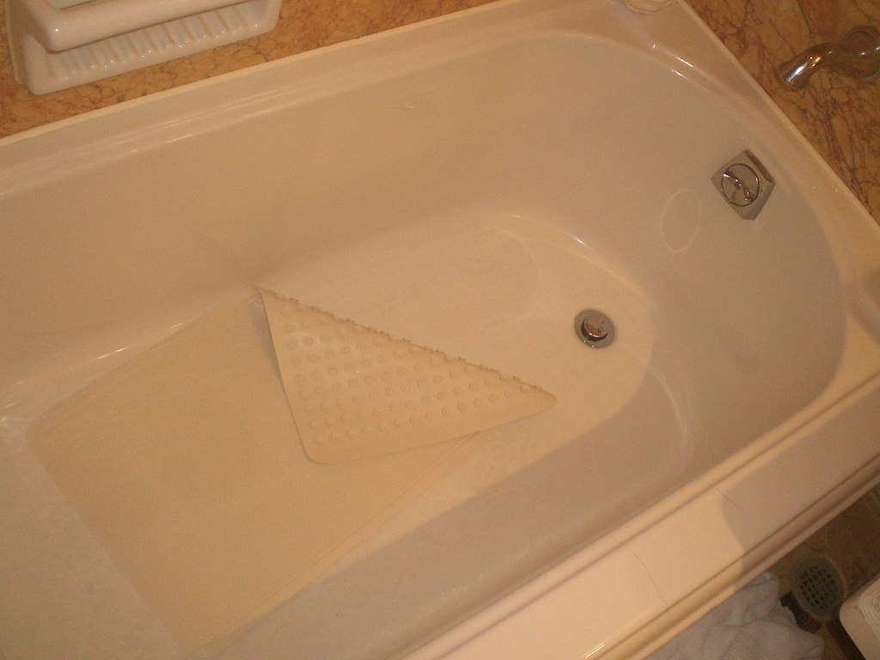



**Photo 9.4** **Various thermoset polyester (TP) and fiber-glass products. (a) TP fiberglass corrugated panels. (b) Polyester fiberglass bath. (c) Polyester fiberglass window of golf cart.**

        Several types of unsaturated polyester resins can be used for many applications. These resins all have polyester linkages along the backbone and contain a carbon-carbon double bond in each repeating unit but differ in the other parts of the molecules. For instance, some polyesters can be almost entirely aliphatic, whereas others have high aromatic content. Flexibility, toughness, strength, weather resistance, flammability, and other physical properties can be affected significantly by the molecular variations. Some common types of unsaturated laminating resins are orthophthalic, isophthalic, BPS fumarate, and chlorendic, names that reflect the structure of a key molecular segment of the molecules. These variations are important in determining part properties and are, therefore, important when specifying the particular polyester resin to be used. For instance, the **isophthalic** (pronounced eye-so-thal'-ick and sometimes called simply **iso**) resin is known to have good environmental resistance and is used extensively in gel coats and in applications where resistance to solvents or weather may be important. **Orthophthalic** (pronounced or-tho-thal'-ick and sometimes called simply **ortho**) resin has generally lesser properties than iso, but ortho is less expensive. Therefore, a common procedure is to use the iso resin as the gel coat and then the ortho resin for the remainder of the material. This procedure is possible because the resin in laminated parts is often applied in layers, and thus two different materials can be used in adjacent layers.

        Using **chlorendic** (pronounced clor-end'-ick) resins can make unsaturated polyesters flame retardant. These resins contain chlorine atoms, which give some natural flame suppression. Bromine-containing resins are also available. Flame retardance can also be achieved by using fillers that contain halogen molecules or that contain water, as was described in Chapter 5.

## 9.6.4. Molding Compounds

        Unsaturated polyester molding compounds are made by mixing the resin or resin solution with fillers or reinforcements. To ensure that the initiator is uniformly distributed throughout the mix, the initiator is usually added to the resin or resin solution prior to adding the filler and reinforcement. Therefore, the shelf life of the molding compound is much less than that of laminating resins. To extend shelf life, molding compounds are often stored at low temperatures.

        The properties of the molded parts are dependent upon the resin type, the solvent, the reinforcement, the filler, and other minor constituents.

        For instance, the long-term stability of polyester thermosets in hot water depends strongly on the selection of all these constituents in the molding compound. If any constituent is changed, the hot water performance is strongly affected. Even with the best of each type of constituent, polyester thermosets are likely to absorb significant moisture in hot water and lose both mechanical and chemical property performance.

        There are several types of polyester thermoset molding compounds. These include alkyds, allylics (principally DAP and DAIP), BMC/DMC, and SMC, which differ in types of unsaturated polyesters, types of active diluents, and the method of adding reinforcement, if any. Each will be discussed briefly.

**Alkyds** (pronounced al'-kids) are polyester molding compounds that are based on the types of resins used in laminating. They are prepared by blending the resin with the initiator and then with cellulose pulp, mineral filler, lubricants, pigments, and, perhaps, short fibers. The mixing is usually done in a heated roller mill, which gives some curing to the polymer. When the proper degree of polymerization is reached, the semisolid material is removed from the rollers, cooled, crushed, and ground into a molding powder. This powder is usually compression molded, often requiring only low pressures. Alkyd parts have high electrical resistance, low moisture sensitivity, and good dimensional stability.

        Alkyds are used principally for paints and molded parts. The paints have high durability and have been on the market for many years, but their relatively slow drying rate has limited their use. Furthermore, the paints and molded parts have some tendency to absorb water, thus restricting them to low-water environments. The molded alkyd resins have been used extensively in electrical applications, especially in automobiles, where their low conductivity and high dielectric strength have value.

        The **allylics** (pronounced al-lil'-icks) are a group of unsaturated polyesters that are based upon resins formed from a monomer containing the allyl group, a particular organic chemistry functional group that contains a carbon-carbon double bond.

        The most common of these monomers are diallylphthalate (DAP) and diallylisophthalate (DAIP). When polymerized into a linear, uncrosslinked polymer and then combined with a filler and, perhaps, a reinforcement, these materials are called allylic, DAP, or DAIP molding compounds. The reinforcements are usually short fibers or mineral fibers so the paste like consistency can be maintained.

         Allylic pastes are used as body putty for repairing automobiles and for many other applications in which a high degree of shaping is required. Allylies are also used extensively for electrical parts (chiefly connectors, switches, bobbins, and insulators). These parts are made by compression or transfer molding (discussed in a later chapter). Allylics are also used for **potting**, a process of encasing an article or assembly in a resinous mass done by placing the article to be potted into a container that serves as a mold, pouring the liquid resin into the mold so that the desired portion of the part is covered with resin, and then curing the resin. After the casting is completed, the mold remains as part of the assembly. Potting is used extensively in the electrical industry to encapsulate wire ends and is discussed more fully in Chapter 16.

**Bulk molding compound (BMC)** or, alternatively, **dough molding compound (DMC)**, is made by combining the unsaturated polyester resin with an initiator, a filler, and reinforcement fibers. The name **premix** can also be applied to these mixtures. The mixing is done at room temperature to avoid premature curing and with as little agitation as possible so that quite long fibers (up to about 2 inches or 5 cm) can be used. The resultant materials are stored at low temperatures to prolong their shelf life. Typical concentrations of BMC components are: resin—30%, filler—60%, reinforcement—10%.

        BMC materials are sticky and have a doughlike consistency, which allows them to be metered, shot by shot, into an open mold. Therefore, the principal molding method is compression or matched die molding, which permits largely automated and rapid molding of parts having moderately high complexity. The automobile industry has adopted this method for the manufacture of numerous parts, including body panels, grills, trim, air-conditioning ducts, electrical components, and various semistructural members.

        One problem inherent in the use of BMC is the limited amount of material movement possible within the mold. Generally, the charge of BMC is placed in the center of a mold and then it moves to fill the mold as the mold presses against the material. Even with careful adjustment of the viscosities of resin and the proper amounts of resin, filler, and reinforcement, movement over long distances in the mold will tend to cause separation of the components. Therefore, parts made by BMC molding are limited to about 16 inches (40 cm) in their longest dimension.

        Larger parts can be made with **sheet molding compound (SMC)**. The composition of SMC is about the same as BMC but the method of mixing the components is quite different. The process for making SMC is depicted in Figure 9.7. Rather than mix the components in a bulk process, the preinitiated resin and filler material is doctored onto a moving sheet of polyethylene film. The reinforcement fibers are chopped to the desired length (typically 1 to 3 inches, 3 to 7 cm) and sprinkled onto the resin/filler layer. A second polyethylene sheet that has also been doctored with a layer of resin and filler is then placed on top of the chopped fibers so that a sandwich is formed, with the reinforcements in the middle, surrounded by the resin/filler mixture, and enclosed by the polyethylene film. This sandwich is passed between rollers that mix the fibers into the resin and filler, then rolled to an appropriate size for easy handling, and removed for storage at a cool temperature.

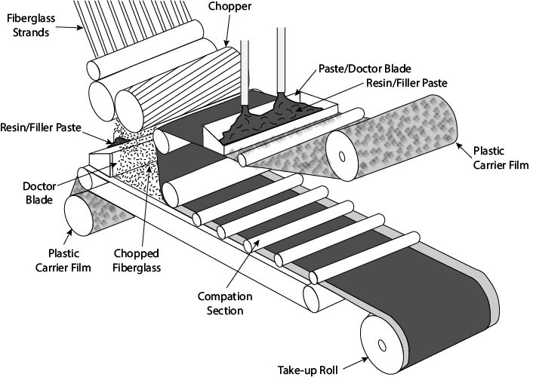

**Figure 9.7Process for making sheet molding compound (SMC).**

        When the SMC is to be used, the roll is taken to the molding station (usually a large compression molding machine) and is unrolled and cut to the desired lengths. These lengths are typically about the same size as the part to be molded. The polyethylene sheets are removed from the SMC sandwich as the material is placed into the mold in sufficient layers to obtain the thickness desired. If additional thickness is desired in some locations, smaller strips of SMC can be laid into the mold at those locations. When all of the material has been properly placed into the mold, the mold is closed and the part is cured. Because the SMC is placed throughout the mold, little movement of material occurs within the mold. Therefore, very large parts can be made by this process. A well-known example of a part made from SMC is the body of the Corvette™ (General Motors).

        The use of BMC and SMC for exterior body panels in automobiles has required the development of a molding system that will result in a very smooth, defect-free surface (often called a **class A surface**). The inherent shrinkage of polyester materials as they crosslink normally results in small sink marks and dimples that are unacceptable in the automotive panel market. A special additive system has been developed to solve this problem, called **low-profile** or **low-shrink system**, which is based upon the addition of some thermoplastic resins and fillers containing divalent metals (such as Ca+2 and Mg+2). The addition of these materials to polyester resins results in a thickening of the resin/fiber/filler mixture (a process called **ripening**), which depends on the formation of ionic bonds between the ionic groups on the polymer and the positive metal ions. The ripening or thickening of BMC and SMC occurs to some extent even without the presence of the low-profile additives because of the normal curing that takes place with an initiated resin system. Therefore, BMC and SMC systems can be viewed as B-staged resin systems. With these systems, the use of thermoset polyesters in automobiles has increased steadily for many years.

Read this online at <https://books.byui.edu/plastics_materials_a/thermoset_polyesters>