# Types of Malnutrition

### 1.2 Types of Malnutrition

#### Prep Videos

The prefix “mal” means bad and when coupled with nutrition would imply “bad-nutrition.” Therefore, malnutrition can refer to both overnutrition or undernutrition. Overnutrition occurs when there is an overconsumption of nutrients from food or supplementation to the point at which health is adversely affected.9 This could manifest as excessive caloric consumption leading to obesity or consuming vitamins or minerals at toxic levels. Undernutrition occurs when there is insufficient consumption of Calories, vitamins, or minerals. This can manifest as impaired growth and development or specific vitamin and mineral deficiency diseases such as scurvy (vitamin C deficiency).10 It is important to understand that initially there may not always be clear signs of malnutrition. The potential serious effects will often develop over time.

#### Overnutrition and Chronic Disease

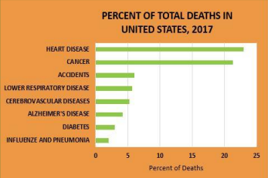

Overnutrition may manifest itself in several different forms. Excessive vitamin or mineral intake from supplementation or fortified foods may lead to toxicities. Despite vitamin and mineral toxicity (or overconsumption), the magnitude of the public health concern from this kind of excess is much less concerning than the over consumption of calorie rich, nutrient poor food that is becoming common throughout the world. This type of “malnutrition” is a contributor to chronic diseases such as heart disease, type 2 diabetes, hypertension, and some cancers. Many of the health problems of modern society could be minimized by simply addressing poor diet choices.11 Cancer and heart disease account for over 40% of the total deaths in the US (see Figure 2). Both diseases have a strong relationship to dietary habits. Globally, high income countries like the United States display a similar pattern (see Table 1). The rate of chronic disease like heart disease and stroke are increasing in underdeveloped countries, but the highest percentage of deaths in underdeveloped countries are related to infectious disease such as respiratory and diarrheal disease and neonatal deaths. This can be contributed to factors such as higher rates of undernutrition, lack of access to healthcare and limited sanitation services.

|  |  |
| --- | --- |
| High income countries, 2021 | Low income countries, 2021 |
| Heart Disease | Lower Respiratory Infections |
| COVID-19 | Stroke |
| Stroke | Heart Disease |
| Alzheimer’s disease and other dementias | Malaria |
| Trachea, bronchus, lung cancers | Preterm birth complications |
| Chronic obstructive pulmonary disease | COVID-19 |
| Colon and rectum cancers | Diarrhoeal Diseases |
| Lower Respiratory Infections | Tuberculosis |
| Kidney Diseases | Birth asphyxia and birth trauma |
| Hypertensive heart disease | HIV/AIDS |

#### Undernutrition and Deficiency Disease

Severe undernutrition is rare in developed countries, but it is a leading cause of death of children in underdeveloped countries. Nutrition status of children can be determined by following growth measures such as height and weight. Severe undernutrition can contribute to stunted height (low height for age) and/or wasting (low weight compared to a person’s height). It is estimated that 144 million children under 5 are stunted and 47 million are wasted worldwide.13

The impact of nutrition on a child's health is profound and long-lasting. Good nutrition supports healthy brain development, helping children reach their full potential in school, work, and life. It improves their overall quality of life and can even contribute to the economic growth of their community and country. In contrast, poor nutrition can lead to serious health problems, lower productivity, higher health care costs, and a continued cycle of poverty and poor health. 13,14

Inadequate intake of Calories and certain vitamins and minerals can also negatively affect the immune system; consequently, undernourished children commonly die from bacterial or viral infections (diarrheal diseases, respiratory infections, tuberculosis etc…). In 2020, the World Health Organization reported about 45% of deaths among children under 5 years of age are linked to malnutrition. The majority of these deaths occurred in low- and middle-income countries.15

Vitamin A, iron, and iodine are some of the most common vitamin and mineral deficiencies in the world. It estimated that 190 million children under the age of 5 are affected by vitamin A deficiency alone.16 Lack of vitamin A impairs immunity which increases death rates from infectious disease, primarily in low income countries. It also results in night blindness and a severe deficiency of vitamin A can result in permanent blindness. Global efforts to increase vitamin A intake has led to extensive supplementation programs, fortification of foods, promoting food sources rich in vitamin A such as orange fleshed sweet potatoes, and genetic modification to increase vitamin A levels in foods. Deficiencies of iron, iodine and other vitamins and minerals can be equally as damaging. Increased access to food preservation techniques like drying and canning, has improved access to nutrient-rich foods. Despite these efforts, deficiency of some nutrients remains high in some areas of the world.

A good example of how knowing about food and using some creativity can make a big difference comes from early American history during the time of the Mormon pioneers. In the winter of 1846, as many as 600 immigrants died at Winter Quarters, mostly from scurvy (a serious illness caused by not getting enough vitamin C). While serving as a missionary in England, George Albert Smith learned that potatoes, when eaten with the skin, could help prevent scurvy. Because potatoes could be stored and used during the winter, he encouraged the pioneers to eat them to stay healthy. George Albert Smith became known as the “Potato Saint” for his efforts.17

Moderately low intake of vitamins and minerals may not cause obvious physical signs of a deficiency, like night blindness, but can still affect a person’s quality of life. Health professionals often call this a sub-clinical deficiency, meaning there are no clear outward symptoms yet. For example, someone with a slightly low vitamin A intake may have a higher risk of infections even though they do not show other obvious signs of deficiency.

#### Double Burden of Malnutrition

Although undernutrition continues to be an issue worldwide, a noticeable number of underdeveloped countries are progressing economically, socially, and culturally. As a country becomes more urban or developed, access to education increases which leads to improved employment opportunities. As a result, income increases, but the time available to prepare traditional foods decreases.18 Urbanization within developing countries yields a greater availability of food in the country. Access to a variety of foods results in a more Westernized diet which includes higher fat, added sugars, meat, milk and overall calories than typically consumed in the traditional diet.19 The loss of the traditional lifestyle results in an increased consumption of ultra-processed foods. Ultra-processed foods are foods that contain many added ingredients (such as fat and sugar) and have gone through multiple refinement processes.

Examples include foods such as soda, some fast foods, candy and packaged foods like chips and cookies.

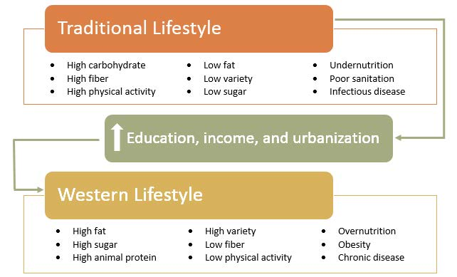



The shift to a westernized diet composition in developing countries is leading to the development of overnutrition in previously largely undernourished countries. Thus, countries that were mainly concerned about undernutrition and infectious disease are now also faced with the burden of chronic diseases caused by this transition to an industrial lifestyle, adoption of a Western diet high in ultra-processed foods and decreased physical activity (see Figure 3).20

This coexistence of overnutrition and undernutrition in the same populations has led to the coining of a new phrase the Double Burden of Malnutrition.21,22 The term also includes other situations where the presence of over and undernutrition is combined. For example, in a single household a child may be vitamin A deficient, but the parents are obese. Even a single individual can display the double burden of malnutrition. For example, a person may be iron deficient but also be overweight.

The urbanization of developing countries has brought some positive outcomes, such as lower rates of infectious diseases and nutrient deficiencies, as well as longer lifespans overall. However, when a country does not recognize the risks of overnutrition or tries to address undernutrition by increasing the consumption of ultra-processed foods, the struggle with chronic disease begins. This rapidly growing "double burden" highlights the importance of educating communities about the risks of both undernutrition and overnutrition.23,24

The increased availability of cheap, ultra-processed foods in developing countries is a central factor to the global growing presence of the double burden of malnutrition. A focus on eating a variety of locally availably healthy foods is critical to curb the declining global health trend and to minimize the presence of the double burden of malnutrition.

#### Key Takeaways

* Malnutrition includes both undernutrition and overnutrition.
* Overnutrition contributes to chronic diseases like heart disease and type 2 diabetes.
* Undernutrition is still a major cause of illness and death, especially in children.
* Micronutrient deficiencies (like vitamin A and iron) remain common worldwide.
* The "double burden of malnutrition" refers to undernutrition and overnutrition occurring together in populations of even individuals.
* A focus on diverse, local, nutrient-rich foods is essential to improve global health.

References (see below)

Read this online at <https://books.byui.edu/nutr_150_principles_/12_types_of_malnutri>