# Critical and Sensitive Periods

### Overview of Concepts

* Critical and Sensitive Periods

## Critical and Sensitive Periods

Critical periods, also known as windows of opportunity, refer to specific time frames during human development when the brain is most receptive to learning and development. Critical periods are important because if certain experiences or stimuli are not present during these times, they can significantly impact the development of certain abilities or skills. Once that window is closed, the opportunity to learn is still there but it becomes a lot harder

The Sensitive Period is a developmental period where children are in the optimal position to learn from their experiences. Learning in the sensitive period comes from stimuli applied to a specific experience. If a child learns a skill outside of the sensitive period they will find it more difficult to learn.

Core Content

## Basic Development

Language development: Language skills form during childhood. During this time, the brain is particularly receptive to learning and acquiring a language. Children are highly receptive to learning new words and grammar. This can be seen in a classroom setting as children quickly pick up new vocabulary and grammar rules, as well as become more proficient in pronunciation.

Vision development: Visual learning skills develop from birth to around age three. During this time, the brain is predominately wired to process visual information and develop visual skills.

Cognitive development: Cognitive skills form primarily in childhood. Children are highly receptive to learning new concepts and tasks. This can be seen in a classroom setting as children quickly learn new mathematical concepts, scientific principles, and other academic subjects.

Social and emotional development: Children primarily develop socially and emotionally from infancy to early childhood. Children are highly receptive to learning about social interactions and emotions. This can be seen in a classroom setting as children learn how to interact with their peers, form friendships, and understand and regulate their emotions. During this time, the brain is wired to process social cues and develop social skills.

Identity Development: During the critical period of adolescence, students are highly receptive to developing their sense of identity, forming and maintaining relationships, and making decisions that will affect their future. This can be seen in a classroom setting as students become more independent and take greater responsibility for their learning and decision-making.

### Critical Periods of Development that occur in the classroom:

* Language development
* Cognitive development
* Social and emotional development
* Identity development

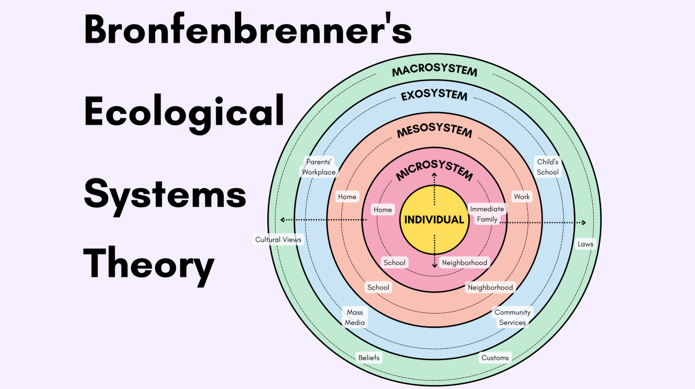

Cuff, 2023

The Bioecological Model of Human Development  
The Bioecological Model can be used in the lifespan approach to development. It emphasizes the importance of understanding bidirectional influences between an individual's development and his or her surrounding environmental contexts.

### Nutrition:

Nutrition is essential for development. Within the critical periods, nutrition helps with:  
Brain development- Nutrients like omega-3 fatty acids, iron, and vitamins are crucial for brain growth and function.  
Neurotransmitter Production- Certain nutrients, such as amino acids from proteins, are precursors for neurotransmitters, which are chemicals that transmit signals in the brain.  
Cognitive Function- Proper nutrition supports better concentration, memory, and problem-solving skills.

Within the sensitive periods, nutrition helps with:  
Cognitive Enhancement- Nutrients like zinc, iron, and omega-3 fatty acids  
continue to support cognitive processes and mental performance.  
Mood Regulation- Nutrients like omega-3 fatty acids and B vitamins can help  
regulate mood and reduce the risk of depression and anxiety, which can affect  
learning.  
Physical Growth- Adequate nutrition supports physical growth and  
development, which indirectly influences cognitive development and learning

## Common Misconceptions about Human Development

Critical periods are not set in stone, and the range for different aspects of development can vary from child to child.

If a child misses a critical period, they will never develop the ability.

While critical periods are important, it is not true that if a child misses a critical period, they will never develop the ability. It may take more time, effort, or a different approach, but the brain can continue to develop and adapt even after the critical period has passed.

Exposure to certain experiences during critical periods will guarantee success.

Exposure to certain experiences during critical periods is important, but it does not guarantee success. Other factors such as genetics, environment, and individual differences also play a role in development.

Critical periods are limited to childhood only.

Critical periods are not limited to childhood only; some skills and abilities have a critical period that extends into adulthood.

Critical periods are the only important time for development.

While critical periods are important, development is a continuous process, and experiences at any stage of life can have an impact on development.

### Notice!

Critical Periods are not mutually exclusive. They can occur and overlap in different areas of development.

### Real-Life Experience

A young new mother shared her experience of observing her baby through the milestones of critical periods in human development.

“I look at the recommendations for when she should hit certain milestones to make sure she’s hitting them, but I also try not to worry if she isn’t doing something right away because each baby develops differently/at their own pace.

It can be hard not to compare her to other babies her age who are doing things she isn’t yet, though. For example, there are some babies her age that are already crawling, and sometimes I might feel like she’s behind since she isn’t yet. In reality, it’s normal for her to not crawl yet, and babies that do are pretty ahead in that area.

Watching her behavior change as she has become more aware of individuals and the environment around her has been super fun! I love seeing her learn and interact more—this is a super fun age. Just in the past month, she has learned to be more interactive both with her toys and with people. It’s really interesting to see her make new connections. She does need to be entertained more than she used to which can be tiring, but it’s also very rewarding.”

## Key Vocabulary

* Critical Periods - Times when a skill SHOULD BE developed.
* Sensitive Periods - Times when it is EASIEST to develop a certain skill.

### Summary

* Critical periods are specific time frames during human development when the brain is most receptive to learning and developing in a certain capacity.
* These periods vary for different aspects of development such as language, vision, social development, and experiences.
* This time can have a more significant impact on development than on later experiences.
* Critical periods are observed in infants and young children, with the key developmental stages being from birth to around age 6.
* Adequate exposure to different environments and experiences during the critical period is crucial for a child's overall development and future learning capabilities.

## References

Fundamentals of development. (n.d.). EdPsych Pressbooks. Retrieved August 20, 2024, from <https://edpsych.pressbooks.sunycreate.cloud/chapter/fundamentals-of-development/>

Sensitive periods in child development. (2018, July 25). Step by Step Montessori. Retrieved August 20, 2024, from <https://www.stepbystepmontessori.com/2018/07/25/sensitive-periods-in-child-development/>

Your child’s developmental windows of opportunity. (n.d.). AIM Montessori Teacher Training. Retrieved August 20, 2024, from <https://aimmontessoriteachertraining.org/your-childs-developmental-windows-of-opportunity/>

Supporting adolescent learners. (n.d.). FutureLearn. Retrieved August 20, 2024, from <https://www.futurelearn.com/info/courses/supporting-adolescent-learners/0/steps/46451>

Laidlaw, D. (2021, August 10). Sensitive periods in child development [Video]. YouTube. <https://youtu.be/ytRC15vIA24>

Critical/sensitive periods. (n.d.). Encyclopedia.com. Retrieved August 20, 2024, from <https://www.encyclopedia.com/children/applied-and-social-sciences-magazines/criticalsensitive-periods>

Sensitive periods in child development. (2021, June 5). Rama Lynn. Retrieved August 20, 2024, from <https://www.ramalynn.org/blog/~board/montessori-education/post/sensitive-periods-in-child-development>

O’Leary, J. (2004). When the effect of experience on development is adaptive for the individual. PubMed. <https://pubmed.ncbi.nlm.nih.gov/15509387/#:~:text=When%20the%20effect%20of%20experience,is%20adaptive%20for%20the%20individual>

## Additional Readings

* [https://www.youtube.com/watch?v=gIZ8PkLMMUo&autoplay=1](https://www.youtube.com/watch?v=gIZ8PkLMMUo&amp;autoplay=1)

Read this online at <https://books.byui.edu/science_of_learning/cGehjtcu>