Parenting Styles
James, E., GPT, C., , Greenwood, A.
Think back to how your parents raised you. Were they strict? Did they show you love? Did they back off and let you live life how you wanted? Did they almost always ignore you?

Parenting styles refer to how parents interact with and raise their children. Diana Baumrind, a developmental psychologist, identified four main parenting styles: authoritarian, authoritative, neglectful, and permissive.
Core Content

Authoritarian Parenting is characterized by high levels of control and strict rules, with little room for negotiation or discussion. Parents who use this style tend to be demanding and unresponsive to their children's needs and emotions (Baumrind, 2010).
AuthoritativeParenting, also known as warm demanders, is characterized by high levels of warmth and responsiveness to children's needs, along with clear boundaries and expectations for behavior. These parents set rules and enforce them, but also provide explanations and reasoning for their decisions. They encourage children's independence which can lead to higher self-esteem, good social skills, and increased academic performance (Baumrind, 2010).
Permissive Parenting is characterized by low levels of control and high levels of warmth and responsiveness. Permissive parents, tend to be indulgent and make few demands of their children, often giving in to their demands and failing to set clear boundaries (Baumrind, 2010).
Neglectful Parenting is characterized by low levels of warmth and control. Neglectful parents may be emotionally distant or unavailable to their children and may fail to provide basic needs such as supervision and discipline (Baumrind, 2010).

CAN YOU NOW IDENTIFY YOUR PARENT'S PARENTING STYLES?

So what parenting style is best for the children?
One study's results point to authoritative parenting being associated with the most positive child outcomes, including high self-esteem, self-competence, and well-being (Sarwar 2016). To back that and add further support, another study found that children of authoritative parents are more self-reliant, independent, and self-controlled (Parker & Benson, 2004).
In contrast, children of authoritarian, permissive, and neglectful parents tend to have more difficulties. Children of authoritarian parents tend to have lower self-esteem and less adaptive social skills. Children of permissive parents tend to be less self-reliant and less competent in handling problems. And children of neglectful parents tend to become unattached and have a negative self-image.
Overall, the research suggests that a balance of high warmth and high demands in parenting, or Authoritative Parenting, is the most effective for promoting positive outcomes/experiences for children. A warm demanding parenting style is beneficial for children because it provides them with the structure and boundaries they need to feel secure, while also providing them with the emotional support and responsiveness that they need to feel valued and loved. The more support the parents are to their children in this learning environment of life, the better off the children will be in the long run (Hess & Holloway, 1984).

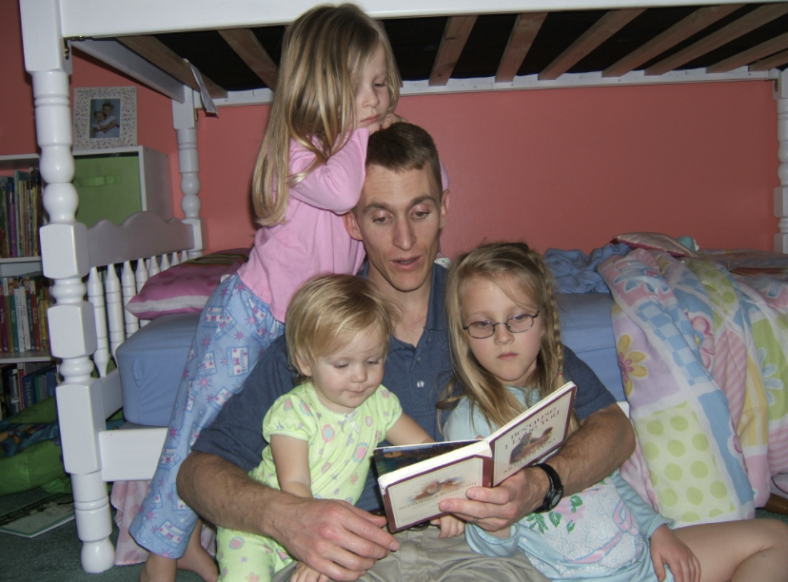
Courtesy of April Greenwood

Additional Videos:
Supernanny is a popular show where Jo Frost who has been working with children for over 30 years coaches parents on how to parent! Here are some examples of parenting styles and how Jo tackles each issue!
o Neglect/ Uninvolved
§ Teens call on Supernanny for help!
· https://www.youtube.com/watch?v=UssmVSSlk9Q
o Authoritarian
§ Observe how the dad in this video is so strict with his kids that it makes it difficult to have a close relationship with them:
https://www.youtube.com/watch?v=Hx1wnPBBQps
o This video shows a mother who tries to get involved with her children but ends up trying to control them. This leads to heavy backlash from the children. She struggles with showing emotion and praising her children.
§ https://www.youtube.com/watch?v=jkVMXEvMhaM
o Permissive
§ This parent let her child get away with everything because she feels bad about an accident.
· https://www.youtube.com/watch?v=NeqXeFjLSaY
o Helicopter (this is not an official parenting style, rather it is a common attitude where both authoritarian and permissive styles are combined.)
§ https://www.youtube.com/watch?v=cdPvW3M_cFE
§ https://www.youtube.com/watch?v=W-H9Nymrak8

Media examples:
Parenting Styles | Characteristics & Effects on Children. (2022). Goose Minds. YouTube. https://www.youtube.com/watch?v=ij1VxfZR6r8

HIGHLY RECOMMEND THE PARENTING STYLES QUIZ BELOW FOR COMIC RELIEF
Parenting Styles Quiz. (2013). 444.FLE. YouTube. https://www.youtube.com/watch?v=PbkzpgBlHUs

Sources:

Baumrind, D. (2010). Parenting Styles and Adolescent Development. In Handbook of Adolescent Psychology (pp. 11-34). John Wiley & Sons, Inc.
Hess, R. D., & Holloway, S. D. (1984). Family and school as educational institutions. In R. M. Lerner & T. T. Baltes (Eds.), Life-span development and behavior. Academic Press. https://www.scirp.org/(S(351jmbntvnsjt1aadkposzje))/reference/references papers. aspx?referenceid=770412
Parker, G., & Benson, M. J. (2004). Parent-adolescent relations and adolescent functioning: Self-esteem, substance abuse, and delinquency. Adolescence, 39(155), 519-530.

Sarwar, S. (2016). Relationship of Parenting Styles with Child's Psychosocial Development: A Review of Literature. International Journal of Academic Research in Psychology, 3(2), 14-28.
Truthful Mothering. (2022). Four Types of Parenting Styles and Their Effects on the Child. YouTube. https://www.youtube.com/watch?v=Sm3KrAgKST0
Read this online at https://books.byui.edu/science_of_learning/FVBcYPCH

