# Dietary Reference Intakes (DRI’s)

### 3.2 Dietary Reference Intakes (DRI’s)

The **Dietary Reference Intakes** (DRIs) are evidence-based standards developed by the Institute of Medicine to evaluate the nutrient intake of healthy individuals. Nutrient values from food labels or databases are only meaningful when compared to these standards. The DRIs include several categories: **Recommended Dietary Allowances** (RDA's), **Adequate Intakes** (AI's), **Tolerable Upper Intake Levels** (UL's), **Acceptable Macronutrient Distribution Ranges** (AMDR's), **Estimated Energy Requirements** (EER), and **Estimated Average Requirements** (EARs). This section will focus on RDA's, AI's, EAR's, and U'Ls (see Figure 5); AMDRs and EERs will be discussed later.

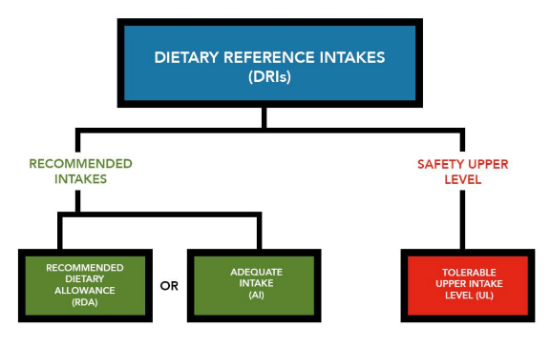

Figure 5: The dietary reference Intakes Includes recommended daily intakes (RDA’s) and adequate intake (AI’s) as well as intake levels that can be detrimental to health (tolerable upper intake level or UL’s)

#### Establishing the recommendations

To establish dietary recommendations for each essential nutrient, experts begin by reviewing current, peer-reviewed research. Researchers use standardized methods to determine nutrient needs, which may be based on factors such as nutrient intake compared to losses, blood levels of the nutrient, or more complex assessments, such as measuring the activity of an enzyme that depends on the nutrient.

In the case of calcium, for example, blood levels do not accurately reflect intake. Therefore, recommendations were based in part on the amount needed to optimize bone mineral density.

Nutrient requirements are typically established for specific age and gender groups. However, even within these similar groups, individual needs vary due to natural biological diversity. For instance, if vitamin A requirements were measured in a large group of women ages 19 to 30, the results would form a distribution (see Figure 6). The amount that meets the needs of 50 percent of the group is known as the **Estimated Average Requirement** (EAR)

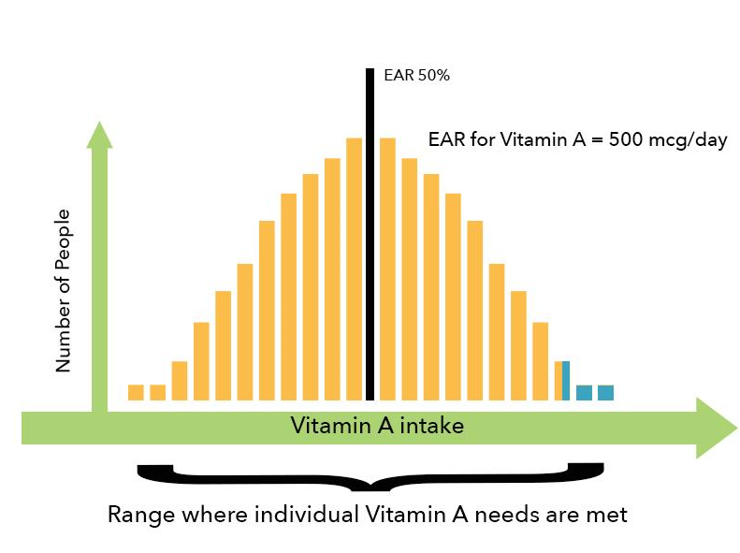

Figure 6: A hypothetical representation of Vitamin A needs of a group of women ages 19-30

If we think about it, using the Estimated Average Requirement (EAR) as a recommended intake for the general population would be a mistake. For example, the EAR for vitamin A in females aged 19 to 30 is 500 micrograms per day. If everyone aimed for that amount, half the population would still be getting too little of the nutrient.

To avoid this, the **Recommended Dietary Allowance** (RDA) is set higher. It is typically calculated as two standard deviations above the EAR, which is enough to meet the needs of 97 to 98 percent of the population. This more inclusive recommendation is what most people should aim for (see Figure 7).

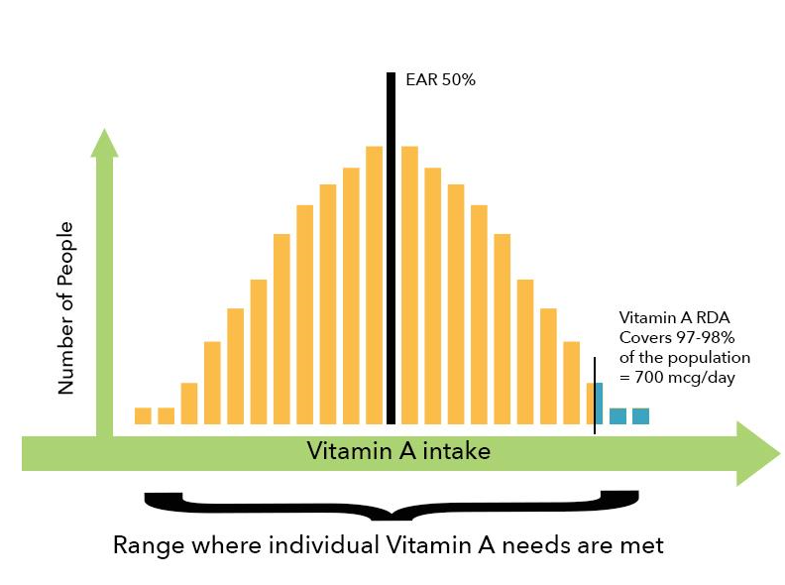

Figure 7: Setting RDA’s

The RDA for vitamin A for a female 19-30 years of age is 700 mcg/day, 200 mcg higher than the EAR. For some of the nutrients, insufficient consistent scientific data is available to set an EAR and associated RDA. In those cases, a recommended intake is still provided, but it is labeled as an **Adequate Intake** (AI), instead of an RDA. It represents an estimation of dietary need based off typical intakes of healthy people.

Establishing recommended intake levels is not the only concern that needs to be addressed when discussing nutrient intake levels; excessive consumption of many of the vitamins and minerals can be harmful. Some have only mild effects; others can be lethal if excessive amounts are consumed. If a nutrient has a known toxicity, a **Tolerable Upper Intake Level** (UL) is set. For example, vitamin A for women 19-30 has a UL of 3000 mcg/day (remember the RDA was 700 mcg/day for women 19-30). It is typically very difficult to exceed the UL by eating food; overdoses of vitamins and minerals most often occur through supplementation. The UL represents the highest level of a nutrient that is likely to pose no adverse health effects. If a nutrient does not have a UL set, it is not necessarily safe to consume in large amounts. Such practices are how we discovered that some nutrients that did not have a UL needed one. Figure 8 correctly displays the appropriate view of most vitamin and minerals. Danger lurks on each end of the spectrum, too much or too little of a nutrient can be harmful. The idea that more of something good is always better, is not the case when considering vitamin and mineral intake.

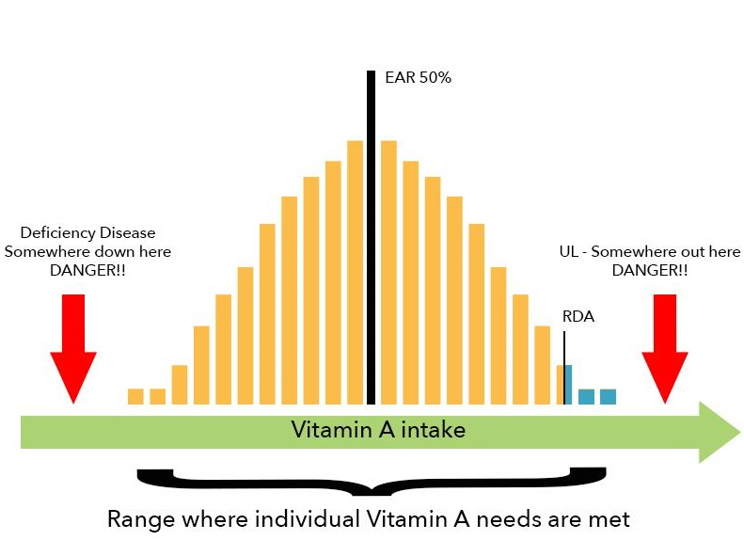

Figure 8: Setting the tolerable upper intake level (UL)

In summary, remember that the RDA’s do not reflect your personal need; to find out your personal need, you would need to be tested individually. The recommendations are set generously, so if your intake reaches the RDA (or AI) it is most likely your intake is just fine. The DRIs are also not appropriate for people who are ill or malnourished, even if they were healthy previously.

The United states and Canada share the same Dietary Reference Intakes. Some other countries have also established dietary intake guidelines that are unique to their country. Typically, you can expect to see categories similar to those observed in the US guidelines such as RDA’s, AI’s, UL’s and AMDR’s. RDA recommendations are typically given by age and gender. Table 4 shows a comparison of the recommended intakes for a few selected nutrients (RDA’s) from the USA, Japan, the Philippines and the United Kingdom.

|  |  |  |  |  |  |
| --- | --- | --- | --- | --- | --- |
|  | Vitamin (μg/day) | Vitamin C (mg/day) | Iron (mg/day) | Folate (xx/day) | Calcium (mg/d) |
| USA | 900 | 90 | 8 | 400 | 1000 |
| Japan | 850 | 100 | 7 | 240 | 800 |
| Philippines | 700 | 70 | 12 | 400 | 750 |
| United Kingdom | 700 | 40 | 8.7 | 200 | 700 |

Table 4: Adult Male Recommended Intakes from selected countries 6,7,8,9

Adult Female-Recommended Intakes

|  |  |  |  |  |  |
| --- | --- | --- | --- | --- | --- |
|  | Vitamin A (μg/day) | Vitamin C (mg/day) | Iron (mg/day) | Folate (μg/day) | Calcium (mg/d) |
| USA | 700 | 75 | 18 | 400 | **1000** |
| **Japan** | 650 | 100 | 6 Not menstruating 10.5 Menstruating | 200 | 650 |
| **Philippines** | 600 | 60 | 28 | 400 | 750 |
| **United Kingdom** | 600 | 40 | 14.8 | 200 | 700 |

Table 5: Adult female Recommended Intakes from selected countries 6,7,8,9

References (see below)

* 5. National Academy of Sciences. Institute of Medicine. Food and Nutrition Board. Dietary United States Department of Agriculture Reference Intakes for Vitamin D and Calcium https://www.nationalacademies.org/our-work/dietary-reference-intakes-for-vitamin-d-and-calcium Published 2011.
* 6. United States Department of Health and Human Services. National Institute of Health. Nutrient Recommendations: Dietary Reference Intakes. Acessed 5/26/2020 https://www.ncbi.nlm.nih.gov/books/NBK56068/table/summarytables.t2/?report=objectonly and https://www.ncbi.nlm.nih.gov/books/NBK545442/table/appJ_tab3/?report=objectonly
* 7. Ministry of Health, Labor and Welfare. Dietary Reference Intakes for the Japanses (2015). https://www.mhlw.go.jp/file/06-Seisakujouhou-10900000-Kenkoukyoku/Full_DRIs2015.pdf
* 8. Repbulic of the Philippines. Department of Science and Technology. Food and Nutrition Research Center. Philippine Dietary Reference Intakes (2015).https://www.fnri.dost.gov.ph/images/images/news/PDRI-2018.pdf
* 9. Public Health England (2016). GovernmentDietary Recommendations. https://assets.publishing.service.gov.uk/government/uploads/system/uploads/attachment_data/file/618167/government_dietary_recommendations.pdf

Read this online at <https://books.byui.edu/nutr_150_principles_/dietary_reference_in>