# Metabolism

### 4.5 Metabolism

The organ systems of the body require fuel and building blocks to perform the many functions of the body. Once our food is digested and absorbed, the blood transports the nutrients to the cells where they are used in processes of metabolism. **Metabolism** is defined as the sum of all chemical reactions required to support life. Some of these reactions help us break down and release energy from carbohydrates, fats, proteins, and alcohol. Others allow us to build and make new substances. A group of chemical reactions in the body that progresses as a sequence from start to finish is called a **metabolic pathway**.

All the pathways that take place in the body can either be categorized as **catabolism**, the process of breaking down materials, or **anabolism**, the process of building larger materials from smaller components. Catabolic processes release energy and anabolic processes consume energy.

#### Catabolism and Energy Production

Each of the macronutrients, glucose, fatty acids, and amino acids, can be catabolized or broken down to release energy. Although these macronutrients do contain low energy bonds, they are not very useful to the cell in this form. As a result, they must undergo **cellular respiration** which is a process that transforms the food macronutrient energy into cellular energy.16 This cellular energy is called **adenosinetriphosphate (ATP)** and it contains very high energy bonds which when broken down and released can be used to perform cellular work such as active transport, muscle contractions, growth, and repair of tissues. All organisms from bacteria to humans use ATP as their main energy source.16

In cellular respiration, glucose, fatty acids, and proteins are converted into carbon dioxide, water, and ATP when oxygen is present (see Figure 10). First the macronutrients are broken down to form acetyl-CoA, a two-carbon molecule. Next, each acetyl-CoA enters the **citric acid cycle**, a multi-step circular pathway which produces ATP, carbon dioxide (CO2), and high energy electrons (e-). These electrons are carried by molecules into the inner membrane of the mitochondria in preparation for the next stage, the **electron transport chain**. In this metabolic pathway, energy is released in the form of ATP as electrons are sequentially transferred between multiple proteins. At the same time, oxygen combines with electrons and hydrogen to form water. 

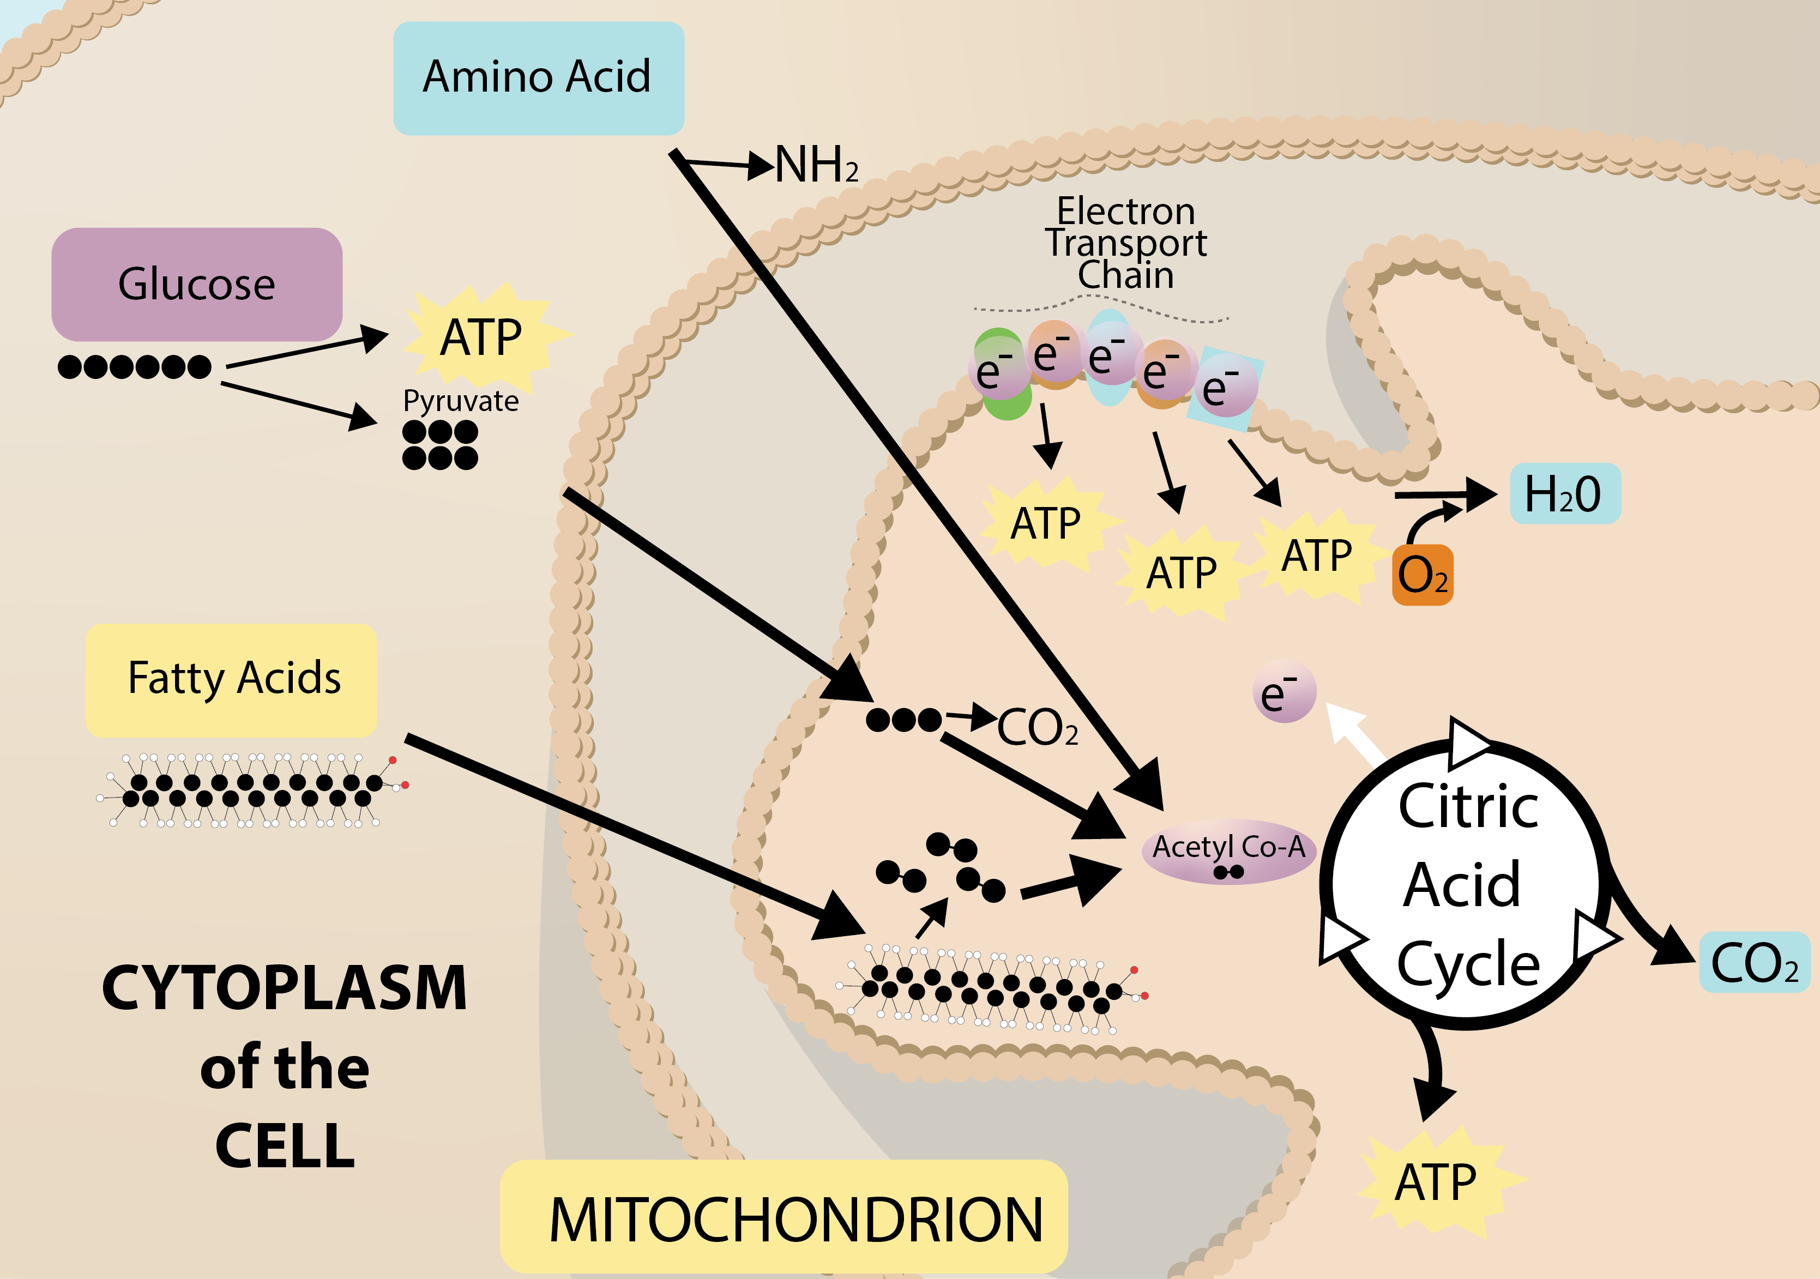

#### Anabolism and Building

The energy released by catabolic pathways powers anabolic pathways in the building of macromolecules, cells, and tissues. Anabolic pathways are required to build new tissue, such as muscle, after prolonged exercise or the remodeling of bone tissue, a process involving both catabolic and anabolic pathways. Anabolic pathways also build energy-storage molecules, such as glycogen, the glucose-storage molecule. The glucose, fatty acids, and amino acids not being used for energy can be diverted and used as building blocks for these anabolic pathways.

References (see below)

* 16. ATP. The True Orgin website https://www.trueorigin.org/atp.php. Accessed July 2017.

Read this online at <https://books.byui.edu/nutr_150_principles_/metabolism>