# Digestion, Absorption and Metabolism of Carbohydrates

### 5.2 Digestion, Absorption and Metabolism of Carbohydrates

The only carbohydrates that can be absorbed are monosaccharides such as glucose, fructose, and galactose. The goal of carbohydrate digestion is to break down the polysaccharides and disaccharides to these three monosaccharides.

#### From the Mouth to the Stomach

The **mechanical** and **chemical** digestion of carbohydrates begins in the mouth. Chewing, also known as mastication, crumbles the carbohydrate foods into smaller and smaller pieces. The salivary glands in the oral cavity secrete saliva that coats the food particles. Saliva contains the enzyme, **salivary amylase**. This enzyme breaks the bonds between the glucose units in starch. The salivary amylase breaks down amylose and amylopectin into smaller chains of glucose, called dextrins, and the disaccharide maltose. Only about five percent of starches are broken down in the mouth. When carbohydrates reach the stomach, no further significant chemical breakdown occurs because the amylase enzyme does not function in the acidic conditions of the stomach. However, the mechanical breakdown is ongoing—the strong peristaltic contractions of the stomach mix the carbohydrates into a more uniform mixture called chyme.

#### From the Stomach to the Small Intestine

The **chyme** (mixture of food and digestive juices) is gradually expelled into the upper part of the small intestine through the pyloric sphincter. Upon entry of the chyme into the duodenum, the pancreas releases pancreatic juice through a duct into the duodenum. This pancreatic juice contains the enzyme **pancreatic amylase** which resumes the breakdown of dextrins into shorter carbohydrate chains. Eventually, starch is broken down completely into maltose. Additionally, enzymes are secreted by the intestinal cells that line the villi (brush border) which continue the breakdown of the disaccharides lactose, maltose, and sucrose. The enzyme **sucrase** breaks sucrose into glucose and fructose molecules. Then the enzyme **Maltase** breaks the bond between the two glucose units of maltose. The enzyme **lactase** breaks the bond between galactose and glucose. Figure 4.10 shows the breakdown of lactose by lactase in the brush border of the small intestine. The process is similar for each of the disaccharides. Once carbohydrates are chemically broken down into single sugar units (glucose, fructose or galactose) they are then transported into the intestinal cells. Glucose and galactose are moved into the cell via active transport; fructose is moved in via facilitated diffusion.

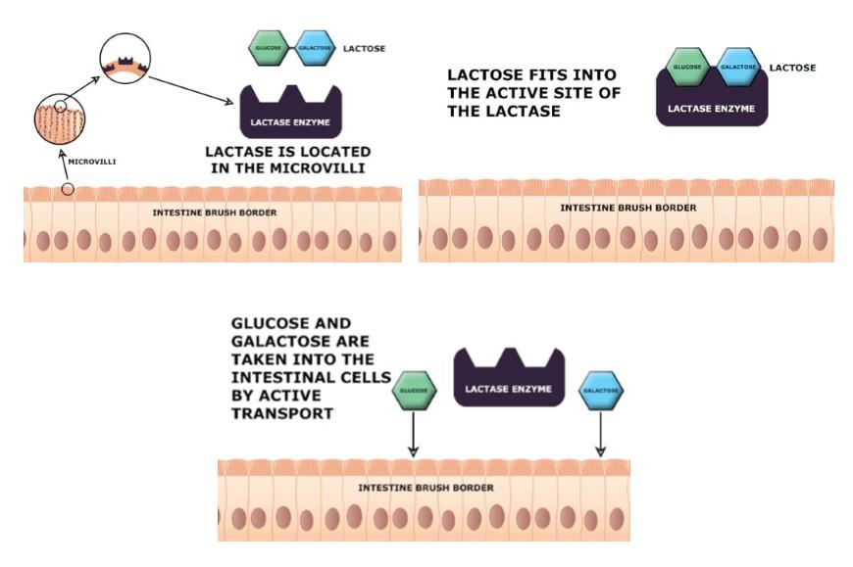

When people do not have enough of the enzyme lactase, lactose is not sufficiently broken down resulting in a condition called **lactose intolerance**. The undigested lactose moves to the large intestine where bacteria are able to digest it. The bacterial digestion of lactose produces gasses which can lead to the symptoms of diarrhea, bloating, and abdominal cramps. Lactose intolerance usually occurs in adults and is more common in certain nationalities. In the United States, it is more common for African Americans, Hispanics/Latinos, Native Americans and Asian Americans to have lactose intolerance than those of European descent.6 Most people with lactose intolerance can tolerate some amount of dairy products in their diet. Cheese is typically better tolerated because most of the lactose is removed when the milk is processed into the cheese. Yogurt is also better tolerated due to the bacterial action on the lactose in the yogurt. There are also products specially formulated for people that experience lactose intolerance. A commercially produced lactose-free milk has already had all the lactose broken down into glucose and galactose before it is sold in the store. The severity of the symptoms a person experiences depends on how much lactose is consumed and the degree of lactase deficiency.

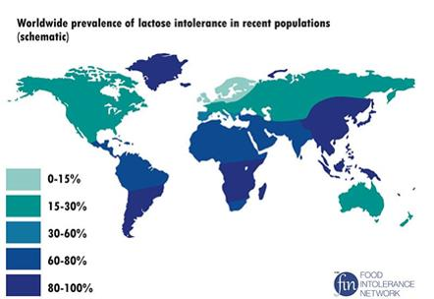

#### Absorption: Going into the Blood Stream

After the monosaccharides (glucose, fructose, and galactose) are absorbed, they move into the bloodstream and move directly to the liver via the portal vein where they are taken up by the liver cells. The liver cells can use small amounts of fructose for energy or convert it to glucose or fat. The fat can either be stored in the liver or transported out of the liver. Liver cells convert galactose to glucose. The liver closely regulates what happens to glucose. It can use some of the glucose to meet its energy needs; it can store the glucose as glycogen; it can convert the glucose to fat, or it can release the glucose into the blood- stream for use in other tissues. For example, glucose is a very important energy source for the central nervous system and to maintain energy levels in the muscle during rigorous activity. Glucose can be used as an energy source the cells in the body. Like the liver, the muscle can also store glucose as glycogen. Because blood glucose levels have to be maintained in a certain range, the liver tightly controls how much glucose is released into the bloodstream.

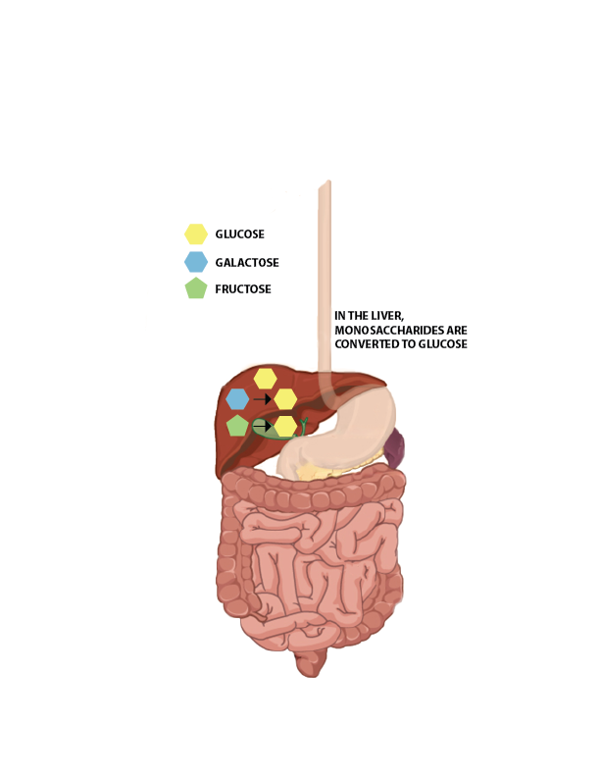

In the big picture, regardless of what carbohydrate goes into our mouth, the only carbohydrate that is made widely available to our body tissues is glucose. The liver is the primary control center that makes this happen. Interestingly, if the liver were to fail in its job, significant damage to the body would occur. Galactose and fructose cannot be metabolized well in other body tissues and can be harmful to them.

#### Leftover Carbohydrates: The Large Intestine

Almost all of the carbohydrates, except for dietary fiber, are efficiently digested and absorbed into the body in the small intestine. The undigested dietary fiber moves on to the large intestine. Within the large intestine, the bacteria break down some of the dietary fiber and use it for energy. In this role, the fiber is acting as a prebiotic as discussed in the digestion chapter. The products of bacterial digestion of fiber are short-chain fatty acids and some gasses (It sounds odd, but the bacteria metabolize the fiber and produce very small fats). The short-chain fatty acids can be used by the bacteria to make energy. They also can be absorbed by the cells of the large intestine. They can either be metabolized by the cells in the large intestine or released into the blood stream for use by other body cells. The yield of energy from dietary fiber is about 2 Calories per gram for humans but this is highly dependent upon the fiber type. These short-chain fatty acids are typically considered a benefit to the body.

#### Key Takeaways

* *Carbohydrate digestion begins in the mouth with salivary amylase and is completed in the small intestine, where various enzymes break down starches and disaccharides into monosaccharides.*
* *Only monosaccharides (glucose, fructose, and galactose) are small enough to be absorbed into the bloodstream.*
* *All absorbed monosaccharides are transported to the liver, which converts galactose and fructose into glucose, making glucose the primary source of carbohydrate energy for the body's cells.*
* *Lactose intolerance is a condition caused by deficiency of the enzyme lactase, leading to uncomfortable digestive symptoms when lactose is consumed.*
* *Undigested dietary fiber reaches the large intestine, where it is broken down by bacteria to produce short-chain fatty acids, which can provide a small amount of energy.*

References (see below)

* 6. Lactose Intolerance. National Institute of Diabetes and Digestive and Kidney Disease website Published June 2014. Retrieved July 2016.

Read this online at <https://books.byui.edu/nutr_150_principles_/digestion_absorption>