# Functions of Carbohydrates

### 5.4 Functions of Carbohydrates

There are five primary functions of carbohydrates in the human body. They are, energy production, energy storage, building macromolecules, sparing protein, and assisting in lipid metabolism.

#### Energy Production

The chief role of carbohydrates is to supply energy to all body cells. Most cells can use glucose and fat as effective energy sources. But some cells are highly dependent on glucose alone. For example, red blood cells and brain cells depend greatly on glucose. Muscle cells use both carbohydrate and fat effectively, but when activity is very intense glucose use become a priority. About 70 percent of the glucose entering the body from digestion is redistributed (by the liver) back into the blood for use by other tissues. Cells that require energy allow the movement of glucose from the blood into the cell through a transport protein in their membranes. The energy from glucose comes from the chemical bonds between the carbon atoms. Sunlight energy was required to produce these high-energy bonds in the process of plant photosynthesis. Cells in our bodies break these high energy bonds found in glucose releasing energy for our use. This process is called cellular respiration.

A cell uses many chemical reactions in multiple enzymatic steps to allow for a slow and efficient release of energy held within the chemical bonds in glucose. This is necessary because the cells cannot use carbohydrate, protein or fat directly for energy; they must have Adenosine Triphosphate (ATP). The following analogy can be used to demonstrate this principle. An employer has 10 workers. Each is paid $10 per day. At the end of the day, the employer goes to the bank to get $100 to pay his workers. If the bank gives the employer a $100 bill, will the boss be able to pay his workers? No. Even though the $100 bill is the correct amount of money to pay the workers, the worth of the money cannot be shared with the workers when it is in the form of just one bill. Converting the $100 bill into smaller units of $10 bills, enables the boss to distribute the value of $100 among the workers. Likewise, food contains lots of valuable energy, but it is useless to the various cells of the body until it can be converted into smaller, usable units called ATP (see Figure 15)

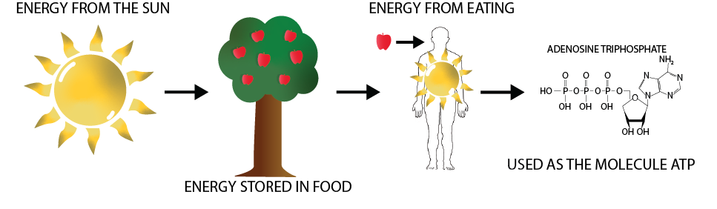

The first stage in the breakdown of glucose is called glycolysis. Glycolysis, or the splitting of glucose, occurs in an intricate series of ten enzymatic-reaction steps in the cytoplasm of cells. At the end of glycolysis, glucose (6 carbons) has been split into two molecules of pyruvate (3 carbons each). A little bit of energy (in the form of ATP) is extracted from the conversion of glucose to pyruvate, but the vast majority of the energy is still locked up in the pyruvate or other byproducts. The rest of the energy will be extracted from the pyruvate inside the mitochondria. This is why the mitochondria are called the power center of cells (see Figure 16).

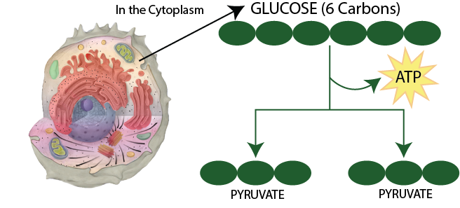

For the next phase of energy extraction to happen, sufficient oxygen must be available in the mitochondria. If oxygen is in short supply, the pyruvate will be stuck in the cytoplasm of the cell and be converted to lactate. The most common example of this occurs in high intense activity (like a 100-meter sprint). In this situation, our need for energy has exceeded our body’s ability to take in oxygen and deliver it to the muscle and lactate levels increase in the body. This is called anaerobic glycolysis and can only continue for a short period. When a critical level of lactate is reached, metabolism slows down to allow the oxygen supply to catch up.

The second stage of glucose breakdown occurs in the mitochondria. The pyruvate molecules move out of the cytoplasm into the mitochondria. There they are converted to a compound called acetyl-CoA. Acetyl-CoA enters another pathway called the Krebs cycle (or the citric acid cycle or TCA cycle –they are all the same thing). There, the remaining energy is extracted from what was once glucose and is prepared for conversion to ATP. The electron transport chain is the final piece of the process. Most of the ATP production occurs within the electron transport chain (see Figure 16).

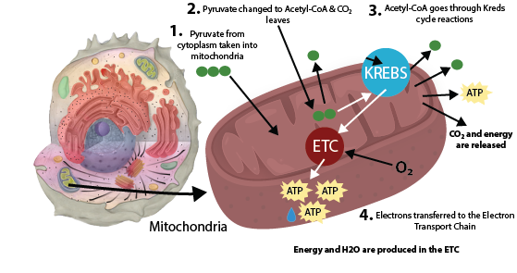

#### Energy Storage

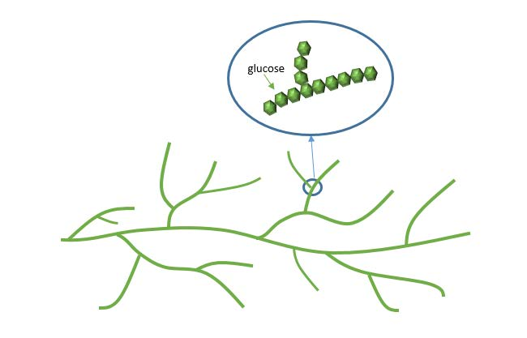

If the body already has enough energy to support its functions, the excess glucose can be stored as glycogen (the majority of which is stored in the muscle and liver). A molecule of glycogen may contain more than fifty thousand single glucose units and is highly branched, allowing for the rapid release of glucose when it is needed to make cellular energy. (Figure 18 shows the branch structure of glycogen.) In between meals or during exercise are times when the body relies on glycogen stores to provide glucose for energy. During rigorous exercise, glycogen stores can be used up within 1-2 hours. This is the point during physical exertion that athletes refer to as hitting the wall or bonking. The body still has plenty of fat to provide energy, but ATP cannot be made nearly as fast from fat as it can be from carbohydrate. During exercise, this can be a problem if an athlete is trying to keep up a high level of exercise intensity.

#### Building Macromolecules

Although most absorbed glucose is used to make energy, some glucose is converted to ribose and deoxyribose, which are essential building blocks of important macromolecules, such as RNA, DNA, and ATP. If all of the energy, glycogen-storing capacity and building needs of the body are met, excess glucose can be used to make fat. This is why a diet too high in carbohydrates and calories can add on the fat pounds—a topic that will be discussed later.

#### Sparing Protein

In a situation where there is not enough glucose to meet the body’s needs, glucose is made from some amino acids through a process called **gluconeogenesis**. Because there is no way for the body to store large pools of free amino acids, this process requires the catabolism (break down) of muscle tissues to provide amino acids for glucose production. Consuming enough carbohydrate to provide for the body’s glucose needs allows the body to spare the body’s protein for its primary functions, like building muscle. Under normal circumstances, gluconeogenesis can produce glucose at a sufficient speed to maintain normal blood glucose levels, such as during an overnight fast. In situations where glucose is in high demand, such as during prolonged rigorous exercise, gluconeogenesis will not produce glucose quickly enough to meet the body’s needs. During rigorous exercise, eating food sources of glucose becomes essential to sustain performance as well as spare protein.

#### Ketosis

Ketosis is a metabolic condition resulting from an elevation of ketone bodies in the blood. Ketone bodies are an alternative energy source that cells, including brain cells, can use when glucose supply is insufficient, such as during fasting or when eating a low carbohydrate diet. Ketone bodies are made from lipid. Ketone bodies are acidic and high elevations in the blood can cause the body to become too acidic. Highly elevated ketone levels is rare in healthy adults but can occur with alcohol abuse, severe calorie restriction and in individuals who have Type 1 diabetes.

The minimum amount of carbohydrate in the diet required to inhibit ketosis in healthy adults is approximately 50 grams per day.

Carbohydrates are critical to support life’s most basic function—the production of energy. Without energy, none of the other life processes are performed. Although our bodies can synthesize glucose, it comes at the cost of protein break down. As with all nutrients, carbohydrates are to be consumed in moderation as having too much or too little in the diet may lead to health problems.

References (see below)

Read this online at <https://books.byui.edu/nutr_150_principles_/functions_of_carbohy>