Amino Acids and Proteins

6.2 Amino Acids and Proteins

Amino Acids
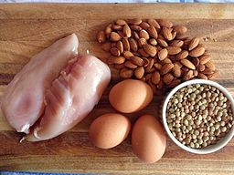
Amino acids
are the building blocks of protein. This can be illustrated using a beaded necklace analogy. The beaded necklace represents a protein, and the individual beads represent amino acids. Accordingly, to understand protein, a person first has to understand amino acids.

Amino acids are composed of the elements carbon, hydrogen, oxygen, and nitrogen. Each amino acid consists of a central carbon atom connected to a side chain, a hydrogen, a nitrogen-containing amino
group, and a carboxylic acid group—hence the name “amino acid.” All amino acids contain these four basic features. The arrangement of the amine group, the acid group and the hydrogen around the carbon center is the same for all amino acids (see Figure 6.1). Only the side chain (R) differs between amino acids. There are 20 different amino acids commonly used in building proteins. With deductive reasoning the conclusion can then be drawn that there are 20 different R groups, which is correct!

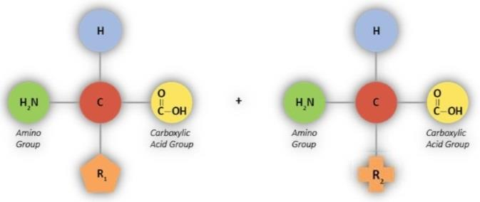

Types of Amino Acids
There are 20 different amino acids that are used to make proteins. If you consider the length of most proteins (hundreds of amino acids long) and the number of possible combinations that can be created with 20 different amino acids, it is apparent why every protein produced in the body can have a unique structure. Of these 20 amino acids, only 9 are considered essential (required to be consumed in the diet.) The other 11 amino acids can be produced by the body from other substances and are therefore considered non-essential. The essential and non-essential amino acids are listed in Figure 6.2.
Essential Amino Acids | Non-Essential Amino Acids
Histidine | Alanine
Isoleucine | Arginine
Leucine | Asparagine
Lysine | Aspartic Acid
Methionine | Cysteine
Phenylalanine | Glutamic Acid
Threonine | Glutamine
Tryptophan | Glycine
Valine | Proline
 | Serine
 | Tyrosine

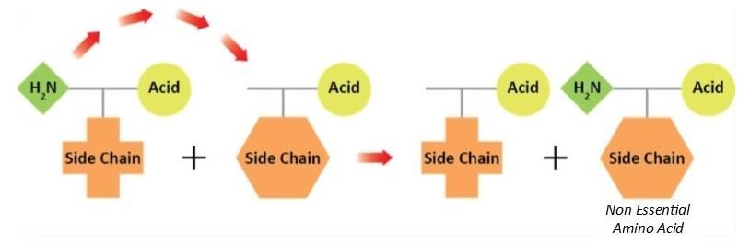
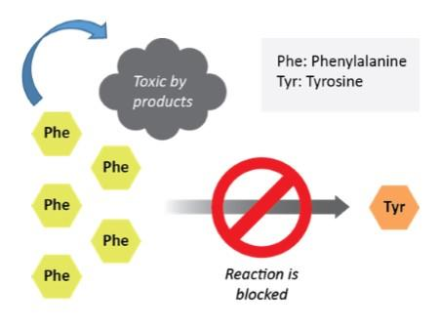
Under special circumstances, some non-essential amino acids can become essential amino acids. These unique amino acids are referred to as conditionally essential amino acids. A classic example of this is the genetic disease phenylketonuria (PKU). This genetic disorder is caused by an error in the DNA. This error prevents the production of an enzyme needed to convert phenylalanine (an essential amino acid) to tyrosine (a non-essential amino acid). Tyrosine is a non-essential amino acid because it can be made from phenylalanine. When people have this genetic error, they cannot break down the amino acid phenylalanine or produce tyrosine (see Figure 6.4). Tyrosine now becomes an essential amino acid since the body cannot make it from phenylalanine due to the missing enzyme.
Even though phenylalanine is an essential amino acid, individuals with PKU end up with too much phenylalanine. The excess phenylalanine is converted to secondary products (toxic byproducts) that are harmful to the body. Untreated PKU will lead to seizures and poor intellectual development. Treatment for PKU includes a specialized diet that restricts phenylalanine along with the consumption of a special formula that includes essential amino acids.4

Peptide Bonds
Proteins are constructed by linking amino acids together in a chain, similar to the beads on a necklace. The beads (amino acids) are held together by bonds. The bonds between amino acids are called peptide bonds. Peptide bonds are formed between the acid and the amine group with the removal of water (see Figure 6.5). Two amino acids form a dipeptide, three amino acids form a tripeptide, and several amino acids bonded together form a polypeptide.
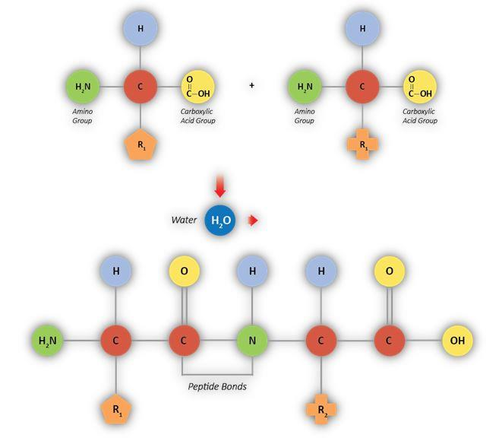

Protein Folding
Once a protein is formed the protein will fold into a functional shape. After a protein is made, chemical and structural forces will ensure that it will fold into the same shape every time. The proteins shape is essential for it to function properly.
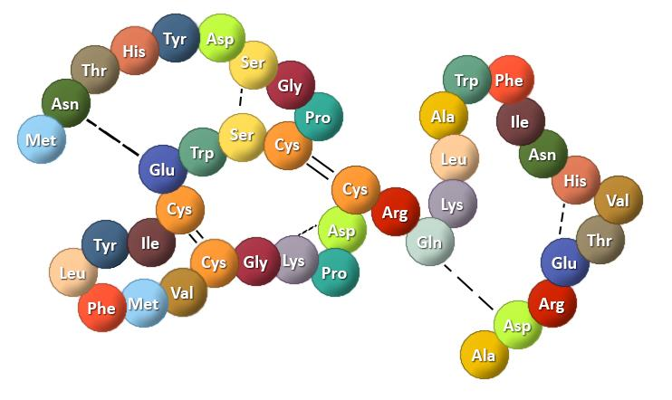
When a protein unfolds it can no longer function properly. The unfolding process is referred to as denaturation. Forces that can cause a protein to denature include: heat, change in acid-base balance, alcohol, and physical force. For example, when the digestive enzyme amylase enters the stomach it is denatured by the stomach acid and will no longer break down starch. If important body proteins become denatured, harm can occur to the body. Examples are illness that may cause a high grade fever or a change in body pH.
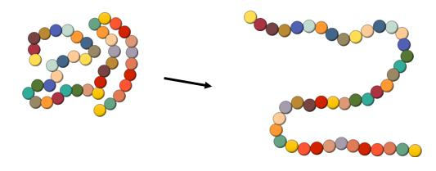
Typically, we don’t want our body proteins to denature because they will not be able to function correctly. But when protein is eaten in food, protein denaturation by the acid in our stomach is necessary for proper digestion and absorption of the food protein.
Protein denaturation can also occur when cooking proteins before consumption. Whether we recognize it or not most of us have seen this process in action. When a raw egg is cracked into a hot pan, the egg white is initially clear, but quickly starts to turn opaque. With exposure to heat, the proteins in the egg white unfold and the denatured proteins link together. Light can no longer penetrate the egg white, and it is no longer transparent. The denaturation of proteins during cooking has no impact on the nutritional value of the protein and can create pleasing textural qualities. Protein denaturation can be positive or negative depending on the circumstances.
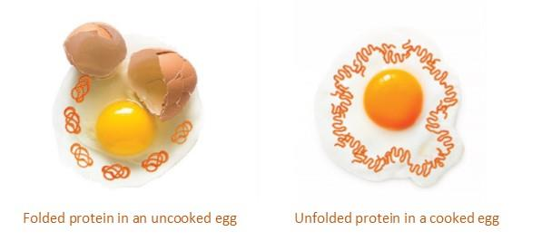
Figure 6.8: Denaturation in the cooking process of an egg

Key Takeaways
- Amino acids are the building blocks of protein, and their unique side chain (R group) distinguishes the 20 different types.
- Of these 20 amino acids, 9 are considered essential (must be consumed in the diet), while the other 11 are non-essential (the body can produce them).
- Amino acids are linked together by peptide bonds to form a chain, which then folds into a specific, functional three-dimensional shape.
- Denaturation is the process where a protein loses its shape and function due to forces like heat, alcohol, or changes in pH.
- Protein denaturation is necessary for the digestion of food but can be harmful if it affects essential body proteins.
Reference (see below)
- 4. Williams RA, Mamotte C, Burnett JR. Phenylketonuria: An inborn error of phenylalanine metabolism. Clin Biochem Rev. 2008; 29: 31-41.
Read this online at https://books.byui.edu/nutr_150_principles_/amino_acids_and_prot

