# Protein Digestion and Absorption

### 6.3 Protein Digestion and Absorption

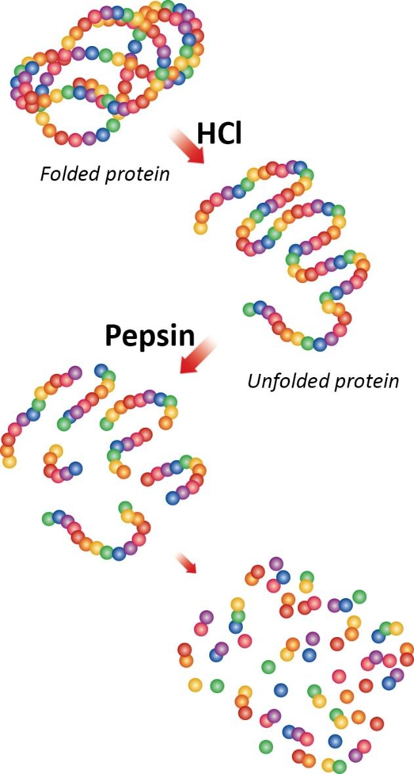

In order to be absorbed, proteins need to be broken down. The body can absorb single amino acids, dipeptides, or tripeptides. Typically, nothing larger than a tripeptide is safely absorbed. In the mouth, large protein pieces can be mechanically separated through chewing, but the chemical digestion (breaking of peptide bonds) of protein begins in the stomach. The stomach releases gastric juices containing hydrochloric acid and the enzyme pepsin, which initiate the breakdown of the protein. The acidity of the stomach facilitates the unfolding of the proteins (denaturation). Pepsin, which is secreted by the cells that line the stomach, dismantles the protein chains into smaller and smaller fragments by breaking the peptide bonds (see Figure 9).

Although the chemical digestion of protein begins in the stomach, the majority of the digestion occurs in the small intestine. The pancreas secretes digestive juices that contain the enzymes trypsin and chymotrypsin that continues the chemical digestion of protein in the small intestine. The cells that line the small intestine (brush border cells) release other enzymes that finalize the process by breaking the small protein fragments into the individual amino acids, dipeptides, and tripeptides. The muscle contractions of the small intestine mix and propel the digested proteins to the absorption sites. In the lower parts of the small intestine, the amino acids are transported from the intestinal lumen into the intestinal cells to the blood. Once the amino acids are in the blood, they are transported to the liver. As with other macronutrients, the distribution of amino acids to other body locations is regulated by the liver.

Reference (see below)

Read this online at <https://books.byui.edu/nutr_150_principles_/protein_digestion_an>