# Protein Undernutrition

### 6.7 Protein Undernutrition

Protein undernutrition is a consequence of inadequate consumption of dietary protein. Understanding the functions of protein leads to an understanding of the characteristics of chronic protein deficiency. Low protein diets negatively impact immunity, growth, development, fluid balance and many other body processes. Two manifestations of severe protein deficiency are kwashiorkor and marasmus. Both are conditions of insufficient protein and calorie intake, with each having distinct characteristics.7

#### Kwashiorkor

Kwashiorkor comes from a language of Ghana. It means “disease of deposed child.” Deposed child refers to a child who is no longer being breastfed because of the birth of a new baby.7 In place of breast milk, the child is fed a watery, low protein, but adequate calorie porridge made from grain. Kwashiorkor is caused by a deficiency in dietary protein. It is characterized by swelling (edema) of the feet and abdomen, poor skin health, growth retardation, low muscle mass, and liver malfunction. In kwashiorkor, the child does not appear dramatically thin because enough calories are consumed to prevent muscle wasting.

#### Marasmus

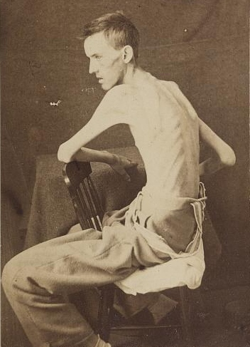

Marasmus comes from a Greek word meaning “withering” or “to waste away.” Marasmus is a severe deficiency of both protein and calories over an extended period of time. Starvation is another name for marasmus.

Marasmus is characterized by an extremely thin or “wasted” appearance because both muscle and fat stores have been depleted to meet the basic needs of the body. Other symptoms include poor skin health, growth retardation, fatigue, hunger and diarrhea. Marasmus is most likely to occur in areas of the world where food is chronically scarce due to entrenched poverty, famine or civil unrest. It can occur in people of any age. However, the statistics for children are grim. A 2020 World Health Organization reported that world-wide, 47 million children under the age of 5 are “wasted” and 14.3 million are “severely wasted.” 8 Children under the age of one may be so severely wasted that their body weight may be as much as 60 percent less than that of a normal child of the same age.9

Marasmus is seen to a much lesser degree in affluent areas of the world. It is usually associated with severe illness (cancer or end stage dementia) and anorexia nervosa.

References (see below)

* 7. Stanton J. Listening to the Ga: Cicely Williams' Discovery of Kwashiorkor on the Gold Coast. Clio Med. 2001; 71: 149–171.
* 8. World Health Organization. “Malnutrition.” April 2020. https://www.who.int/news-room/fact-sheets/detail/malnutrition
* 9. Titi-Lartey, O.A., Gupta, V. Marasmum. Treasure Island, Florida. StatPearls LLC, 2020 Accessed at https://www.ncbi.nlm.nih.gov/books/NBK559224/

Read this online at <https://books.byui.edu/nutr_150_principles_/protein_undernutriti>