# Types of Fatty Acids

### 7.3 Types of Fatty Acids

#### Chain Length

Fatty acids can come in different lengths of carbon chains: short-chain (4-7 carbons), medium chain (8-12 carbons) and long-chain (more than 12 carbons).1 The length of the carbon chain of the fatty acids affects its melting point. The shorter the chain length the lower the melting point.

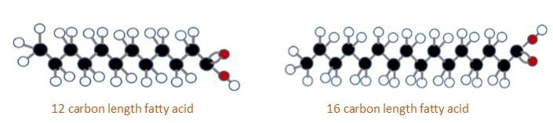

#### Saturation

Fatty acids can vary in length but also in the number of double bonds. Fatty acid chains are held together by carbon atoms that attach to each other and to hydrogen atoms. The term saturation refers to whether or not a fatty acid chain is filled (or “saturated”) to capacity with hydrogen atoms. If each available carbon bond holds a hydrogen atom, we call this a **saturated fatty acid chain**. All carbon atoms in a saturated fatty acid chain are bonded with single bonds.

Sometimes the chain has a place where hydrogen atoms are missing. This is referred to as the point of unsaturation. When one or more bonds between carbon atoms are a double bond (C=C), that type of fatty acid is called an **unsaturated fatty acid**, as it has one or more points of unsaturation. Any fatty acid that has only one carbon to carbon double bond is a **monounsaturated fatty acid**, examples of oils high in monounsaturated fatty acids include olive, canola and avocado. A **polyunsaturated fatty acid** is a fatty acid with two or more carbons to carbon double bonds or two or more points of unsaturation. Soybean oil contains high amounts of polyunsaturated fatty acids.

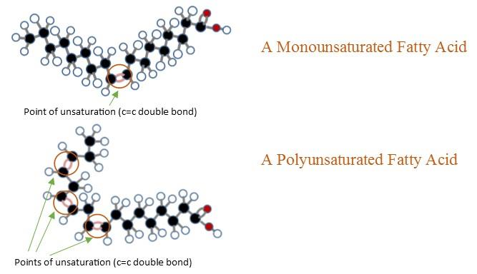

Foods that have a high amount of saturated fat include whole milk, cheese, and many meat products. Fats from these foods will typically be solid at room temperature when separated out of the food. Butter is a good example of this principle in action. When milk fat is separated out of the milk and turned into butter, it remains solid at room temperature. The exception to this rule is the tropical oils (coconut and palm). They have a high percentage of saturated fatty acids but are considered oils. The short length of their fatty acid chains (they contain many fats only 8- 12 carbons long and are called medium chain fatty acids) cause them to melt at a lower temperature.

Foods rich in unsaturated fatty acids include olives, avocadoes, fish, nuts and seeds. When the oil is extracted from these foods it is liquid at room temperature. Knowing the connection between chain length, degree of saturation, and the state of the fatty acid (solid or liquid) can be helpful in making food choices. Generally having a diet rich in unsaturated fatty acids is better for a person’s cardiovascular health than a diet rich in saturated fatty acids. 1 If the fat is visible, it can be a useful tool to judge what type of fat you are eating. If the fat in a food is not visible (for example in mixed foods like soups, cookies or ice cream), it is called a hidden fat. To know what kind of fat is in the food, refer to the recipe, ingredient list or nutrition facts label.

#### Cis and Trans Fatty Acids

The introduction of a carbon double bond in a carbon chain, as in an unsaturated fatty acid, can result in different structures for the same fatty acid composition. When the hydrogen atoms are bonded to the same side of the carbon chain, it is called a **cis fatty acid**. Because the hydrogen atoms are on the same side, the carbon chain has a bent structure. Naturally occurring unsaturated fatty acids usually have a cis configuration (Figure 13). When the hydrogen atoms are attached on opposite sides of the carbon chain, a **trans fatty acid** is formed (Figure 14). These fatty acids are usually linear shaped.

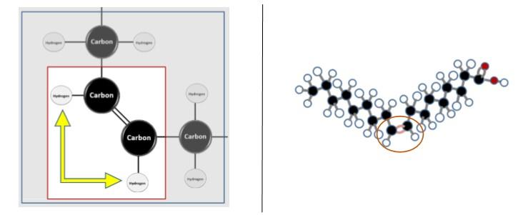

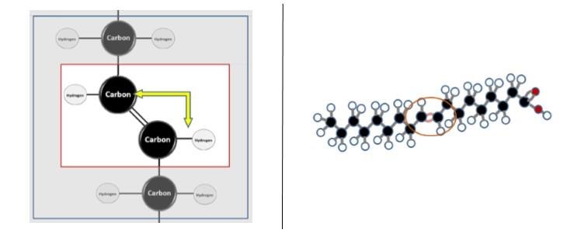

Unlike cis fatty acids, most trans fatty acids are not found naturally in foods but are a result of a manufacturing process called partial hydrogenation. Hydrogenation is the process of adding hydrogen to an unsaturated fatty acid. Double bonds between carbons are broken to receive the hydrogen. This is how vegetable oils are converted into semi-solid fats like margarine. During partial hydrogenation, some of the unsaturated fatty acids become saturated and some of the unsaturated fatty acids’ bonds shift from cis bonds to trans bonds (Figure 15).

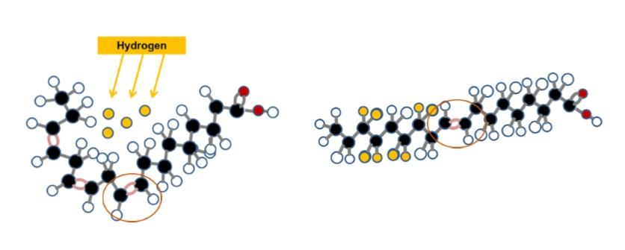

When the partial hydrogenation process was first introduced, it appeared to be a good way to produce shelf-stable, low-cost margarines as a substitute for butter. Over time, research showed a high intake of the artificial trans fats created from partial hydrogenation was associated with increased risk for cardiovascular disease. 2 There are naturally occurring trans fats in some foods, but these trans fats do not appear to be harmful.

In the United States, to improve overall health related to fats allowed in foods and the impact on heart health, the FDA has helped initiate changes in regulations regarding artificial trans fats. In 2015, the FDA determined that partially hydrogenated oils are no longer considered "Generally Recognized as Safe" or GRAS as a food additive. As a follow up action towards improved health, January 1, 2020 was the date set for all manufacturers to remove any partially hydrogenated oils from their products. In place of partial hydrogenated fats, some producers include fully hydrogenated fats or various forms of saturated fats such as coconut and palm oil (see Figure 16). The **fully hydrogenated** process results in converting all of the unsaturated fatty acids to saturated fatty acids (see Figure 17). These options eliminate the trans fats from partial hydrogenation from food.

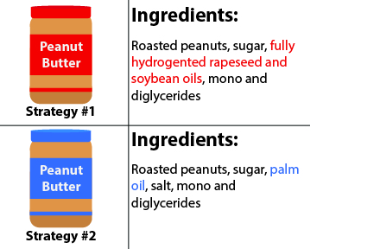

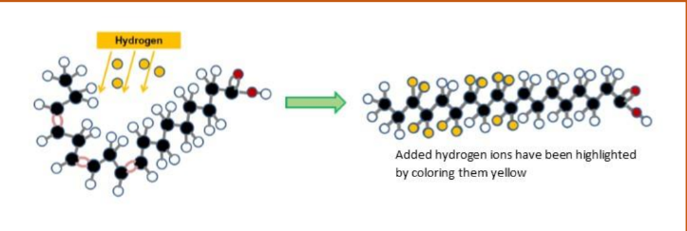

Figure 17: The process of full hydrogenation (100%) removes all the double bonds in the fat,  
removing the possibility for the formation of trans fats, but leaving the fat completely saturated.

#### Essential Fatty Acids

Fatty acids are vital for the normal operation of all body systems. The fatty acids the body can make are called **non-essential fatty acids**. The fatty acids the body cannot make are called **essential fatty acids** and must be obtained from food. The two essential fatty acids are **alpha linolenic acid (ALA)** and **linoleic acid**. They are both 18 carbons long. The essential fatty acids are part of two larger families of fatty acids called the omega-3 and omega-6 fatty acids.

The omega 3 fatty acids have their first double bond three carbons from the omega end of the fatty acid (see Figure 18). The omega 6 fatty acids have their first double bond 6 carbons from the omega end.

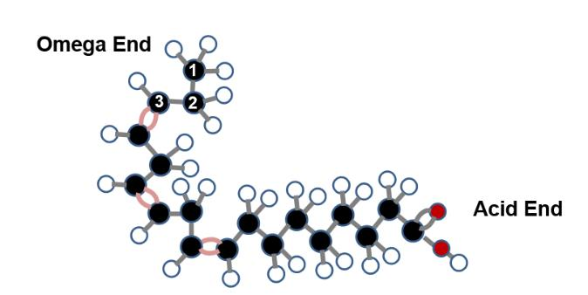

The key fatty acids in the omega-3 family include alpha-linolenic acid (ALA), eicosapentaenoic acid (EPA), and docosahexaenoic acid (DHA). Although our body cannot make alpha-linolenic acid (ALA), it can make the small amounts of eicosapentaenoic acid (EPA) and docosahexaenoic acid (DHA) from alpha-linoleic acid (ALA). Consequently, EPA and DHA are not considered essential. The key fatty acids in the omega-6 family are linoleic acid (LA) and arachidonic acids (AA). Similar to EPA and DHA, our body can make arachidonic acid (AA) from linoleic acid and is not considered essential (see Figure 19).

All the fatty acids in the omega-3 and omega-6 families have biologically significant functions and are important dietary components. Some of these fatty acids are precursors to important compounds called **eicosanoids**. Eicosanoids are powerful hormones that are involved in the regulation of many important body functions including clotting, inflammation, and blood pressure control.5

Alpha-linolenic acid and linoleic acid are found in several plant oils and food (Figure 20). Because these essential fatty acids are easily accessible in our food supply, an essential fatty acid deficiency is rare and would typically be associated with some type of fat malabsorption disease (like cystic fibrosis). Although both omega-3 and omega 6-fats are important to include in our diets, the intake of omega-3 fatty acids have generally been low. It is recommended to include more food sources of omega-3 fatty acids.

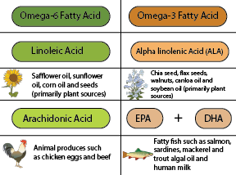

Read this online at <https://books.byui.edu/nutr_150_principles_/types_of_fatty_acids>