# Digestion and Absorption of Lipids

### 7.4 Digestion and Absorption of Lipids

Lipids are large molecules and generally are not water-soluble. Like carbohydrates and protein, lipids are broken into small components for absorption. Since most of our digestive enzymes are water-soluble, for digestion to occur and fat to be absorbed, the body has a distinct system for dealing with dietary fat.

#### From the Mouth to the Stomach

The first step in the digestion of triglycerides and phospholipids begins in the mouth as lipids encounter saliva. The physical action of chewing mixes the food with saliva. The salivary glands produce the enzyme lingual lipase which initiates the process of digestion. Gastric lipase continues the digestive process when the food reaches the stomach. Collectively the effects of these enzymes on fat digestion are small. The majority of fat digestion occurs in the small intestine.

#### Small Intestine

As stomach contents enter the small intestine, the fats in our food must mix with the water-based digestive fluids through a process called emulsification. Phospholipids present in foods can help with this process, but bile is the primary emulsifier. Bile contains bile salts and phospholipids, which have both hydrophilic (water-attracting) and hydrophobic (water-repelling) regions. These properties allow bile to act like a detergent, breaking large fat droplets into smaller ones so they can be more easily digested and absorbed. Bile is stored in the gallbladder until it is needed in the small intestine (see Figure 21).

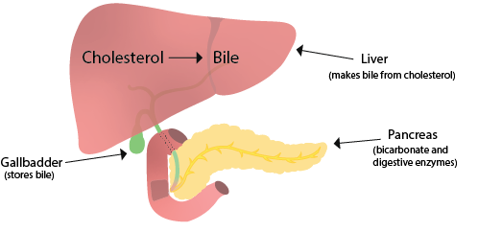

The emulsification of dietary fat by the bile increases the surface area of lipids over a thousand-fold, making them more accessible to the digestive enzymes. The small droplets of fat surrounded by bile are called **micelles**(Figure 22).

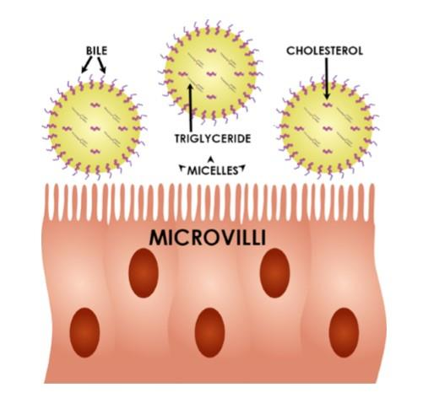

Once the stomach contents have been emulsified by the bile in the small intestine, pancreatic lipase severs fatty acids from the glycerol backbone of triglycerides and diglycerides. The pancreatic lipase ultimately breaks down the triglycerides into free fatty acids and monoglycerides. This in an example of chemical digestion.

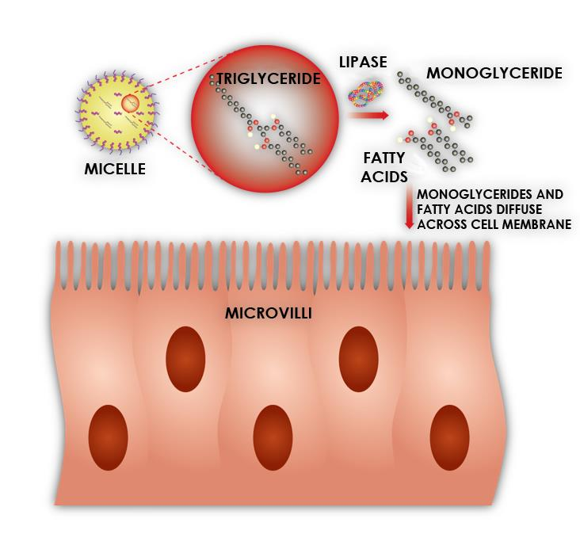

In the form of free fatty acids and monoglycerides, the dietary fat is now able to be absorbed. The micelles can move to the lining of the small intestine, and the fat components are released and distributed into the cells of the digestive tract lining. Phospholipids follow a similar digestive path as the triglycerides but only require that one of the fatty acids be removed. Cholesterol does not require any chemical digestion to be absorbed.

#### Transport of Fats in the Blood Stream

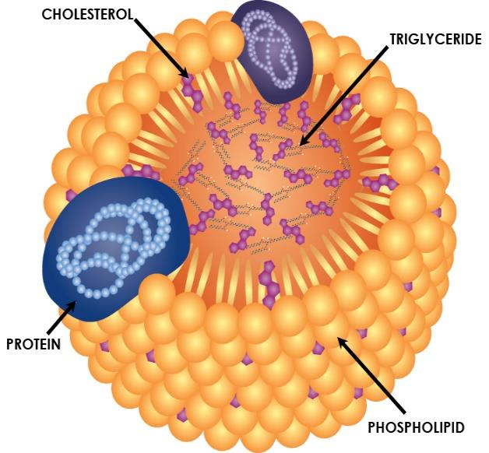

Inside the intestinal cells, the digested monoglycerides and fatty acids are reassembled into triglycerides and phospholipids and packaged into a lipoprotein called a chylomicron. The chylomicron leaves the intestine, enters the lymphatic system, and eventually enters the bloodstream at the thoracic duct, which drains into the left subclavian vein near the neck. Chylomicrons transport dietary fats efficiently through the body’s water-based environment. As they circulate, they deliver triglycerides and cholesterol to body cells that need them, such as muscle and adipose tissue. Eventually, the remaining part of the chylomicron, known as the chylomicron remnant, is delivered to the liver.

The liver also produces lipoproteins, but these differ in size and composition from chylomicrons. The main lipoproteins originating from the liver are **very low-density lipoproteins (VLDL)** and **high-density lipoproteins (HDL)**. **Low-density lipoproteins (LDL)** are formed in the bloodstream from VLDL after it has delivered triglycerides to body cells. VLDL and LDL both transport triglycerides and cholesterol to tissues throughout the body. In contrast, HDL helps remove excess cholesterol from cells and transports it back to the liver for disposal or recycling.

Both roles are important and necessary for health. However, problems arise when lipoprotein levels become imbalanced. Elevated levels of LDL are strongly associated with an increased risk of heart attack and stroke, which is why LDL is often referred to as "bad cholesterol." It is important to note that all lipoproteins contain cholesterol, including HDL. Structurally, the cholesterol is the same in each type of lipoprotein. Therefore, it is more accurate to say that having high levels of LDL particles in the blood is harmful, rather than labeling the cholesterol itself as "bad."

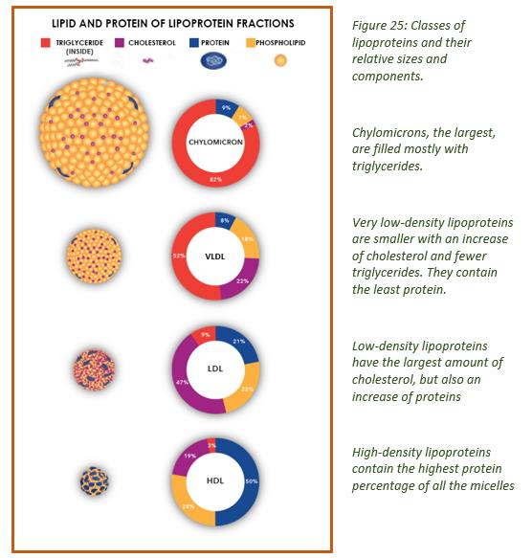

References (see below)

Read this online at <https://books.byui.edu/nutr_150_principles_/digestion_and_absorp>