# Dramatic Play and the Importance of Play

Merritt, A., Fairbanks, M., ,

Dramatic Play:

Core Content

Jean Piaget was a Swiss psychologist and developmental theorist who is known for his work on the cognitive development of children. One of the areas of child development that he studied was dramatic play, or the role that pretend play and role-playing play in the development of children. According to Piaget, dramatic play is an important part of a child's cognitive development because it allows them to represent their understanding of the world and practice new skills. Through dramatic play, children can experiment with different roles, try out new ideas, and express their thoughts and feelings.

Piaget believed that dramatic play helps children develop their symbolic thinking skills, which allow them to use one thing (such as a toy) to represent something else (such as a real object or a person). This type of play also helps children to develop their social skills, as they learn how to interact with others and take on different roles in a group.

Overall, Piaget's theory of dramatic play suggests that this type of play is an important part of a child's cognitive and social development and that it plays a crucial role in helping children understand and make sense of the world around them.

Rough and tumble play: does it have positive impacts? (IT does, insert citation here!)

The Importance of Play:

**Play** is a fundamental facet of human development that offers opportunities to explore, learn, and express themselves. Play, first and foremost, is a voluntary activity. It is meant to be pleasurable, and mostly child-led. It can take many forms, including physical, social, and creative activities, and can be pursued alone or with others. Play can serve a variety of purposes; promoting physical and mental development or relieving stress. Through play, children can acquire a variety of skills that are essential for their growth and development. **Physical play**is tasks such as running, jumping, or climbing. **Cognitive play** includes activities like puzzles, board games, and building blocks. **Social play**includes role-playing and any activity involving another person.

In the classroom, play can be used as a tool to enhance learning, as it allows students to apply their knowledge in a fun and engaging way. Play-based learning is an effective method to assist in the absorption and retention of new information. Making learning an interactive and entertaining experience can inspire children to engage with the learning process, causing complex concepts to be more accessible. This type of learning can be applied to all school subjects.

Core Content

Core Content

Play can also be beneficial for adults. Engaging in play can lead to an improvement in mood, a decrease in stress levels, and an enhancement of creativity and **productivity**. Play can also serve as a **therapeutic tool** for adults facing mental health challenges, such as anxiety and depression. Moreover, play can be used to foster and strengthen **social connections**, playful activities, whether it be in the form of sports, games, hobbies, or other leisure activities, can provide adults with a sense of pleasure, relaxation, and satisfaction that can contribute to their overall well-being.

Play is important for a variety of reasons. It allows children to develop physical, social, emotional, and cognitive skills. Physically, play helps children develop **fine motor skills** and **gross motor skills**, coordination, and balance. Socially, play allows children to learn how to interact with others, share, and negotiate. Emotionally, play allows children to express themselves and work through their feelings. Cognitively, play helps children learn problem-solving, creativity, and critical thinking skills. Play is a low-stakes environment for children to try for different outcomes in scenarios, which helps adaptation skills. It allows them a safe place where they are in charge--not their parents. Additionally, play is a way for children to explore and make sense of their world, and it can also be a source of joy and pleasure. Overall, play is an essential part of a child's development and well-being.

In conclusion, play is a vital aspect of human development and well-being. It offers each individual the opportunity to explore, learn, and express themselves, and it can improve mood, reduce stress, and increase creativity and productivity as well. Encouraging play at all ages is crucial for physical, cognitive, and emotional development and overall well-being, and can be used as a tool to enhance learning.

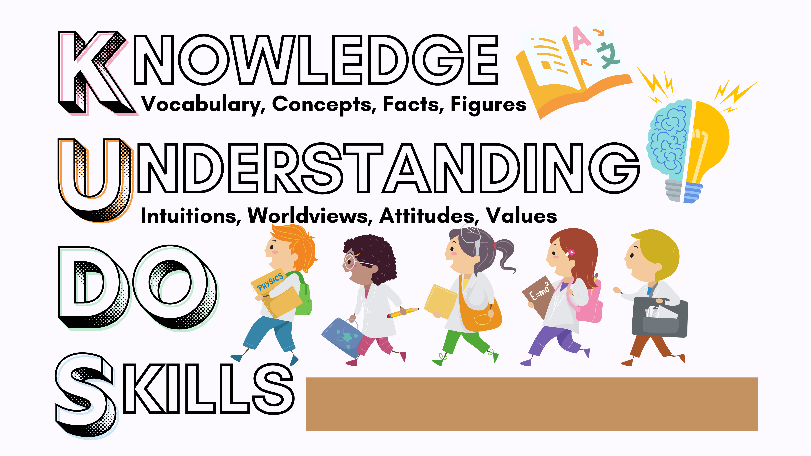

### Vocabulary

**Play:** A fundamental aspect of human development that allows children to explore, learn, and express themselves.

**Physical play:** Activities that help children develop gross motor skills and coordination.

**Cognitive play:** Activities that help children develop problem-solving skills and creativity.

**Social play:** Activities that help children develop communication skills and the ability to understand and navigate social interactions.

**Play-based learning:** A method of learning that makes education interactive and entertaining, and improves absorption and retention of new information.

**Productivity:** The rate at which goods or services are produced by a standard workforce or machine.

**Therapeutic tool:** A technique or method used in therapy to help children cope with mental health issues.

**Social connections:** The relationships and interactions with other people.

**Child-led activities:** More reliant on group work, fewer lectures. These activities allow students to ask and answer questions that guide the work.

**Teacher-led activities:** More lecturing, with students generally seated and listening or taking notes. The teacher is the one who guides the discussion and the work.

**Fine motor skills:** Coordination between the small muscles, like those in the hands, wrists, and fingers in coordination with the eyes.

**Gross motor skills:** The abilities required to control the muscles of the body for large movements such as crawling, walking, jumping, running, and more.

### Key Thinkers

Dr. Suma Metla: A pediatric physical therapist, suggests ways to use the playground to enhance a child's play skills. These activities, such as climbing slides, walking a pet, jumping down from a step, or creating an obstacle course, can be used to improve overall strength, creativity, memory, and endurance.

Jean Piaget: A Swiss psychologist who developed a theory of cognitive development that emphasized the role of play in children's learning and development. Piaget observed that children learn through active exploration and manipulation of their environment, and that play is an important way for children to make sense of the world around them.

Lev Vygotsky: A Russian psychologist who focused on the social and cultural aspects of play. According to Vygotsky, through engaging in rule-based play, children respond to external pressures to act in socially desirable ways.



### Misunderstandings

Play is often misconstrued as an unproductive or superficial activity only suitable for children. Play an essential part in human growth and well-being. Engaging in play has benefits for adults, such as enhancing mood, reducing stress levels, and augmenting creativity and productivity. Activities such as sports, games, hobbies, or other leisure pursuits, can provide adults with a sense of pleasure, relaxation, and satisfaction that can contribute to their overall well-being. Another prevalent misconception is that play is limited to physical activities alone. While physical play is undoubtedly important, it encompasses a wide range of activities, including cognitive, social, and creative. It is often believed that play is a privilege that can only be enjoyed by those who have ample time and resources at their disposal. However, play should be viewed as a basic human need that can be incorporated into daily life regardless of time and resources. Play can be simple and inexpensive; with others or alone. It is essential to recognize that play should be accessible to all, and not just a luxury but a crucial aspect of human development and well-being.

### Additional Media Sources

<https://www.ted.com/talks/shahneila_saeed_learning_through_play>

[https://www.google.com/search?q=peter+gray+importance+of+play&rlz=1C5CHFA_enUS897US904&source=lnms&tbm=vid&sa=X&ved=2ahUKEwjq1Y-u_M_9AhUxIjQIHT6GBowQ0pQJegQIBhAI&biw=1440&bih=763&dpr=2#fpstate=ive&vld=cid:f98defb3,vid:wJaAegok8L4](https://www.google.com/search?q=peter+gray+importance+of+play&amp;rlz=1C5CHFA_enUS897US904&amp;source=lnms&amp;tbm=vid&amp;sa=X&amp;ved=2ahUKEwjq1Y-u_M_9AhUxIjQIHT6GBowQ0pQJegQIBhAI&amp;biw=1440&amp;bih=763&amp;dpr=2#fpstate=ive&amp;vld=cid:f98defb3,vid:wJaAegok8L4)

For more information: <https://uark.pressbooks.pub/hbse1/chapter/cognitive-development-in-early-childhood_ch_14/>

References:

Blahey, L. (2021, August 4). The power of play: 6 benefits for child development. Edmonton Public Library. Retrieved January 21, 2023, from<https://www.epl.ca/blogs/post/importance-of-play-for-kids/>

Ginsburg, K. R. (2007, January 1). The importance of play in promoting healthy child development and maintaining strong parent-child bonds. American Academy of Pediatrics. Retrieved January 21, 2023, from<https://publications.aap.org/pediatrics/article/119/1/182/70699/The-Importance-of-Play-in-Promoting-Healthy-Child?autologincheck=redirected>

Metla, D. S. (2023, January 17). The importance of playground play. Honolulu Magazine. Retrieved January 28, 2023, from<https://www.honolulumagazine.com/the-importance-of-playground-play/>

Robinson, L., Smith, M., Segal, J., & Shubin, J. (2022, December 5). The benefits of play for adults. HelpGuide.org. Retrieved January 21, 2023, from<https://www.helpguide.org/articles/mental-health/benefits-of-play-for-adults.htm>

Saeed, S. (2018). Learning through play. Shahneila Saeed: Learning Through Play | TED Talk. Retrieved January 28, 2023, from<https://www.ted.com/talks/shahneila_saeed_learning_through_play>

TEDxTalks, B. G. (2016, June 8). Play is important! | Brody Gray | TEDxYouth@Columbus. YouTube. Retrieved January 28, 2023, from<https://www.youtube.com/watch?v=UqJ6f-cddbk>

ChatGPT3 and Consensus. app was used in the creation of this resource.

Read this online at <https://books.byui.edu/science_of_learning/dramatic_play>