# Introduction to Minerals

### 9.1 Introduction to Minerals



The book of Genesis teaches us that our physical bodies were formed from the dust of the earth.1 The details of the process God used to create the bodies of our first parents’ has not been revealed, but today's science can certainly verify that the elements found in the earth are consistent with elements that make up a human body. The periodic table is a collection of the known elements. Regular dietary intake of many of the elements is necessary to sustain life. Carbohydrate, protein, fat, water and vitamins are essential nutrients that are composed of combinations of different elements; mostly carbon, hydrogen, oxygen, nitrogen, and some sulfur (see highlighted elements in Figure 1). These elements are organized into essential organic (carbon-containing) compounds by plants and animals that humans then eat to sustain life. In addition, a number of other elements in the periodic table are also dietary essentials but perform their function as inorganic elements(do not contain carbon.) These are referred to as the essential minerals and must be consumed in the diet for health to be sustained.

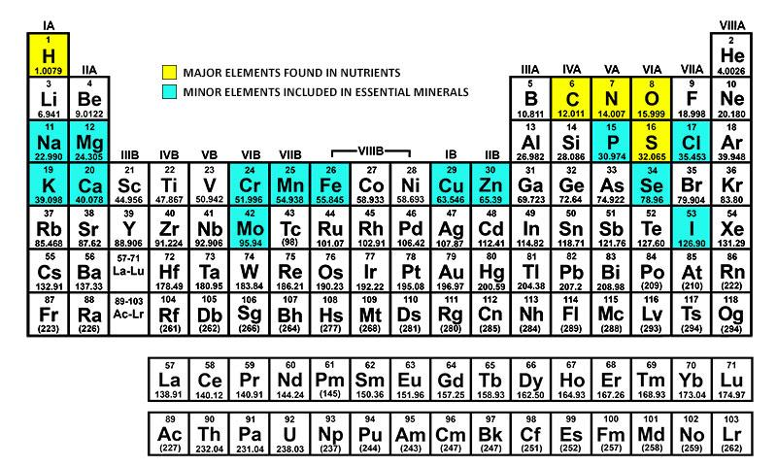

The essential minerals can then be further subdivided into two groups: the major minerals and trace minerals. Major minerals are needed by adults in quantities greater than 100 mg/day. Minerals needed in amounts of 100 mg/day or less are grouped into the trace and ultra-trace mineral categories. For the ease of discussion, the trace and ultra-trace minerals will be grouped into one category and referred to as trace minerals (see Figure 2).

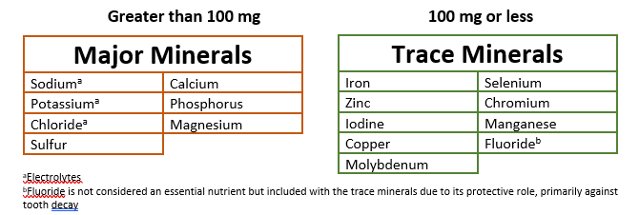

By studying the highlighted minerals on the periodic table, it is apparent that only a fraction of the elements has been established as essential. It is interesting to note that the discussion on the essentiality of a number of the remaining minerals is still open. For example, boron, vanadium, silicon, and arsenic are among those minerals that are not considered essential currently but are under discussion as possible essential nutrients. The inclusion of arsenic may be curious to some, due to its high toxicity even in very small quantities. But the fact that many of the minerals, if taken in excess, can be dangerous makes the consideration of arsenic in extremely low doses more understandable.

#### Functions of Minerals

Because of their physical properties, minerals are often recognized for their structural role. For example, minerals are a primary component of bones and teeth. Minerals also play a substantial regulatory role. For example, they are key cofactors in many enzymatic reactions affecting key events such as DNA transcription, metabolism and muscle contraction. A cofactor is a metallic substance that is necessary for an enzyme to function properly. The minerals sodium, potassium, and chlorine have a unique role in fluid balance and nerve conduction. Because of their close association with water, they were discussed in the fluid chapter.

#### Minerals in our food supply

Where we get our food, how the food is processed, and how we prepare our food can alter the mineral content, particularly in plant-based foods. For example, in many areas of the world iodine has been leached from the soil. Plants grown in these areas will be low in iodine. Plants grown in iodine-rich soils versus iodine-poor soils may have 100 times more iodine content.2 The mineral content of animal-based foods are often higher than plant-based foods because the animal eats the plants and concentrates the minerals from the plants to the desired level.

The processing of food can decrease or increase the mineral content of foods. For example, when grains such as wheat and rice are processed, often the bran and germ are removed, which contain a substantial amount of the important minerals found in these grains. In the United States, it is required by law that iron is added back in. Unfortunately, other minerals originally found in the grains such as magnesium, zinc, and copper are not required to be added back in (see Figure 3). In contrast, sodium levels are often increased. This is not a desired change for most people.

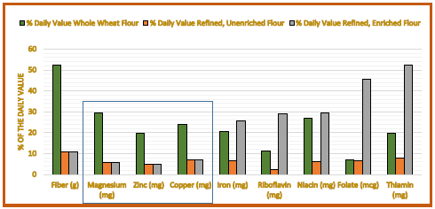

Minerals may be intentionally added to some foods for specific health benefits. For example, iodine is added to salt. While these carefully selected additions to our food have proven helpful, the random fortification of minerals and vitamins to processed food products has become so common that the wisdom of this continued pattern can be questionable.

Minerals can also sneak into our food supply unintentionally. For example, cooking with cast iron cookware can increase the iron content of the food, and iodine has found its way into our milk supply due to its use as a sterilization agent in the milking process. Neither of these additions are harmful, and in some cases there could be a health benefit. However, the unintentional addition of potentially harmful levels of minerals may be a concern.

#### Bioavailability

Food composition tables list the amount of the various minerals found in many foods. What is not clear from these tables is the actual ability of the body to absorb and use the minerals in a particular food. The term **bioavailability**is used to describe this principle. Generally, it is other substances that are in the food that affect the bioavailability of minerals. Minerals found in animal products generally have a higher bioavailability compared to minerals found in plant based foods. The presence of phytates, oxalates, and polyphenols such as tannins in plant-based foods all negatively affect the bioavailability of certain minerals. For example, oxalates (found in some leafy greens vegetables like spinach) negatively impact the absorption of calcium. Phytates (found in whole grains) negatively impact the absorption of zinc. Some might wonder if this is a justification to eat refined grains more often, but despite the decreased bioavailability of zinc in whole grains, the increased levels of zinc in the whole versus refined grains more than makes up for the difference in bioavailability.3

Minerals of similar charge can compete for absorption; for example, calcium and iron are both positively charged minerals and compete for absorption. Under normal dietary circumstances, the effect is small, but if large amounts of these minerals are taken as supplements the concern increases. In contrast, the effect of substances on the bioavailability of minerals is not always negative; the presence of vitamin C with certain forms of iron can increase the availability of iron. The nutritional need of an individual can also positively impact the bioavailability of some nutrients. For example, during pregnancy the bioavailability of several nutrients increases to meet the increased need of the mother and developing fetus.

**Mineral Bioavailability**

|  |  |
| --- | --- |
| Lower Bioavailability | Higher Bioavailability |
| Phytates | Generally animal foods |
| Oxalates | Stage in lifecycle (example pregnancy and calcium) |
| Polyphenols (Tannins) | Vitamin C and non-heme iron |
| Mineral Supplements with same charge | Vitamin D and Calcium |

Read this online at <https://books.byui.edu/nutr_150_principles_/introduction_to_mine>