# Additional Factors

### 11.3 Additional Factors

After considering the role that energy intake and energy expenditure play in weight management, it is important to consider other factors that may contribute to the development of obesity. 

#### Genes

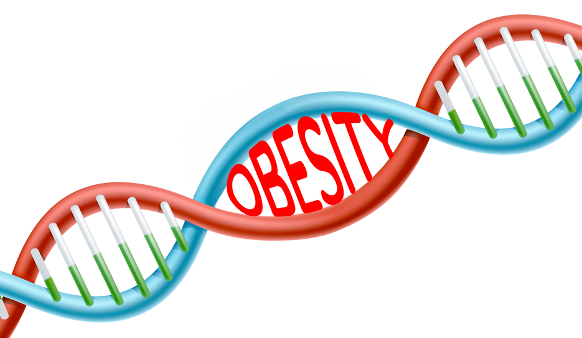

Genetics certainly play a role in the development of body fatness and weight. It is estimated that genes are responsible for 40-70% of variation in BMI of the population.29 Evidence of this fact can be seen in children who have been adopted. Typically, the BMI of an adopted child more closely resembles the BMI of their biological parents than their adoptive parents.29 Moreover, identical twins are twice as likely to be of similar weights as compared to fraternal twins.29 Specific genes have been identified that increase a person’s risk for obesity. Typically, these genes are associated with an increased intake of food. For example, errors in the production of the hormone leptin due to genetic variation increases hunger. 29 As our understanding of the relationship between genes and obesity has increased it has become apparent that obesity cannot be attributed to one or even a few genes, but is rather the interaction of hundreds of genes with the environment coupled with environmental factors. 29 Fortunately, even if a person has obesity related genes, obesity can be prevented if their environment is managed well. 

#### Hormones

Hormones are clearly linked to hunger and satiety which can affect weight status. The levels of certain hormones influence when a person desires food or feels satiated (feels full).

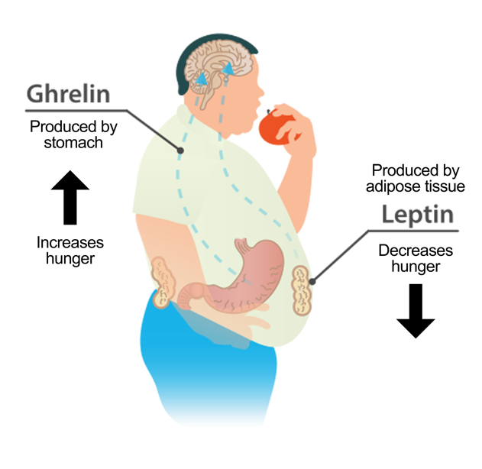

**Ghrelin** is often referred to as the hunger hormone. It is produced and secreted by the stomach. Ghrelin travels through the bloodstream to the brain and signals the hypothalamus to increases hunger signals. When a person hasn’t eaten, ghrelin levels will increase and stimulate hunger. After a person eats, levels of the ghrelin hormone will decrease. 30

**Leptin** is a hormone produced by the adipose tissue. Leptin travels through the bloodstream to the brain and signals the hypothalamus to decrease hunger signals. When the adipose stores are full, increased amounts of leptin are produced, which sends a message to the hypothalamus the body energy stores are full and to lower hunger signals. 30 With obesity, a person may develop leptin resistance. When this happens, an increase in leptin production does not cause a corresponding decrease in hunger.31

When ghrelin levels are abnormally high and/or leptin levels are abnormally low, a person can experience increased hunger and decreased satiety. Over the long term, these errors in signaling can contribute to increased caloric intake and weight gain.

References (see more)

* 29. Herrera BM, Lindgren CM. The genetics of obesity. Curr Diab Rep. 2010;10(6):498-505.
* 30. Klok MD, Jakobsdottir S, Drent ML. The role of leptin and ghrelin in regulation of food intake and body weight in humans: A review. Obes Rev. 2007;8(1):21-34.
* 31. Gruzdeva O, Borodkina D, Uchasova E, Dyleva Y, Barbarash O. Leptin resistance: underlying mechanisms and diagnosis. Diabetes Metab Syndr Obes. 2019; 12:191-198.

Read this online at <https://books.byui.edu/nutr_150_principles_/additional_factors>