# Chapter 4: Recreational Water Environments and Swimming Pools

### Vocabulary List

* **Recreational:** relating to an activity done for enjoyment when one is not working
* **Supervision:** the action of controlling someone or something
* **Scum:** a layer of dirt or foam on the surface of a liquid
* **Deficiencies:** a failing or shortcoming
* **Lifeguard:** an expert swimmer employed to rescue people who get into difficulty in a swimming pool or at the beach
* **Slip resistant:** the relative force that resists the tendency of the shoe or foot to slide along the walkway surface
* **Ingress:** the action or fact of going in or entering
* **Egress:** the action of going out of or leaving a place
* **Ventilated:** cause air to enter and circulate freely in (a room, building, etc.)
* **Occupancy:** the action or fact of residing in a place
* **Hygiene:** conditions or practices maintaining health and preventing disease, especially through cleanliness
* **Hierarchy:** a system or organization in which people or groups are ranked one above the other according to status or authority
* **Malnutrition:** lack of proper nutrition, caused by not having enough to eat, not eating enough of the right things, or being unable to use the food that one does eat
* **Lather:** a frothy white mass of bubbles produced by soap when mixed with water

#### Case Example 1

Three young men were out hiking alongside a river when one of them spotted a group of snails in the nearby marshes. They didn’t touch the snails and a short distance later they arrived at a beautiful lake with very clear water. Soon the young men were swimming in the lake. As they started back home, they started feeling a tingling itch of the skin. By the time they got home, they had red pimples on their skin. Scratching the skin just seemed to make it worse. They were diagnosed with Swimmer’s Itch, an allergic reaction to certain microscopic parasites carried by snails that can be found in contaminated water.

#### Case Example 2

Clara took her 5-year-old daughter, Inez, to a local swimming pool. While she was swimming, another kid pooped in the pool. Although the lifeguard did a good job of cleaning up the mess, he assumed that the chlorine in the water would kill any microbes left in the pool, so the other children were allowed to return to the pool. A few days later, Inez started to get watery diarrhea. The doctor diagnosed her as being exposed to cryptosporidium which is resistant to the normal level of chlorine in pools.

While swimming can be a fun experience, care should be taken to swim in clean water to avoid getting sick. Inspection of recreational water environments and swimming pools along with routine water quality testing can reduce the amount of illness and accidents that occur while swimming.

### Introduction

#### Recreational Facilities

Recreational water environments are any places where people can enter bodies of water, whether manmade or not, for the purpose of recreation. Examples of outdoor recreational water environments include the ocean, lakes, rivers, swimming pools, hot tubs, splash parks, wave pools, and waterslides. Indoor recreation water areas can also include swimming pools, wave pools, and waterslides.

There are many hazards associated with recreational water environments including: possible drowning, paralysis, slips, trips, and falls, as well as biological hazards such as bacteria, viruses, and parasites. Often the amount of supervision at these venues reduces hazardous situations. Ideally, there should be lifeguards on site and if not, experienced adults. In areas where a local health department operates, inspectors are called on to oversee routine inspections and water quality testing.

**What hazards are associated with recreational water environments?**

Possible drowning, paralysis, slips, trips, and falls, as well as biological hazards such as bacteria, viruses, and parasites.

Another hazard associated with recreational water is cyanobacteria, also called blue-green algae, which are microscopic organisms found naturally in all types of water. These single-celled organisms live in fresh, brackish (combined salt and freshwater), and marine water. These organisms use sunlight to make their own food. In warm, nutrient-rich (high in phosphorus and nitrogen) environments, cyanobacteria can multiply quickly, creating blooms that spread across the water’s surface. The blooms might become visible.

Cyanobacteria blooms may or may not be seen in the water. They sometimes stay below the water’s surface, they sometimes float to the surface. Some cyanobacteria blooms can look like foam, scum, or mats, particularly when the wind blows them toward a shoreline. The blooms can be blue, bright green, brown, or red. Blooms sometimes look like paint floating on the water’s surface. As cyanobacteria in a bloom die, the water may smell bad, similar to rotting plants.

### Swimming Pool Inspection Protocol

Swimming pool inspections follow a similar protocol as well as inspections.

#### Opening Conference

During the opening conference an inspector should explain why they are there and the scope of the inspection. Next, the inspector should ask to look at the facility’s paperwork. The paperwork could include an operating permit, employee training records, previous water testing results, pool rules, and occupancy rating. The inspector may also ask about water sources and treatment methods used by the pool.

#### Walkaround Inspection

The inspector should walk through the pool facility, not only looking at the pool but also at the changing areas, treatment areas, and spectator areas. During the inspection, the inspector may decide to collect water samples for testing. Often the inspector will ask the pool employees to collect the water samples to demonstrate how experienced they are.

#### Closing Conference

After completing the walkaround inspection, the inspector should meet with the supervisor to discuss what was observed and what can be done to fix any deficiencies that were identified.

#### Written Report

After an inspector finishes the inspection, they should use the notes from the inspection to write an inspection report. The report should include the following:

* An introduction
* Narrative
* Methodology (if any testing was conducted)
* A results table (if testing was conducted)
* A deficiencies and recommendation table that lists any unsafe areas, practices, or equipment and how to resolve their issues.

The final report should be sent to the supervisor of the swimming pool facility.

### Examples of swimming pool issues

Swimming pool regulations are jurisdiction dependent, which means every city, county, state or province may have its own regulations. Inspectors should learn and become familiar with the regulations in the area where they work. Below is a list of general swimming pool issues organized by specific categories.

**Posted Signs**

* Pool occupancy signs
* Lifeguard signs, either lifeguard on duty or no lifeguard on duty
* Pool rules
* No diving signs where appropriate

**Changing/Restroom Areas**

* Have hot running water, soap
* Appropriate number of toilets and showers for the rated occupancy of the pool
* Lockers should be located off the ground
* Floors should be well drained
* Separate dressing room must be provided for each sex
* Entrances and exits designed to break the line of sight
* Located facing the shallow end of the pool

**Pool Construction**

* Easy cleanable slip resistance surface
* White or light pastel color walls and floor
* Drains at bottom of pool should have protective grates
* Pool floors should not be too steep, recommended no greater than 1 to 10 slopes in pool areas below five feet (1.5 meters).
* Pools should have adequate ingress and egress such as stairs or ladders
* Decks should be large enough for people to pass and be sloped away from the pool
* Pool depths should be legibly marked above the water line
* Water line should be high enough to reach the edge of pool while not covering up the depth markings
* Pools designed with adequate flow and turnover

**Safety/life-saving devices**

* Easily accessible first aid kit and backboard
* Rescue devices should be present such as roped buoys, shepherds crook poles, or other similar devices
* The diving area should be divided off from the swimming area by a rope or barrier

**Diving Areas**

* No diving should be allowed in shallow parts of pools less than eight feet deep
* Diving boards should be on same side of the pool and not perpendicular to each other
* There should be enough space in between diving boards to prevent coming into contact with other divers
* High dive diving boards should have handrails for the climb and guard rails on top

**Chemical/Treatment area**

* Chemicals and materials stored in original and labeled containers
* Chemicals and materials are stored in well-ventilated areas
* Chemicals should be located so that swimmers or the public cannot access them
* There should be rapid sand filters or other filters made for pools to filter the water
* Only chlorine or bromine systems allowed to disinfect pool

**Spectators’ area**

* When a fence is not present, spectators or animals may not be allowed within ten feet (three meters)
* Food or drink is prohibited within ten feet (three meters)
* Beverages must be served in non-breakable containers. No glass!
* Trash containers must be provided in visitors' area

### Protocol for calculating pool occupancy restrictions

Pools should have a maximum occupancy rating posted. The pool should always maintain an occupant load below this limit. The rating is also used to assign the proper number of showers and toilets. Each jurisdiction can determine how they will set occupancy requirements. Below is a tool to calculate occupancy load in an area with no specific regulation.

#### Rules and Definitions

* “Non-Swimmers Area” is an area in the shallow end of a pool where it is not always necessary to swim. It is generally an area below five feet deep (1.5 meters). Pools are allowed one occupant for every ten square feet (three square meters).
* “Swimmers Area” is an area of the pool where most people will have to swim to move around. It is generally between the depths of five to eight feet (one to two meters). Pools are allowed one occupant for every 24 square feet (eight square meters).
* “Diving Area” is the area of the pool often called the deep end, where diving is allowed. The diving area should be of sufficient size for the divers and pools are allowed nine occupants for the entire diving area.
* “Showers” - There should be sufficient showers for all swimmers to wash before entering the pool. There should be one shower for every 50 occupants based on the pool's rating. There should be at least one shower for each sex and there can be shared showers in a commons area.
* “Toilets” - There should be sufficient toilet facilities for all the pool occupants and at least one shower for each sex. There should be at least one toilet for the first 25 occupants based on the pool occupancy rating and another toilet for every 50 that follow the initial 25.

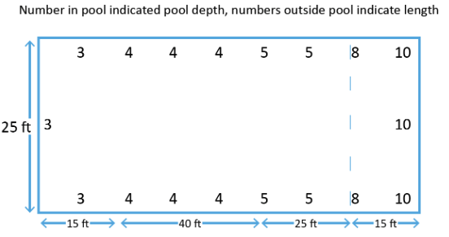

#### Calculations

Below is a picture depicting a swimming pool with its depths and widths marked. Use the information provided in the picture to calculate pool capacity and the required number of showers and toilets.

Step 1: Calculate the Non-Swimmers Area.

The length below four feet is 15 feet, the length between four feet and five feet is 40. The width of the pool is 25 feet

(15 + 40) * 25 = 1,375ft2

Step 2: Calculate the occupant load for the Non-Swimmers Area.

One occupant for every 10ft2

1,375/10 = 137.5 occupants

Rounds up to 138 occupants

Step 3: Calculate the Swimmers Area.

Length from five to eight feet is 25, the width of the pool is 25 feet

25*25 = 625ft2

Step 4:Calculate the occupant load for the Swimmers Area.

One occupant for every 24ft2

625/24 = 26.02 occupants

Rounds down to 26 occupants

Step 5: Calculate the occupancy for the Divers Area.

Diving areas are given nine occupants

Step 6: Calculate total pool occupancy rating.

Non-Swimmer Area 138, Swimmer area 26, Diving area nine

138 + 26 + 9 = 173

173 maximum occupancy rating

Step 7: Calculate how many showers are required.

173 occupancy one shower per 50 occupants

173/50 = 3.46

Rounds up to four showers per side or a combination of showers that includes at least one per side and the rest as common showers. One per side with three shared, two per side with two shared, or three per side with one shared.

Step 7: Calculate how many toilets are required.

173 occupancy rating, one for first 25 occupants, one for each additional 50 occupants

One for first 25, one for 25–75, one for 75–125, one for 125–175

Four toilets per side, a minimum total of eight toilets

#### Pool testing protocol

The main tests conducted on a pool are disinfectant levels and pH levels. The disinfectant can be either chlorine or bromine. Other tests that can be performed on pool water include temperature, hardness, alkalinity, and cyanuric acid, although cyanuric acid should only be used in outdoor pools to help maintain chlorine during the evaporation process. The disinfectant and pH are tested using a colorimetric method. Below is the protocol for that testing.

|  |  |
| --- | --- |
| Do’s | Don'ts |
| -Take lids offthesampling tubes  -Rinse sample tube in the water  -Submerge sample tube to at least elbow depth at least 6 inches (15 centimeters) from edge of pool  -Shake out excess water  -Fill so bottom of water reaches fill line  -Add the proper number of drops of reagents  -Hold reagent dropper vertically  -Seal the sample tube  -Shake the sample tube  -Compare the color in the tube to the color standards against a white background | -Collect near water inlet or return  -Collect after shock treatment  -Use a dirty or rusty sample container  -Use a glass sample container |

## WASH: Water, Sanitation, and Hygiene

#### Case Example

Eight-year-old Andrew had been sick for about a week. Finally, he was rid of his diarrhea and started to feel good. His family had an outhouse with no running water. Usually, they washed their hands by pouring water on their hands from a two-liter bottle stationed right outside the outhouse. Andrew went to the bathroom, but when he finished there was no water in the bottle, so he didn’t wash his hands. Later that afternoon, a neighboring family visited Andrew’s family. Andrew’s father brought out a five-gallon bucket full of water that had one cup floating on top of the water. During the afternoon several of the family members, neighbors, and Andrew took turns filling the cup with water, drinking the water, and replacing the cup in water. About three days later, Andrew’s entire family and several of the neighbors were sick with diarrhea.

Poor sanitation and hygiene can lead to contaminated water which in turn can make people sick. Pathogens are often passed through the fecal oral route if proper handwashing does not take place.

#### Introduction

WASH is an acronym that stands for Water, Sanitation, and Hygiene, which are some of the greatest public health concerns in developing parts of the world. The consequences of unsafe water, sanitation, and hygiene (WASH) on children can be deadly. Over 700 children under age five die every day of diarrheal diseases due to a lack of appropriate WASH services. Growing up in a clean and safe environment is every child’s right. Access to clean water, basic toilets, and good hygiene practices not only keeps children thriving but also gives them a healthier start in life (Unicef, e).

#### Water

Almost 785 million people worldwide do not have basic access to water and 2.2 billion still lack access to safe drinking water. Ensuring an adequate and safe water supply is essential for the survival and growth of children. When children don’t have access to clean water, it affects their health, nutrition, education, and learning abilities, thus impacting many aspects of their lives. Water must also be safe. It must come from a reliable source like a well, a tap, or a hand pump, free from fecal and chemical contamination. Millions of people rely on water sources that are at high or moderate risk of fecal contamination due to a lack of toilets or poor sewer systems. Even water that is safe at its source is at risk of becoming contaminated unless it is treated, transported, stored, and handled safely (Unicef, d).

In developing areas, community wells are often the main source of water. To prevent contamination, well sites should be kept clean, properly maintained, and protected from damage. Below is a hierarchy of procedures for maintaining safe wells.

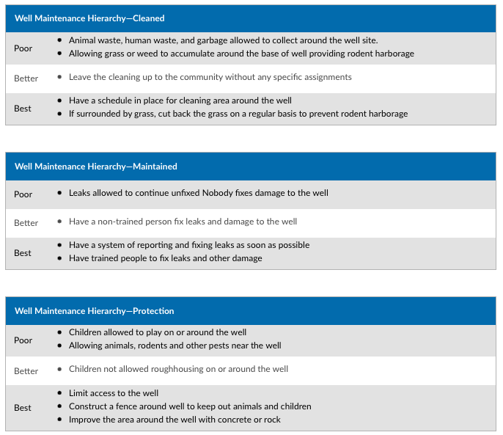

Once water has been retrieved, it should be maintained in a clean condition. The key points in maintaining safe water are the storage, dispensing, and drinking of the water. Below is a hierarchy of procedures for maintaining safe drinking water.

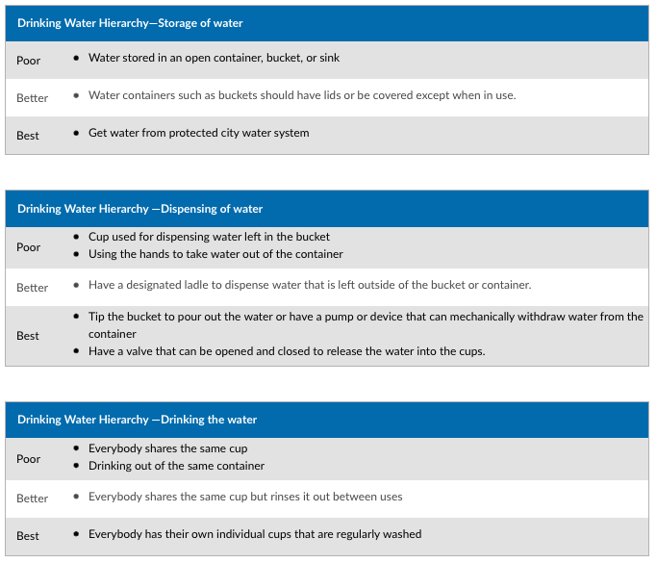

### Sanitation

More than half of the global population does not have access to safe sanitationservices; of those people, 673 million practice open defecation. Adequate sanitation is essential to childhood survival and development, improving children’s education, increasing productivity, and building resilience in the face of disease and disaster. Poor sanitation puts children at risk of diseases and malnutrition that can impact their overall development. While some parts of the world have improved access to sanitation, millions of children in poor and rural areas have been left behind. Without basic sanitation services, people have no choice but to use inadequate latrines or to practice open defecation. Even in communities with toilets, waste containment may not be adequate if they are difficult to clean or not designed or maintained to safely contain, transport, and treat excreta (Unicef, c).

There are many ways in a community or on a residential level to handle human waste. Below is a hierarchy of how to deal with human waste.

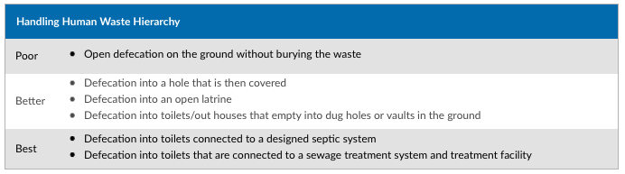

### Hygiene

Good hygiene is critical for preventing the spread of infectious diseases and allows children to stay healthy and miss fewer days of school.For families, good hygiene means avoiding illness and spending less on healthcare.Many children around the world live in conditions that make it difficult to maintain good hygiene. Where homes and schools have dirt floors, where water for handwashing is unavailable, and where families share spaces with domestic animals, maintaining hygiene can be a challenge (Unicef, b).

**Hand Washing**

Good hand hygiene is a cornerstone of safe and effective health care and a highly cost-effective way of maintaining public health. It protects against a range of diseases. However, about three billion people do not have a handwashing facility with adequate water and soap at home (Unicef, b). Additionally, almost half of schools lack a handwashing facility with water and soap, affecting some 818 million school-age children (Unicef, a). Handwashing, if done properly, is one of the best ways to protect people from getting sick. Below are five steps that describe how to wash your hands.

1. Wet your hands with clean, running water (warm or cold), turn off the tap, and apply soap.
2. Lather your hands by rubbing them together with soap. Lather the backs of your hands, between your fingers, and under your nails.
3. Scrub your hands for at least 20 seconds. Need a timer? Hum the “Happy Birthday” song from beginning to end twice.
4. Rinse your hands well under clean, running water.
5. Dry your hands using a clean towel or air dry them (CDC, 2022).

Two of the key points in handwashing are the water and the soap. Below is a hierarchy of procedures for handwashing.

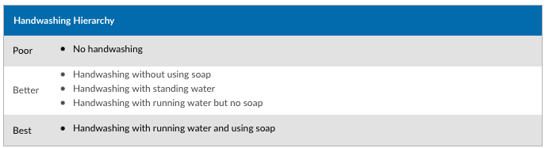

Not only is washing hands important, but it is also good to understand when to wash your hands. Hands should be washed before, during, and after preparing food, before and after eating food, before and after caring for someone at home who is sick with vomiting or diarrhea, before and after treating a cut or wound, after using the toilet, after changing diapers, after blowing your nose, coughing, or sneezing, after touching an animal, animal feed, or animal waste, and after touching garbage (CDC, 2022).

**When should you wash your hands?**

Hands should be washed before, during, and after preparing food, before and after eating food, before and after caring for someone at home who is sick with vomiting or diarrhea, before and after treating a cut or wound, after using the toilet, after changing diapers, after blowing your nose, coughing, or sneezing, after touching an animal, animal feed, or animal waste, and after touching garbage.

### 

### References

CDC. (2022). Keeping Hands Clean. Retrieved Feb 15, 2023, fromhttps://books.byui.edu/-GGLDq

Unicef. (a). Hand Washing. Retrieved Feb 15, 2023, fromhttps://books.byui.edu/-RaYA

Unicef. (b). Hygiene. Retrieved Feb 15, 2023, fromhttps://books.byui.edu/-oRp

Unicef. (c). Sanitation. Retrieved Feb 15, 2023, fromhttps://books.byui.edu/-yVE

Unicef. (d). Water Retrieved Feb 15, 2023, fromhttps://books.byui.edu/-EAHq

Unicef. (e). Water, Sanitation and Hygiene (WASH) Retrieved Feb 15, 2023, fromhttps://www.unicef.org/wash

CDC. Cyanobacteria (Blue-Green Algae) Blooms. Retrieved Mar 18 2023, from https://books.byui.edu/-xGqc

Read this online at <https://books.byui.edu/osh_450_readings/chapter_4_recreation>