# Chapter 1: Intro to Lifespan Development

## Why study lifespan development?

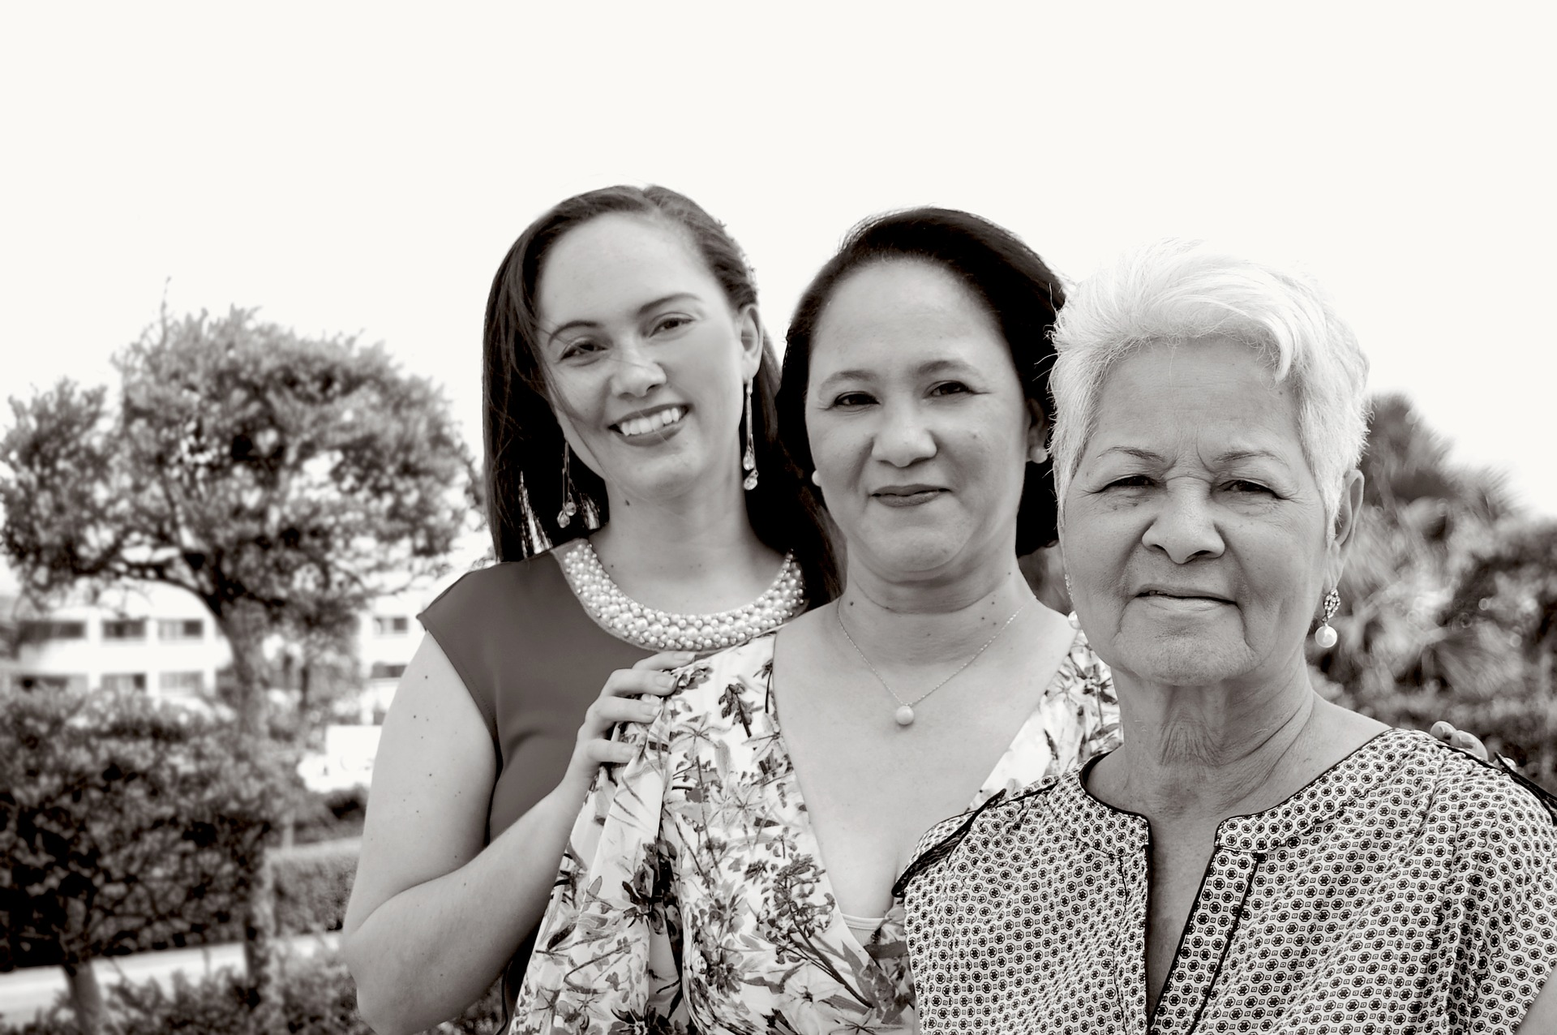

Welcome to the study of lifespan development! This is the scientific study of how and why people change or remain the same over time.

Think about how you were five, ten, or even fifteen years ago. In what ways have you changed? In what ways have you remained the same? You have probably changed physically; perhaps you’ve grown taller and become heavier. But you may have also experienced changes in the way you think and solve problems. Cognitive change is noticeable when we compare how 6-year olds, 16-year olds, and 46-year olds think and reason, for example. Their thoughts about themselves, others, and the world are probably quite different. Consider friendship—a 6-year-old may think that a friend is someone with whom they can play and have fun. A 16-year old may seek friends who can help them gain status or popularity. And the 46-year old may have acquaintances, but rely more on family members to do things with and confide in. You may have also experienced psychosocial change. This refers to emotions and psychological issues as well as social roles and relationships. Psychologist Erik Erikson suggests that we struggle with issues of trust, independence, and intimacy at various points in our lives (we will explore this thoroughly throughout the course.)

This is a very interesting and meaningful course because it is about each of us and those with whom we live and work. One of the best ways to gain perspective on our own lives is to compare our experiences with those of others. In this course, we will strive to learn about each phase of human development and the physical, cognitive, and psychosocial changes, all the while making cross-cultural and historical comparisons and connections to the world around us.

In addition, we will take a lifespan developmental approach to learn about human development: from the moment of conception until death. That means that we won’t just learn about one particular age period by itself; we will learn about each age period, recognizing how it is related to both previous developments and later developments. For instance, it helps us to understand what’s happening with the 16-year old by knowing about development in the infant, toddler, early childhood, and middle childhood years. In turn, learning about all of that development and development during adolescence and early adulthood will help us to more fully understand the person at age 46 (and so on throughout midlife and later adulthood).

Development does not stop at a certain age; development is a lifelong process. We may find individual and group differences in patterns of development, so examining the influences of gender, cohort/generation, race, ethnicity, culture, socioeconomic status, education level, and time in history is also important. With the lifespan developmental perspective, we will gain a more comprehensive view of the individual within the context of their own developmental journey and within social, cultural, and historical contexts. In this way, this course covers and crosses multiple disciplines, such as psychology, biology, sociology, anthropology, education, nutrition, economics, and healthcare.

### Think It Over

Wherever you are in your own lifespan developmental journey, imagine yourself as an elderly person about to turn 100 years old (becoming a “centenarian”). If researchers want to understand you and your development, would they get the full picture if they just took a snapshot (so to speak) of you at that point in time? What else would you want them to know about you, your development, and your experiences to really understand you?

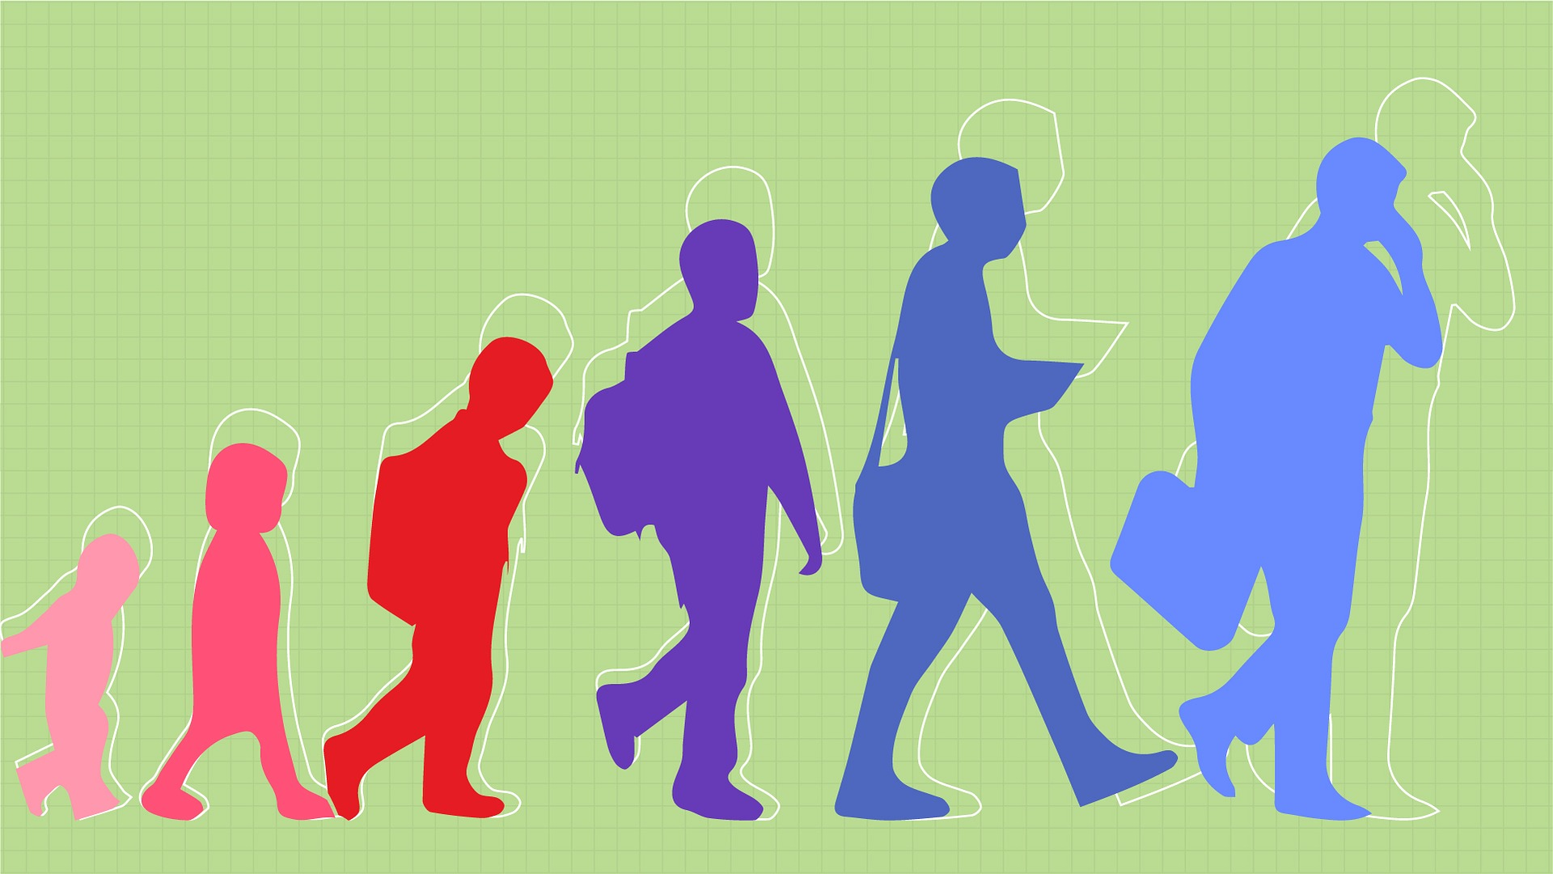

What aspects of ourselves change and develop as we journey through life? We move through significant physical, cognitive, and psychosocial changes throughout our lives—do these changes happen in a systematic way, and to everyone? How much is due to genetics and how much is due to environmental influences and experiences (both within our personal control and beyond)? Is there just one course of development or are there many different courses of development? In this module, we’ll examine these questions and learn about the major stages of development and what kind of developmental tasks and transitions we might expect along the way.

### Learning Objectives

* Describe human development and its three domains: physical, cognitive, and psychosocial development
* Describe who studies human development and why
* Describe the basic periods of human development

## Defining Human Development

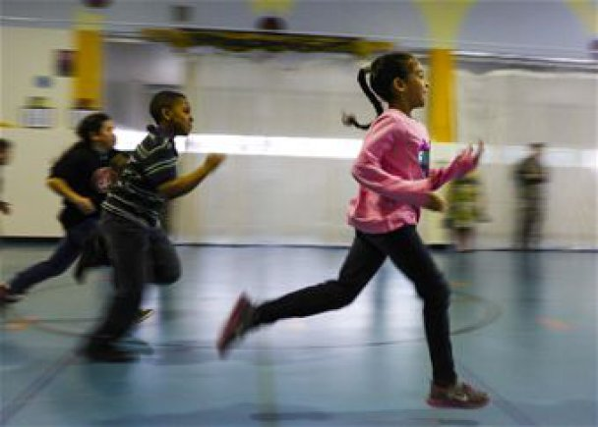

Human development refers to the physical, cognitive, and psychosocial development of humans throughout the lifespan. What types of development are involved in each of these three domains, or areas, of life? Physical development involves growth and changes in the body and brain, the senses, motor skills, and health and wellness. Cognitive development involves learning, attention, memory, language, thinking, reasoning, and creativity. Psychosocial development involves emotions, personality, and social relationships.

### Physical Domain

Many of us are familiar with the height and weight charts that pediatricians consult to estimate if babies, children, and teens are growing within normative ranges of physical development. We may also be aware of changes in children’s fine and gross motor skills, as well as their increasing coordination, particularly in terms of playing sports. But we may not realize that physical development also involves brain development, which not only enables childhood motor coordination but also greater coordination between emotions and planning in adulthood, as our brains are not done developing in infancy or childhood. Physical development also includes puberty, sexual health, fertility, menopause, changes in our senses, and primary versus secondary aging. Healthy habits with nutrition and exercise are also important at every age and stage across the lifespan.

### Cognitive Domain

If we watch and listen to infants and toddlers, we can’t help but wonder how they learn so much so fast, particularly when it comes to language development. Then as we compare young children to those in middle childhood, there appear to be huge differences in their ability to think logically about the concrete world around them. Cognitive development includes mental processes, thinking, learning, and understanding, and it doesn’t stop in childhood. Adolescents develop the ability to think logically about the abstract world (and may like to debate matters with adults as they exercise their new cognitive skills!). Moral reasoning develops further, as does practical intelligence—wisdom may develop with experience over time. Memory abilities and different forms of intelligence tend to change with age. Brain development and the brain’s ability to change and compensate for losses is significant to cognitive functions across the lifespan, too.

### Psychosocial Domain

Development in this domain involves what’s going on both psychologically and socially. Early on, the focus is on infants and caregivers, as temperament and attachment are significant. As the social world expands and the child grows psychologically, different types of play, and interactions with other children and teachers become important. Psychosocial development involves emotions, personality, self-esteem, and relationships. Peers become more important for adolescents, who are exploring new roles and forming their own identities. Dating, romance, cohabitation, marriage, having children, and finding work or a career are all parts of the transition into adulthood. Psychosocial development continues across adulthood with similar (and some different) developmental issues of family, friends, parenting, romance, divorce, remarriage, blended families, caregiving for elders, becoming grandparents and great grandparents, retirement, new careers, coping with losses, and death and dying.

### Dynamic Systems Approach

As you may have already noticed, physical, cognitive, and psychosocial development are often interrelated, as with the example of brain development. As we age, our brain matures, partially driven by our genes (physical) but also from being exposed to new ways of thinking (cognitive) and relationships (psychosocial). We will examine human development in these three domains in detail throughout the modules as we learn about infancy/toddlerhood, early childhood, middle childhood, adolescence, young adulthood, middle adulthood, and late adulthood development, as well as death and dying. Even though each domain is covered separately, it’s critical to keep in mind that the domains constantly interact and influence each other. This is consistent with the **dynamic systems approach**: human development is the result of a ongoing interaction between an individual, their physical, cognitive, and psychosocial domains and their environment.

## **Who Studies Human Development and Why?**

Many academic disciplines contribute to the study of development and this type is offered in some schools as psychology (particularly as developmental psychology); in other schools, it is taught under sociology, human development, or family studies. This multidisciplinary course is made up of contributions from researchers in the areas of health care, anthropology, nutrition, child development, biology, gerontology, psychology, and sociology, among others. Consequently, the stories provided are rich and well-rounded and the theories and findings can be part of a collaborative effort to understand human lives.

The main goals of those involved in studying human development are to describe and explain changes. Throughout this course, we will describe observations during development, then examine how theories provide explanations for why these changes occur. For example, you may observe two-year-old children be particularly temperamental, and researchers offer theories to explain why that is. We’ll learn a lot more about theories, especially developmental theories, in the next module.

## Periods of Human Development

Think about the lifespan and make a list of what you would consider the basic periods of development. How many periods or stages are on your list? Perhaps you have three: childhood, adulthood, and old age. Or maybe four: infancy, childhood, adolescence, and adulthood. Developmentalists often break the lifespan into nine stages:

1. Prenatal Development
2. Infancy and Toddlerhood
3. Early Childhood
4. Middle Childhood
5. Adolescence
6. Emerging Adulthood
7. Early Adulthood
8. Middle Adulthood
9. Late Adulthood

In addition, the topic of “Death and Dying” is usually addressed after late adulthood since overall, the likelihood of dying increases in later life (though individual and group variations exist). Death and dying will be the topic of our last module, though it is not necessarily a stage of development that occurs at a particular age.

The list of the periods of development reflects unique aspects of the various stages of childhood and adulthood that will be explored in this book, including physical, cognitive, and psychosocial changes. So while both an 8-month-old and an 8-year-old are considered children, they have very different motor abilities, cognitive skills, and social relationships. Their nutritional needs are different, and their primary psychological concerns are also distinctive. The same is true of an 18-year-old and an 80-year-old, both considered adults. We will discover the distinctions between being 28 or 48 as well. But first, here is a brief overview of the stages.

Read this online at <https://books.byui.edu/developmental_psychology/chatper_1>