# Erikson's Stages

## **Erikson’s Stages**

Erikson maintained that personality develops in a predetermined order through eight stages of psychosocial development, from infancy to adulthood. During each stage, the person experiences a psychosocial crisis that could positively or negatively affect personality development.

Erikson proposed a series of predetermined stages related to personality development. The stages are time-related.

According to the theory, successful completion of each stage results in a healthy personality and the acquisition of basic virtues. Basic virtues are characteristic strengths that the ego can use to resolve subsequent crises.

Failure to complete a stage can result in a reduced ability to complete further stages and, therefore, a more unhealthy personality and sense of self.  These stages, however, can be resolved successfully at a later time.

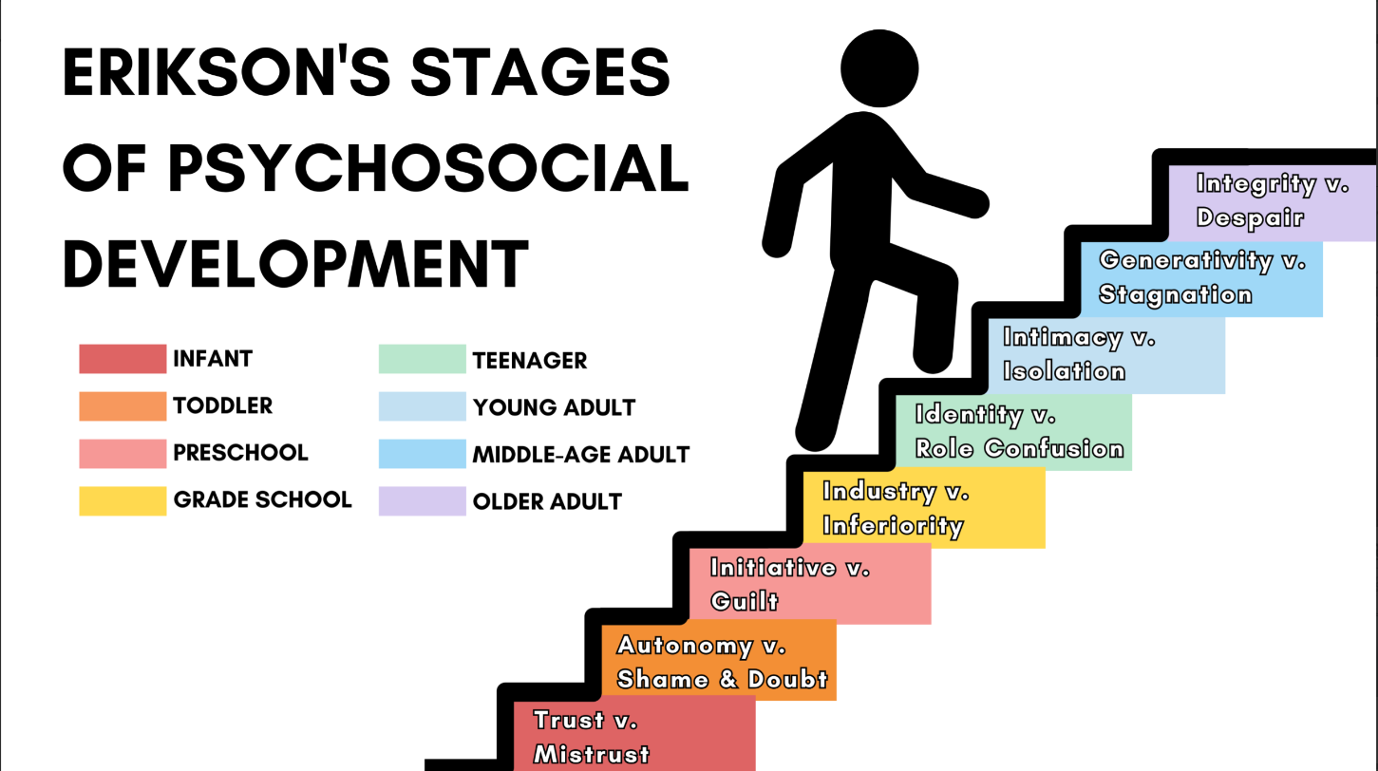

### 8 Stages:

#### Stage 1. Trust Vs. Mistrust

* Trust vs. mistrust is the first stage in Erik Erikson’s theory of psychosocial development. This stage begins at birth and continues until approximately 18 months of age. During this stage, the infant is uncertain about the world in which they live and looks towards their primary caregiver for stability and consistency of care.

#### Stage 2. Autonomy Vs. Shame And Doubt

* Autonomy versus shame and doubt is the second stage of Erik Erikson’s stages of psychosocial development. This stage occurs between the ages of 18 months to approximately 3 years. According to Erikson, children at this stage are focused on developing a sense of personal control over physical skills and a sense of independence.

#### Stage 3. Initiative Vs. Guilt

* Initiative versus guilt is the third stage of Erik Erikson’s theory of psychosocial development. During the initiative versus guilt stage, children assert themselves more frequently through directing play and other social interactions.

#### Stage 4. Industry Vs. Inferiority

* Erikson’s fourth psychosocial crisis, involving industry (competence) vs. Inferiority occurs during childhood between the ages of five and twelve.

#### Stage 5. Identity Vs. Role Confusion

* The fifth stage of Erik Erikson’s theory of psychosocial development is identity vs. role confusion, and it occurs during adolescence, from about 12-18 years. During this stage, adolescents search for a sense of self and personal identity, through an intense exploration of personal values, beliefs, and goals.

#### Stage 6. Intimacy Vs. Isolation

* Intimacy versus isolation is the sixth stage of Erik Erikson’s theory of psychosocial development. This stage takes place during young adulthood between the ages of approximately 18 to 40 years. During this stage, the major conflict centers on forming intimate, loving relationships with other people.

#### Stage 7. Generativity Vs. Stagnation

* Generativity versus stagnation is the seventh of eight stages of Erik Erikson’s theory of psychosocial development. This stage takes place during middle adulthood (ages 40 to 65 years).

#### Stage 8. Ego Integrity Vs. Despair

* Ego integrity versus despair is the eighth and final stage of Erik Erikson’s stage theory of psychosocial development. This stage begins at approximately age 65 and ends at death. It is during this time that we contemplate our accomplishments and can develop integrity if we see ourselves as leading a successful life.

#### Teacher Insight

* The theory was significant because it addressed development throughout a person's life, not just during childhood. It also stressed the importance of social relationships in shaping personality and growth at each point in development.
* Most resources say the aspects of Erikson's theory that are the most important for educators to understand are stage 4 Industry vs. inferiority that are being developed and the crisis that is happening in the lives of their students.

## Role Confusion

Role Confusion: The concept of being unsure of who you are and where you fit in.

In Erik Erikson's theory of psychosocial development, identity vs. confusion is the fifth stage of development and typically occurs between the ages of 13 - 21. During this stage, individuals are faced with the task of developing a sense of their own identity and determining who they are and what they want to be. This process involves exploring different roles and trying on different identities to figure out which ones fit them best. Erikson believed that this process of identity formation is an essential part of healthy development and that individuals who successfully navigate this stage will emerge with a sense of self-confidence and direction.

Role confusion can have a variety of negative effects on a person's emotional and mental well-being. Some of the potential impacts of role confusion include:

-Difficulty making decisions: When an individual is unclear about their role or identity, they may have trouble making choices about their career, relationships, or other important aspects of their life.

-Lack of direction or purpose: Role confusion can lead to a sense of aimlessness or lack of purpose, which can be demoralizing and lead to feelings of anxiety or depression.

-Difficulty forming and maintaining relationships: Role confusion can make it challenging for individuals to know how to behave and interact with others in appropriate ways, leading to difficulty building and maintaining healthy relationships.

- Low self-esteem: The uncertainty and lack of clarity that come with role confusion can lead to feelings of inadequacy or worthlessness.

In summary, role confusion is a stage in Erik Erikson's theory of psychosocial development that occurs during adolescence. It is characterized by uncertainty and confusion about one's identity and future direction, which can lead to difficulties in making decisions and forming intimate relationships. Resolving role confusion involves exploring and developing a clear sense of self and purpose, and establishing a direction for one's future.

Core Content

https://www.youtube.com/watch?v=70yDo6cexyY&autoplay

Read this online at <https://books.byui.edu/science_of_learning/moderate_concept_23_eriksons_stages>