# Chapter 1: The Genealogical Proof Standard

In this chapter, you will learn the following:

* The benefits of incorporating professional standards into your personal and professional family history and genealogy endeavors.
* The standards required for family history research.

## The Genealogical Proof Standard

### Study Questions

* SQ: What is the GPS?
* SQ: What is the purpose of the GPS, and how is it used?
* SQ: What are the five elements of the GPS?

It is common for industries to establish their own high standards. Genealogists used to borrow standards from other professions, but in the year 2000, the**Board for Certification of Genealogists (BCG)** published a list of genealogical standards in The BCG Genealogical Standards Manual.

An important part of these standards for genealogists is the **Genealogical Proof Standard (GPS)**, which guides how professional and amateur genealogists should conduct their research. As a genealogist, you should meet all five elements of the GPS at all times as you conduct your research, whether you are researching for yourself, as a consultant, as a student, or as a professional. The five GPS elements are as follows:

1. Conduct reasonably exhaustive research.
2. Use complete and accurate source citations.
3. Conduct thorough analysis and correlation.
4. Resolve any conflicting evidence.
5. Write a soundly written conclusion based on the strongest evidence.

This standard should overarch all of your documentation, research, and writing. According to the Board for Certification of Genealogists, the GPS is applied to “measure the credibility of conclusions about ancestral identities, relationships, and life events.”1

### 

### Five GPS Elements

To really understand the GPS, one needs to look at each of the five elements individually.

#### GPS 1: Conduct Reasonably Exhaustive Research

As a genealogist, you will plan and complete research that is systematic and broad in scope. The phrase "reasonably exhaustive research" indicates that a researcher has identified and searched all relevant and available records.

A researcher begins by gathering known information and determining a focused research objective or question. The researcher then identifies which records are available to answer the research question. The researcher looks for records for any location and time-period by consulting reference resources such as the [FamilySearch Wiki](https://www.familysearch.org/en/wiki/Main_Page) and the [FamilySearch Catalog](https://www.familysearch.org/search/catalog). The FamilySearch Wiki identifies records that are available anywhere, not just on FamilySearch. There are many other reference resources available to help researchers identify records. The researcher lists the records he/she plans to search in a research plan. Records are listed in order of priority, and the location of each record is listed.

The researcher then completes research in the records listed in the research plan and records the results in a research log. It is important to conduct reasonably exhaustive research to ensure all available and relevant information has been located which may help resolve a research question.

You will learn more about conducting reasonably exhaustive research in future chapters.

#### GPS 2: Use Complete and Accurate Source Citations

A complete and accurate source citation is a reference that provides all the necessary details to identify and locate a source of information. Whether you are a student, a teacher, an amateur, or a professional genealogist, you should always cite the source of your information completely and accurately.

* Different disciplines use different style guides. In the BYU-Pathway Family History Research program, the “[Guide to Citing Sources](https://content.byui.edu/file/b1ccb04d-0b2a-4c39-8e73-688d45a949f2/9/Guide%20to%20Citing%20Sources%202nd%20Edition%20(Winter%202024%20Version).pdf)” is the standard.
  + The “Guide to Citing Sources” is available to students in the Student Resources section of the course. You may wish to bookmark it.
  + The “Guide to Citing Sources” is based on the Chicago Manual of Style (CMOS), which students may also access.
  + Because the Chicago Manual of Style does not cover all potential record sources for genealogical work, genealogists may also use a book called Evidence Explained. Evidence Explained  is not available online without purchasing it, but you can look for this book at your local library or FamilySearch Center.
  + You will use the “Guide to Citing Sources,” Evidence Explained, and the CMOS in your work in the BYU-Pathway Family History Research program.
  + As you perform personal or professional genealogical work, it is important that you learn the standards for writing citations in your country. You will learn more about how to do this in a future chapter.

You should cite**anything**that is not common knowledge. As a genealogist, you will use footnotes for these citations.

* A basic citation includes the author’s name, the source title, and the source publication information, but this is not all that is required.
* The citation should include all the details needed to locate the original source.

Why is it important to use complete and accurate source citations? “Citations, narrative text, and connections between the two enable genealogists and others to (a) assess the credibility of each source or image a genealogist used, (b) locate that source or image, and (c) understand the research scope."2

You will learn more about citations in Chapter 2.

#### GPS 3: Conduct Thorough Analysis and Correlation

As a genealogist, your work does not stop once you finish the research. You must analyze what you have found and correlate (or compare) it with known information and the information you have found in other records.

To complete the third element of the GPS we test "through processes of analysis and correlation … all sources, information items, and evidence contributing to an answer to a genealogical question or problem.”3

#### Analysis

The definition of analysis is a “detailed examination of anything complex in order to understand its nature or to determine its essential features: a thorough study.”4 So, as a researcher, you must thoroughly examine a genealogical problem as well as what was used to answer the problem. It is important to analyze sources and the information in the sources to ensure our evidence is credible.

#### Correlation

The definition of correlation is “the state or relation of being correlated, specifically: a relation existing between phenomena or things … which tend to vary, be associated, or occur together in a way not expected on the basis of chance alone.”5 So, it is important to correlate sources and information to determine how a research question and the items that help answer a research question are connected or related. We must do so in a way that shows the items are not connected just by chance. This is often accomplished using tools such as charts, tables, timelines, maps, lists, and so on. It is important to complete correlation to ensure the information we have found belongs to the right person.

To successfully meet this third element of the GPS, you must look at 1) sources, 2) information items, and 3) evidence—to thoroughly examine and analyze each source, information item, and piece of evidence and correlate them by finding their logical and real relationship. We analyze the following:

* **The source.** A source can be a book, certificate, letter, family bible, local history, online family tree, etc. How reliable is it? Does it include citations? Is it an original document or has the information been copied?
* **The information in that source.** We do this by deciding who the informant was and how close to the event the informant reported information. (Was the informant an eyewitness to the event? Or was it someone who heard about the event? Was the birth date found in a birth certificate, or was the birth date found on the death certificate?)
* **The evidence found in the information.** We analyze the evidence by deciding if it answers the research question either directly or when combined with other evidence.

The information we find may or may not contribute to answering our research question. It is just as important to note negative search results where nothing is found as it is to note positive search results where information is found.

GPS 3 deals with Analysis and Correlation and can seem overwhelming and confusing, but it can be broken down to make it more understandable. Remember the basic difference between Analysis and Correlation:

**Analysis** is analyzing one source, information item, or piece of evidence. **Correlation** is comparing two or more sources, information items, or pieces of evidence.

**Analysis:** analyzing one source, information item, or piece of evidence. The analysis begins with the classification of sources, information, and evidence.

**Correlation:** Comparing two or more sources, information items, or pieces of evidence for conflicting or agreeing data.

The following chart helps show how analysis will be approached in a future course.

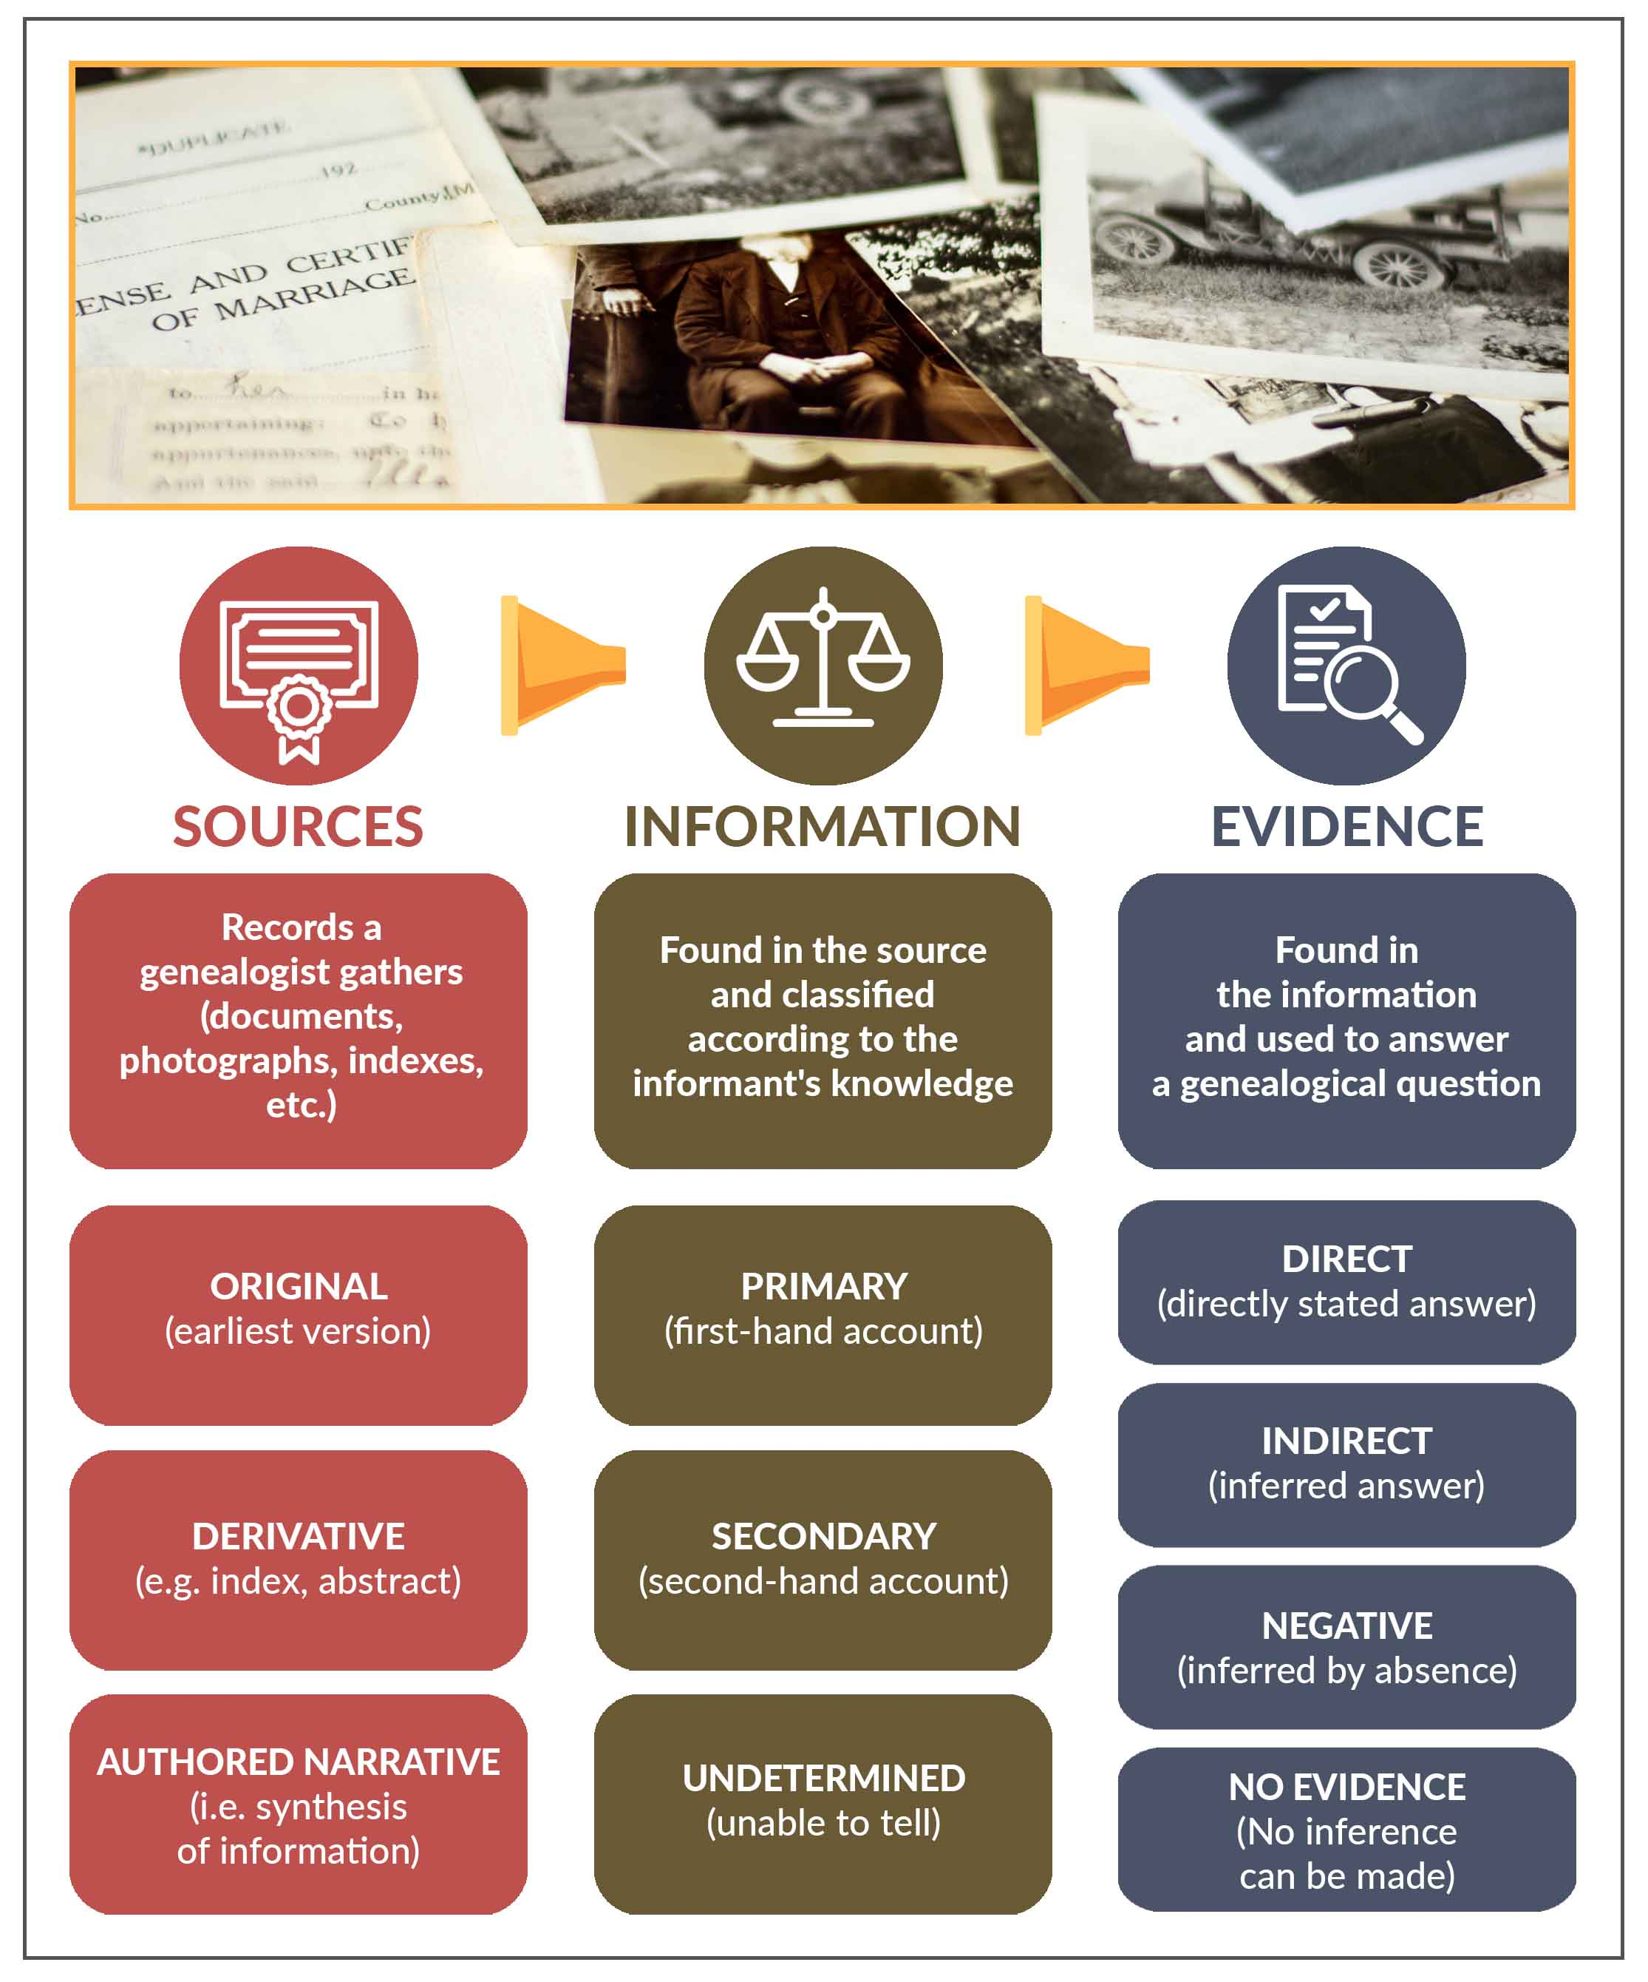

Genealogists sometimes use a Classification Chart such as the one below to help classify until it becomes familiar.

Once you have analyzed your sources, you need to correlate/compare them. For instance, a person’s name may be slightly different on each of three different documents. One uses initials, one is spelled differently from the other two, and the last one shows the middle name for the first name. Which is correct? Can you be sure they all refer to the same person? These questions are answered by determining the reliability of the sources through analysis (of each single document) and correlation (comparing the documents against each other).

Genealogists often find it helpful to use a correlation chart when comparing sources.

You will learn more about analysis and correlation in a future week of this course.

If there is conflicting evidence, you also determine if the conflicts can be resolved. (See GPS 4 below.)

#### GPS 4: Resolve Any Conflicting Evidence

Sometimes when you are conducting genealogical research, you will discover pieces of evidence that do not agree with each other. Most of the evidence might point in one direction, but one piece is confusing because it doesn’t fit with all the rest. In genealogical research, we call this conflicting evidence. The Genealogical Proof Standard addresses conflicting evidence and its resolution. Genealogists do not simply ignore evidence that disagrees with their conclusion. It is important to address and resolve that conflicting evidence to ensure the research conclusion is accurate and to help fellow researchers understand the conflicting evidence when they find it.

As a genealogist, you will present both the evidence that supports your conclusion and the evidence that disagrees with that conclusion. You then analyze conflicting evidence by considering the source and informant details below.

* Analyze the reliability of the source. (You will learn more about this in a future unit.)
  + Is it legible and in good condition?
  + Is it an original document, a transcription such as an index, or a compiled history?
* Analyze the reliability of the informant. (You will learn more about this in a future unit.)
  + Could the informant have forgotten or not remembered correctly?
  + Does the informant have a reason to lie about the information provided?
  + Does the informant have primary or secondary knowledge of the event?

Resolve conflicting evidence by using the results of your analysis to explain why the discrepancy exists, or why one piece of evidence is more reliable than another.

As mentioned before, you will be studying each of the GPS standards separately in more detail in future FHGEN courses. For now, you will need to understand just enough to know how the process works.

#### GPS 5: Write a Soundly Written Conclusion Based on the Strongest Evidence

As a genealogist, your work is not done until you write a conclusion to your research. The conclusion proves to the reader you arrived at the correct decision. Your written conclusion will include evidence that supports your research conclusion and will clarify the research for future genealogists.

As genealogists, it is important to record conclusions carefully to show that we have not based them on “bias, preconception, or inadequate appreciation of the evidence. [We] also show or explain how the evidence leads to the conclusion.”6 The conclusion is the culmination of our research.

When writing conclusions, we aim for [traits such as] accuracy, clarity, and readability.7 Accuracy means we don’t make up information, exaggerate, or hide information. Clarity means we don’t use clichés, if we directly quote someone, we identify them in the text, and if we introduce a new person to the text, we identify them immediately. Readability means we follow the rules for writing and proofread our work.

The Chicago Manual of Style, Evidence Explained, and Professional Genealogy are resources (or writing tools) for genealogical writing standards. Reading genealogical journals can also enhance your writing skills.

 You will learn more about soundly written conclusions in future chapters.

*Because you are still learning about citations, use the following citation when citing information from this chapter: BYU-Idaho Family History Research Program Faculty, “The Genealogical Proof Standard,” in Family History and Genealogical Research (Rexburg, Idaho: BYU-Idaho, 2023), Unit 1 Chapter 1, https://books.byui.edu/.

1. Board for Certification of Genealogists, “Ethics and Standards,” bcgcertification.org/ethics-standards, accessed 11 June 2019. (*see note above)
2. Board for Certification of Genealogists, Professional Standards, 50th anniversary edition (Nashville, TN:  Ancestry, 2014), 6.
3. Board for Certification of Genealogists, Genealogy Standards, 2nd ed. (Nashville, TN: Ancestry.com, 2019), 1-2.
4. Merriam-Webster Online, s.v. “analysis” (https://www.merriam-webster.com/dictionary/analysis : accessed 24 September 2019).
5. Merriam Webster Online, s.v. “correlation” (https://www.merriam-webster.com/dictionary/correlation : accessed 24 September 2019).
6. Board for the Certification of Genealogists, Genealogy Standards, 2nd ed., (Nashville, TN: Ancestry.com, 2019), 3.
7. Elizabeth Shown Mills, CG, CGL, FASG, FNGS, FUGA, “Good Genealogical Writing,” OnBoard 4 (May 1998): 16.

Read this online at <https://books.byui.edu/fhgen_110_textbook_/chapter_1__the_genealogical_proof_standard>