# Quality Management

*I have been quoted as saying, ‘Do the best you can.’ But I want to emphasize that it be the very best. We are too prone to be satisfied with mediocre performance. We are capable of doing so much better.*

*PresidentGordonB.Hinckley33*

Within thefirstyearofserviceasPresidentofTheChurchofJesusChristofLatter- day Saints, President Spencer W. Kimball made the following remarks in a devotional address at Brigham Young University.

Perfection is a long, hard journey with many pitfalls. It’s not attainable overnight. Eternalvigilanceisthepriceofvictory.Eternalvigilanceisrequiredinthesubduing of enemies and in becoming the master of oneself. It cannot be accomplished in little spurts and disconnected efforts. There must be constant and valiant, purposeful living—righteous living. 34

The words of President Hinckley and President Kimball make it abundantly clear that achieving the highest level of personal, individual quality—even perfection— requires consistent, vigorous effort over a long period of time. Fortunately, as we face this seemingly impossible task, great hope is extended to us in the perfect example andenablingpower of the Savior. Indeed,we are told in Ether 12:27 thatif wecomeuntotheLordHewillshowusourweakness,andifwearehumble,Hewill make those weak things become strong.

### ChapterObjectives

Strivingforindividualperfectionorworkingtoimprovequalityinabusinesssetting requires similar ingredients. Among them are *humility*—a willingness to look for andacknowledgeweaknesses—and*resolve*—thefireanddrivetofaceandovercome those weaknesses. This process is not for the proud or the faint of heart, as our nature leads most of us to seek a specious safety in our comfort zones. But such complacencyisarecipeforlong-termmediocrityorworse,bothindividuallyandin business.

Inthischapteryouwillbecomefamiliarwithsomeofthethoughtleadersinquality managementwhohelpedorganizationsdevelopthehumilityandresolveto successfully address quality-related matters and consequently reap great rewards. Moreover, you should be able to see, in many cases, how their techniques are similar to many Gospel principles and practices in place within the Church. Specifically, after studying this chapter you should be able to

* 1. Understand and articulate the many dimensions of quality, including the costs of quality.
  2. Describe the main concepts and tools of Total Quality Management (TQM).
  3. Identify the key thought leaders in the quality movement, as well as their respective contributions to quality management.
  4. Describe Quality Function Deployment (QFD) and the House of Quality.
  5. Describe Six Sigma and its methodologies.
  6. Describe the roles of the International Standards Organization and the Malcolm Baldrige Awards in promoting quality.

### IntroductiontoQuality

Quality is an important aspect of product or service differentiation. Along with productpriceandproductavailability(orsupplyresponsiveness),itisoneofthekey pillars upon which companies can and do compete.

##### Question: What is quality?

Eachofusmightthinkweknowwhat“quality”means,buttherealityisthatquality can mean different things to different people. One reputable definition states that “Quality means user satisfaction: that goods or services satisfy the needs and expectations of the user.”35 This definition is helpful, but it still leaves room for individual interpretation.

While it may be unrealistic to pen a simple universally-accepted definition of quality, here are several widely accepted dimensions of quality that can be identified.36

* + - **Performance.** Refers to a product’s primary operating characteristics. For instance, with an economy car this would be miles per gallon.
    - **Features.** This is a secondary dimension of performance, often referring to the “bells and whistles” of a product.
    - **Reliability.** The probability of a product malfunctioning or failing within a specific time period. This is usually measured in terms of MTBF (mean time between failure).
    - **Conformance.** The degree to which the product’s design and performance meet established standards. Meeting this dimension is typically manufacturing’s responsibility.
    - **Durability.** A measure of the product’s life, after which it can no longer be repaired.
    - **Servicability.** The speed and ease of product repair.
    - **Perceived Quality.** Largely based on reputation, an indirect measure of a product’s quality.

##### 

##### Question: What are the costs of poor quality?

Thecostsofpoorqualityfallintofourcategories.

* 1. Prevention costs or costs incurred to minimize appraisal and failure costs.
  2. Appraisal costs or costs incurred to determine the degree of conformance to quality standards.
  3. Internal failure costs or costs associated with defects that are found before  
     the customer receives the product or service.
  4. External failure costs or costs associated with defects that are found after the customer receives the product or service.

Thefirstthreecategoriescanbereasonablyestimated,butexternalfailurecostscan farexceed theactual costsofrepairor of fixing theproblem. Thehighly-publicized 2010 recall of several Toyota automobile models with faulty accelerator pedals is as an example of where the external costs of failure (the loss of sales from a tarnished reputation, lawsuits,andsoforth)farexceedtheactualcoststorepair thevehicles.

### TotalQualityManagement(TQM)

##### Question: What is Total Quality Management (TQM)?

Total quality management is a customer-focused, process-oriented management system that involves all employees in organizational efforts to improve “processes, goods, services, and the culture in which they work.”37 Very simply, TQM is a management approach that promotes long-term success through customer satisfaction.TQMphilosophiesandtoolscomefromtheteachingsofqualityleaders like W. Edwards Deming and others.

##### Question: Whatare the main concepts of TQM?

While there is no single list of universally accepted TQM concepts, most lists will include the following:

* + - **Customer focus.** Listening to customers and conforming the design of products and services to meet customer-driven standards. Customers ultimately determine—with their wallet—whether products and services meet their quality needs and wants.
    - **Management commitment and systematic efforts.** Setting the tone for the organization through word and deed. This means integrating quality into the organization’s vision, mission, and goals and personally following up on progress toward those goals.
    - **Total employee involvement and empowerment.** Training employees in quality methods and pushing decision making as low as possible in the organization (often through the use of quality circles, where small groups of employees meet to identify, analyze, and solve quality-related problems).
    - **Process-centered continuous improvement.** Establishing stable, repeatable processes and then relentlessly seeking and finding ways to improve those processes.
    - **Benchmarking.** Comparing company performance in key processes to that of a company thought to have superior performance and then incorporating what was learned in order to make improvements.
    - **Supplier partnering.** Minimizing total cost (not just acquisition costs) by partnering with single-source suppliers.
    - **Fact-based decision making.** Gathering required data, using appropriate tools and statistical methods to measure process performance and identify opportunities for improvement.
    - **Communications.** Ensuring open communication flows freely in all directions. Successful quality implementations depend on effective communication within the organization and with customers and suppliers.

##### Question: Whatare the main tools of TQM?

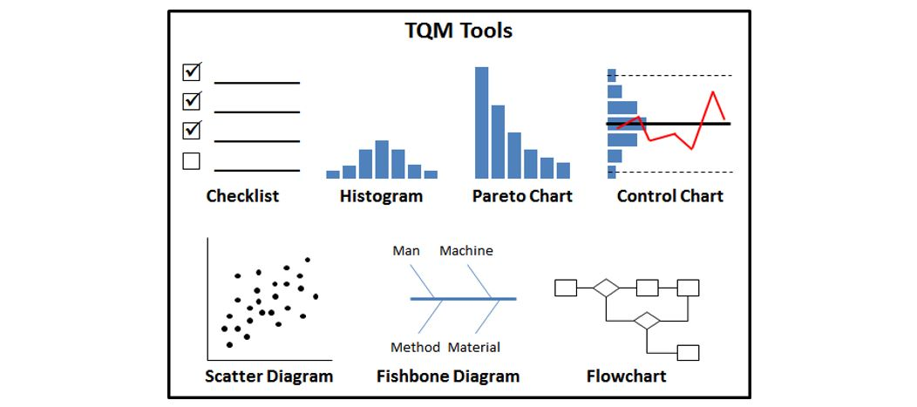

**Checklist**—A simple data-recording device. Check sheets and simple surveys are effective methods, easy to design and implement. They provide a snapshot of the processbeingstudiedandrevealunderlyingpatternsincludingthefrequencyofan event or activity. Frequently, check sheet results are turned into Pareto charts.

**Histogram**—A graphic summary of a set of data that reveals the amount of variation that a process has within it. The pictorial nature of the histogram lets peopleseepatternsthataredifficulttodetectinasimpletableofnumbers.Control chartsareactuallyaseriesofhistogramslaidontheirsidewithacceptablevariation levels indicated in the form of upper and lower statistical control limits.

**Pareto Chart**—A graphical tool for ranking causes from most significant to least significant.AParetochartisaseriesofverticalbarslinedupinadescendingorder— fromhightolow—toreflectfrequency,importance,orimpact.Paretochartsquickly draw everyone's attention to the most important factor—providing an at-a-glance snapshot of priorities.

**Control Chart**—A run chart with upper and lower control limits on which values of some statistical measure for a series of samples or subgroups are plotted. The chartfrequentlyshowsacentrallinetohelpdetectatrend ofplottedvalues.Ithelps determine whether a process is experiencing common variation (natural and acceptable) or abnormal variation (assignable to some special cause) that would require further investigation and action.

**Scatter Diagram**—A graphical technique to analyze the relationship between two variables.Twosetsofdataareplottedonagraph,withthey-axisbeingusedforthe variable to be predicted and the x-axis being used for the variable to make the prediction. The graph will show possible relationships among variables: those who know most about the variables must evaluate whether they are actually related or only appear to be related.

**FishboneDiagram**—Afishboneorcause-and-effect diagram isatoolforanalyzing andillustratingaprocessbyshowingthemain causesandsub-causesleadingtoan effect (symptom). It is sometimes referred to as an “Ishikawa diagram,” because Kaoru Ishikawa developed it. A fishbone diagram is easy to construct and invites interactiveparticipation.Inordertoidentifytherootcauseofaparticularproblem, ateamwillrepeatedlyask“why”theproblemexists(see“**fivewhy’s**”intheglossary) andwillassignthecausestooneof“**fourMs**”orcategorieswhichcorrespondtothe main“bones”orbranchesinthediagram:(1)man,(2)machine,(3)method,and(4) materials.

**Flowchart/Process Map**—Graphical tools that show the major steps in a process. Developing a flowchart requires identifying key process steps and inventory points and the dominant flow among them. Flowcharts are useful for examining how various steps are related to each other. By studying these charts individuals and teamscanoftenuncoverpotentialsourcesoftroubleoridentifystepstobetakento improve or error-proof a process.

### W.Edwards Deming

##### Question: WhowasDeming,and whatarehis14 points?

Dr. W. Edwards Deming is known as the father of the industrial revival that took placeinJapanafterWorldWarII.In1950hetrainedhundredsofJapaneseengineers instatisticalprocesscontrol(or“SPC,”coveredinthenextchapter)andconceptsof quality. He encouraged industrial leaders to improve quality, saying it was the key to lower costs and higher productivity.

In1982Demingpublished*Quality,Productivity,andCompetitivePosition*(renamed to*OutoftheCrisis*in 1986)which challengedmany ofthemanagement practices found in US companies. *Out of the Crisis* contains Deming's famous “14 Points” (**listed below**, with *additional comments from this author*).38 Contemplate how these points challenge beliefs that might be prevalent in the workplace, and how things might be improved by following them.

* 1. **Create constancy of purpose for improving products and services.**(Resources should primarily be allocated to meet long-term needs rather than merely focusing on short-term profitability.)
  2. **Adopt the new philosophy.**(The post-war era of American dominance is long past and the United States should abandon the traditional Western management approach and adopt a new way of managing business, with a long-term focus, if it is going to compete in the global marketplace.)
  3. **Cease dependence on inspection to achieve quality.**(Quality should be built into the product in the first place, evidenced by statistical measures, rather than depend on end-of-the-line mass quality checks.)
  4. **End the practice of awarding business on price alone; instead, minimize total cost by working with a single supplier.**(The goal is to minimize total cost, not just initial cost. Working with a single supplier for any one item increases loyalty and trust, ultimately leading to higher quality and lower total costs.)
  5. **Improve constantly and forever every process for planning, production and service.** (Management should focus on improving the processes and systems within a business—design, innovation, incoming materials, maintenance, equipment, supervision, training, retraining, etc.)
  6. **Institute training on the job.**(Institute modern training methods for all employees, including management. New skills are required to compete globally and to keep up with changing developments in materials, equipment, information technology, and service innovation.)
  7. **Adopt and institute leadership.**(Institute leadership that focuses on improving processes and systems, thus making it easier for employees to do their job. Focus more on quality, not merely on numbers. Make sure that immediate action is taken on defects and conditions detrimental to quality.)
  8. **Drive out fear.**(Encourage two-way communication and other means to eliminate fear so that employees will be more productive and effective.)
  9. **Break down barriers between staff areas.**(Use cross-functional teams to increase focus on and improve products and services, as most business processes run across departmental boundaries.)
  10. **Eliminate slogans, exhortations and targets for the workforce.**(The right employees don’t respond to a lot of hoopla but rather are intrinsically and naturally motivated when they are part of logical efforts and plans that confront the “brutal facts” of their workplace reality.39 Managerial slogans without managerial focus on the system—fixing processes—do not improve productivity, but often foster an adversarial relationship.)
  11. **Eliminate numerical quotas for the workforce and numerical goals for management.**(Arbitrary goals, set solely by management, can be demotivating to the workforce. Perhaps it is better to let those closest to the processes set goals, or provide input on goals, and have management focus on fixing the system or processes so that such goals can be met.)
  12. **Remove barriers that rob people of pride of workmanship, and eliminate the annual rating or merit system.**(Perhaps this point, like the previous one, is a bit too idealistic. Nevertheless, it again highlights the view that management should be more focused on improving quality—by improving the system—than on pushing and micromanaging employees.)
  13. **Institute a vigorous program of education and self-improvement for everyone.**(Employee knowledge improves competitive position.)
  14. **Put everybody in the company to work accomplishing the transformation.** (Action is required by all employees. Top management must set the tone by clearly defining their permanent commitment to improve quality and productivity. This commitment should include a structure to implement the 13 preceding points. All employees should feel the pride of ownership for quality—and be empowered to make a difference.

##### Question: What is the Deming Cycle or PDCA?

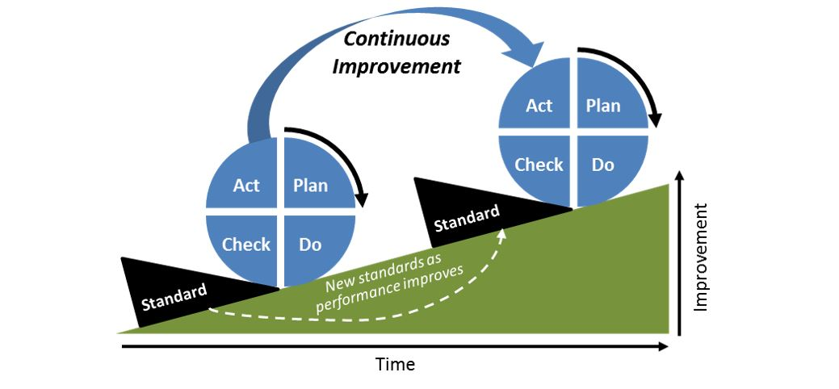

PDCA (“Plan-Do-Check-Act”) is an iterative four-step problem-solving process typically used in quality control. A fundamental principle of the scientific method andPDCAis iteration—once a hypothesis is confirmed (ornegated), executingthe cycleagainwillextendtheknowledgefurther. RepeatingthePDCAcyclecan bring usclosertothegoal,usuallyaperfectoperationandoutput.ThePDCAcycleisone way we can implement these words from President Thomas S. Monson.

A cardinal principle of industrial management teaches: “When performance is measured, performance improves. When performance is measured and reported, the rate of improvement accelerates.”40

### OtherLeadersandPioneersinQualityManagement

##### Question: Besides Deming, who are other key figures in quality management?

InadditiontoW.EdwardsDeming,thefollowingindividualshavemadesignificant contributions to the field of quality management.

* + - **Philip B. Crosby** was a corporate quality manager and consultant who published Quality is Free in 1979. This was his first business book and it came out when American companies were facing a quality crisis and losing business to Japanese companies who had higher quality products. The book’s premise is that it is better to do the job right the first time and that doing so would save more than the cost of the effort, hence “quality is free.” He also coined the phrase zero defects.
    - **Armand V. Feigenbaum** is an American businessman and quality expert who devised the concept known as Total Quality Control, later to be known as Total Quality Management (TQM).
    - **Kaoru Ishikawa** was a Japanese university professor and quality innovator who was instrumental in the transformation of Japan’s post-war industrial sector. He is credited with the introduction of quality circles and with the development of the Ishikawa diagram (fishbone/cause-and-effect diagram).
    - **Joseph M. Juran** was an American management consultant and evangelist for quality. Among his contributions are the application of the Pareto principle (the 80/20 rule of “the vital few and the useful many”) and the human element in quality management. He made 10 trips to Japan starting in the 1950s and focused on training senior and middle managers, with his work paying off by the 1970s when Japanese products started to be recognized for high quality. (Also interesting to note are his marriage of 81 years and living to nearly 104!)
    - **Genichi Taguchi** is a Japanese engineer who developed methods for applying statistics to improve the quality of manufactured goods. His key contributions are in the areas of (1) measuring the financial loss from poor quality—the “quality loss function,” (2) promoting robust product design where high quality is less affected by adverse process conditions, and (3) target-oriented quality.

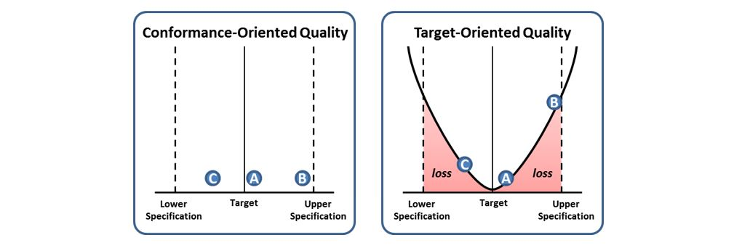

##### **More on Target-Oriented Quality**

Genichi Taguchi contends that conformance-oriented quality is not good enough (whereproductsA,B,andC,asseenbelowleft,eachfallwithintheupperandlower design specifications. Rather, there is an increasing cost (loss in value to the company, customer, and society) the further products stray from the design target (above right). The difference between conformance-0riented and target-oriented quality is illustrated in the following anecdote.

Ford Motor Company was simultaneously manufacturing a car model with transmissionsmadeinJapanandtheUnitedStates.Soonafterthecarmodelwason themarket,Ford customers wererequestingthemodel withJapanesetransmission over the US-made transmission, and they were willing to wait for the Japanese model.Asbothtransmissionsweremadetothesamespecifications,Fordengineers could not understand the customer preference for the model with the Japanese transmission. Finally, Ford engineers decided to take apart the two different transmissions. The American-made car parts were all within specified tolerance levels. On the other hand, the Japanese car parts were virtually identical to each other, and much closer to the nominal values for the parts—e.g., if a part was supposedtobeonefootlong,plusorminus1/8ofaninch—thentheJapaneseparts wereallwithin1/16ofaninch,lessvariation.ThismadetheJapanesecarsrunmore smoothly and customers experienced fewer problems.41

An outstanding discussion on how target-oriented quality applies in our personal livescanbefoundinaBYUDevotionaladdressentitled“LookingTowardtheMark,” byBYUEngineeringprofessorValD.Hanks.42BrotherHanksproposesthatlooking at and barely staying within boundaries of personal conduct (“lower” or “upper specifications”) is a far inferior mindset and approach to living the gospel than looking toward the perfect mark of the Savior and striving to live like Him.

### QualityFunctionDeployment(QFD)andtheHouseofQuality(HOQ)

##### Question: What is Quality Function Deployment?

Quality Function Deployment (QFD) is a method for (1) determining customer needsandwants(thevoiceofthecustomer[VOC])and(2)translatingthosedesires intoaproductorservicedesign.AthoroughdiscussionofQFDisbeyondthescope ofthisbook;however, abriefoverviewof the HouseofQuality, QFD’smaintool, is in order.

The House of Quality (HOQ) is a house-shaped diagram or tool that helps firms implement QFD. It is used iteratively to help define and refine the relationship betweencustomerrequirementsandtechnicalrequirementssothatfirmsmaymore effectivelydesign andimplementproductandserviceofferings. To further assistin this design process, HOQ diagrams can also provide a structured way to assess competitorofferings,understandtherelationshipbetweenspecificfirmcapabilities or offerings, and document product or service specifications or target values.

Let’s suppose we run a small diner named“Breakfast at Home.” The HOQdiagram below right shows how our offerings or capabilities stack up to what customers are asking for. (The “HOQ Structure” diagram is merely for reference purposes so that you can clearly see this tool’s basic structure.)

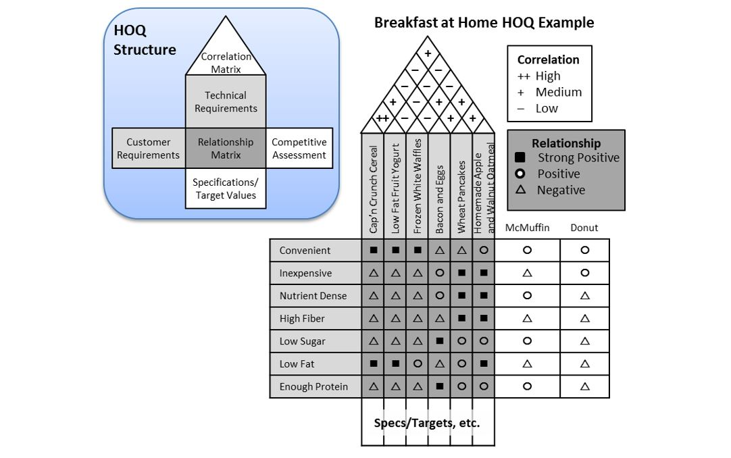

Of course this example is quite simple, but it does show how well our technical requirementsorcurrentcapabilities(thevariousbreakfastitemswecanmake)stack up to our list of customer requirements. The relationship matrix gives us a clear picture of where our capabilities fall short of the voice of the customer (VOC), and this knowledge should guide us to promote those offerings that match customer requirementsandmodifyorswapoutthosethatdon’t.Inmostcases,respondingto theVOCwouldrequireseveraliterationsorversionsoftheHOQuntilourtechnical requirements are adequately defined with targets and detailed specifications—down to the exact ingredients to be used in our offerings as well as all process steps for making those items.

### OverviewofSixSigma

##### Question: What is Six Sigma?

Six Sigma is a business management strategy, originally developed by Motorola, which today enjoys widespread application in many sectors of industry. Six Sigma seeksto identifyandremovethecausesofdefectsanderrorsinmanufacturing and businessprocesses.Itusesasetofqualitymanagementmethods,including statistical methods, and creates a special infrastructure of people within the organization who are experts in these methods. Each Six Sigma project carried out within an organization follows a defined sequence of steps and has quantified financial targets.

The statistical definition of a six sigma process is one that produces 3.4 defective partspermillionopportunities(**DPMO**).Thisisbasedonthefactthataprocessthat is normally distributed will have 3.4 parts per million beyond a point that is 4.543 standard deviations above or below the mean.

##### Question: What are the Six Sigma certifications? How do you get certified?

IndividualscanbecomecertifiedinthedifferentlevelsofSixSigmaexpertise(Green Belt, Black Belt, Master Black Belt, etc.). Note that there is no single sanctioning bodyororganizationthatawardsSixSigmacertifications.Rather,certificationscan be obtained from four different types of providers: (1) employers, (2) professional associations, (3) colleges and universities, and (4) certification service provider institutions.

TheprocessforobtainingaSixSigmacertificationcanvarygreatlygiventhenumber and variety of granting organizations. Certification typically requires two to four weeks of training, the passing of a qualifying exam, and the participation in or the leading of one or more relevant projects.

##### Question: What are the main methodologies used in Six Sigma?

Six Sigma has two key methodologies: **DMAIC** and **DMADV**, both inspired by Deming'sPlan-Do-Check-Act Cycle.DMAICisusedtoimprovean*existing*business process; DMADV is used to create *new product or process* designs.

##### **DMAIC–Thebasicmethodologyconsistsofthefollowingfive steps:**

* + - **Define** process improvement goals that are consistent with customer demands and the enterprise strategy.
    - **Measure** key aspects of the current process and collect relevant data.
    - **Analyze** the data to verify cause-and-effect relationships. Determine what the relationships are, and attempt to ensure that all factors have been considered.
    - **Improve** or optimize the process based upon data analysis using techniques like Design of Experiments.
    - **Control** to ensure that any deviations from target are corrected before they result in defects. Set up pilot runs to establish process capability, move on to production, set up control mechanisms and continuously monitor the process.

##### **DMADV –Thebasicmethodologyconsistsofthefollowingfive steps:**

* + - **Define** design goals that are consistent with customer demands and the enterprise strategy.
    - **Measure** and identify CTQs (characteristics that are Critical To Quality), product capabilities, production process capability, and risks.
    - **Analyze** to develop and design alternatives, create a high-level design and evaluate design capability to select the best design.
    - **Design** details, optimize the design, and plan for design verification. This phase may require simulations.
    - **Verify** the design, set up pilot runs, implement the production process and hand it over to the process owners.

### ISOandtheMalcomBaldrigeNationalQualityAward

##### Question: What is ISO?

The International Organization for Standardization, also known as ISO, is an international-standard-setting body with over 150 cooperating institutes representing nearly 100 countries. It was founded in 1947 and acts as a bridge between public and private (industrial) sectors. In many cases, an ISO certification can be a deal qualifier for establishing a business relationship.

**ISO<span style="letter-spacing: -.05pt;"> </span>9000**isthemostwidelyknown setofinternational standardson quality. They weredevelopedtohelpcompaniesdocumentandmaintaintheirqualityprocedures. These standards were published in 1987 and are not particular to any industry, product, or service. ISO 9000 focuses more on quality practices than on quality outcomes. Companies who follow these standards will periodically bring in independent auditors to certify that their company is indeed ISO 9000 compliant.

With the recent push for environmentally friendly business practices, ISO has developed the ISO 14000 set of standards (environmental management standards) and ISO 24700 (standard for reusing recovered components).

##### Question: What is the Malcom Baldrige National Quality Award?

This award is named after the late Secretary of Commerce, Malcom Baldrige, who was a great proponent of quality management. It was established in 1987 to raise awareness of quality management within American companies. It is awarded annually, bythePresidentofthe UnitedStates, to companieswho arejudgedto be outstanding in their practices and outcomes related to quality management.

### ChapterSummary

Belowaresomeofthemainpointsyoushouldhavegarneredfromthestudyofthis chapter.

* + - **The term “quality” can mean different things to different people.** Eight dimensions of quality were identified earlier in this chapter. At a basic level, quality should focus on meeting or satisfying customer needs. Poor quality can be very costly to a company.
    - **TQM** (total quality management) is a management approach to long-term success through customer satisfaction. TQM consists of many concepts and tools to help organizations strive for consistent high quality.
    - **The chief pioneers** in the quality movement include Deming, Crosby, Feigenbaum, Ishikawa, Juran, Taguchi, and others. Their teachings helped Japan develop its post-war manufacturing prowess and later found their way into American industry.
    - **Quality Function Deployment** (QFD) and the House of Quality (HOQ) provide a structured process for understanding customer requirements or the **Voice of the Customer** (VOC) and designing appropriate product and service offerings.
    - The **Six Sigma** management strategy was started by Motorola and has become the quality rage in recent years. Six Sigma’s methodologies are similar to Deming’s PDCA cycle. Six Sigma practitioners can achieve “green belt” or “black belt” status or certification. Despite its widespread popularity, there is no single sanctioning body for Six Sigma certifications.
    - **Free-flowing communication is essential to establishing and maintaining high levels of quality.** As Elder M. Russell Ballard states, “**An effective leader encourages free expression**”44 or, in other words, open two-way communication. This is how quality problems are identified, and once identified, they can be addressed. On the other hand, failing to discuss problems destroys working relationships and organizations.45

33Gordon B. Hinckley, “Standing Strong and Immovable,” Worldwide Leadership Training Meeting, January 2004.

34SpencerW.Kimball,“BeYeThereforePerfect,”BYUDevotional,17September, 1974.

35J.R. Tony Arnold,*Introduction to Materials Management*(Prentice Hall, Upper Saddle River, NJ, 2008), pg. 466.

36“CompetingontheEightDimensionsofQuality,”DavidA.Garvin,*HarvardBusinessReview*, November-December 1987.

37

38Modified from the list on the American Society for Quality (ASQ) website at

39SeeJimCollins,*GoodtoGreat*(NewYork:HarperCollinsPress,2001),pp.177-78.

40ThomasS.Monson,GeneralConferenceReport,October1970.

41Aguayo,Rafael(1991).Dr.Deming:TheAmericanWhoTaughttheJapaneseaboutQuality.Fireside,

pp.40–41,quoted from

42

43The number 4.5 is derived by taking 6 sigma or standard deviations minus the 1.5 sigma shift introducedtoaccountforlong-termvariation.Hence,“sixsigma”istechnically4.5sigma,butthename “six sigma” is the standard name for these types of programs.

44M.RussellBallard, *CounselingwithOurCouncils*(DeseretBook,SaltLakeCity,UT,1997),pg.24.

45In a February 2014 *Ensign* magazine article entitled, “Speak, Listen, and Love,”the author states, “If couples tiptoe around deeper issues that should bediscussed,they will never learn to resolve conflict or connectwitheachother. Couplesbond asthey discussthingsthatmatter—notthingsthat don’t. I have seen manycouples inmypractice who have tried to preserve their relationship by keeping their communicationatthesuperficiallevel.Byavoidingthe‘weightiermatters’(Matthew23:23),theyhave actually destroyed their marriage.”

Read this online at <https://books.byui.edu/a_very_industrious_people/quality_management>