# Project Management

*And there stood one among them that was like unto God, and he said untothosewhowerewithhim:* ***Wewillgodown,forthereisspacethere, and we will take of these materials, and we will make an earth whereon these may dwell****;*

*Abraham3:24*

Thus we have the great project charterof the Creation of our earth. This charter describestheprojectscopeandobjectivesaswellasthekeyrolesoftheparticipants involved.

* + - **Scope and Objectives**: “we will take of these materials, and we will make an earth whereon these may dwell;”
    - **Key Roles**: “We” included “the Gods, who organized and formed the heavens and the earth”48 and “these” comprised “the intelligences that were organized before the world was”49 who would dwell upon the earth.

### ChapterObjectives

A project charter is just one of the tools that are required to effectively manage projects. In this chapter you will learn about project management and the main concepts, tools, and techniques that will help you effectively manage projects. Specifically, after studying this chapter you should be able to

* + 1. Explain the difference between business operations and projects.
    2. Describe the major project phases.
    3. Describe the organization options for projects and the role of a project manager.
    4. Construct a project network diagram, calculate the project duration, and identify the activities in the project’s critical path.
    5. Calculate the earliest start and finish times for each activity (forward pass), calculate the latest finish and start times for each activity (backward pass), and calculate each activity’s slack time.
    6. Crash a project.

### OverviewofProjectManagement

##### Question: What is a project?

A project is a temporary, organized effort with a set of activities designed to meet specific objectives such as the creation of the earth, the development and introduction of a new product or service, the construction of a new building or highway, or the implementation of a new business process and related systems.

##### Question: What is project management?

Projectmanagementistheuseofskillsandknowledgetoinitiate,plan,execute,and close out the activities associated with a project.

##### Question: How do projects differ from daily business operations?

Projects differ from operations in that they typically have a temporary, one-time focus whereas day-to-day business operations are generally more repetitive in nature. For example, constructing and launching a new restaurant would be a project whereas running the restaurant once it is opened would require a different set of operations management tools and techniques.

ReturningtoourexampleoftheCreation,theformingoftheearthcouldbeviewed as a “project” that has made it possible for God to pursue the day-to-day “business operation” or work of “[proving us] herewith, to see if [we] will do all things whatsoever”Heshallcommandus.50Thisprojectandoperationareconsistentwith our Father’s overall mission or vision “to bring to pass the immortality and eternal life of man.”51

##### Question: What is the project management triangle?

The basic constraints of (1) time, (2) cost, and (3) quality (or scope) represent the three sides of a “triangle” of tradeoffs known as the “project management triangle” (similartothe“valuetriangle”introducedinchapter2).Likeanyendeavor,projects haveconstraintswithinwhichtheteammustwork.Hence,thesayinggoesthatyou canchoosetomakeimprovementsononeortwoofthesethreeconstraintsbutyou cannot improve all three simultaneously. Therefore, tradeoffs are required.



For example, let’s say you’re building a house and you want it to be done quickly (timeconstraint),atlowcost(costconstraint),andwithmanylabor-intensiveextras like custom tile work, extensive wallpaper, real wood floors, in-house vacuum, and so forth (quality or scope constraint). Well, it’s pretty obvious that you can’t have all three—done quickly, atlow cost, and with lots of extras—atthe same time.You can choose up to two. If you want the house

$$ \begin{flalign} \bullet\text{    Quickly and at a low cost}\rightarrow\text{ it cannot have lost of extras (reduce scope).} && \end{flalign} $$

$$ \begin{flalign} \bullet\text{    Quickly and with lots of extras}\rightarrow\text{ it cannot be low cost (increase cost).} && \end{flalign} $$

$$ \begin{flalign} \bullet\text{    Low cost with lots of extras}\rightarrow\text{ it cannot be done quickly (more time).} && \end{flalign} $$

We should note, however, that at times, with the inspiration of the Light of Christ or the Holy Ghost, it is possible for individuals and organizations to make simultaneousimprovements acrossthese three dimensions.PresidentKim B.Clark’s inaugural response in 2005 included such a bold endeavor when he outlined the “three imperatives” for BYU-Idaho.

* + 1. "Raise substantially the quality of every aspect of the experience our students have” (improve the quality, or in other words, the scope of the student experience).
    2. "Make a BYU-Idaho education available to many more of the young people of the Church” (increase the university’s capacity, or in other words, get more done with the university’s available time).
    3. "Lower the relative cost of education”52 (self-evident, the cost dimension).

As we saw in the Productivity chapter, it has been prophesied that a hallmark of a BYU-Idahoeducationandanincreasingtrademarkofitsgraduateswillbetheability todomorewithless—inasense, tosummon thefaith andmarshalthegoodworks necessary to overcome man’s conventional wisdom as represented in the project management triangle. *(Author’s note: I pray that this will be your heritage!)*

##### Question: What are the phases in a project?

There are four basic phases to most any project: (I) Initiation, (II) Planning, (III) Execution, and (IV) Close Out. (Sometimes “monitoring” a project is considered a separatephase,thusmakingatotaloffivephases.)Belowaremoredetailed,though notcomprehensive,explanationsofeachprojectphaseaswellassomeexamplesof each that are drawn from the creation of the earth.

* + - **PHASE I: Initiation or Concept** - In this phase, a project idea or opportunity is explored to determine the feasibility of proceeding. As the Savior taught, “For which of you, intending to build a tower, sitteth not down first, and counteth the cost, whether he have sufficient to finish it?”53 The output of this phase is formally documented in a project charter—a statement that lists the project’s goals (financial and otherwise), objectives, scope, and key resources.
      * Charter Example: “We will go down, for there is space there, and we will take of these materials, and we will make an earth whereon these may dwell.”54
    - **PHASE II: Planning** - The key deliverables of this phase include breaking down the work into assignable tasks or activities, sequencing these activities by honoring predecessor relationships, and assigning and scheduling resources (people) to do this work.
      * Plan Example: “And every plant of the field before it was in the earth, and every herb of the field before it grew. For I, the Lord God, created all things, of which I have spoken, spiritually, before they were naturally upon the face of the earth.”55 (Of course, this quote is a highly simplified version of pre-creation planning and does not contain all the detail that would normally be covered in this phase. But we can safely assume that there was adequate detail in these plans for them to perfectly perform the work. )
    - **PHASE III: Execution** - The focus of this phase is to monitor and control or adjust the project’s activities as work progresses.
      * Execution and Monitoring Example: Read Moses 2:2-30 for a day-by-day narrative of all the detailed work that was done in the execution phase of the creation. Each completed activity was declared as being “good” upon completion. We gain further insights on this phase from Elder M. Russell Ballard who tells us that “a council of Gods, operating under the direction of God our Heavenly Father, worked together to physically create the world on which we live….Throughout the entire creative period this council worked closely together, receiving specific instructions from God, carefully carrying out these instructions, and then returning and reporting their progress while awaiting further instructions.”56
    - **PHASE IV: Close Out** - This phase typically includes a final evaluation by the project’s customer and key stakeholders. The project team would also perform a “post-mortem” to gather “lessons learned” that could be applied to future projects.
      * Final Deliverable and Close-out Report Example: Upon completion of all the project work we read, “And I, God, saw everything that I had made, and, behold, all things which I had made were very good;”57

### ProjectLeadershipandOrganization

##### Question: What makes a good project manager (or project leader)?

AccordingtoElderBallard,animportantlessonthatwe“canlearnfromtheCreation council is that Heavenly Father didn't do all of the work Himself—even though He certainly could have. As God, He had all of the authority and power He needed to create the world, and Heclearly was the one who had the full vision of the project. Still He chose to delegate responsibilities, always asking for a follow-up report to make sure that the work had been done correctly.”58

Thus we learn that good project managers should have proper organizational **authority**, understand and be able to **articulate the full vision** of the project, know how to **effectivelydelegate**, and skillfully **followup** tomake sure the work is done correctly. However, we should note that as non-omniscient beings, it is nearly impossible for a single project manager to have deep knowledge of and the skillsrequiredforalltheworktobedoneacrossacomplexcross-functionalproject. Hence, it is critical that project managers be **skillful “investigators”** who ask lots ofquestionsofthefunctionalexpertsinordertobreakdowntheworktoassignable activitiesandtoidentifyalloftheinterdependenciesofthoseactivitieswheninthe planning phase of a project.

##### Question: What organization designs are used for managing projects?

As depicted in the graphic below59 there are three basic ways to structure cross- functional organizations to work on projects: (1) project organization, (2) lightweight project matrix organization, and (3) heavyweight project matrix organization. The cross-functional nature of many projects often poses organizational challenges, especially in large organizations. The two basic approachestoprojectorganizationalstructureareaprojectorganizationoramatrix or hybrid organization, of which there are two varieties. The most appropriate organizational structure depends on the goals and objectives of the given project.

* + - In a **project organization**, all team members report directly to the project manager, thus creating clear allegiance and enabling rapid coordination among team member
    - **Lightweight project matrix organizations** preserve project team members’ “solid line” or direct reporting relationships to their functional managers,thushelpingthemmaintaintheirdeepfunctionalexpertisewhile still having a “dotted line” or matrix reporting relationship to the “lightweight” project manager.
    - **Heavyweight project matrix organizations** reverse the lightweight reportingrelationshipssothatthereisadirectreportingrelationshiptothe “heavyweight” project manager and a matrix relationship to the functional manager—thus placing a stronger allegiance to the project team while still encouraging access to deep functional expertise through the matrix relationship to the functional group.

### ProjectScheduling:NetworkDiagrams

##### Question: What are the steps to scheduling a project?

Schedulingaprojectispartoftheplanningphaseandincludesthefollowingsteps.

* 1. Break down the major tasks of the project into a list of assignable activities.
  2. Estimate the time required to complete each activity and determine the precedent relationships among these activities.
  3. Construct a network diagram for the project.
  4. Determine the project duration and identify the project’s critical path.
  5. Calculate the earliest start and finish times for each activity (forward pass), calculate the latest finish and start times for each activity (backward pass), and calculate each activity’s slack time.

Over the next several pages we will walk through many of these steps to help you become familiar with them. While much of this work in the workplace is typically done with the assistance of specialized software, going through these scheduling mechanics will further your knowledge of project management and prepare you to participate more effectively as a project team member or even a project manager.

##### Question: What is a network diagram?

A network diagram is a drawing or graph that (1) uses small circles (or nodes) to represent project activities and (2) uses lines (or arcs) to show the precedent relationships among these activities. Before examining these diagrams further, however,weneedtounderstandabitmoreaboutakeypredecessortothisprocess: the work breakdown structure.

Let’s say we want to host a hamburger barbecue. At a very high level we would say themaintaskwouldsimplybeto“barbecuehamburgers.”Butthisseeminglysimple task is too general for usto assign work and beconfident that everything would be taken care of. Okay, so let’s break down this single task to the next level, into two parts: (1) grill themeatand(2) preparethehamburgerbuns.Doesthisnextlevel of additionalinformationgiveusenoughconfidencetoendtheplanningatthispoint? Probably not. We need more details. These tasks need to be broken down further. Ifwewereto continuetheworkbreakdownprocesswewouldfinally endupwitha list of assignable activities that would look something like this.

Creating theworkbreakdown structure requires thatprojectmanagersbeeffective questioners, who don’t assume “everything is under control”or that “so andso will take care of all of that.” Rather, effective project managers assume nothing and “leave no stone unturned” in their quest to understand all the work that must be doneaspartoftheirprojects.Withthisworkbreakdownstructureinplace—which includes activity names, descriptions, durations (in minutes), and predecessor relationships—we can now draw our network diagram (below).

Notice how all the nodes and arrows in the network diagram comply with the predecessor relationships as outlined in the work breakdown structure (table above). For example, activity D (Grill patties) cannot begin until after both activity A (Heat charcoal) and activity B (Prepare patties) are completed. In other words, eventhoughitwillonlytake11minutesbeforewehaveformedthepattiesandthey are ready to be grilled, we must also wait until the charcoal is ready (20 minutes) before we can place them on the grill.

Inanutshell,thisishowaprojectnetworkdiagramisconstructed.

##### Question: How do you determine the project’s duration?

Todeterminetheproject’sdurationwemust(1)calculatethedurationofeachpath through the project and (2) identify the longest path to determine the overall duration of the project. In our example above

$$ \begin{flalign} \bullet\text{ Path A-D-H } = 20+6+2 = 28\text{ minutes} && \end{flalign} $$

$$ \begin{flalign} \bullet\text{ Path A-D-G} = 20+6+4 = 30\text{ minutes}\leftarrow\text{ the longest path!} && \end{flalign} $$

$$ \begin{flalign} \bullet\text{ Path B-D-H} = 11+6+2 = 19\text{ minutes} && \end{flalign} $$

$$ \begin{flalign} \bullet\text{ Path B-D-G} = 11+6+4 = 21\text{ minutes} && \end{flalign} $$

$$ \begin{flalign} \bullet\text{ Path C-E-F-G} = 9+4+8+4 = 25\text{ minutes} && \end{flalign} $$

In this case, the project’s **duration** is 30 minutes. Path A-D-G—the longest path throughtheproject—isalsoknownastheproject’s**criticalpath,**whichmeansthat any delay to any activity on this path (A, D, or G) will result in an increase to the overall project duration.

##### Question: What is the critical path method (CPM) and how does it differ from PERT (program evaluation and review technique)?

The critical path method—which comprises creating a project network diagram, calculatingtheprojectduration,andidentifyingthecriticalpath—isatechniquefor planning and controlling the activities in a project.

PERTissimilartoCPMinthatitalsomakesuseofnetworkdiagramstoplanproject durations. However, PERT requires that each activity be assigned an optimistic, most likely, and pessimistic estimate of duration from which a weighted average duration for each activity is then derived. This estimation process allows for probabilisticprojectdurationstobecalculated.(Yes,thissoundsabitcomplex,and it is rarely used except for in the most complex, uncertain project management environments.Therefore,themechanicsofPERTcalculationsarebeyondthescope of this book.)

##### Question: What is slack time, how is it calculated, and why is it important?

Slack time is the amount of time an activity can be delayed without increasing the overall project duration. Its importance will be more easily understood after we show how it is calculated. To calculate slack time

* + 1. Calculate the earliest start time (ES) and earliest finish time (EF) for each activity. This is done by doing a “forward pass” through each path in the network diagram, working only in the top half of each activity node.
    2. Calculate the latest start time (LS) and latest finish time (LF) for each activity with a “backward pass” through each path in the network diagram, working only in the bottom half of each node.
    3. Calculate the slack time for each activity by subtracting its earliest start time from its latest start time or by subtracting its earliest finish time from its latest finish time. Slack time = LS – ES or LF – EF.

When calculating ES, EF, LS, LF, and slack times, it’s best to draw the network diagram with detailed nodes like the one below.

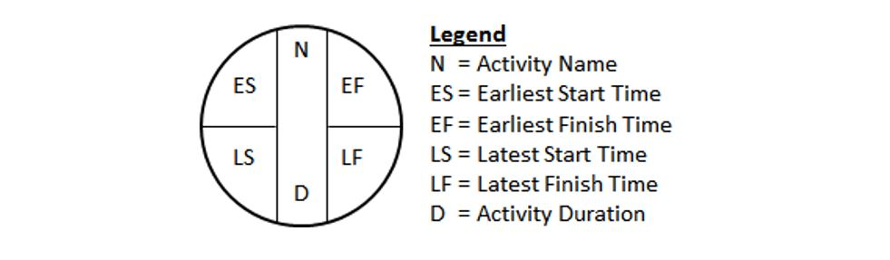

##### 

##### **Calculating Earliest Start and Earliest Finish Times**

Returning to our barbecue example, the new network diagram shows the earliest start times and earliest finish times for each activity.

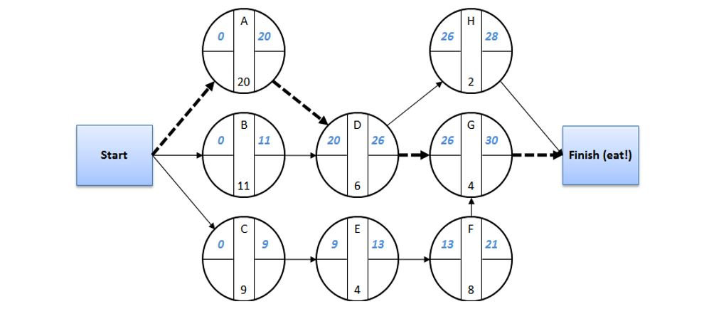

Thesenumbers werederived by workingfromlefttoright.Startingat minutezero

(0) for the earliest start times of activities A, B, and C and then adding these activities’ duration to zero (the ES for these three activities) we come up with the earliestfinishtimesofminute20,minute11,andminute9foractivitiesA,B,andC, respectively.

Theprocesscontinuesworkingtotherightaswedetermineeachactivities’ earliest start time. Notice that activity D has two immediate predecessors—activity A and activity B—so in these cases we take the largest earliest finish time of the predecessorsandusethatnumberastheearlieststarttimeforthesuccessor,activity D (A’s EF = 20 and B’s EF = 11, so we make D’s ES = 20). When there is only one immediate predecessor we simply make the ES of the successor equal to the EF of the predecessor (C’s EF = 9 so E’s ES = 9). Again, we see thatthe overall duration is still 30 minutes, but now we have a bit more detail in the diagram.

##### **Calculating Latest Start and Latest Finish Times**

When calculating the latest start times and latest finish times we follow a similar process except we work from right to left. The network diagram below shows the latest start times and latest finish times in the bottom half of the activity nodes.

Starting with activity H we ask ourselves, what is the latest time we can finish this activitywithoutincreasingtheoveralldurationoftheproject?Theanswerisminute 30, which we input as the latest finish time (LF) for activity H. Working to the left, we subtract the activity’s duration from the LF to derive the latest start time (LS), which in the case of activity H would be minute 28.

For activity G we again ask ourselves, what is the latest time we can finish this activity without increasing the overall duration of the project? The answer again is minute 30. Working down, we ask ourselves the same question of activity F, which has only one immediate successor (activity G). The answer is minute 26. The latest finishtimeofthepredecessor(activityF)isequaltothelateststarttimeofthe immediate successor (activity G), meaning activity F must be done no later than minute 26 in order to preserve the overall project duration of 30 minutes.

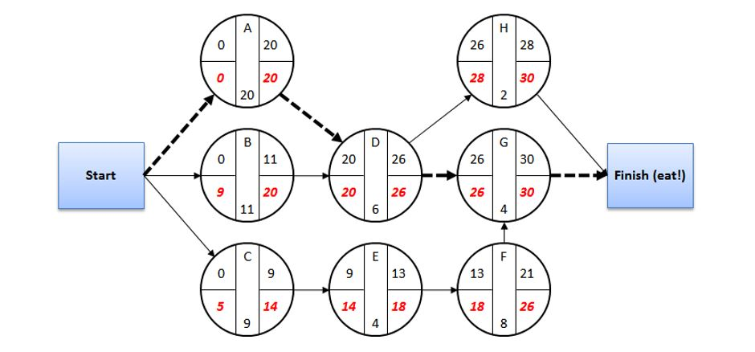

Whathappenswhenanactivityhastwoormoreimmediatesuccessorsasisthecase withactivityD?Wemustmakethatactivity’slatestfinishtimeequaltothesmallest latest start time of the successors(G’s LS =26 andH’s LS=28,sowemakeD’s LF= 26). As we continue with these calculations from right to left we end up with the latest start times and latest finish times as depicted in the diagram above.

##### **Calculating Slack Time**

It’s quite easy to calculate each activity’s slack time once we have calculated the lateststarttimesandlatestfinishtimesthroughtheentirenetwork.Asstatedabove (in step 3), slack time can be calculated in one of two ways.

* + - Slack Time = LS - ES, or
    - Slack Time = LF - EF

Thetablebelowgivesuseachactivity’sES,EF,LS,LF,andslacktimes.

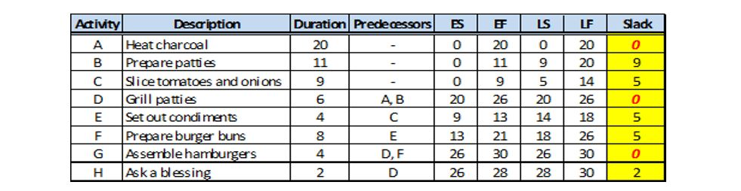

Notice that the critical path activities A-D-G have no slack time. In other words, if the duration of any one of these three activities is increased, then the overall durationoftheprojectisalsoincreased.Conversely,wehavesomeflexibility with those activities that are not on the critical, meaning they can be delayed by their slack time without pushing out the overall project duration.

Forexample,let’ssupposeyouassignedtwopeopletoslicetomatoesandonionsbut only one person shows up. Now instead of taking 9 minutes this activity will take twiceaslong(18minutes)andwillpushouttheoveralllengthoftheprojectbecause that activity only has 5 minutes of slack time (assuming two workers). However, since you know that the activity of preparing patties has 9 minutes of slack time, you reassign that person to help slice tomatoes and onions for 9 minutes. This will delay your patties preparation activity by 9 minutes, but that won’t be a problem because that activity had 9 minutes of slack time.

As can be seen in this example, skillful project managers understand that they operate in dynamic environments and know how to use slack time and other knowledge (of resource skills, availability, etc.) to help them adjust plans without adversely affecting overall project schedules.

### Project Crashing

##### Question: What does it mean to “crash” a project?

Crashing a project is a methodical process of reducing the project’s duration. Slippagetoaproject’sschedule(increasedduration)canresultinlostrevenue(due to a late introduction of a new product), tarnished reputation, or even large contractual penalties (large public works projects). When a project’s schedule is at risk of slipping, management may want to intervene by crashing the project.

**Note** that crashing a project does not mean you can eliminate required activities. Youmustshorten the project’s duration by shortening the duration of critical path activities.Thiscanbedonebyworkingovertime,subcontracting,buyingorrenting extra equipment, and so forth. Crashing involves increasing the project’s cost, so careshouldbetakentocrashtheprojectinthemostcost-effectivemannerpossible.

##### Question: What are the steps to crashing a project?

* + 1. Identify the critical path.
    2. Identify the activity on the critical path that has the lowest crashing cost per period (per day, per week, etc., whichever time bucket is being used).
    3. Crash the lowest-cost activity until (a) the crashing objective is met, (b) that activity cannot be crashed further, or (c) a new critical path emerges.
    4. If further crashing is required (crashing objective not yet met), then continue by crashing the next critical-path activity that has the lowest crashing cost per period.
    5. If two critical paths emerge, see if there is an activity that (a) is common to both critical paths and (b) would be the most cost effective to crash (cheaper than crashing two separate items, one on each critical path).
    6. Crashing ends when the objective has been met or the critical path cannot be crashed any further.

##### 

##### **Crashing Example**

For this example we’ll start by taking our previous network diagram, except in this caseitwon’tbeforabarbecue.Instead,let’sjustsupposethesearegenericactivities andthedurationsarenowinweeksandnotinminutesasinthebarbecueexample. Everything else (critical path, slack time, etc.) will be the same.

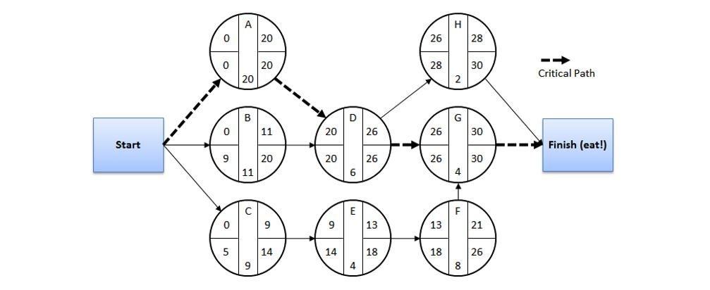

Before walking through this example we will need more information. The table below provides the required information—both given and computed.



Finally,ournewobjectiveistomakesuretheprojecttakesnolongerthan25weeks (downfromtheoriginalprojectdurationof30weeks).Thismeanswemustshorten the project by 5 weeks via crashing.

Withallthisinformationwearenowreadytowalkthroughthestepsofthecrashing process.

* + 1. Identify the critical path.
       - Action Taken: Identify A-D-G as the critical path.
    2. Identify the activity on the critical path that has the lowest crashing cost per period (per day, per week, etc., whichever time bucket is being used).
       - Action Taken: Identify activity G as the critical path activity with the lowest crash cost per week (A = $200, D = $150, and G = $75). The example below shows how we got this number for activity A and the same process was followed for all the activities in the project.
    3. Crash the lowest-cost activity until (a) the crashing objective is met, (b) that activity cannot be crashed further, or (c) a new critical path emerges.
       - Action Taken: Crash activity G by 2 weeks (from 4 weeks down to 2 weeks) at which point it cannot be crashed further. We must still shorten the project by another 3 weeks, so we proceed to the next step.
       - Cost of crashing activity G by 2 weeks = 2 x $75 = $150.
    4. If further crashing is required (crashing objective not yet met), then continue by crashing the next critical-path activity that has the lowest crashing cost per period.
       - Action Taken: No action is appropriate with this step because we now have two critical paths, A-D-G and A-D-H (each being 28 days long), and we therefore must proceed to the next step.
    5. If two critical paths emerge, see if there is an activity that (a) is common to both critical paths and (b) would be the most cost effective to crash (cheaper than crashing two separate items, one on each critical path).
       - Action Taken: Crash activity D by 2 weeks (from 4 weeks down to 2 weeks) because it has a lower crash cost per week than activity A (A =  
         $200, D = $150). At this point activity D cannot be crashed further. Now the project has been crashed a total of 4 weeks, still 1 week short of the objective.
       - Cost of crashing activity D by 2 weeks = 2 x $150 = $300.
       - Action Taken: Crash activity A by 1 week. This activity is common to both critical paths so crashing it by 1 week meets the objective of crashing the project by a total of 5 weeks.
       - Cost of crashing activity A by 1 week = $200.
    6. Crashing ends when the objective has been met or the critical path cannot be crashed any further.
       - Action Complete: The crashing objective has been met (from 30 weeks project duration down to 25 weeks—shortening the project by 5 weeks).
       - Total cost of crashing the project by 5 weeks = $650.

Uponcompletionofthiscrashing exercise,ournetworkdiagramappearsasfollows (with changes to the durations and affected start and finish times).

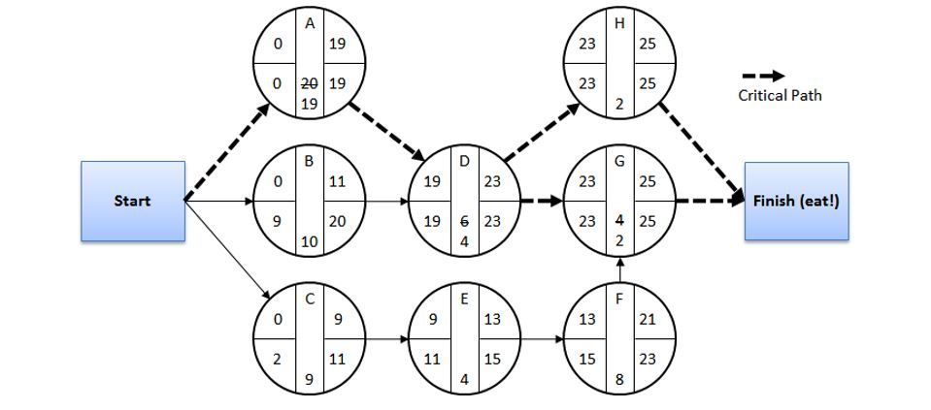

### ProjectManagementSoftware

Now that you understand how network diagrams are constructed, read, and used, you’ll be interested to know that there are sophisticated software applications that do this work.

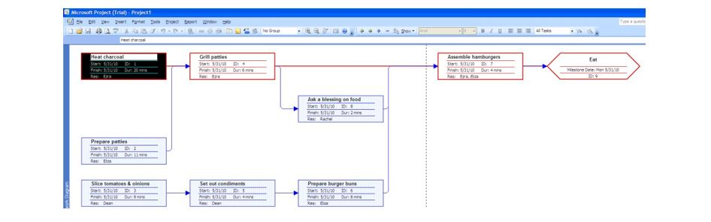

Thenetworkdiagramaboveislikeouroriginalbarbecue“project”networkdiagram, but the one above was drawn within Microsoft Project (just one of many project management software applications). You will notice that the critical path nodes (activities)arehighlightedinredandthateachonehasconfigurablefieldsthatcan display important information like start and finish times, duration, and resources, among others.

Perhaps the most popular view of a project’s schedule is a Gantt chart as shown below (again, a screen shot from Microsoft Project). Gantt charts provide an easy- to-read list of activities or tasks (on left-hand side of the graphic). Gantt charts are great for displaying a concise list of activities and for tracking a project’s progress. However, as projects become large and complex, the Gantt chart’s view of activity

interdependencies is not nearly as intuitive or easy-to-read as that found in a network diagram.

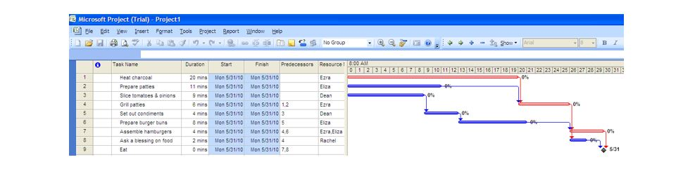

##### **More than Network Diagrams and Gantt Charts**

As can beexpected, project management softwareapplications offer many features that go beyond project scheduling. Such features include project costing, resource tracking, progress reporting, calendaring, and what-if analysis, to name a few. Hopefullythissectionhasgivenyouaflavorforsomeofthetoolsthatareavailable to help project managers.

### ChapterSummary

Belowaresomeofthemainpointsyoushouldhavegarneredfromthestudyofthis chapter.

* + - **Projects are one-time endeavors** as opposed to ongoing operations and are typically staffed and managed with a temporary organization.
    - **Projects consist of four phases:** (I) Initiation, (II) Planning, (III) Execution, and (IV) Close Out. The Creation gives us an excellent example of the phases of a project.
    - **Project managers need to be good investigators, organizers, communicators, motivators, and negotiators,** but do not have to be experts in all the functional areas involved in the project. In addition to these “soft” skills, project managers should also develop the baseline technical skills of knowing how to manually draw network diagrams, determine earliest and latest start times, compute slack times, and crash projects—even if they use project management software to help with these things.

48Abraham 4:1

49Abraham 3:22

50Abraham3:25

51Moses1:39

52

53Luke 14:28

54Abraham 3:24

55Moses3:5

56M.RussellBallard,*CounselingwithOurCouncils:LearningtoMinisterTogetherintheChurchandin the Family* [Salt Lake City: Deseret Book Co., 1997], 25 - 26.

57Moses2:31

58M.RussellBallard,*CounselingwithOurCouncils:LearningtoMinisterTogetherintheChurchandin the Family* (Salt Lake City: Deseret Book Co., 1997), 29.

59 AdaptedfromRobertH.Hayes,StevenC.Wheelwright,andKimB.Clark,DynamicManufacturing: Creating the Learning Organization (New York: The Free Press, 1988).

Read this online at <https://books.byui.edu/a_very_industrious_people/project_management>