# Inventory Management

*Behold,therecomesevenyearsofgreatplentythroughoutallthelandof Egypt…NowthereforeletPharaohlookoutamandiscreetandwise,andsethim over the land of Egypt.Let Pharaoh do this, and lethim appoint officers over the land, and take up the fifth part of the land of Egypt in the seven plenteous years.And let them gather all the food of those good years that come, and lay up corn under the hand of Pharaoh, and let them keep food in the cities.And that food shall be for store to the land against the seven years of famine, which shall be in the land of Egypt; that the land perish not through the famine. Genesis41:29,33-36*

We can learn much about managing inventory from the story of Joseph in Egypt— especially from his handling of the food supply in response to Pharaoh’s dream. First,weseehowdecisionsregardinginventory(purchaseandstorageofgrain)were largely driven by a“forecast” (Pharaoh’s dream). Second,Joseph andthe appointed officers were able to make large “forward buys” of food at a significant “quantity discount” given the bounteous harvest (oversupply) during the seven fat years. Third, the food was properly stored to extend its “shelf life” such that it would be edible or useful for the entire time it would be needed (seven lean years).

### ChapterObjectives

Quite often in business, when we think of inventory, we have a knee-jerk reaction that says we must “reduce inventory” to save on costs. Such thinking often comes when we don’t fully understand the many legitimate and useful purposes of inventory.InthestoryofJoseph,havingadequatestocksof“hedgeinventory”saved countless individuals andseveral nations, including the House of Israel. Therefore, thesimpleandtriteplatitudinousgoalof“reducinginventory”shouldbesupplanted by the more judicious goal of having *the right amount* of inventory given the situation. To help you achieve this and other inventory-related goals, this chapter will give you the ability to

* + 1. Describe the basic categories and functions of inventory.
    2. Perform an ABC analysis or classification and use that information to calculate the frequency of inventory cycle counts for each classification.
    3. Describe continuous review, periodic review, and single-period inventory systems.
    4. Calculate order quantity, reorder point, and safety stock for each inventory system.
    5. Use a quantity discount model and compute total annual inventory cost.

### OverviewofInventoryManagement

Inventory management is the branch of business management concerned with the planning and controlling of inventories. Perhaps the **most basic challenge of inventorymanagement**istobalancebetweeninventoryinvestmentandcustomer service levels. To better understand inventory management it will be useful to first learn some basic terms and concepts related to inventory.

##### Question: What is inventory?

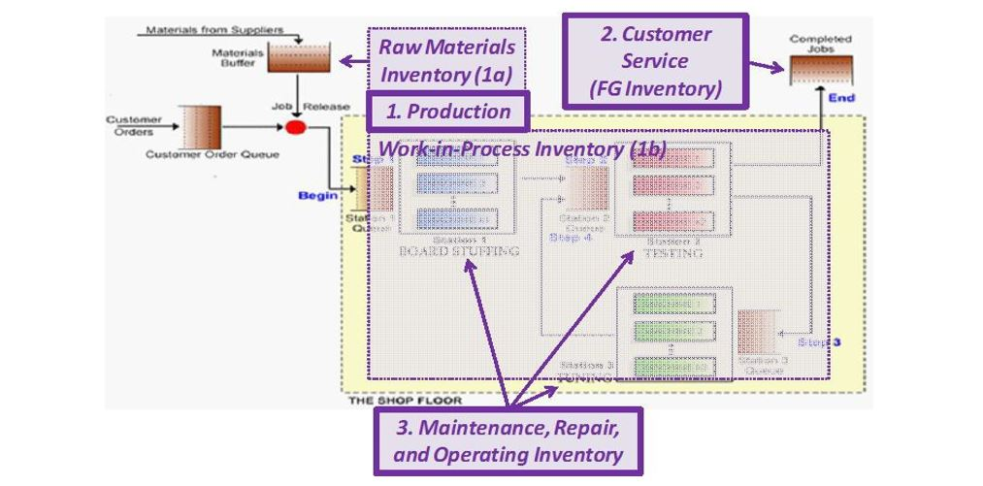

Inventoryisstockofitemsthatareusedto support:

* + 1. Production. These stocks include **raw materials** and **work-in-process.** Such items are also known as **direct materials,** meaning that stocks of these items will eventually be transformed or assembled into finished goods.
    2. Customer Service. These stocks include both **finished goods** (items that are sold to customers) and **spare parts** (which are used to service previously sold items).
    3. Maintenance, repair, and other activities. These items are sometimes called MRO or **indirect materials.** These items do not go on the product, rather they are used to keep equipment and other operations running.

The graphic above superimposes these three basic categories of inventory onto the high-levelschematicofafactorysimulation.Inadditiontothethreebasicinventory categories outlined above, inventory can be categorized further as follows:

* + - **Cycle inventory**, which includes safety stock, represents the inventory that is required from one supply replenishment to the next.
    - **Safety stock** is a quantity of stock planned to be in inventory to protect against fluctuations in demand or supply.
    - **Pipeline inventory** is the stock that is in transit between locations.
    - Anticipation inventory are stocks above and beyond basic pipeline inventory and are used to cover projected trends of increasing demands due to planned sales promotions, seasonal fluctuations, plant shutdowns and vacations.
    - **Hedge inventory** is a form of inventory buildup to buffer against an event that may or may not happen. Planning for such inventory involves speculation related to potential labor strikes, price increases, political unrest, and so forth.

### ABCClassificationandCycleCounting

##### Question: What is an ABC classification?

Loosely based on Pareto’s law (the 80-20 rule), an ABC classification is a grouping of items in decreasing order of annual dollar volume or some other user-defined criteria.ThisarrayisthensplitintoclassescalledA,B,andC.TheAgrouptypically represents 10% to 20% of the item numbers and 50% to 70% of the dollar volume. The next grouping, B, usually represents about 20% of the items and about 20% of the dollar volume. The C class contains 60% to 70% of the items and represents about 10% to 30% of the dollar volume. The ABC principle can be applied to inventories, suppliers, sales, and so forth.

##### **ABC Classification Example**

PerforminganABCclassificationisnotdifficultfromaquantitativestandpoint,but itoftenisdifficulttoacquiretherequireddata.Italsorequiresattentiontodetailin following the steps below. We will first start with this data.

* + 1. Compute the Annual Dollar Volume (column D in the spreadsheet graphic below) for each item by multiplying the Annual Unit Volume (column B) by the Unit Cost (column C) for each item.
    2. Sort the spreadsheet by column D (Annual Dollar Volume) in descending order (largest to smallest) as shown in the table below. **This is a very importantstepanditisthestepmostfrequentlyskippedbystudents who fail to properly perform an ABC classification**.
    3. Compute the % (percent) of Annual Dollar Volume (column E) by dividing the Annual Dollar Volume for each item by the sum of the Annual Dollar Volume for all items. The formula for this calculation in cell E2 can be found in the formula bar in the graphic below.
    4. Calculate the Cumulative Percentage (%) of Annual Dollar Volume (ADV) foreachitemin columnF. Theformulaforthiscalculation in cellF2 can be found in the formula bar in the graphic below.
    5. Assign theappropriate inventoryclasstoeachitemintheanalysis.(Forour purposes, thiscanbedonemanually.)Asstatedaboveintheexplanationof ABC classifications, the criteria for what constitutes each inventory group is user defined, meaning there is more than one way to perform an ABC classification. For our purposes in this example we will define A items as those items which constitute up to 80% of the total or cumulative annual dollar volume; B items from 80.01% up to 95%; and C items from 95.01% up to 100%. Performing this step gives us
       - 4 A items(20%oftheitemsmakingup77.42%ofthetotal value)
       - 6 B items(30%oftheitemsmakinguproughly15%ofthetotal value)
       - 10 C items(50%oftheitemsmakinguproughly5%ofthetotal value)

##### Question: What is the value of performing an ABC classification?

TheABCprinciplestatesthateffortandmoneycanbesavedthroughapplyinglooser controlstothelow-dollar-volumeclass(C)itemsthanwillbeappliedtohigh-dollar- volume class (A) items (as will be seen in the definition of cycle counting).

##### Question: What is cycle counting?

Cyclecountingisaninventoryaccuracyaudittechniquewhereinventoryiscounted on a cyclic schedule rather than once a year. A cycle count is usually taken on a regular, defined basis (high frequency for A items, medium frequency for B items, and low frequency for C items). By discriminating in our item-class based cycle counts, we are able to give more attention to the important items and spend less time and resources (money) on keeping track of the lower-value (C) items. Most effective cycle counting systems require the counting of a certain number of items every workday with each item counted at a prescribed frequency.

The**keypurposeofcyclecounting**istoidentifyandfixdiscrepanciesbetweenthe system’s inventory record and what is physically on hand. This way, companies reduce the risk of overcommitting or under committing to customers, as accurate data is required to make and keep delivery commitments.

##### **Cycle Counting Example**

Let’s start this example by assuming we have one hundred times the number of items used in the ABC classification example above. We’ll preserve the same proportionsofeachitemclassgivingus400Aitems,600Bitems,and1,000Citems. Let’s further suppose that we want to count each class of items as follows:

* + - 400 A items, each counted once a month (assume 20 working days)
    - 600 B items, each counted once a quarter (assume 60 working days)
    - 1000 C items, each once a year (assume 250 working days)

**How many items will we count each working day?**

$$ = \left(\frac{400\textit{ A items}}{20\textit{ days}}\right)+\left(\frac{600\textit{ B items}}{60\textit{ days}}\right)+\left(\frac{1,000\textit{ C items}}{250\textit{ days}}\right)  $$

Dividing then adding these numbers gives us 20 + 10 + 4 = **34 items per day** need tobecountedinordertocountallitemsbytheprescribedfrequency.Thisexample reinforcestheABC conceptthatgreaterattention isgiven thehigher-valueAitems than the lower-value C items.

### ContinuousReviewSystems

A continuous review system is an independent demand, **fixed-quantity** ordering systemwhichtriggersarestockingorderwheneverstockreachesacertainpoint(the reorder point). Such systems typically make use of economic order quantityor **quantity discount** models to determine *how much* to buy. They also use **reorder point** models to determine *when* to place those orders.

##### **Economic Order Quantity**

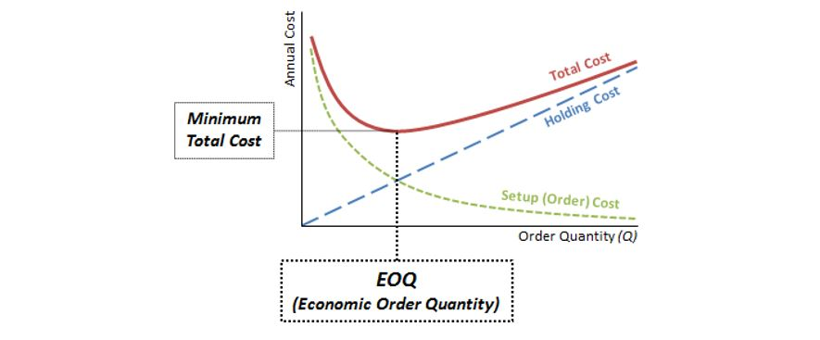

##### Question: What is the **economic order quantity (EOQ)** and how is it calculated?

Theeconomicorderquantityisatypeoffixedorder quantity modelthatdetermines the amount of an item to be purchased at one time. The EOQ formula *perfectly* balances the tradeoff between the cost of acquiring inventory (the ordering costs) and the cost of carrying or holding the inventory. The economic order quantity is that quantity in which the sum of ordering cost and holding cost is minimized (at the intersection of the holding cost and re-order cost lines as seen in the graphic above). In this course we will learn how to work with two basic EOQ formulas.

$$ EOQ = \sqrt\frac{2DS}{H}\textit{ or }EOQ = \sqrt\frac{2DS}{IC} $$

Where

*D*=annualdemand

*S*=orderingcost(theadministrativecoststoplaceanorder)

*H*=annualholdingcost

*I*=annualinterestrate

*C* =thematerialscostforone unit

##### **EOQ Example 1**

TheBYU-IdahoUniversityStorepurchasesclassroomclickersfor$360foreachcase of 20 units. Annual demand is estimated to be 3,600 units per year. It costs $70 to process and receive an order with a $2.20 holding cost per unit per year.

**What is the University Store's Economic Order Quantity (EOQ) for orders placed with its classroom clicker supplier?**

In this case, *D* = 3,600, *S* = $70, and *H* = $2.20. Hence, we input this data into the formula as follows:

$$ EOQ = \sqrt\frac{\left(2\times3,600\times70\right)}{2.20} = 479 $$

Here’s what this problem looks like when you work it in Excel.

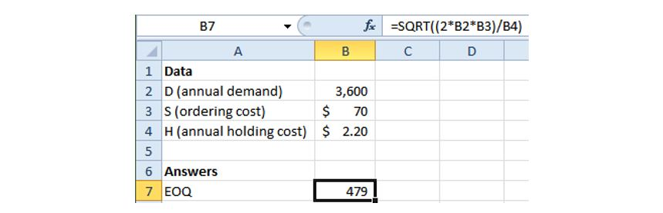

##### **EOQ Example 2**

Nowlet’ssupposethattheUniversityStoredidnothaveanaccuratecostforholding itsinventorybutitdidknowthatitcost8%toborrowmoneytomakeanypurchases andthateachclickercostthem$20.UsingthealternativeEOQequationwouldgive us the following:

* + - D = 3,600
    - S = $70
    - I = 8%
    - C = $20

Hence

$$ EOQ = \sqrt\frac{\left(2\times3,600\times70\right)}{0.08\times20} = 561 $$

Again,turningtoExcel,hereiswhatweget:

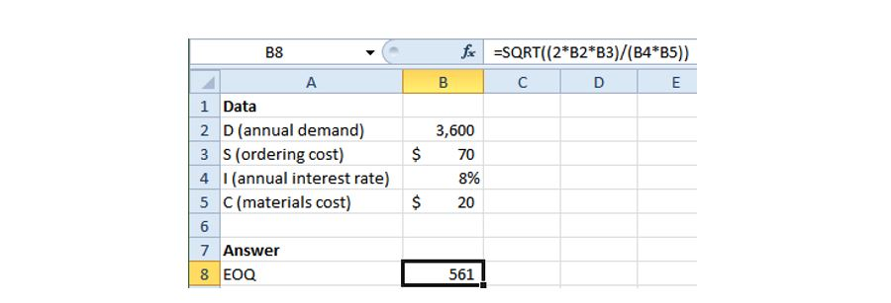

**We should be careful to note** that in these very simple examples we have been spoon fed the necessary data to perform these calculations. Quite often demand data may be expressed in monthly or weekly terms and costs may be for cases of productandnotindividualunitcosts.Therefore,itisextremelyimportanttomake sure the time bucket and unit of measure (UOM) data are consistent within the EOQ equation.

For example, if you are given *monthly* demand data but you only have an *annual* holding cost, you have a *time-bucket mismatch* and must either (1) convert the monthlydemandtoanannualnumberbymultiplyingby12or(2)converttheannual holdingcosttoamonthlyholdingcostbydividingby12.Eitherchangewillresultin thesameanswer.Theimportantpointistomakesurethatthetimebucketandunit of measure assumptions are consistent in the numerator and denominator of the selected EOQ equation.

##### Question: Is there a way—without referring to an answer key—to determine if your EOQ calculation is correct?

If you have calculated EOQ properly, the **annual ordering cost should equal annual holding cost**. Let’s use the data in Example 1 above to illustrate this fact.

**To compute annual ordering cost** we multiply the ordering cost (for one order) bythenumberofordersplacedperyear. Thenumberofordersplacedperyearcan be found by dividing annual demand by the computed EOQ.

$$ \textit{Annual Ordering Cost }=\textit{ Ordering Cost }\times\textit{ Number of Orders Placed per Year} $$

$$ \textit{Annual Ordering Cost }=\textit{ Ordering Cost }\times\frac{\textit{Annual Demand}}{EOQ} $$

$$ \textit{Annual Ordering Cost (for Example 1)} = $70\times\frac{3600}{479} = $526 $$

**To compute annual holding** cost we multiply the annual holding cost (per the designated unit of measure) by the average inventory. **When there is no safety stock**,averageinventoryisnothingmorethantheorder quantity (Q,orEOQinthis case) divided by 2.

$$ \textbf{Average Inventory} = \frac{Q}{2} \textit{or} \frac{EOQ}{2} $$

In other words, the range of stock goes from zero (when stock is completely consumed) to 479 (when a new replenishment is received). Hence, on average, the level of stock will be onehalfthe order quantity of 479. The graphic below helps to illustrate why average inventory is equal to the order quantity divided by 2.

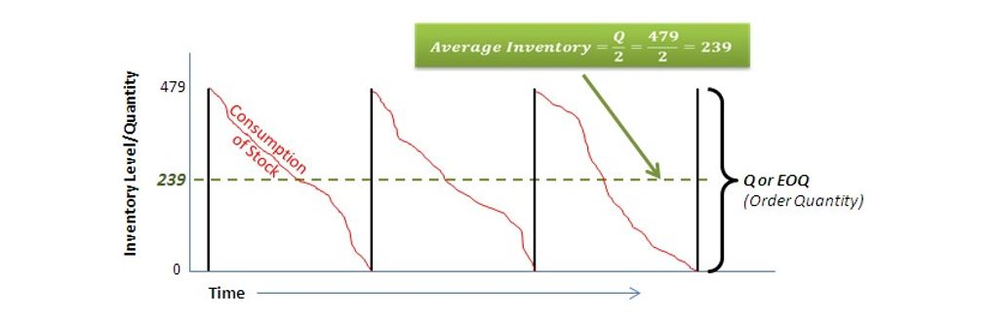

$$ \textit{Annual Holding Cost} = \textit{Annual Holding Cost (per UOM)}\times\textit{ Average Inventory} $$

$$ \textit{Annual Holding Cost} = \textit{Annual Holding Cost (per UOM)}\times\frac{Q\textit{ (or EOQ)}}{2} $$

$$ \textit{Annual Holding Cost (for Example 1)} = $2.20\times\frac{479}{2} = $526 $$

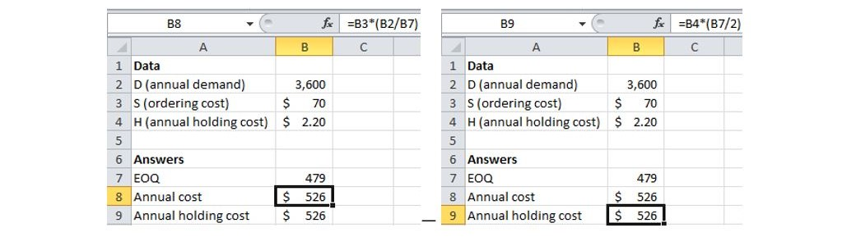

Aswecanseeinthisexample,theannualorderingcost=annualholdingcost=$526. Here’s how the formulas are written in Excel for annual ordering cost and annual holding cost, respectively.

We should note that **in practice, purchase quantities often vary from the calculatedEOQ**.Forexample,ifoursuppliersellsagivenitemincasesof400units but our EOQ is 479, we would likely set our order quantity to 400. Such a case- or lot-size restriction is just one example among several possible reasons why actual purchasequantitiesmayvaryfromacalculatednumber.Purchasequantitiescanbe adjusted to support marketing promotions, off-season purchases, transportation efficiencies, quantity discounts, and so forth.

##### **Quantity Discounts**

##### Question: What is the **quantity discount model** and how is it used?

Manycompanieswillofferquantitydiscountstotheircustomersinordertoincrease sales. In such situations, customers will make use of a quantity discount model to determine the best order quantity. A quantity discount model is a variation of the EOQ model. The main difference is that the quantity discount model must look at thetotalannualinventorycost—includingthecostofpurchasingthematerial—and not just at balancing ordering cost and holding cost. The beginning point of this analysisisascheduleofpricesbasedonrangesofordervolume.Belowisanexample of such a schedule (modified from Example 2 above).



Total annual inventory cost (ordering, holding, material cost) is calculated as follows:

$$ \textit{Total annual inventory cost} = \left(\frac{D}{Q}\right)S + \left(\frac{Q}{2}\right)H + DP $$

Or,ifholdingcost(*H*)isnotgiven,then*IP* shouldbeusedtocalculatetotalannual inventory cost.

$$ \textit{Total annual inventory cost} = \left(\frac{D}{Q}\right)S + \left(\frac{Q}{2}\right)IP + DP  $$

Where

*D*=Annualdemandinunits

*Q*=Orderquantity

*S*=Orderingorsetupcost

*I*=Annualinterestrate

*P*=Priceperunit

*H*=Holdingcostperunitperyear

Whenquantitydiscountsareofferedwemustfollowafour-stepprocessto determine the order quantity.

* + 1. Calculate the EOQ for each pricing option. If the EOQ can be purchased for the lowest price, then you are done. If not, proceed to step 2.
    2. Calculate the adjusted order quantity for each quantity discount range. If the calculated EOQ is below the quantity discount threshold, then adjust the order quantity (Q) upward to that threshold amount.
    3. Calculate the total annual inventory cost for each quantity discount, based on the adjusted order quantity (in step 2).
    4. Select the quantity discount with the lowest total annual inventory cost.

Let’sfollowthesestepswithourmodifieddatafromEOQExample2andseewhich quantity discount is best.

* + 1. The calculated EOQ of 463 for the highest discount of 2% cannot be purchased because this quantity is below the minimum order quantity requirement of 1,800 units.
    2. The minimum order quantity for each discount can be found in column D. Notice that when this minimum order quantity is higher than the calculated EOQ, then the minimum order quantity in column D is used in the calculation of annual ordering cost and annual holding cost. (The formula bar in the graphic below shows how an “IF” function is employed to make sure the right order quantity is used for calculating the annual ordering cost. The same IF-function approach is used to calculate annual holding cost as well, though the details are not shown.)
    3. Total annual inventory cost for each discount can be found in column I. The sum in cell I8 is nothing more than the sum of F8+G8+H8.
    4. In this example, the second quantity discount gives us the lowest total annual inventory cost of $72,629 and should therefore be selected.

##### **Reorder Points and Safety Stock**

##### Question: What is the **reorder point (ROP)** and how is it used in a continuous review system?

The reorder point is an inventory level where, if the total stock on hand falls to or below that point, action is taken to replenish the stock. There are several ways reorder point can be calculated, largely determined by the nature of the available data. In this chapter we will cover only one way to compute safety stock (perhaps the most common way). The diagram below not only shows the reorder point, but depicts many other elements of a continuous review (replenishment) system.

* + - **Demand during the lead time period** is typically the average demand observed from when the stock hits the order point to the time a new replenishment is received.
    - **Safety stock,** as noted at the beginning of the chapter, is to guard against fluctuations in demand, such as seen in the second replenishment cycle where lead-time demand exceeds the average and the consumption line dips into the safety stock zone.
    - The **equation for reorder point** is demand during lead time plus safety stock.
    - The **order quantity** should be matched to the computed EOQ or to the amount computed from utilizing quantity discounts.

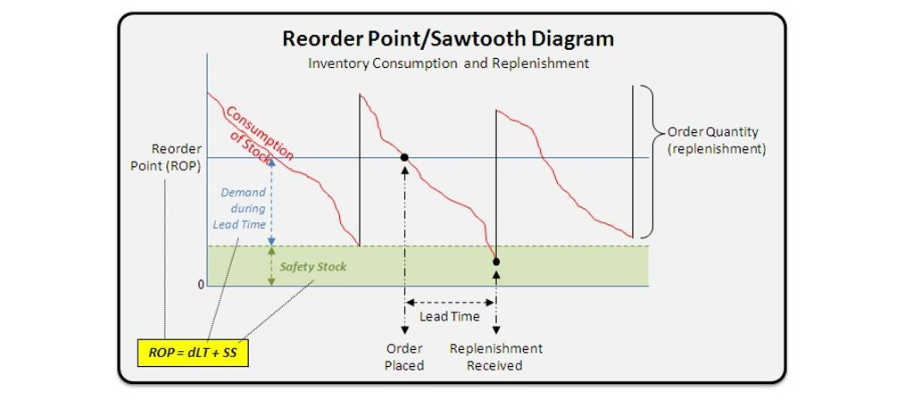

##### Question: How is reorder point (and its components) calculated?

Computing reorder point is a multi-step process. At a high level the equation is simple: demand during the lead-time period plus safety stock. It is written as follows:

$$ ROP = dLT + SS $$

Where

*dLT*=demandduringtheleadtimeperiod

*SS*=safety stock

Calculating demand during lead time is simple. For example, if demand is 3 units per day and the lead time is four days, then over the lead-time period demand will be 12 (simply 3 x 4). Calculating safety stock, on the other hand, can be a bittricky, depending on the available data. For our purposes, where lead time is constant, safety stock can be calculated using one of the two following formulas:

$$ \left(1\right) SS = Z\sigma_{dLT} $$ $$ \text{or} $$ $$ \left(2\right) SS = Z\sigma_d\sqrt{LT} $$

Where

*Z*=thez-scorethatcorrespondstothedesiredservicelevel

Tip*:*UseExcel’sNORMSINVfunctiontofindthez-score

*sdLT*=thestandard deviation ofdemandduringtheleadtimeperiod

*sd*=thestandarddeviationofdemandforasingleperiod

*LT*=thereplenishmentleadtime

Theselectionofasafetystockequationdependsonthegranularityofthegivendata. More often than not, the second safety stock equation (above) is more closely related to the kind of data that would be available in such cases.

##### Question: How do you calculate the standard deviation of demand during the lead time period?

Thestandarddeviationofdemandduringtheleadtimeperiodisnothingmorethan the standard deviation for one period times the square root of the lead time.

$$ \sigma_{dLT} = \sigma_d\sqrt{LT} $$

##### 

##### **ROP Example**

A large independent food distributor sells an average of 50 cases of tater tots each daywithastandarddeviationofdailydemandbeing7.Thereplenishmentleadtime fromthetatertotssupplieris9days.Thisdistributorisverybigoncustomer service and therefore wants to maintain a 98% service level. Given this information, what should be the distributor’s reorder point?

*d*=50(averagedailydemand)

*LT*=9

*Z*=2.054(whichcorrespondstoa98%servicelevel)

*sd*=7

Populatingthisdataintothe(second)equationwegetanROPof493(450+ 43).

$$ \begin{flalign} ROP = \textcolor{red}{dLT} + \textcolor{blue}{SS} && \end{flalign} $$

$$ \begin{flalign} \textcolor{red}{dLT} = 50\times9 = 450 && \end{flalign} $$

$$ \begin{flalign} \textcolor{blue}{SS} = 2.054\times7\times\sqrt9 = 43 && \end{flalign} $$

$$ \begin{flalign} \text{Hence, } ROP = \textcolor{red}{450}+\textcolor{blue}{43} = 493 && \end{flalign} $$

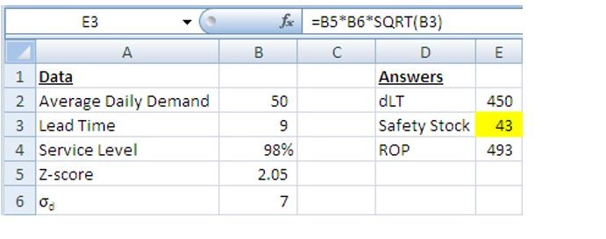

PerhapsthetrickiestpartoftheROPequationisfiguringoutsafetystock.TheExcel graphic above shows how this is done (formula from cell E3 is shown).

Thegraphicbelowdepictsthereorderpointexampleabove(althoughnottoscale). The 98% desired service level is represented by thearea under the far rightnormal distribution whichisabovethezero(0)line.The2%oftheareabelowthezeroline represents the risk of stocking out. If we had no safety stock at all, then we would have a 50/50 chance of stocking out, as shown by the far left normal distribution.

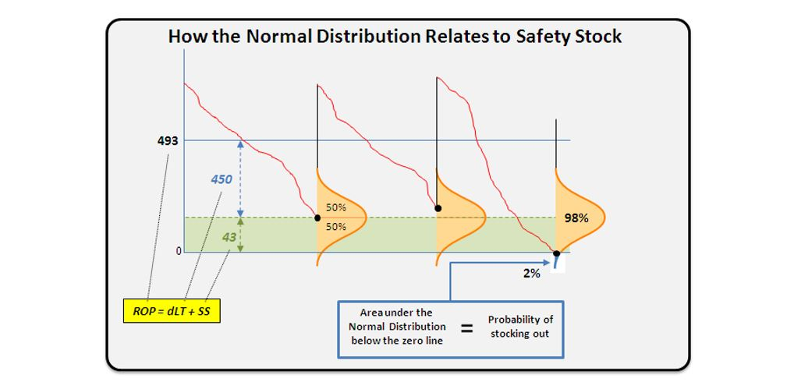

This concludes the discussion and examples related to continuous review systems, namely economic order quantity, quantity discount models, and reorder point.

### PeriodicReviewSystems

Aperiodicreviewsystemisanindependentdemand,**fixed-period**orderingsystem whichchecksinventorylevelsandplacesrestockingordersatregularintervals.Itis also known as an “order up to” system as the order quantity varies depending on how much inventory is required to bring levels “up to” the desired target.

Periodicreviewsystemsarewellsuitedtoitems forwhichrestockingiseconomical and holding safety stock is inexpensive. Examples of fixed-period systems include vendingmachinesandsnackfooddisplaysingroceryandconveniencestores.Such items are restocked on a regular (or fixed-period) basis.

Relatively speaking, periodic review systems are simple when compared to continuous review systems. In continuous review systems, perpetual inventory records are required, meaning that each addition to or withdraw from inventory must be recorded so that order quantities and order points can be correctly calculated. In a fixed-period system inventory records only have to be updated at the end of the period, just prior to placing the next order.

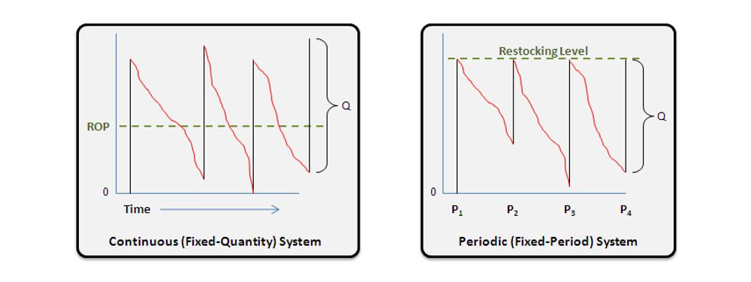

##### Question: How is the restocking level determined in a periodic system?

Themaintaskwithsettingupaperiodicsystemisdeterminingtherestockinglevel,

*R*.Theequationforcalculating*R*isasfollows:

$$ R = \mu_{RP+LT}+z\sigma_{RP+LT} $$

Where

*RP* =thereorderperiod(theregulartimeintervalbetweeneachorder)

*LT*= the order lead time (how long it takes for the order to arrive)

*μRP+LT*= average demand during the reorder period plus lead time

*σRP+LT*=standarddeviationofdemandduringthereorderperiodplusleadtime

*Z*=thez-value(whichcorrespondstothedesiredservicelevel)

##### **Restocking Level Example**

TheMCMarketsellsavarietyofsnacks,includingthe“CaramelCob”popcorntreat. Replenishmentordersforthisitemareplacedonceaweekandthereisa2-dayorder leadtime.Theaveragedailydemandis4andthestandarddeviationofdemandover thereplenishmentperiodplusleadtimeis9.TheMCMarketwantstokeeptherisk of stocking out at 10%.

**What is the MC Market's restocking level (R) for Caramel Cob popcorn treats?**

In this case,

*μRP+LT*=4x(7+2)=36

*σRP+LT*=9

*Z*=1.28(a90%servicelevelor10%chanceofstockingout)

Hence,

$$ R = \mu_{RP+LT}+z\sigma_{RP+LT} $$

$$ R = 36 + 1.28\times9 $$

$$ R = 48 $$

### Single-PeriodInventorySystems

Single-period inventory systems are used in situations where unused items cannot be used elsewhere. Example items include newspapers, magazines, calendars, and Christmas trees. When such items go unused they must be sold at a loss or simply thrownaway(atadditionalcost).Insuchcircumstancescompaniesmustweighthe costofbeing shortagainstthecostofhaving excessinventory. Thegoalofasingle- period inventory system is to establish a **target stocking point** that will strike a balance between shortage costs and excess costs.

##### Question: How is the target stocking point determined in a single-period inventory model?

Determining the **target stocking point** in a single-period inventory model is a 2- step process. We must first determine the **target service level** (a percentage) and then use it as an input into the target service point equation.

Hereisthe**targetservicelevel** equation.

$$ SL_T = \frac{C_{Shortage}}{C_{Shortage} + C_{Excess}} $$

$$ \begin{flalign} \text{Where} && \end{flalign} $$

$$ \begin{flalign} C_{Shortage} = \text{shortage cost} = \text{revenue } \textit{if} \text{ demanded — item cost} && \end{flalign}  $$

$$ \begin{flalign} C_{Excess} = \text{excess cost} = \text{item cost + disposal cost — salvage value} && \end{flalign} $$

Hereisthe**targetstockingpoint**equation.

$$ SP_T = \mu_{Demand} + SL_T\times\sigma_{Demand} $$

$$ \begin{flalign} \text{Where} && \end{flalign} $$

$$ \begin{flalign} \mu_{Demand} = \text{average} && \end{flalign} $$

$$ \begin{flalign} \sigma_{Demand} = \text{standard deviation of demand} && \end{flalign} $$

##### *Target Stocking Point Example*

**TietheKnot** isanIBC companywhichsellsavarietyofnecktiesto theBYU-Idaho community. As the semester comes to a close they must shut down their business. Of course, they want to maximize profits before shutting down, so they want to make sure they have adequate stock of ties to sell during the last week of business. During the previous six weeks they sold an average of 150 ties per week with a standard deviation of weekly demand being 21. Each tie sells for $7 and costs the company $3. A local merchant has agreed to purchase all excess ties at the end of the week for a price of $2 per tie.

**What is Tie the Knot’s target stocking point for ties during its last week of business?**

We’llstartbycalculatingthetargetservicelevel.

$$ SL_T = \frac{C_{Shortage}}{C_{Shortage} + C_{Excess}} $$

$$ SL_T = \frac{(7-3)}{(7-3)+(3-2)} $$

$$ SL_T = \frac{4}{5} = 0.80 \textit{ or } 80\textit{%} $$

With the target service level calculated, we’re now ready to calculate the target stocking point.

$$ SP_T = \sigma_{Demand} + SL_T\times\sigma_{Demand} $$

$$ SP_T = 150 + 0.80\times21 $$

$$ SP_T = 167 $$

Therefore, in order to maximize profit during the last week of sales, Tie the Knot should have 167 ties on hand after it makes its last-time purchase.

### ReplenishmentModels,IndependentandDependentDemand

Continuousreview,periodicreview,andsingle-periodreviewinventorymodelsare all examples of **independent demand** replenishment systems. Demand for items is said to be independent when it is largely out of the organization’s control. Finishedgoodsitemsandservicepartsareexamplesofindependentdemanditems. The selection of an appropriate replenishment model for such items is largely a functionofthenatureofproductdemand(andforecastingmethod),orderingcosts, the quality and availability of inventory data, and the availability of quantity discounts.

**Dependentdemand**items,ontheotherhand,areitemswhosedemandisdirectly related to or derived from the bill of material structure for other items or end products.Thesedemandsarecalculatedratherthanforecasted,aswillbediscussed in the MRP and ERP chapter.

### ChapterSummary

Belowaresomeofthemain pointsyoushouldhavegarneredfromthestudyofthis chapter.

* + - **Inventory is stock of items which is used to support production, customer service, and other activities.**
    - A basic challenge of inventory management is **balancing the tradeoff between inventory (cost) and customer service (revenue)**. Cycle inventory, safety stock, pipeline inventory, anticipation inventory, and hedge inventory are all used to support customer service.
    - ABC classification **enables the efficient tracking of stocks and the reconciling of inventory records with physical inventories.** Inventory record accuracy is critical to making and keeping delivery commitments to customers.
    - There are **three types of independent demand item replenishment models** (1—continuous review, 2—periodic review, and 3—single period), eachwithitsownorderingmethods.Takingadvantageofquantitydiscounts may require adaptation of the selected replenishment model.

Read this online at <https://books.byui.edu/a_very_industrious_people/inventory_management>