# Material Requirements Planning (MRP) and Information Systems

*Nowthesearethenamesofthedifferentpiecesoftheirgold,andoftheir silver, according to their value…Now the reckoning is thus—a senine of gold, a seon of gold, a shum of gold, and a limnah of gold.A senum of silver, an amnor of silver, an ezrom of silver, and an onti of silver.Asenumofsilverwasequal toasenine ofgold,andeitherforameasure of barley, and also for a measure of every kind of grain.Nowtheamountofaseonofgoldwastwicethevalueofasenine. And a shum of gold was twice the value of a seon.Andalimnahofgoldwasthevalueofthemall.Andanamnorofsilverwasasgreatastwosenums. Andanezromofsilverwasasgreatasfoursenums. And an onti was as great as them all.Nowthisisthevalueofthelessernumbersoftheirreckoning—A shiblon is half of a senum; therefore, a shiblon for half a measure of barley.Andashiblumisahalfofashiblon. And a leah is the half of a shiblum.Nowthisistheirnumber,accordingtotheirreckoning. Now an antion of gold is equal to three shiblons. Alma11:4-19*

WhywouldMormonincludesomanyversesrelatedtoNephitecoinageintheBook of Mormon? Are there some important things we learn from them? Here are two (plus an interesting aside).

* + - **Standardization enables organizational growth and unity.** Prior to “the reign of the judges” the Nephites had “altered their reckoning and their measure according to the minds and the circumstances of the people.” One can safely assume that such variation in reckoning and measures among different locales (cities, provinces, regions) caused confusion and hindered trade and the development of a cohesive Nephite society. The standardization of coinage and measures is a great testament to the inspiration and far-sightedness of King Mosiah, who engineered the transition of Nephite society from a monarchy to the rule of the judges, as elected by the voice of the people.
    - **Hierarchical structure enables working knowledge of complex relationships.** The hierarchical relationships of Nephite coinage provides a quick reference of relative value, highly intuitive and easily understood by all who dealt with money—especially when viewed in a hierarchical graphic like the one below.
    - **Finally, an interesting aside**…Nephite currency was ultimately tied to something of true value—grain or food.

### ChapterObjectives

Just as standardized coinage andmeasures were essential to the growth ofNephite society, standardized data and systems are essential to the successful management and growth of a business. Of course, today’s corporations deal with much greater complexitiesthanNephitecoinage,buttheprinciplessurroundingstandardization and organization of data are the same.

This chapter is a natural successor to the previous chapter’s discussion on production planning as it dives deeper into the realm of material requirements planning (MRP) and the supply chain systems which support this and other planning processes. After studying this chapter you should be able to

* + 1. Draw and interpret a bill of material.
    2. Describe the inputs to and outputs from MRP.
    3. Make MRP calculations under various sets of assumptions.
    4. Describe enterprise resource planning (ERP) and distinguish between front- office systems and back-office systems.
    5. Name the supply chain macro processes and main system transactions related to each one.

### OverviewofMaterialRequirementsPlanning(MRP)

Materialrequirementsplanningisasetoftechniquesusedtocalculaterequirements for materials. Asmentionedin theInventoryManagementchapter, MRP is usedto calculate demand for *dependent* items—the components or ingredients which are buried in a bill of material.

For example, sandwiches at a delicatessen would be considered *independent demanditems* whereasthecomponents(ingredients)wouldbe dependent demand*items*.Thedelicatessenmightuseforecaststodeterminehowmanysandwichesthey will sell whereas they would use MRP logic to calculate the demand for the components (meats, cheeses, etc.) based on the forecast for sandwiches.

##### **Question:**  What are the **inputs** to and **outputs** from MRP? How does MRP work?

ThemaininputintoMRPisthe**masterproductionschedule**.ViaMRPlogic,this schedulefortheproductionofenditemsis“exploded”throughtheproduct’sbill of material(or “BOM,” an MRP input) and netted against the **inventory status** for eachcomponent(anMRPinput)toultimatelyderivetime-phasedrequirementsfor each component within the BOM. These requirements become part of either a *purchasing action plan* or a *production actionplan*, dependingon whether the componentisa“**buy**”item(anitemthatis purchasedfromasupplier)ora “**make**” item (an item that is produced or assembled internally).

### MRP Mechanics

Suppose we are a toy manufacturer and we want to plan the material requirements for one of our toy cars. To do so we will need the following inputs: a master productionschedule,abillofmaterial,andinventorystatusforthetoycarandeach ofitscomponents. In addition to theaboveinputs, wealsowillmakeuseofseveral MRPworksheets(oneforthetoycarandoneforeachcomponent)thatwillhelpus organize these inputs so that we can make the required MRP calculations. (Note that MRP is generally done with sophisticated MRP software. However, in this text we will employ Excel-based MRP sheets to show how MRP logic works.)

Belowisthegraphicalbillofmaterialforthistoycar.Thisviewofthebillofmaterial clearly shows the parent-child relationships for alllevels of the BOM. For example, the toy car final assembly is the “parent” to two “children” components: the body and the wheel assembly. Notice that the wheel assembly is also a parent to two children: the axle and the wheel. The top level assembly in the BOM is said to be “level0”witheachsucceedinglevelbeingcalledlevel1,level2,andsoforthuntilthe bottom of the hierarchy is reached (level 2 in this case).

The BOM also shows (in parentheses) how many children are required for each parent.Forexample,eachtoycarrequiresonebodyandtwowheelassemblies.Each wheel assembly requires one axle and two wheels.

Themaster<span style="letter-spacing: -.35pt;"> </span>production<span style="letter-spacing: -.25pt;"> </span>schedule andinventorystatus—bothkeyinputstotheMRP process—can best be shown in an MRP worksheet or table, along with other key datawhicharerequiredformakingMRPcalculations.EachitemintheBOMofour toy car example will have its own worksheet, but to keep things simple we’ll begin just with the MRP worksheet for the top-level assembly, the toy car final assembly.

In the left-hand side of the table we are given information that governs how MRP willbecalculatedforthisparticularitem.Indescendingorderweseethatthisitem hasa1-weekleadtime(LT), alot size of 250, andthatthisisan “M”or “make”item (Type of item). Here are the descriptions of the row headings found in the third column of the table.

* + - Gross Requirements: The total of independent demand (**master production schedule**) and dependent demand (MRP calculated) for a component before the netting of on-hand inventory and scheduled receipts.
    - Scheduled Receipts: An open, confirmed, and committed purchase order or production order that has an assigned due date. These differ from planned order receipts, which are merely computer-generated suggestions, and not yet opened, confirmed, and committed to purchasing and production schedules.
    - Projected On-Hand: Current **inventory status** (week zero) and inventory balance projected into the future. It is the running sum of on-hand inventory minus requirements plus scheduled receipts and planned orders.
    - Net Requirements: the requirements for a part or an assembly derived by taking gross requirements for the period and subtracting the sum of the previous period’s projected on-hand balance and the current period’s scheduled receipts. (If this number is less than zero, then simply put zero.)
    - Planned Order: A computer-generated suggested order, greater than or equal to net requirements, divisible by the designated lot size. Typically, planned orders for “buy” items “**graduate**” to become **actual purchase orders** once a buyer reviews and approves them. Planned orders for “make” items become **actual production orders** once a production planner has reviewed and approved them. In MRP worksheets and systems, these approved purchase orders and production orders show up as scheduled receipts.  
      * + Planned Order Receipts: The planned receipt date and quantity of planned orders. Planned order receipts differ from scheduled receipts in that they have not been “graduated” or released by a buyer or planner (not yet opened, confirmed, and committed).
        + Planned Order Releases: The planned release date (to a supplier or to production) of planned orders. Each planned order release quantity and date will correspond to a planned order receipt quantity and date, offset by the lead time. Planned order receipts and releases are like two sides of the same coin (the coin being planned orders).

##### **MRP Process Steps for Top-Level Items**

Withtheabovedescriptions,wearenowreadytoreviewthestepsrequiredtofillin all the data in this MRP sheet. Before enumerating the steps, we must first emphasize the following points.

* + - **Do not change any data in the gross requirements row** as this is given data and must not be changed in order to properly complete this worksheet.
    - **Do not change any data in the scheduled receipts row** as this is given data and must not be changed in order to properly complete this worksheet.
    - **Do not change the initial “On Hand” quantity** which is given before the first week of the worksheet. (You will compute projected on-hand quantities for all dated weeks in the worksheet.)

Thestepsforthetop-levelassemblyareasfollows:

* + 1. **Compute net requirements** in the first week (gross requirements minus the sum of the previous period’s projected on-hand balance and the current period’s scheduled receipts). Note that if this number is zero then net requirements for that week is simply zero.
    2. **Determine planned order receipts** in the first week.
       - If there are no lot-sizing restrictions, then planned order receipts will equal net requirements.
       - If there are lot-sizing restrictions, then planned receipts must be greater than or equal to net requirements **and** divisible by the lot size.
    3. **Determine planned order releases** in the first week (equal to planned order receipts, but offset or pulled back by the number of lead time (LT) periods.
    4. **Compute projected on-hand balance** in the first week (previous period’s projected on-hand plus the current period’s scheduled receipts and planned order receipts minus the current period’s gross requirements).
    5. Repeat steps 1–4 for each week.

##### **Top-Level Assembly Example**

NowthatwehaveoutlinedtheprocessthatMRPfollows,wearereadytowalk through the steps with our toy car top-level assembly.

      1. Compute net requirements in the first week (1-Aug).

* + - * Action Taken:**Input zero** (or leave cell blank). There were no gross requirements in the first week, so net requirements will also be zero.

      2. Determine planned order receipts.

* + - * Action Taken:**Input zero** (or leave cell blank). There were no net requirements in the first week, so planned order receipts will also be zero.

      3. Determine planned order releases.

* + - * Action Taken:**Nothing**. Actually, planned order releases for the first week (1-Aug) will correspond to the planned order receipts from the second week(8-Aug) dueto the 1-weeklead time for this item. In other words, we must first see if there are any planned order receipts in the secondweek(8-Aug)beforewecaninputthepropervalue—zerointhis case—into planned order releases for the first week.

      4. Compute projected on-hand balance.

* + - * Action Taken:**Input 700**. Following the detailed description in step 4 above,weget200+500+0–0=**700** (previousweek’son-handplusthe current period’s scheduled receipts plus current period’s planned order receipts minus current week’s gross requirements).

Nowlet’sstepforwardafewweeksanddothesamecalculationsforweek3(15-Aug). Thiswillgiveusmorevariety,moreopportunitytoseehowleadtimeandlotsizing rules come into play.

      5. Compute net requirements for week 3 (15-Aug).

* + - * Action Taken:**Input 300**, derived from 1,000 – 700 – 0 (gross requirements minus previous week’s on-hand balance – current week’s scheduled receipts).

      6. Determine planned order receipts.

* + - * Action Taken:**Input 500**. Since there is a lot-sizing restriction of 250 units, wemustinput the minimum valuewhichis greaterthan or equal to the net requirements of 300 and divisible by 250.70 That number is 500.

     7. Determine planned order releases.

* + - * Action Taken:**Input 500 in week 2** (8-Aug). With a 1-week lead time, theplannedorderreleasesmustbeinputintothefieldwhichisoneweek before the planned order receipts (15-Aug). Think of it this way. With a 1-weekleadtime,inorderforcompletedproductionunitstobereceived week3(plannedorderreceipts)theunitsmustbereleasedtoproduction in week 2 (planned order releases).

      8. Compute projected on-hand balance.

* + - * Action Taken:**Input 200**, derived from 700 + 0 + 500 – 1,000 (previous week’s on-hand balance plus current week’s scheduled receipts plus current week’s planned order receipts minus current week’s gross requirements).

**Becarefulinthisprocess!** Youshouldnotethatprojectedon-handbalanceisthe lastitemcomputedinthisprocess,eventhoughplannedorderreceiptsandplanned order releases appear lower in the worksheet. Make sure you focus on walking through these steps as numbered and not as the titles appear in the worksheet.

##### **MRP Process Steps for Components (or "child" items)**

The process for filling out an MRP worksheet for the components or “child” items in the bill of material is nearly identical to the steps above. The only difference is that *we must first compute gross requirements* from the direct “parent” item *before* we proceed with step 1. For the top-level assembly, gross requirements typically comefromacombinationofsalesforecastandcustomerorders.However,forchild items, gross requirements are computed as follows:

* + - Take the planned order releases (quantities by date) for the direct parent item and multiply those quantities by the number of child items required per parent item (from the bill of materials).

##### **Component Example**

For our example we will use the wheel assembly. It is both a “parent” and a “child” item—aparenttotheaxleandwheelandachildtothetoycar(top-levelassembly).

Recall from our bill of material above that there are two wheel assemblies for each toy car. Therefore, to compute gross requirements for the wheel assembly we take the planned order releases for the toy car—the direct parent of the wheel assembly—andwemultiply those quantities by two andinputthe product ofthese factorsintothegrossrequirementsrowofthewheelassembly(asseeninthegraphic above).

Justto bethorough, weshouldworkthisprocessthrough onemorelevelinthebill ofmaterial.BelowweseethecompleteMRPworksheettableforthewheelassembly andthewheel.Theplannedorderreleasesforthewheelassemblyaremultipliedby twoandinputintothegrossrequirementsrowforthewheel.Oncedone,wecanfill out the remainder of the wheel’s MRP table.

TakenotethatourdisciplinedandpreciseMRPthoughtprocessdoesnotask,“How many wheels are there per toy car assembly?” Rather, it asks, “How many wheel assembliesaretherepertoycar?”andthen,“Howmanywheelsperwheel assembly?” MRP calculations follow this disciplined, step-by-step, level-by–level methodical process.

Output from MRP will drive purchasing and production decisions. At times, the master production schedule may need to be adjusted when purchasing and production cannot support the material and capacity requirements from MRP. In suchcases,MRPbecomesaniterativeprocess,adjustingtheMPSuntilitcanbefully supported.

### Bill of MaterialConsiderations

##### **BOM Accuracy**

Thetoy carexamplesabovearequitesimpleaswearedealing withasimple3-level bill of material. Contrast that with the bill of material for Boeing 787 Dreamliner where there are thousands upon thousands of components and many,manylevels. When all the BOM structures are properly set up and when inventory data is accurate,MRPcanbeanextremelypowerfultooltohelporganizationsmanagetheir complex material planning challenges. Needless to say, MRP is very data intensive andMRPsystemshaveexceedinglyhighstandardsfordataaccuracy(wellover99% accuracy) in order to be effective.

##### **Single Bill of Material Database is Critical**

The bill of material is central to a company. Materials are ordered based on the BOM. Product cost is calculated based on the BOM. Production and supplier schedulesareconnectedtotheBOM.Productfeatures,importanttomarketingand engineering,aretiedtotheBOM.Inlargecorporations,wheretheusesoftheBOM may vary across departments, there is a strong temptation to create department- specificBOMstomeetthosediverseneeds.However,wisecompaniesputforththe efforttomakesurethereisasinglebillofmaterialdatabasefortheentirecompany andthatthebillsofmaterialcontainedthereinmeetthediverseneedsofallinternal users.

*Yes, this is an abstract discussion for most of you. Think of it this way. How much confusionin the Christianworld is there because ofthe multiple versions of the Bible and even more interpretations of the same? Multiple bill of material databases are kind of like having multiple Bibles within an organization. A single bill of material databaseprovides“oneversionofthetruth”whichgreatlyaidsinkeepingunitywithin an organization.*

##### **Bill of Material Change Control and Managing a BOM Cutover**

Strict cross-functional controls must be put in place to keep all concerned parties “onthesamepage”withrespecttoBOMs.Billsofmaterialarelivingdocumentsthat change over a product’s lifecycle. Most manufacturers have some sort of “change controlboard”(CCB)processforreviewing,approvingandpreparingforallchanges tothebillofmaterial.AdetaileddiscussionofCCBmanagementisbeyondthescope of this book, but perhaps the following scenario will provide some sufficient food for thought.

Howshouldanorganizationhandlethetransitiontoanewcomponentinoneofits products? Suppose a computer manufacturer wants to switch to a new disk drive supplier,onewithbetterqualityandperformance.Let’ssupposethattheyalsohave atwomonths’supplyofthecurrentdiskdrives.Let’sfurthersupposethattheirsavvy customers know this change is coming. When should they make the transition to the new disk drives? Marketing, engineering, and quality assurance might want to cut over immediately to keep customers happy and minimize quality risks. On the other hand, finance and purchasing might want to use existing inventory to minimizescrapcosts.Whowins?Thisiswhereachangecontrolboardcomesin.A change control board—a committee composed of all internal stakeholders, with potentially conflicting interests—meets and determines how such decisions are handled.

### Information(SupplyChain)Systems

The discussions on MRP and BOMs above are fairly technical and comprise merely one area within a larger environment of supply chain management systems. When we look at all the systems required to run an organization, especially alarge multi- national manufacturing organization, we may feel a bit overwhelmed at the scope of data, information, and transactions contained therein. We may ask, “Isn’t there an easier way to keep track of all these business transactions? Is all the effortto set up and organize such systems really worth it?” The simple answer is, “Yes.”

At the end of the June 21, 2003 Worldwide Leadership Training Meeting, President Gordon B. Hinckley posed a similar question to Church leaders (stake presidents andbishops,inparticular)whohadbeengivencounselonhowtobestmanagetheir many, many responsibilities.

As I have been listening with you, a question has arisen in my mind as I believe it hasineachofyours.Thatquestionis,“HowcanIfindthetimetodoitall?”Letme say that there is never enough time to do it all. There is so much more than any of us can singlehandedly give attention to. I think I know something of this. I have been where many of you are today. There is only one way you can get it done. That is to follow the direction which the Lord gave Joseph Smith. To him He said, “Organize yourselves; prepare every needful thing” (D&C 88:119).

This counsel highlights the connection between getting organized and being productive, getting as much done as possible. Information technology is crucial to organizing the work of a vibrant business.

##### **Enterprise Resource Planning**

##### Question: What is enterprise resource planning (ERP)?

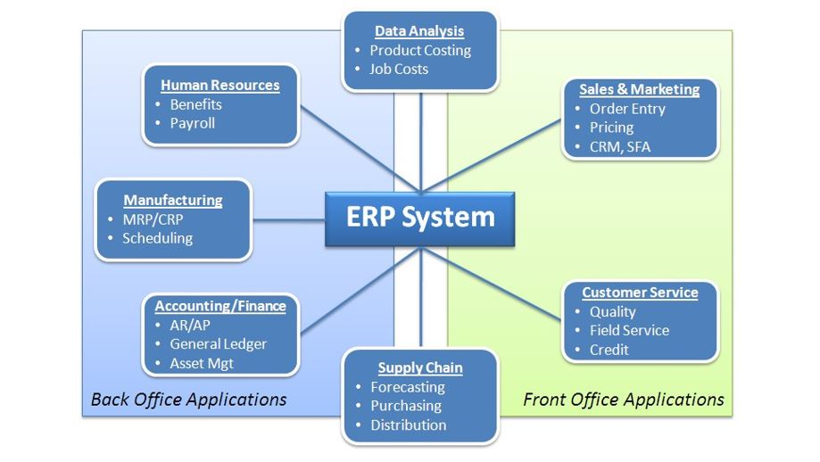

ERPis“aframeworkofsystemmodulesfororganizing,defining,andstandardizing the business processes necessary to effectively plan and control an organization so the organization can use its internal knowledge to seek external advantage.”71

An **ERP system** is an integrated information system or set of applications that serves all departments within an enterprise. ERP evolved out of the manufacturing industry and MRP systems, and implies the use of packaged software—usable by many customers—versus custom software written for one customer. ERP systems typically include software for manufacturing, order entry, accounts receivable and payable, general ledger, purchasing, warehousing, transportation and human resources. Major ERP vendors include SAP, Oracle (PeopleSoft and J.D. Edwards), SSA Global (Baan) and Microsoft.

##### Question: What are front office applications and back office applications?

ERP applicationsareoften classifiedas“frontoffice”and“backoffice”applications. Front office applications are those software modules that face customers directly. They provide functionality and data necessary to take orders, configure products, and provide effective service and support to customers. Modules include customer relationship management (CRM), sales force automation (SFA), customer support and field service.

Back office applications do not interact directly with customers. They provide functionality for internal operations such as inventory control, production and all of the supply chain activities associated with procuring goods, services and raw materials.

You shouldnote that in service operations,the “front room”is where the customer comesintocontactwiththeserviceoperation.The“backroom”referstothepartof the service operation that is completed without direct customer contact.

##### **Supply Chain Macro Processes and System Transactions**

##### Question: What are the macro supply chain processes which are supported by supply chain systems?

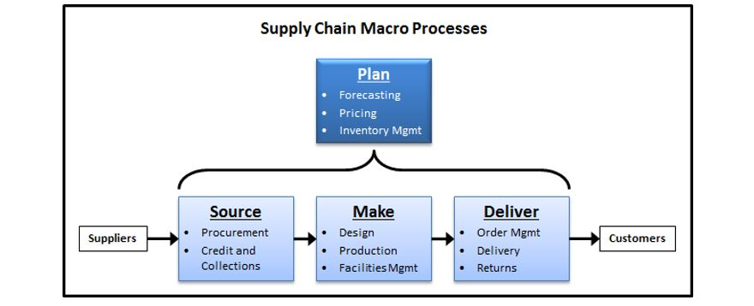

Supplychainsystemsare designedtosupportthesourcing,making, anddelivering of goods and services, as well as all related planning activities. These basic macro processes are part of virtually all organizations’ supply chains, whether they be service firms or manufacturers.

##### Question: What are a firm's basic systems transactions related to sourcing, making, and delivering of goods and services?

Thediagrambelowshowsboththephysical(material)flowsandinformationflows that are associated with the system transactions which support sourcing, making, and delivering of goods and services.

Thebasicsupplychaintransactionsdepictedonthenextpageare:

* + - Purchase orders, which support **sourcing** from suppliers.
    - Production orders, which support **making** of goods and services.
    - Transfer orders, which support **delivering** to inter-plant customers.
    - Sales orders, which support **delivering** to customers.

If you think about it, systems transactions occur every time you make a purchase from a retailer, although most retailer-to-customer transactions are less formal. Therearesomesmalldifferences,however.Whenconsumersmakeretailpurchases, they do not first create a formal purchase order in some sort of system. However, theretailerwilllogasales(order)transactionwhichisrecordedinitscomputerized inventory system. You should also note that purchase orders and sales orders are two systems transactions—one on the customer’ssystem and oneon the supplier’s system—that relate to the same movement of material.

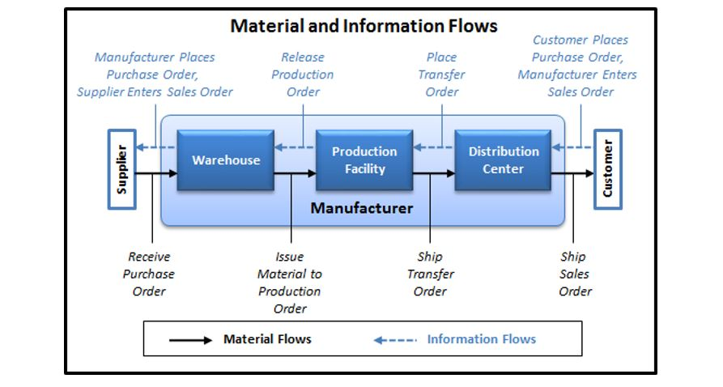

##### **Master Data – Foundation for System Transactions**

##### Question: What is master data and how does it relate to system transactions?

Masterdatareferstothatpermanentinformationwhichisfoundinamasterfileor mainreferencefile.EachERPmodulerequiresasignificantamountofsetupinorder to support the myriad transactions that correspond to business processes. (The list above of basic supply chain system transactions only begins to scratch the surface of the many transactions that are captured in an ERP system.) This setup is performed within master files, which files are maintained on a periodic basis. Examples of master files include

* + - **Item Master**—a file which contains descriptive data (size, unit of measure, etc.) and control values (lead time, lot size, etc.) for an item.
    - **Location Master**—a file which contains all possible inventory locations.
    - **Bill of Material**—a product structure record which defines the relationship of one component to its immediate parent item and governs how material requirements are computed.
    - **Routing Sheet**—contains a listing of all the operations to be performed within a given process.
    - **Approved Vendor List (AVL)**—a list of suppliers which have been approved through the firm’s formal vendor selection process.
    - **Vendor Master**—contains the name, address, terms, quality rating, and shipping method for each vendor.
    - **Customer File**—contains contact information, discount schedule, credit rating, billing and ship-to addresses, and other related information.
    - **Employee Master**—contains pertinent information on each employee such as hire date, birth date, title, wage, and job class.

Thinkofitthisway,masterfilesarelikethestreetsinacityandtransactionsarelike the driving routes individual cars take. Master files govern how transactions will take place just as streets govern where the cars can go.

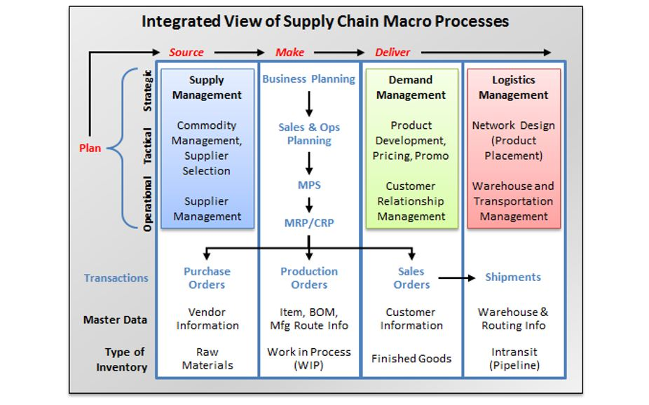

Thediagramaboveprovidesaconceptualframeworkthatlinksinventorytypeand master data titles with corresponding supply chain system transactions. Additionally, it attempts to connect some of the planning concepts in this chapter (MRP)withsomeofthosediscussedinotherchapters(businessplanning,salesand operations planning, master production scheduling, supply management, demand management, and logistics management).

When companies make the effort to organize business processes and supporting supply chain systems (which collect, process, and disseminate information), employees can be more productive in their planning, decision making, and operationalcontrol processes. Lack ofsucha foundation can bring anorganization to its knees, while business process and information technology excellence can facilitate rapid and sustained growth.72

### ChapterSummary

Belowaresomeofthemainpointsyoushouldhavegarneredfromthestudyofthis chapter.

* + - **Output from the MPS drives MRP**, which calculates requirements for dependent demand items. MRP output drives purchasing and production decisions.
    - **MRP is highly dependent on data accuracy, particularly in the bill of material.**
    - **Standardized data and systems are essential to the successful management and growth of a business.** Adequate effort invested in system and master data setup and maintenance will result in opportunities to automate business processes and system transactions, helping to improve productivity.

70Lot-sizing restrictions are production (or purchase) order policies that say, in effect, “We’re not goingtoproduceanyunitsunlesswecanproduceinincrementsof250(orwhatever thenumbermay be).

71APICS OnlineDictionary,12thedition,

72Wal-Mart, Dell, Cisco Systems, and Oracle all provide great examples of how companies have effectively used information technology to support both organic growth and growth through acquisition.

Read this online at <https://books.byui.edu/a_very_industrious_people/material_requirements_planning_mrp_and_information_systems>