# Chapter 1: What is Public Health?

### Vocabulary List

(Merriam-Webster, 2023)

* **Cessation:**Stop
* **Imitation:**Something produced as a copy.
* **Paraphrase:** A restatement of a text or passage giving the meaning in another form, as for clearness.
* **Plagiarism:** A piece of writing or other work reflecting such unauthorized use or imitation.
* **Radiation:**The process of emitting radiant energy in the form of waves or particles
* **Restating:** To state again or in a new way.
* **Sedentary:** Doing or requiring much sitting; not physically active.
* **Synonym:** one of two or more words or expressions of the same language that have the same or nearly the same meaning in some or all senses
* **Thesaurus:** A book of words and their synonyms
* **Transcript:** A written, typewritten, or printed copy; something transcribed or made by transcribing.
* **Vaccinate:**To administer a vaccine, usually by injection.

### Introduction

Public health is a scientific discipline that deals with health on a population level. Those who work in public health rely on accurate scientific data to make informed decisions on healthy lifestyles, disease prevention, and so on. Public health professionals use academic or scientific writing to ensure the information given to the public is clear and accurate. This course, and all other public health courses, expect students to write objectively and attribute ideas and words of other people appropriately. Academic or scientific writing skills are highly valuable for success in all of your university courses and the public health field. This first week will introduce the science of public health and present the writing format used in public health writing and publication.

### What is Public Health?

Public health differs from medical care because it addresses health on a population level rather than an individual level. Public health studies groups. These groups could be a community, a country, or the whole world. (What Is Public Health?, 2015)

Public health professionals do both surveillance and research to understand the outcomes or health risks that groups of people are exposed to, and they plan interventions to prevent disability and disease.

They study the magnitude of the health risks and how the risks are distributed among different places or different cultures or socioeconomic groups. It is important to learn the causes of diseases to plan how to prevent them.

Disease risk factors may come from many of the following:

* Hereditary factors/Genetics
* Environment, like air pollution, radiation, or contaminated foods
* Social determinants like poverty, lack of education, or gender discrimination

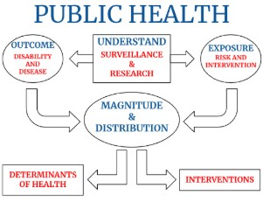

Public health seeks both to keep people healthy and to ensure they have access to healthcare when needed. For example, they work on reducing smoking rates to lower cancer risks. For those who already have cancer, public health workers make effective cancer treatment available.

Health systems need to have both capability and capacity. That is the capability to care for the sick and provide care to all those who need it.

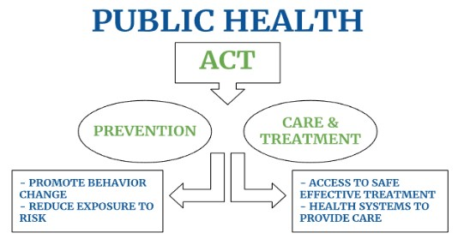

#### Another Definition of Public Health

"The activities that ensure conditions in which people can be healthy. These activities include community-wide efforts to identify, prevent, and combat threats to the health of the public."  - Institute of Medicine Definition of Public Health (National Association of County & City Health Officials, n.d.)

#### Important Note:

Public health does not work with individuals one-on-one as clinicians. A clinician is someone such as a nurse or doctor. When you complete the Community and Environmental Health Certificate or graduate with an associate’s or bachelor's degree in Applied Health, you will not be able to work as a clinician without further schooling.

Public health interacts with health on a population level. This work may be done in groups, communities, countries, on a global scale, and so on.

If public health professionals do not work with people one-on-one, then what do they do? The primary responsibilities of public health include the following: "10 Essential Services." (Centers for Disease Control and Prevention, Office for State, Tribal, Local and Territorial Support, 2014)

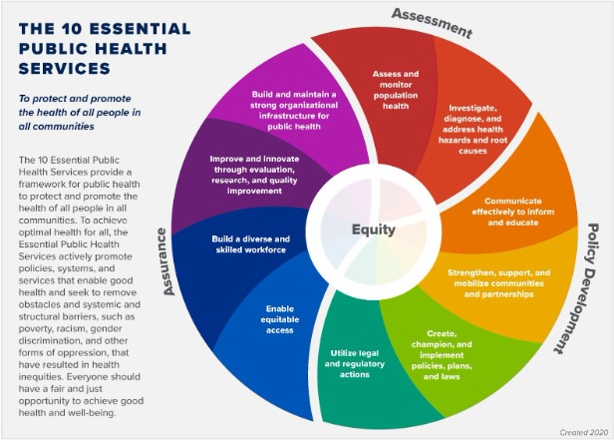

(Centers for Disease Control and Prevention, 2023)

10 Essential Services:

1. Monitor health status.
2. Diagnose and investigate problems.
3. Inform, educate, and empower people.
4. Mobilize community partnerships.
5. Develop policies.
6. Enforce laws and regulations.
7. Link people to needed services.
8. Assure a competent workforce.
9. Evaluate effectiveness, accessibility, and quality of services.
10. Research new insights and solutions for problems.

Here are examples of public health which have made a positive difference in population health:

* Vaccinations.
* Smoking cessation.
* Safety in the workplace.

What other examples can you think of?

### Public Health and The Church of Jesus Christ of Latter-day Saints

In 1833, the Lord revealed the Word of Wisdom to Joseph Smith in response to his question regarding the brethren using tobacco in their meetings (The Church of Jesus Christ of Latter-day Saints, 2018).

* Read [Doctrine and Covenants section 89](https://www.churchofjesuschrist.org/study/scriptures/dc-testament/dc/89?lang=eng).
* Consider this question: How can the Word of Wisdom relate to public health efforts?

#### Optional Additional Materials

Video "[This is Public Health](https://cdnapisec.kaltura.com/p/1157612/sp/115761200/embedIframeJs/uiconf_id/47306393/partner_id/1157612?iframeembed=true&amp;playerId=kaltura_player_1651790782&amp;entry_id=1_gggzap32)" (03:01 mins, "[This is Public Health](https://docs.google.com/document/d/e/2PACX-1vR6NP62upLG8asOGa9eYUwcNWsbwT-YiChwyVE-H9GYiJtjbp0-e4CG0UVgsDSkmtPBrJ6e7GU73DhF/pub)" Transcript) and while watching the video, record your thoughts on the following:

* Things in your community you may not have previously thought of that are related to public health.
* Why are these things related to public health?

Video: [What is public health?](https://youtu.be/jA8uYvJ_i8Y)

Job Skills: Paraphrasing and Summarizing

When you report on the information you find online, you must not copy it directly into your document. Copying is considered plagiarism and is dishonest because you claim it as your own when written by someone else. Therefore, it is important to report information by either paraphrasing or summarizing. In either case, you also need to cite your source to give credit to where you found the information. Chapter 4 of this textbook will explain how to cite your sources properly.

Paraphrasing means using your own words to report the information, changing the words from your source into your way of explaining them. Paraphrasing text can be challenging, especially with academic content or if English is not your first language.

Summarizing means rewriting the main points of a long passage of text into a few sentences.

Job skills: Paraphrasing and summarizing are important skills used in the professional writing of public health workers. This week, we will learn about and practice paraphrasing and summarizing. This will also help you avoid plagiarism as we move through the course.

### 

### Study Skills: Turnitin

Purpose: Explain what Turnitin is used for and how to improve your paraphrasing skills.

Turnitin is an online program that checks the originality of the work you submit. Turnitin will help you improve your writing and avoid plagiarism. This program is used in this course to provide immediate feedback so that you will know what needs to be fixed in your writing before submitting your assignments.

#### 

##### How to use Turnitin

To check your Turnitin score, select the Grades tab on the left side of your screen.

On the Grades page, you will see a colored flag on the right side of the assignment you have turned in (as shown in the picture below). The colored flag may take a few minutes to appear after submitting your assignment. Select this colored flag (the color can vary).



Each colored flag indicates the degree to which Turnitin has matched your work to that of other people's assignments. The different flags and their plagiarism percentages are as follows:

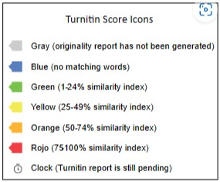

Once you have selected the colored flag, you will see a number on the right-hand side which indicates the plagiarism score. This score will show you all the highlighted text in your work that Turnitin has flagged as copied.

A red flag indicates that you have a plagiarism score of 75% or higher. Your work will then be flagged and your instructor will be notified. You can resubmit your work as many times as you want as long as it is submitted before the assignment’s due date.

### Introduction to Public Health Term Paper Project

In this course and throughout the Applied Health program, you must find and analyze academic literature on public health. Each step of the term paper will help you learn a different skill needed to demonstrate your ability in this area.

**NOTE:** It is extremely difficult, if not impossible, to type a paper in APA format on a phone or mobile device. Please do your best to find a computer, preferably one with Microsoft Word or Google Docs, either of which can be used for this assignment.

#### Project Overview

1. Each step of the term paper will help you learn a different skill needed to demonstrate your ability in this area.
   * You will be writing a 2–3 page term paper (with a title page and reference page, a total of 4–5 pages) on a health topic about a specific target population and target location.
   * The tasks will be broken down into six weeks.
   * You will use the **same** topic, **same** target population, and **same** target location for all term paper assignments each week.

**A breakdown of the tasks for each section of your paper is listed below.**

W02 Term Paper: Title Page & Resources  
Choose a topic, target population, and target location for your research paper. Create your title page and find three scholarly, peer-reviewed articles on your topic.

W03 Term Paper: Intro & Prevalence  
Write your Introduction and Prevalence paragraphs. This assignment allows you to demonstrate your ability to write an introduction that hooks your reader, states your thesis, and includes a prevalence paragraph that explains the prevalence of the problem within your target population and target location.

W04 Term Paper: Data & Interventions  
Write the data and intervention paragraphs of your paper discussing two interventions that have been implemented.

W05 Term Paper: Conclusion & Rough Draft  
Using the content of the paper you created last week, write the conclusion of your paper. Use this section to highlight some of the challenges that remain in addressing the health problem in the target population and area you are studying.

W06 Term Paper: Edits & Revisions  
Make revisions to your rough draft of your term paper. Take the opportunity to revise the previous parts of your paper and receive feedback before you submit the final draft of your term paper.

W07 Term Paper: Final Draft  
Make final revisions and submit the final edition of your term paper.

#### References

https://youtu.be/jA8uYvJ_i8Y

Centers for Disease Control and Prevention. (2023, March 6). 10 Essential Public Health Services. Centers for Disease Control and Prevention. https://www.cdc.gov/publichealthgateway/publichealthservices/essentialhealthservices.html

Centers for Disease Control and Prevention, Office for State, Tribal, Local and Territorial Support. (2014). The 10 Essential Public Health Services: An Overview. https://www.cdc.gov/publichealthgateway/publichealthservices/pdf/essential-phs.pdf

Merriam-Webster. (2023). Merriam-Webster Dictionary. Merriam-Webster. https://www.merriam-webster.com/

National Association of County & City Health Officials. (n.d.). Public Health 101. https://view.officeapps.live.com/op/view.aspx?src=https%3A%2F%2Fwww.naccho.org%2Fuploads%2Fdownloadable-resources%2FPublic-Health-REVISED-April-13.ppt%23%3A~%3Atext%3DWhat%2520is%2520Public%2520Health%253F%2Cthe%2520health%2520of%2520the%2520public&wdOrigin=BROWSELINK

The Church of Jesus Christ of Latter-day Saints. (2018). Chapter 15: Holy Places. In Saints, The Story of the Church of Jesus Christ in the Latter Days (Vol. 1, pp. 167–168). Intellectual Reserve, Inc. https://www.churchofjesuschrist.org/study/history/saints-v1/15-holy-places?lang=eng&id=p42-p49#p42

What is public health? (2015). https://youtu.be/jA8uYvJ_i8Y

Read this online at <https://books.byui.edu/pubh_240_readings/chapter_1_what_is_public_health>