# Unit Conversion Involving Area

This section demonstrates how to solve unit conversions involving area. There are two problems to solve. Walk through the first problem alongside the text, then complete the second problem on your own before coming back to check your answer.

### Example 1

A rectangular garden has dimensions of 12 meters by 8 meters. If the area of the garden needs to be expressed in square feet, what is the equivalent area in square feet (1 meter = 3.2808 feet)?

To solve this problem, first determine what you already know and what question needs answered.

The problem gives the following information: 

* Formula for the area of a rectangle:
* The garden's length is 12 meters.
* The garden's width is 8 meters.
* 1 meter is equal to 3.2808 feet.

Considering the information above, what is the garden's area in square feet?

Open an Excel spreadsheet to help with your calculations. Create a table like the one below.

First, convert meters to feet by multiplying the dimensions in meters by the number of feet in a meter (3.2808 feet). The garden is 12 meters long; to convert meters to feet, enter this equation into Excel:

$$ \text{=12*3.2808} $$

The garden is **39.3696 feet long**.

Use the same process to find the garden's width in feet. The garden is 8 meters wide; to convert meters to feet, enter this equation into Excel:

$$ \text{=8*3.2808} $$

Press **Enter** to solve.

The garden is **26.2464 feet wide**.

To calculate the area in square feet, use cell referencing to multiply the garden's length in feet (B2) by its width in feet (B4). The Excel equation will look like this:

$$ \text{=B2*B4} $$

Press **Enter** to solve. The solution's units will be in square feet.

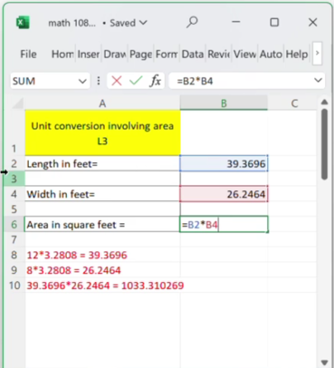

The area of the rectangular garden in square feet is **1,033.310269 square feet**, which is aproximately **1,033 square feet**(rounded to the nearest square foot).

### 

### Example 2

A rectangular tabletop has dimensions of 150 centimeters by 90 centimeters. If the area of the tabletop needs to be expressed in square meters, what is the equivalent area in square meters (1 meter = 100 centimeters)?

Solve this problem on your own, then return to check your answer. The solution is shown below. If your answer is incorrect, continue reading to see how to solve it correctly.

View Solution

The equivalent area of the rectagular tabletop in square meters is **1.35 square meters**.

To solve this problem, first consider what you know and what question needs answered.

The problem gives the following information:

* Formula for the area of a rectangle:
* The tabletop's length is 150 centimeters.
* The tabletop's width is 100 centimeters.
* 1 meter is equal to 100 centimeters.

Considering the infomation above, what is the area of the tabletop in square meters?

Open an Excel spreadsheet to help with your calculations. Create a table like the one below.

First, convert the dimensions from centimeters to meters by multiplying the dimensions in centimeters by the number of meters in one centimeter. There are 100 centimeters in a meter, which means there are 0.01 meters in one centimeter. The tabletop is 150 centimeters long; to convert centimeters to meters, enter this equation into Excel:

$$ \text{=150*0.01} $$

Press **Enter** to solve.

The tabletop is **1.5 meters long**.

The tabletop is 90 centimeters wide; to convert this measurement into meters, enter this equation into Excel:

$$ \text{=90*0.01} $$

Press **Enter** to solve.

The tabletop is **0.9 meters wide**.

To find the area of the tabletop in square feet, use cell referencing to multiply the tabletop's length in feet (B22) by its width in feet (B24). The Excel equation will look like this:

$$ \text{=B22*B24} $$

Press **Enter** to solve.

The equivalent area of the rectangular table top in square meters is **1.35 square meters**.

Read this online at <https://books.byui.edu/math_for_the_real_world_transcripts/unit_conversion_involving_area>