# Exponential Equations

This section demonstrates how to graph exponential equations. There are two problems to solve. Walk through the first problem alongside the text, then complete the second problem on your own before coming back to check your answer.

### Example 1

Consider the exponential function below:

$$ f(x)=2^{x}+3 $$

1. Calculate the y-intercept of the exponential function.
2. Determine the equation of the horizontal asymptote.
3. Determine whether the exponential function exhibits growth or decay.

Graph the quadratic equation to visually confirm your answers.

Remember:

1. To calculate the y-intercept solve for f(0).
2. The horizontal asymptote is
3. When b is greater than one, the graph exhibits growth.
4. When b is greater than zero but less than one, the graph exhibits decay.

Calculate the y-intercept of the function. Remember, the x-value of the y-intercept will always be zero; solve the exponential equation for f(0) to calculate the y-value of the y-intercept.

$$ f(0)=2^{0}+3 $$

Any number to the power of zero is 1.

$$ f(0)=1+3 $$

$$ f(0)=4 $$

The coordinates of the y-intercept are **(0,4)**.

Determine the equation of the horizontal asymptote. Exponential functions always follow the form below:

$$ f(x)=a*b^{x}+c $$

The equation for the horizontal asympote is y=c; the value of c in this equation is 3.

The equation for the horizontal asymptote is **y=3**.

Determine whether the graph is increasing or decreasing. Remember, if the value of b is greater than 0 but less than 1, the graph exhibits decay. If the value of b is greater than one, the graph exhibits growth. The value of b in this exponential function is 2. This exponential function exhibits **growth** because the value of b is greater than 1.

1. The coordinates of the y-intercept are **(0,4)**.
2. The value of the horizontal asymptote is **y=3**.
3. The graph exhibits **growth**.

Plot the equation on [Desmos.com](https://www.desmos.com/calculator) or another graphing device to visually confirm your answer.

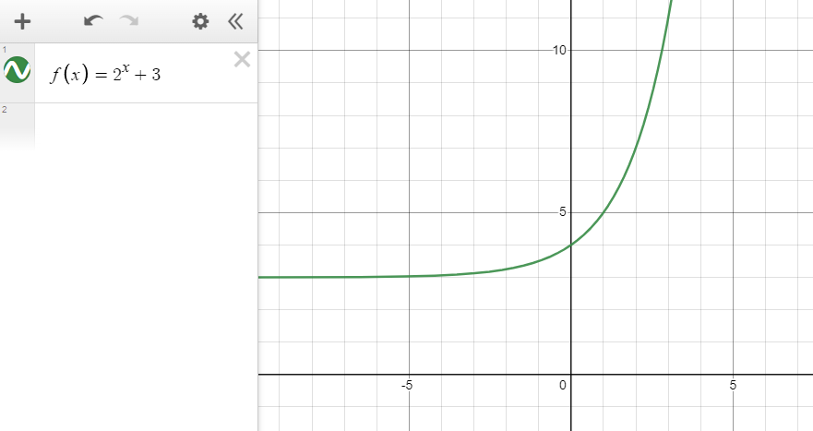

### 

### Example 2

Consider the exponential function:

$$ g(x)=0.5^{(x-1)} $$

1. Calculate the y-intercept of the exponential function.
2. Determine the equation of the horizontal asymptote.
3. Determine whether the exponential function exhibits growth or decay.

Graph of the exponential function to visually confirm your answers.

Solve this problem on your own, then return to check your answer. The solution is shown below. If your answer is incorrect, continue reading to see how to solve it correctly.

View Solution

1. The coordinates of the y-intercept are **(2,0)**.
2. The value of the horizontal asymptote is **y=0**.
3. The exponential graph exhibits **decay**.

The x-value of the y-intercept is always 0. Solve the original exponential function for g(0) to calculate the y-value of the y-intercept.

$$ g(0)=0.5^{(0-1)} $$

$$ g(0)=0.5^{-1} $$

Any value with an exponent of -1 is equal to the reciprocal of its base. In this case, the base is 0.5, or 1/2. The reciprocal of 1/2 is 2/1, or 2.

$$ g(0)=2 $$

The coordinates of the y-intercept is **(0,2)**.

The equation of the horizontal asymptote is y=c. The value of c is not visible in the function, so its value is 0. This function's horizontal asymptote is **y=0**.

Determine whether this graph exhibits growth or decay. Consider the leading coefficient; in this equation, the leading coefficient is 0.5. The graph exhibits **decay** because the leading coefficient is less than one but more than zero.

Solutions:

1. The coordinates of the y-intercept are **(0,2)**.
2. The horizontal asymptote is **y=0**.
3. The exponential graph exhibits **decay**.

Plot the equation on [Desmos.com](https://www.desmos.com/calculator) or another graphing device to visually confirm your answer.

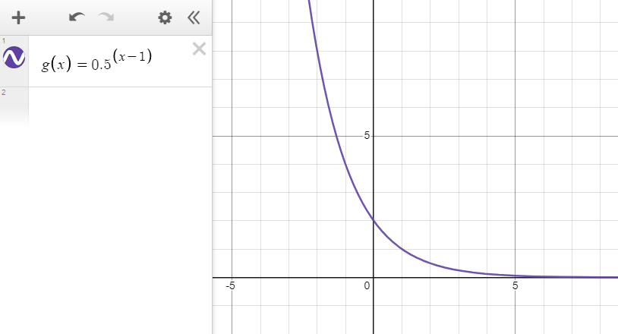

Read this online at <https://books.byui.edu/math_for_the_real_world_transcripts/exponential_equations>