# Natural (Logical) Consequences

### Key Terms:

* Natural Consequences: Natural consequences are those things that happen in response to your child's behavior without parental involvement. These consequences are imposed by nature, society, or another person. Natural consequences are not something you deliver yourself.
* Logical Consequences: Logical consequences are consequences for actions that are reasonable, respectful, and related to the action. "If you break it, you buy it" principle.

## Why is it important to know?

Understanding the distinction betweennatural and logical consequences is crucial for teachers as it influences their approach to classroom management and discipline.Natural consequences are outcomes that naturally result from a student's behavior, without intervention from the teacher. Teachers who recognize and allow natural consequences provide students with the opportunity to learn from their actions. On the other hand, logical consequences are imposed by the teacher to teach responsibility and encourage positive behavior. Knowing when to apply each type of consequence enables teachers to create a balanced and effective disciplinary strategy that fosters a positive and respectful learning environment. It also helps in promoting a sense of fairness and accountability among students, contributing to their overall social and emotional development.

## When is it important to implement Logical Consequences?

Here are times when you would want to implement Logical Consequences:

* Repeated Misbehavior: When a student consistently engages in disruptive or inappropriate behavior despite previous interventions.
* Disrespectful Language or Behavior: Instances where a student demonstrates disrespect towards peers, teachers, or property.
* Violation of Classroom Rules: When a student knowingly and willfully breaks established rules within the classroom.
* Interference with Learning: If a student's actions impede the learning process for themselves or others in the class.
* Dishonesty or Cheating: When a student engages in dishonest practices such as cheating on exams or plagiarizing.
* Property Damage: Instances where a student intentionally damages school property or the belongings of others.
* Refusal to Follow Instructions: When a student consistently refuses to follow reasonable and appropriate instructions from the teacher.
* Inappropriate Use of Technology: Misuse of electronic devices or online platforms during class time.
* Disruptive Behavior During Assessments: If a student disrupts the examination environment or engages in inappropriate behavior during assessments.

It is important for teachers to consider the context and severity of the behavior when deciding on the appropriate logical consequence. Additionally, logical consequences should aim to be educational, promoting responsibility and encouraging positive behavioral change.

## What are some examples?

|  |  |
| --- | --- |
|  |  |
|  |  |
|  |  |
|  |  |
|  |  |
|  |  |
|  |  |
|  |  |
|  |  |
|  |  |
|  |  |
|  |  |
|  |  |

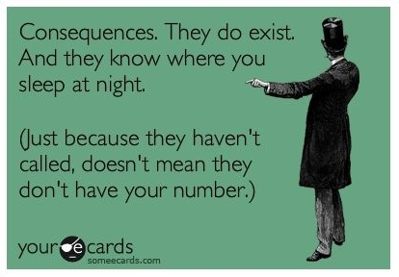

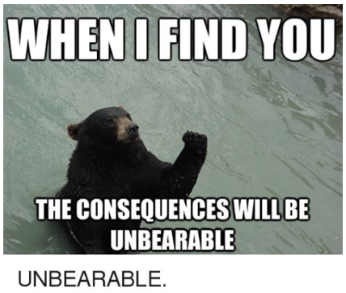

**Recorces**

Barth, K., Masri, K., & Curtis, C. (2019). Oklahoma Cooperative Extension Service Co-Parenting for Resilience.         <https://extension.okstate.edu/fact-sheets/print-publications/t/parenting-with-natural-and-logical-consequences-t-2390.pdf>

Team, T. T. P. (2020, August 28). Natural Versus Logical Consequences - Parenting Now. <https://parentingnow.org/natural-versus-logical-consequences/>

Read this online at <https://books.byui.edu/the_science_of_learning/confabulation>