# Trait anxiety vs. State Anxiety

**State Anxiety vs. Trait Anxiety & How the OCEAN Personality Model Relates**

**Key Terms:**

o   *State Anxiety* - a temporary, situation-specific emotional state characterized by feeling of tension, apprehension, and nervousness.

o   *Trait Anxiety* – a more stable and enduring form of anxiety that is more personality related and presents a general predisposition to respond to situations with a heightened level of anxiety.

o   *The OCEAN Personality Model* – also known as the Big Five Personality Model, and the only personality model based in any form of research, consists of Openness, Conscientiousness, Extraversion, Agreeableness, and Neuroticism.

**What is State Anxiety?**

State anxiety refers to a temporary state of anxiety that is typified by feelings of tension, apprehension, and nervousness. State anxiety can vary in its intensity and is specially triggered by particular situations or events. It is the response one experiences emotionally in the face of a perceived threat, challenge, or stressor, and the response changes in conjunction with the changing circumstances and environment. Seeing as state anxiety is context-dependent, common stress-inducing events such as public speaking, job interviews, and taking exams can cause the presentation of state anxiety. State anxiety also includes a myriad of physiological responses in sequence with the cognitive components that characterize it. Namely, increased heart rate, sweating, muscle tension, and shallow breathing are symptoms of state anxiety. These bodily changes are more commonly known to be part of the ‘fight or flight’ phenomenon within the body. The cognitive aspects of state anxiety include excessive worry, a sense of impending danger, and negative thoughts. The intensity of these cognitive and physical symptoms can range across individuals and situations.

**What is Trait Anxiety?**

Trait anxiety refers to a the relatively stable and enduring tendency an individual has to perceive stressful situations negatively and response with a consistent level of anxiety. Trait anxiety is commonly described as being part of an individual’s personality or way of seeing the world (Lener, 2022). Unlike state anxiety, which is notably temporary and reliant upon situation, trait anxiety is a long-term predisposition or equilibrium form of anxiety that persists regardless of various circumstances. Seeing as trait anxiety is considered to be personality-related, it is likewise commonly conceptualized as one of aspect of the more encompassing trait of neuroticism within the context of the Big Five personality traits. The key features of trait anxiety include its stability, tendency for generalization, chronic state, negative reactivity, and impact on one’s well-being. Trait anxiety is relatively stable throughout one’s lifetime, thought to have a biological and genetic component. The tendency to generalize is something that individuals with trait anxiety tend to engage in, making it a more pervasive quality that creates anxiety that is more enduring and long-lasting. The chronic state of anxiety that trait anxiety presents is commonly shown through persistence and excessive concern about future so-called threats, which influences feelings of unease within an individual. High trait anxiety is commonly associated with an increase of emotional reactivity to stressors, causing negative emotions such as fear and restlessness to supersede other emotions. All of these factors create an elevated state of anxiety that has been linked to various negative life outcomes, namely, overall pessimism, increased risk of developing other mental health disorders, and impaired physiological responses.

**How are State and Trait Anxiety applicable to the OCEAN Personality Model?**

The OCEAN Personality Model, also known as the Big Five Personality Model, is one of the only personality models to employ any type of research and is therefore the only personality model that has merit in a practical sense. Because the OCEAN Personality Model is the most researched of all personality models, it is thought to be a predictor of certain important life outcomes such as education and health (Lim, 2023). The OCEAN Personality Model consists of five broad dimensions of personality: Openness, Conscientiousness, Extraversion, Agreeableness, and Neuroticism. Each will first be defined and then explored through the context of state and trait anxiety.

*Openness* – a person’s willingness to explore new ideas, manners of thinking, and experiences. While openness is not directly linked to anxiety, its common association with creativity denotes a willingness to adapt to change, potentially reducing anxiety related to uncertainty.

*Conscientiousness –* how organized, responsible, and goal-oriented an individual is, presenting as dependability, discipline, and diligence. High conscientiousness may manifest as helping individuals manage stressors and reduce their anxiety.

*Extraversion –* the extent to which a person is outgoing, energized by social interaction, and sociable. Social support is often thought to be a crucial factor in coping with anxiety, enabling extraverts to benefit from their social connections in regard to both state and trait anxiety.

*Agreeableness* – refers to an individual’s level of cooperation, empathy, and consideration. These traits can directly influence one’s social interactions, which have been noted to have a possible buffering effect on anxiety.

*Neuroticism –* the emotional stability and tendency of a person to experience negative emotions such as anxiety, depression, and mood swings. This trait is most specially relevant to anxiety, commonly presenting as trait anxiety which is more personality-based.

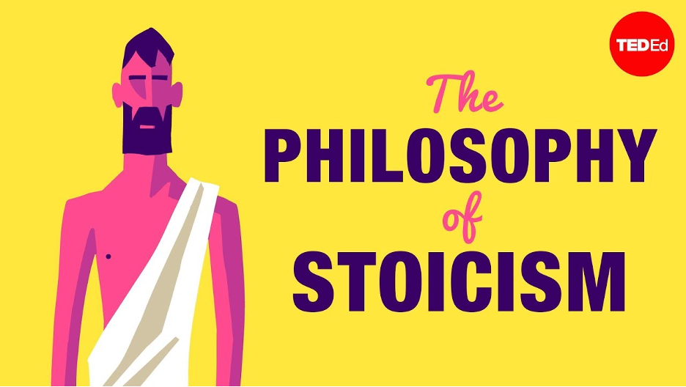

[The Big Five Personality Traits - Watch on YouTube](https://www.youtube.com/watch?v=IB1FVbo8TSs&amp;autoplay=1)

**References**

*The Big Five Personality Test*. Truity. (2022, December 15).

Lim, A. G. Y., & (Hons), A. G. Y. L. E. (2023, May 12). *Big five personality traits: The 5-factor model of personality*. Simply Psychology.

Personality Perfect. (n.d.). *Free personality test online*. Personality Perfect.

<https://www.mayoclinichealthsystem.org/hometown-health/speaking-of-health/11-tips-for-coping-with-an-anxiety-disorder>

Read this online at <https://books.byui.edu/the_science_of_learning/adhd>