Vygotsky's Sociocultural Theory

Key Terms:
- ZPD (Zone of Proximal Development): A theory that states all children have three zones of learning. The first is what they can do on their own, the second (ZPD) is what they can do with direct guidence, and the thirs is what they do not yet have the cognitive capacity to do.
- Scaffoldiong: The base and support for learning as provided by parents, teachers, mentors ect. to help further the childs knowledge.
- Culture Specific Tools: The tools and responces learned by children. Their culture impacts how they will respond to differing situations.
- MKO (More Knowledgeable Other): Someone of a higher ability or level of understanding.

Vygotsky's Social Cultural Theory

So, it Takes a Village to Raise a Child?
Well, if you ask Lev Vygotsky... yes! Vygotsky believed that children's language and brain development in influenced by social interaction, specifically interaction with an MKO. According to Vygotsky's Social Cultural Theory, society helps rear the child by providing meaningful experiences that help the child develop formal reasoning. Adults convey to children how their culture responds to different events (culture specific tools). He believed that the lessons a child learns vary depending on the school and culture.

What was Vygotsky's Model for Learning?
Vygotsky believed that the best way for children to learn way by guidance from others. His theory taught to have the MKO use scaffolding to help provide the basis for learning. As teachers, we need to teach in the childs ZPD to insure they understand, but by using scaffolding, you are able to teach the students more effetily and help expand their knowledge.

What does this mean for Teachers?
Vygotsky encoraged teachers to use direct instruction when teaching. Vygostky loved the creativity and curiosity of children. He believed that we as teachers, being the childs MKO, should focus more on how the students learn rather than what they know. He also believed that an educational system that was built on memorization and conformity caused a child to be "helpless in the face of any sensible attempt to apply this acquired knowledge."

Sources:
Lev Vygotsky's Sociocultural Theory Of Cognitive Development (simplypsychology.org)
https://www.youtube.com/watch?v=rVaRdVt6Ihw
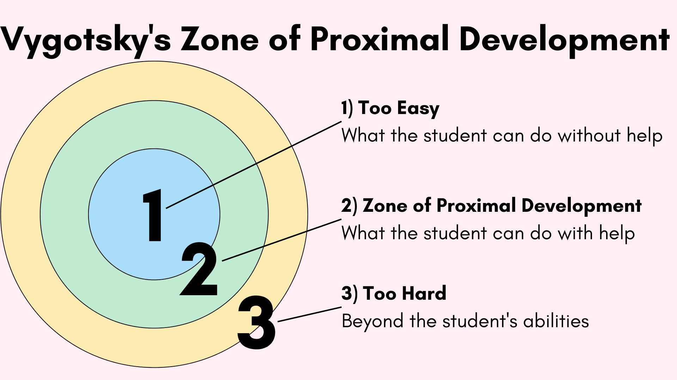
Read this online at https://books.byui.edu/the_science_of_learning/vygotskys_sociocultural_theory

