# Asch Conformity Experiment

### Overview of Concepts

* Asch Conformity Experiment

**"The Tendency to conformity in our society is so strong that reasonably intelligent and well-meaning young people are willing to call white black. This is a matter of concern. It raises questions about our ways of education and about the values that guide our conduct."**

- Solomon Asch

## Solomon Asch

Solomon Asch was a noted psychologist in the early 20th century who pioneered the way of social psychology and is most known for his conformity experiment. One of Asch’s approaches to his studies in psychology suggests that social acts needed to be viewed in terms of their setting.

Born in Warsaw, Poland on September 14, 1907, Asch emigrated to the United States in 1920 at the age of 13. He attended the College of the City of New York, where he graduated with his bachelor's degree in 1928. He later went on to Columbia University, where he earned a master's degree in 1930 and, in 1932, a PhD. While a professor of psychology at Brooklyn College, Asch began studying the impact of propaganda and indoctrination (Cherry, 2023).

## Asch Conformity Experiment

In 1951, Solomon Asch observed the extent to which the social pressure of the majority group would affect an individual. Asch was interested in observing how pressure from a group could lead people to conform. For his experiment, Asch asked seven of the eight participants in each group to answer the questions wrong to see if the other participant’s answers changed to match theirs.

He gathered 50 male students from Swarthmore College to participate in his experiment and told them they were participating in a vision test. He put one participant in a line with seven other participants, who already knew what their answer would be when given the line test. The participant who was being tested sat at the end of the line.

There were 18 trials and the other 7 participants gave the incorrect answer 12 times.

After the seven participants gave the wrong answer 12 times, about ¾ of the participants conformed at least once and about ¼ did not conform. (Modern Therapy, 2012).



## The Line Test

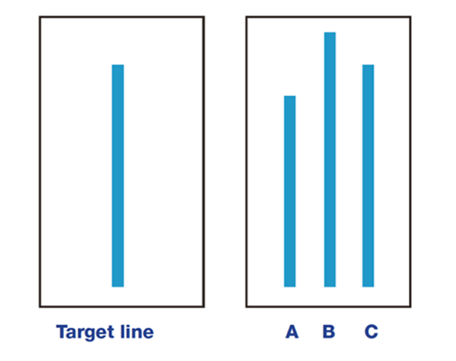

Video 3.7 How Far Will People Go to Fit In?

**Core Content**

Video 3.8

**Core Content**

## Significance of the Asch Conformity Experiment

The purpose of the Asch Experiment was to demonstrate the power of conformity in groups. Even when the individual knows that the other people are not correct, they continue to choose the incorrect answer.

## References

Asch Conformity Experiment. (2012, February 20). YouTube. <https://youtu.be/NyDDyT1lDhA?si=S7HEEVVWycAomhfY>

Cherry, K. (2023, November 14). Meet the social psychologist behind the conformity experiments. Verywell Mind. <https://www.verywellmind.com/solomon-asch-biography-2795519>

Cherry, K. (2023a, November 13). Asch’s seminal experiments showed the power of conformity. Verywell Mind. <https://www.verywellmind.com/the-asch-conformity-experiments-2794996#:~:text=Asch%20was%20interested%20in%20looking,power%20of%20conformity%20in%20groups>.

Modern Therapy. (2023, November 28). Asch Conformity Experiment explained. <https://moderntherapy.online/blog-2/asch-conformity-experiment-explained>

Read this online at <https://books.byui.edu/science_of_learning/asch_conformity_experiment>