# Collective Teacher Efficacy

### Rachel Eells

“Having a faculty that believes that it can accomplish great things is vital for the health of a school. Because of the dynamic nature of school functioning, wherein school achievement acts as both antecedent and consequence of collective teacher efficacy, interventions designed to improve the efficacy beliefs of teachers and a faculty as a whole can be a starting point for positive change within the school system.”

According to John Hattie: “Collective Teacher Efficacy is the collective belief of teachers in their ability to positively affect students”(Hattie).

**John Hattie's 252 Influences and effect sizes related to student achievement**

John Hattie studied many meta-analyses to create a list of [252 influences](https://visible-learning.org/hattie-ranking-influences-effect-sizes-learning-achievement/) and their positive or negative effects on student achievement. He found that the average effect size was 0.4. This means that on average, students learn at a rate of 0.4 with or without a good teacher. This became his hinge point for education. Anything above 0.4 is considered to have a significant positive effect on education. Collective Teacher Efficacy is number one on the list with an effect size of 1.57, making it the number one positive effect of education.

Figure 2.1 Effect Size Related to Student Achievement

Critiques of Hattie's work:

* Hattie’s work has been contested by a number of serious researchers
* Hattie focuses nearly exclusively on test scores when teachers have a much broader impact on students.
* Hattie's work does not pay enough attention to the quality of the underlying research that he cites.

Video 2.1 Collective Teacher Efficacy #1 impact on students (John Hattie's Visible Learning research)

**Core Content**

Video 2.2 John Hattie—Collective Teacher Efficacy 2018

**Core Content**

**Collective Teacher Efficacy and Student Achievement**

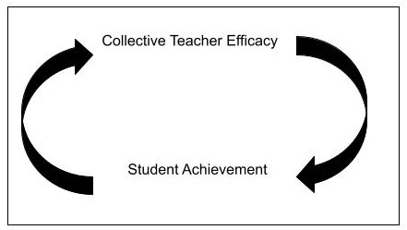

Student achievement and Collective Teacher Efficacy (CTE) are what Brother Pacini refers to as a **4-stroke engine**. Student achievement receives **fuel** from CTE and CTE gives the energy to fuel student achievement much like a 4-stroke engine. In a 4-stroke engine, each stroke or step of the engine relies on the energy from the previous stroke to execute. The next stroke then creates more energy to fuel the next stroke. This creates an endless cycle of energy to propel a vehicle forward. This is student achievement and CTE.

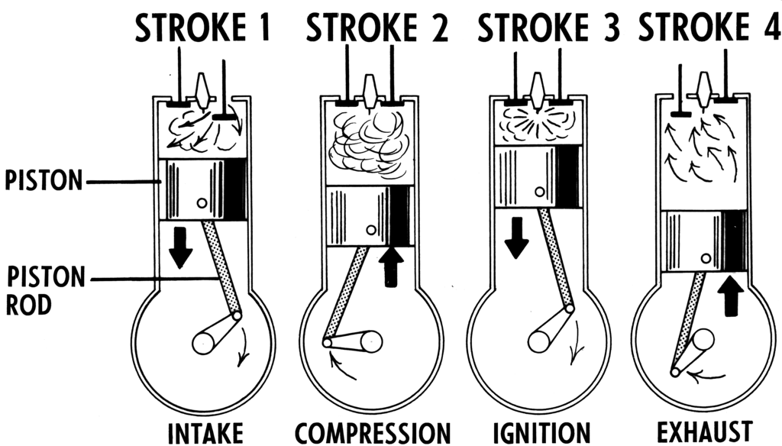

**How do we implement it?**

Collective Teacher Efficacy starts first with self-efficacy. As educators, we have the power to change the environment and culture where we work. What does self-efficacy look like? Examine the following points:

* Develop a culture of accountability—own your stuff first.
* Seek and accept feedback.
* Give other educators feedback when needed.

True change and belonging start in environments with high amounts of love and high expectations. Love yourself and those around you enough to hold them to a high standard.

Collective Teacher Efficacy happens when a group of educators apply self-efficacy and commit to working together for a common goal.

**Kasey Kiehl gives us five ways that groups of teachers can build collective efficacy:**

(This is on the basis that all educators involved are teaching the same material, but it can be applied to different situations)

* Collaborate to develop common lessons and assessments—Meet with other educators to discuss what materials to use and how you will implement them in the classroom.
* Observe each other's teaching—Create opportunities to see other educators teach to gain new ideas to implement in your class and see how learners respond.
* Look at student work together—Work together to evaluate the effectiveness of teaching methods. Student work = feedback
* Maintain professional relationships—Realize that other educators are there to help you. Regularly check in with other educators to exchange ideas and reflect on student outcomes.
* Establish a process for idea sharing—Have a consistent and open way to share ideas with other educators.

**Collective Teacher Efficacy in short:**

* Work together with other educators to create a common vision or goal.
* Create a plan to reach the goal.
* Collectively implement the plan.
* Meet together to reflect on progress and the effectiveness of the plan to meet the goal.
* Adjust as needed.
* Repeat the cycle.

“The most valuable resource that all teachers have is each other. Without collaboration, our growth is limited to our own perspectives.” - Robert John Meehan

### Summary

* CTE is the #1 positive influence on student achievement according to John Hattie.
* CTE and Student Achievement work together.
* CTE starts with self-efficacy

## References

Eells , R. J. (2011). Meta-analysis of the relationship between collective teacher ... Loyola eCommons.[https://ecommons.luc.edu/cgi/viewcontent.cgi?article=1132&context=luc_diss](https://ecommons.luc.edu/cgi/viewcontent.cgi?article=1132&amp;context=luc_diss)

Hattie, J. (2018, October 12). Collective teacher efficacy (CTE) according to John Hattie. VISIBLE LEARNING. https://visible-learning.org/2018/03/collective-teacher-efficacy-hattie/

Hattie, J. (2018a). Hattie Effect Size List - 256 influences related to achievement. VISIBLE LEARNING.

<https://visible-learning.org/hattie-ranking-influences-effect-sizes-learning-achievement/>

Kiehl, K. (2020). Building collective teacher efficacy to improve student learning. The Literacy Effect. https://theliteracyeffect.com/2022/05/01/building-collective-teacher-efficacy-to-improve-student-learning/

Eaton, G., Jaworski, L., Banks, C., & Korteman, M. (n.d.). Primary. Rivers International School Arnhem.

<https://www.riversarnhem.org/primary/news-and-information/-news-articles-and-innovation-/professional-learning-communities/>

Haynes. (2023, September 19).

Beginner’s Guide: What is a four-stroke engine and how does it work?

Haynes Manuals. https://haynes.com/en-us/tips-tutorials/beginners-guide-what-four-stroke-engine

Read this online at <https://books.byui.edu/science_of_learning/collective_teacher_efficacy>