# 7.3 Cathinones—Synthetic and Natural

## Introduction: Cathinone

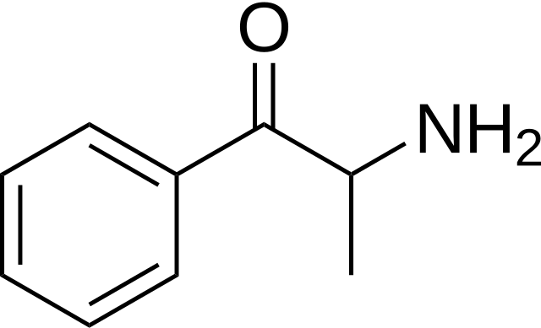

Cathinone is a naturally occurring stimulant naturally found in the leaves of the khat plant (Catha edulis), which is native to East Africa and the Arabian Peninsula. It is an analog of amphetamine, meaning it shares a similar chemical structure and stimulant effects (increased alertness, euphoria, and sense of well-being). However, cathinone is unstable and degrades into less potent compounds, such as cathine and norephedrine, as the leaves dry.1

Synthetic cathinones, often referred to as "bath salts" are man-made derivatives of cathinone that have been modified by adding different substituents to the chemical structure. These modifications can alter the potency and effects of the drugs2. Synthetic cathinones emerged in the recreational drug market in the early 200s and have been associated with significant public health concerns due to their potent stimulant effects and potential for abuse3.

##### Examples of Synthetic Cathinones:

* Mephedrone (4-methylmethcathinone)
* Methylone (bk-MDMA)
* MDPV (3,4-methylenedioxypyrovalerone)
* Methcathinone (ephedrone)
* Pyrovalerone
* Naphyrone
* 4-Fluoromethcathinone
* Butylone
* Alpha-PVP (α-pyrrolidinopentiophenone)

### Pharmacology and Effects

Cathinones act primarily by increasing the levels of neurotransmitters such as dopamine, norepinephrine, and serotonin in the brain. This leads to their stimulant and euphoric effects. However, they also pose significant risks, including:

* Cardiovascular Issues: Increased heart rate, hypertension, and potential for heart attacks.
* Neurological Effects: Agitation, paranoia, hallucinations, and in severe cases, psychosis.
* Addiction and Dependence: High potential for abuse and addiction, similar to other stimulants like cocaine and methamphetamine (Synthetic Cathinones: Epidemiology, Toxicity, Potential for Abuse, and Current Public Health Perspective, Brain Sci, Chen, S., Zhou, W., and Lai, M., 2024).

##### Khat

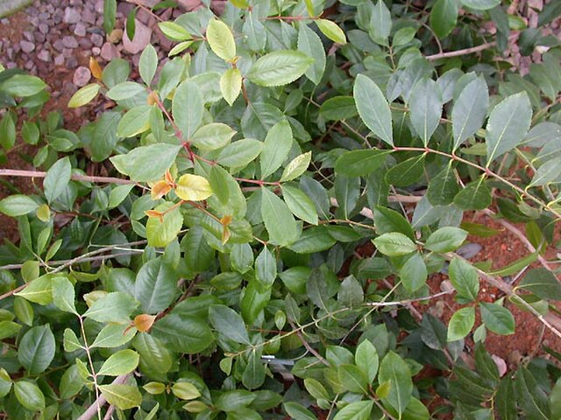

Khat (Catha edulis) is an evergreen shrub that grows naturally in East Africa and the Arabian Peninsula. It has been traditionally used for its stimulant effects, primarily by chewing the fresh leaves and shoots. The main psychoactive compounds found in khat are cathinone and cathine.

Other compounds like tannins, terpenoids, flavonoids, vitamins and minerals are also present but do not contribute to the stimulant effects4.

##### Effects on the Body

When khat leaves are chewed, the alkaloids are absorbed through the oral mucosa. The effects are similar to amphetamines and include:

* Euphoria and increased alertness
* Excitement and increased libido
* Anorexia and insomnia
* Hypertension and tachycardia

Chronic khat use can lead to psychological dependence, psychosis, cardiovascular disorders, liver damage and other adverse effects5.

##### Environmental Impact

Khat cultivation requires significant amounts of water and pesticides, which can deplete water resources and contaminate soil in arid regions where it is grown. Deforestation to create new khat farms is also an environmental concern6.

* Video: [Djibouti's Khat, An Expensive Habit](https://www.youtube.com/watch?v=nXMoPRuUa9Y) (17:14 min), France 24, 2018.
  + Consider the following from the video:
    - What is Khat?
    - How does it affect individuals, families, and society?
    - How do individual stories relate to addiction, rationalization, and dependence?

## Synthetic Cathinones

Recent research on synthetic cathinones, often referred to as “bath salts,” has highlighted several key findings regarding their epidemiology, toxicity, and potential for abuse. Here are some of the latest insights:

##### Epidemiology and Trends

**Prevalence:** Synthetic cathinones remain one of the most frequently seized groups of new psychoactive substances (NPS). Despite regulatory efforts, new derivatives continue to emerge, maintaining their presence in the illicit drug market3.

**Emergence of New Compounds:** Between early 2019 and mid-2022, 29 new synthetic cathinones were identified. These new compounds often appear in various countries and are associated with different intoxication symptoms7.

##### Toxicity and Health Risks



**Neurotoxicity:** Synthetic cathinones can induce neuroinflammation, disrupt neurotransmitter systems, and alter monoamine transporters and receptors. These effects contribute to their neurotoxic properties8.

**Adverse Effects:** Users may experience severe agitation, paranoia, hallucinations, and cardiovascular issues such as increased heart rate and hypertension. In extreme cases, these substances can lead to fatal overdoses1.

**Combination with Other Drugs:** The risks are exacerbated when synthetic cathinones are used in combination with other illegal drugs, leading to unpredictable and often dangerous interactions.

##### 

##### Abuse Potential

**Addiction:** Synthetic cathinones have a high potential for abuse and dependence, similar to other stimulants like cocaine and methamphetamine. Their rewarding effects are a significant factor in their abuse potential3.

**Public Health Concerns:** The continuous emergence of new derivatives complicates public health responses. Efforts to control these substances are ongoing, but the dynamic nature of the market poses significant challenges1.

Review the following resources:

**Fact Sheet:**[Fact Sheet: Bath Salts](https://www.dea.gov/sites/default/files/2020-06/Bath%20Salts-2020.pdf) (DEA, 2020)

**Article:**[Flakka Addiction and Abuse](https://www.addictioncenter.com/drugs/flakka-addiction-abuse/). Addiction Center, 2023

## References:

1. An updated review on synthetic cathinones, Archives of Toxicology, Soares, J., Costa, V., Bastos, M., Carvalho, F., and Capela, J., 2021
2. European Monitoring Centre for Drugs and Drug Addiction, 2024; Tamama, K, 2021
3. Synthetic Cathinones: Epidemiology, Toxicity, Potential for Abuse, and Current Public Health Perspective, Brain Sci, Chen, S., Zhou, W., and Lai, M., 2024
4. DEA, 2022
5. Silva, B., Soares, J., Rocha-Pereira, C., Mladenka, P., and Remiao, F., 2022
6. Gezon, L., 2012
7. A Review of Synthetic Cathinones Emerging in Recent Years (2019-2022), Forensic Toxicology, Kuropka, P., Zawadzki, M., and Szpot, P., 2022
8. An Updated Review on Synthetic Cathinones, Archives of Toxicology, Soares, J., Costa, V., Bastos, M., Carvalho, F., and Capela, J., 2021

HIDDEN CONTENT

## Images:

Figure 1: Cathinone via Wikimedia Commons <https://commons.wikimedia.org/wiki/File:Cathinone.svg>

Figure 2: Catha edulis via Wikimedia Commons <https://commons.wikimedia.org/wiki/File:Catha_edulis.jpg>

Figure 3: Blood pressure monitor showing a high blood pressure via Pixabay <https://pixabay.com/photos/category-seek-emergency-care-care-8132648/>

Read this online at <https://books.byui.edu/drugs_use_and_abuse/72_cathinonessynthetic_and_natural>