# 11.3 Alcohol: AUD, Impacts, & Treatment

## Current Use Statistics

#### [Alcohol Deaths Have More Than Doubled in Two Decades](https://www.nytimes.com/2024/11/22/health/alcohol-deaths-americans.html?smid=nytcore-ios-share&amp;referringSource=articleShare) (NY Times, Rabin, R., November 22, 2024)

The number of deaths caused by alcohol-related diseases more than doubled among Americans between 1999 and 2020, according to new research. Alcohol was involved in nearly 50,000 deaths among adults ages 25 to 85 in 2020, up from just under 20,000 in 1999. The increases were in all age groups. The biggest spike was observed among adults ages 25 to 34, whose fatality rate increased nearly fourfold between 1999 and 2020. Women are still far less likely than men to die of an illness caused by alcohol, but they also experienced a steep surge, with rates rising 2.5-fold over 20 years. The new study,

published in [The American Journal of Medicine](https://www.amjmed.com/article/S0002-9343(24)00704-6/fulltext), drew on data from the Centers for Disease Control and Prevention.

Deaths related to alcohol included those caused by certain forms of heart disease, liver disease, nerve damage, muscle damage, pancreatitis and alcohol poisoning, as well as related mental and behavioral disorders. The study did not include other deaths influenced by alcohol, such as accidents. “The totality of the evidence indicates that people who consume moderate to large amounts of alcohol have a markedly increased incidence of premature deaths and disability,” said Dr. Charles Hennekens, a professor of medicine at Charles E. Schmidt College of Medicine at Florida Atlantic University and one of the study’s authors.

The study is one of several recently that have drawn attention to the toll of rising alcohol consumption, particularly since the Covid pandemic, as Americans faced heightened anxiety, economic uncertainty and social isolation. Some local jurisdictions also eased restrictions on the sale of alcohol during the pandemic. The increase at the onset of the pandemic appears to have persisted. Adults reported more heavy drinking and binge drinking in 2022, another recent study found. Some 48,870 alcohol-related deaths were reported in 2020, up from 19,356 in 1999, the new study found. The mortality rate rose to 21.6 deaths per 100,000 in 2020, an increase from 10.7 deaths per 100,000 in 1999.

Alcohol-related deaths increased in all age groups, with the highest number among those aged 55 to 64. (The increase in deaths among those 85 and over was not significant.) Deaths increased among all racial and ethnic groups and in all geographic regions, the new study found. But the steepest rises occurred among Asian Americans and Pacific Islanders, whose death rate increased 2.4-fold. In the Midwest, the death rate increased 2.5-fold over the two-decade period. The new study is not the first to confirm disturbing trends in U.S. alcohol consumption. Men still die of alcohol-related disease at the highest rates and numbers, but two groups especially vulnerable to the health effects of drinking — women and older Americans — are consuming more alcohol than in the past.

Moderate drinking is defined as one drink or less per day for women and two drinks or less for men. Heavy drinking for women is four standard servings or more a day and eight or more a week; for men, heavy drinking is defined as five servings or more in a day, and 15 per week. Binge drinking means having four to five drinks in a roughly two-hour period. Dr. Hennekens and his colleagues hypothesized that rising rates of overweight and obesity may also be playing a role in alcohol-related deaths.

Nearly three-quarters of American adults are overweight or obese, according to a recent study. They are becoming overweight or obese at younger ages than in the past. Both obesity and heavy drinking are associated with risk factors for cardiovascular disease and with liver disease. The combination of drinking and overweight may accelerate the progression of those illnesses, Dr. Hennekens said. The authors urged health care providers to be aware that high blood pressure linked to obesity can be worsened by drinking, and to screen patients for alcohol consumption. “We have a strong message for health care providers and their patients to try to do something about both these issues, alcohol consumption and overweight and obesity,” Dr. Hennekens said.

### Alcohol Use Disorder (AUD)

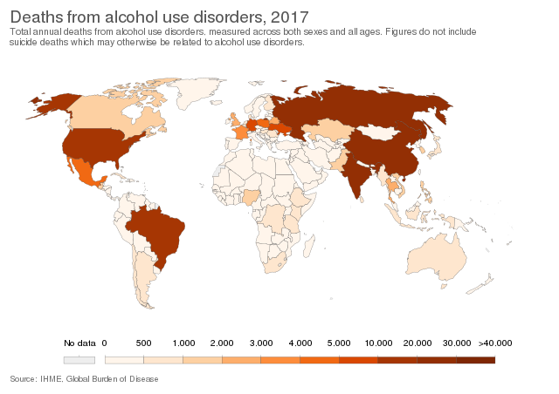

Alcohol use disorder (AUD) is a medical condition characterized by “an impaired ability to stop or control alcohol use despite adverse social, occupational, or health consequences”.1 AUD, also known as alcohol addiction, alcohol dependence, alcohol abuse, and alcoholism, can be mild, moderate or severe, based on the number of symptoms an individual experiences. Signs and symptoms may include:

##### Symptoms of Alcoholism:

* Being unable to limit the amount of alcohol you drink
* Wanting to cut down on how much you drink or making unsuccessful attempts to do so
* Spending a lot of time drinking, getting alcohol or recovering from alcohol use
* Feeling a strong craving or urge to drink alcohol
* Failing to fulfill major obligations at work, school or home due to repeated alcohol use
* Continuing to drink alcohol even though you know it's causing physical, social, work or relationship problems
* Giving up or reducing social and work activities and hobbies to use alcohol
* Using alcohol in situations where it's not safe, such as when driving or swimming
* Developing a tolerance to alcohol so you need more to feel its effect, or you have a reduced effect from the same amount
* Experiencing withdrawal symptoms — such as nausea, sweating and shaking — when you don't drink, or drinking to avoid these symptoms.2

The causes of AUD can be genetics, social/environment (being around alcohol use/growing up where it is common practice), mental illness, or early use.

##### Risk Factors:

**Steady drinking over time**. Drinking too much on a regular basis for an extended period or binge drinking on a regular basis can lead to alcohol-related problems or alcohol use disorder.

**Starting at an early age**. People who begin drinking — especially binge drinking — at an early age, are at a higher risk of alcohol use disorder.

**Family history**. The risk of alcohol use disorder is higher for people who have a parent or other close relative who has problems with alcohol. This may be influenced by genetic factors.

**Depression and other mental disorders**. It's common for people with mental disorders such as anxiety, depression, schizophrenia or bipolar disorder to have problems with alcohol or other substances.

**History of trauma**. People with a history of emotional trauma or other trauma are at increased risk of alcohol use disorder.

**Social and cultural factors**

. Having friends or a close partner who drinks regularly could increase your risk of alcohol use disorder. The glamorous way that drinking is sometimes portrayed in the media also may send the message that it's OK to drink too much. For young people, the influence of parents, peers and other role models can impact risk.

2

* Video: **4 Warning Signs of Alcoholism** (1:43 min) Cleveland Clinic, 2023

### Impact of Alcohol

Alcohol can have significant effects on individuals beyond the person consuming it. The following are examples of how alcohol can impact others:

**Family and Relationships:** Excessive alcohol consumption can strain relationships with family members and loved ones. It can lead to conflicts, arguments, and breakdowns in communication. A 2024 study reveals the pervasive consequences of parental alcohol abuse such as low self-esteem, emotional instability and difficulties in establishing and maintaining healthy relationships.3

Parental alcoholism is associated with lower marital satisfaction and intimacy in adult children's marriages, as well as increased physical aggression and attachment issues.4 Children of heavy drinkers face higher risks of mental disorders, hospitalizations, mortality, criminality, poor educational outcomes, and abuse/neglect.5

**Social Behavior:** Alcohol can influence social behavior, leading to changes in mood, aggression, or uninhibited actions. This can affect interactions with others and may lead to risky behaviors.

**Work and Productivity:** Alcohol impairment can affect a person's ability to perform well at work or school. Absenteeism, poor performance, and accidents can result from alcohol-related issues.

**Financial Impact:** Excessive alcohol consumption can lead to financial strain, as the cost of purchasing alcohol adds up over time. Additionally, alcohol-related incidents such as legal fees or medical bills can further impact finances.

**Community and Society:** Alcohol-related incidents, such as drunk driving accidents or alcohol-fueled violence, can have broader impacts on communities and society as a whole. This can include strain on emergency services, increased healthcare costs, and damage to public infrastructure.

**Healthcare System:** The healthcare system may bear the burden of alcohol-related health issues, including liver disease, injuries, and mental health disorders. This can lead to increased healthcare costs and strain on resources.

**Legal and Criminal Consequences:** Alcohol-related behaviors can lead to legal issues, including DUI (driving under the influence) charges, public intoxication, and alcohol-related violence. These consequences can impact not only the individual but also their families and communities.

* **Video: Is Alcohol Really Helping Us Cope?** (8:44 min) Samantha Perkins, TEDxBellarmineU, 2022.

##### Driving Under the Influence of Alcohol

Drunk driving, also known as driving under the influence (DUI) or driving while intoxicated (DWI), is a serious and dangerous offense that involves operating a vehicle with a blood alcohol concentration (BAC) above the legal limit. Here's an overview of drunk driving information including BAC, laws, and current statistics:

**Blood Alcohol Concentration (BAC)**: BAC is a measure of the amount of alcohol in a person's bloodstream. In most countries, the legal BAC limit for drivers is 0.08%, although it can vary. BAC is affected by factors such as the amount of alcohol consumed, the rate of consumption, and individual factors like weight and metabolism.

**Laws:** Laws regarding drunk driving vary by country and jurisdiction, but they generally prohibit driving with a BAC above the legal limit. Penalties for drunk driving can include fines, license suspension or revocation, and imprisonment. Some jurisdictions also have administrative penalties, such as vehicle impoundment or mandatory alcohol education programs.

**Statistics:** Drunk driving remains a significant problem worldwide. According to the World Health Organization (WHO), alcohol-related crashes account for around 30% of all traffic fatalities globally. In the United States, drunk driving is a leading cause of traffic fatalities, with approximately 10,000 people dying in alcohol-impaired driving crashes each year, according to the National Highway Traffic Safety Administration (NHTSA).

**Prevention:** To prevent drunk driving, many countries have implemented strategies such as sobriety checkpoints, public awareness campaigns, and harsh penalties for offenders. Additionally, technologies such as ignition interlock devices, which prevent a vehicle from starting if the driver's BAC is above a certain level, are increasingly being used to deter drunk driving.

**Responsibility:** It's important for individuals to understand the risks of drunk driving and to make responsible choices when consuming alcohol. This includes planning ahead for a safe ride home, using public transportation, or arranging for a designated driver.

Overall, drunk driving is a preventable behavior, and efforts to reduce it through education, enforcement, and legislation are crucial for improving road safety and saving lives.

Drunk driving kills far too many people each year. But it doesn't always kill.

Watch the following two videos and ponder how a legal drug like alcohol can affect individuals directly and indirectly.

* **Video: Sean’s Story Drive Sober. No Regrets,** (6:07 min) 2012.
* **Video: Forgiveness: My Burden Was Made Light** (8:24 min) The Church of Jesus Christ of Latter-day Saints, 2010.

#### Sean’s Story

Sean’s Story (6:07 min) Drive Sober. No Regrets, 2012.

#### Forgiveness: My Burden Was Made Light

Forgiveness: My Burden Was Made Light (8:24 min) The Church of Jesus Christ of Latter-day Saints, 2010.

### Treatment

Detoxification (Detox): Medical supervision to safely manage withdrawal symptoms.

**Behavioral Therapies:**

* Cognitive Behavioral Therapy (CBT): Helps individuals identify and change behaviors and thoughts related to drinking.
* Motivational Enhancement Therapy (MET): Aims to increase motivation to change drinking behavior.
* Contingency Management: Provides incentives for positive behaviors, such as abstaining from alcohol.
* 12-Step Programs: Programs like Alcoholics Anonymous (AA) that offer support and a structured approach to recovery.

**Medications:**

* Disulfiram: Creates unpleasant effects (such as nausea and vomiting) when alcohol is consumed.
* Naltrexone: Reduces the craving for alcohol and blocks the pleasurable effects of drinking.
* Acamprosate: Helps reduce symptoms of withdrawal and support abstinence.
* Topiramate: Sometimes used off-label to reduce drinking and promote abstinence

Support Groups: Joining groups such as AA can provide ongoing support and a sense of community.

Counseling and Therapy: Individual or group therapy can help address underlying issues and provide coping strategies.

Lifestyle Changes: Making changes to reduce stress, improve sleep, and engage in healthy activities can support recovery.

##### Recovery and Relapse Prevention:

Recovery from alcoholism is a lifelong process that requires ongoing effort and support. Relapses are common but does not mean failure. It can be an opportunity to learn and strengthen one's commitment to recovery. Developing a strong support network and having coping strategies in place can help prevent relapse. It's important for individuals with alcoholism to seek help from healthcare professionals who can tailor a treatment plan to their specific needs. Treatment approaches may vary based on the severity of the disorder and individual circumstances.

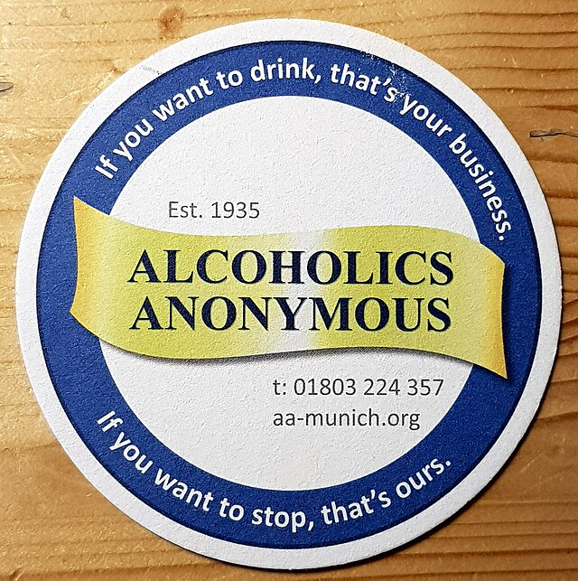

### 12-Step Program

The 12-step program, originally developed by Alcoholics Anonymous (AA), has become one of the most widely recognized and utilized approaches for addiction-recovery since its inception in the 1930s. This comprehensive introduction will explore the program's history, core principles, effectiveness, criticisms, and current statistics.

##### History and Origins

The 12-step program originated with the founding of AA in 1935 by Bill Wilson and Dr. Bob Smith. Wilson, having struggled with alcoholism himself, had a spiritual experience that led him to believe that surrendering to a higher power and helping other alcoholics were key to maintaining sobriety.6

In 1938, Wilson began writing what would become known as the "Big Book," which outlined the 12 steps and the program's philosophy. The book was published in 1939, marking the official codification of the 12-step approach.7 Prior to 1938 and the publication of the “Big Book,” the ideas and practices of AA were primarily shared through word of mouth and informal writings. The book’s publication marked the point at which these ideas were officially written down, organized, and presented in a standardized form to be easily shared and replicated. The codification of the 12-step approach (Big Book) formally laid out the 12 steps in a specific, written sequence, provided detailed explanations of each step, outlined the philosophy and methodology of the program, established guidelines for how meetings should be conducted, and included personal stories to illustrate the program's effectiveness.

##### The Steps

The 12 steps, as outlined in AA's Big Book, are:

1. We admitted we were powerless over alcohol — that our lives had become unmanageable.
2. Came to believe that a Power greater than ourselves could restore us to sanity.
3. Made a decision to turn our will and our lives over to the care of God as we understood Him.
4. Made a searching and fearless moral inventory of ourselves.
5. Admitted to God, to ourselves, and to another human being the exact nature of our wrongs.
6. Were entirely ready to have God remove all these defects of character.
7. Humbly asked Him to remove our shortcomings.
8. Made a list of all persons we had harmed, and became willing to make amends to them all.
9. Made direct amends to such people wherever possible, except when to do so would injure them or others.
10. Continued to take personal inventory and when we were wrong promptly admitted it.
11. Sought through prayer and meditation to improve our conscious contact with God as we understood Him, praying only for knowledge of His will for us and the power to carry that out.
12. Having had a spiritual awakening as the result of these Steps, we tried to carry this message to alcoholics, and to practice these principles in all our affairs.

**The Twelve Steps of Alcoholics Anonymous. Alcoholics Anonymous**,1952;1953; 1981; 2021.

##### Expansion and Adaptation

Following AA's success, the 12-step model was adapted for various other addictions and compulsive behaviors for substance use disorders, behavioral addictions, eating disorders, financial issues, emotional and mental health, and family support groups to just name a few.

The Church of Jesus Christ of Latter-day Saints Addiction Recovery Program (ARP) is one of those programs using the 12-step approach. The ARP is a comprehensive program designed to help individuals overcome an addiction or compulsive behavior and lead healthy, productive lives with a gospel framework. There are separate groups for individuals who struggle with general addictions and pornography use. There are also support groups for spouses and family members to attend (The Church of Jesus Christ of Latter-day Saints Newsroom, 2021).

* [Healing through the Savior: Addiction Recovery Program 12-Step Recovery Guide](https://www.churchofjesuschrist.org/study/manual/addiction-recovery-program-2023?lang=eng )

##### Effectiveness and Success

The 12-step program has helped millions of people achieve and maintain sobriety. According to the Substance Abuse and Mental Health Services Administration (SAMHSA), as of 2020, approximately 65.5% of addiction treatment centers in the United States utilize 12-step models (American Addiction Centers, 2024).

Research has shown that active participation in 12-step programs can lead to better long-term outcomes for individuals struggling with addiction. Moos & Moos (2006) conducted a 16-year follow-up study of initially untreated alcohol-dependent individuals. They found that 12-step participation in the first year predicted better substance use outcomes at 16 years.

* Moos, R. H., & Moos, B. S. (2006). Participation in treatment and Alcoholics Anonymous: A 16-year follow-up of initially untreated individuals. Journal of Clinical Psychology, 62(6), 735-750.

A study by Fiorentine (1999) showed that consistent, early, and frequent attendance (e.g., three or more meetings per week) in 12-step programs is associated with better substance use outcomes.

* Fiorentine, R. (1999). After drug treatment: Are 12-step programs effective in maintaining abstinence? American Journal of Drug and Alcohol Abuse, 25(1), 93-116.

A study by Kelly and Moos (2003) found that 91% of patients with substance use disorders attended at least one 12-step group meeting either during treatment or in the year after treatment. However, 40% of these individuals dropped out by the 1-year follow-up. Compared to patients who continued to attend, those who dropped out were less likely to be abstinent, less likely to be in remission, and more likely to report substance-related problems at the 1-year follow-up.

* Kelly, J. F., & Moos, R. (2003). Dropout from 12-step self-help groups: Prevalence, predictors, and counteracting treatment influences. Journal of Substance Abuse Treatment, 24(3), 241-250.

##### Criticism and Weaknesses

Despite its widespread use, the 12-step program has faced criticism over the years for example:

**Religious emphasis:** Some individuals struggle with the program's spiritual component, perceiving it as too religious.

**Lack of scientific basis:** Critics argue that the program lacks a strong scientific foundation and relies heavily on anecdotal evidence.

**One-size-fits-all approach**: The program may not be suitable for everyone, as it doesn't account for individual differences in addiction and recovery.

**Emphasis on powerlessness**: Some argue that the focus on powerlessness may be counterproductive for certain individuals.

The 12-step program remains a significant force in addiction recovery, offering a structured approach that has helped millions of people worldwide. While it faces criticism and challenges, its enduring popularity and widespread adoption in treatment settings underscore its continued relevance in the field of addiction recovery.

12-Step program is a set of guiding principles for recovery from addiction, originally developed by Alcoholics Anonymous (AA) and later adapted by other groups for various types of substance abuse and behavioral problems. Look over these steps and ponder why they are written the way they are and how someone can apply them. Here is a basic overview of the 12-Step program:

* **The Twelve Steps of Alcoholics Anonymous**. Alcoholics Anonymous, 2021

## References:

1. National Institute on Alcohol Abuse and Alcoholism, 2020
2. Alcohol use disorder, Mayo Clinic, 2022
3. The Effects of Alcoholism on the Destruction of relationship values, AD ALTA, Danek, A., Sotolova, E. & Starek, L., 2024
4. Kearns-Bodkin & Leonard, 2008
5. Brummer et al., 2021
6. American Addiction Centers, 2024; Cornerstone of Recovery, n.d.
7. Cornerstone of Recovery, n.d.

## Images:

Figure 1: Deaths from alcohol use disorders, OWID 2017 via Wikimedia Commons <https://commons.wikimedia.org/wiki/File:Deaths_from_alcohol_use_disorders,_OWID.svg>

Figure 2: Alcoholics Anonymous Logo via Wikimedia Commons <https://commons.wikimedia.org/wiki/File:Bierdeckel-AA.jpg>

Read this online at <https://books.byui.edu/drugs_use_and_abuse/113_alcohol_effect_on_others>