13.2 Tobacco: Youth
In the 20th century, tobacco companies began targeting youth with aggressive marketing campaigns, including advertisements that glamorized smoking and associated it with social status and independence (This will be discussed further in the next chapter). This led to a significant increase in youth smoking rates, despite growing awareness of the health risks associated with tobacco use.
Tobacco companies have a long history of targeting youth in their advertising campaigns. They have used various tactics to appeal to young people, including using colorful packaging, celebrity endorsements, and sponsoring events and activities popular among youth.
In the 1990s, many countries began to implement restrictions on tobacco advertising, particularly aimed at protecting youth. These restrictions included bans on television and radio advertising, limits on the use of brand logos and imagery, and restrictions on advertising in places where youth are likely to be exposed.
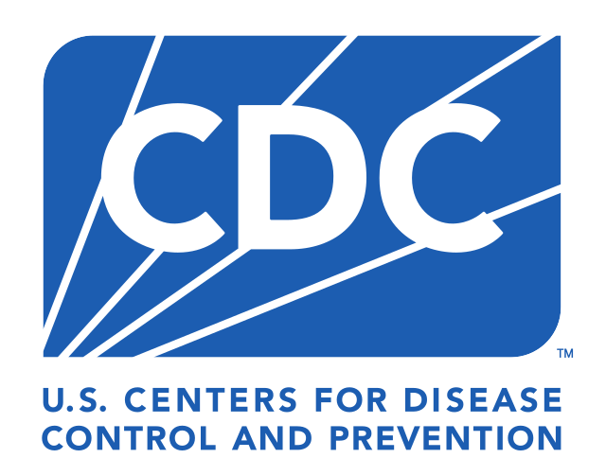
Despite efforts to reduce youth smoking rates, tobacco use remains a significant issue among young people worldwide. According to the World Health Organization (WHO), nearly 9 out of 10 smokers start smoking by the age of 18, and almost all start by age 26.
In the United States, the Centers for Disease Control and Prevention (CDC) reports that about 4.6 million middle and high school students were current users of tobacco products in 2020. While cigarette smoking has declined among youth in recent years, the use of e-cigarettes and vaping products has increased significantly, raising concerns about nicotine addiction and long-term health effects.
The history of youth and tobacco products is characterized by the aggressive marketing tactics of tobacco companies and the ongoing efforts to protect young people from the harm of tobacco use. Despite progress in reducing youth smoking rates, the rise of e-cigarettes and vaping presents new challenges that require continued attention and action to prevent youth tobacco use.
- Video: Sex, Lies, & Cigarettes (45:00 min) Vanguard, Putzel, C., 2012).

Youth Health Issues
Youth who use tobacco products are at risk for a variety of health issues and negative outcomes. Here are some of the key risks associated with youth tobacco use:
Nicotine Addiction: Adolescents are particularly vulnerable to nicotine addiction due to the developing brain's increased sensitivity to nicotine found in tobacco products. Nicotine addiction can lead to long-term tobacco use and dependence. Most e-cigarettes contain nicotine, which is highly addictive" and that "Nicotine can harm the parts of an adolescent's brain that control attention, learning, mood, and impulse control"¹.
Negative Impact on Brain Development: Tobacco use during adolescence can harm brain development, affecting areas responsible for attention, learning, mood, and impulse control. This can have long-lasting effects on cognitive function and behavior. Even in small doses, nicotine exposure in adolescence causes long-lasting changes in brain development, which could have negative implications for learning, memory, attention, behavior problems, and future addiction².
Increased Risk of Other Substance Use: Youth who use tobacco are more likely to engage in other risky behaviors, such as alcohol and drug use. This can have negative effects on health and well-being. E-cigarette use among youth and young adults is strongly linked to the use of other tobacco products, such as regular cigarettes, cigars, hookah, and smokeless tobacco³.
Impact on Mental Health: Tobacco use has been linked to an increased risk of mental health issues among youth, including depression, anxiety, and mood disorders. Nicotine dependence can cause stress and mood fluctuations, which can lead to poor mental health².
Long-Term Health Risks: No tobacco products, including e-cigarettes, are safe, especially for children, teens, and young adults⁴.

- The 2022 National Youth Tobacco Survey found that 11.3% of middle and high school students reported using a tobacco product in the last 30 days⁵.
- In 2024, 1.63 million (5.9%) students currently used e-cigarettes, including 410,000 (3.5%) middle school students and 1.21 million (7.8%) high school students⁴.
- Most middle and high school students who vape want to quit and have tried to quit⁴.
- Factors influencing youth tobacco use include tobacco advertising, product accessibility, the availability of flavored products, social influences, and adolescent brain sensitivity to nicotine⁴.
To reduce these risks, it is important for parents, educators, healthcare providers, and policymakers to work together to prevent youth tobacco use through education, policy initiatives, and community-based programs.
- Study: E-Cigarette and Nicotine Pouch Use Among Middle and High School Students — United States, 2024

Images:
Figure 1: Centers for Disease Control and Prevention via Wikimedia Commons <https://commons.wikimedia.org/wiki/File:CDC_logo_2024.svg>
Read this online at https://books.byui.edu/drugs_use_and_abuse/125_tobaccos_effects

