# 13.1 Tobacco Advertising

In this section we will look at the world of tobacco advertising and how it has impacted the world around us. Regardless of whether you smoke or not, our world has changed and been affected by the tobacco industry. The science of persuasion and flattery has been used for years to get individuals to smoke and smoke more often. How can we use that same science to get individuals to stop smoking?

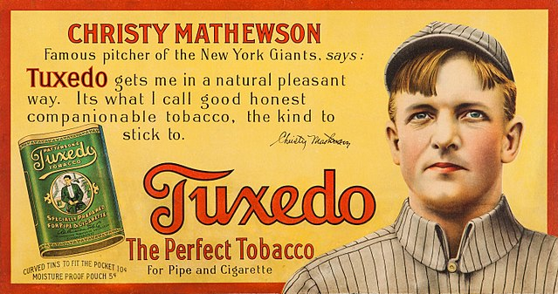

Advertising and communication, both verbal and visual, have been integral to human interaction throughout history. Social influence, a key concept in this context, refers to how interactions with others can shape our attitudes, beliefs, values, and behaviors1.This influence extends beyond face-to-face interactions to include exposure to messages through various media channels, such as television shows, commercials, web advertisements, and the popular social media platforms.

Social psychology theories have enabled companies and campaigns to develop more effective advertising strategies. By leveraging these psychological principles, marketers can create messages that resonate with their target audience and drive desired behaviors2. While much attention has been given to the negative effects of media on body image and substance abuse, it's important to recognize that advertising can also have positive impacts.

Social influence marketing (SIM) has emerged as a powerful approach that taps into the influence of social networks, groups, and individuals to promote products or services. This strategy relies on understanding the psychological factors that shape human behavior and decision-making processes2. For instance, influencer marketing has become a prominent tool, leveraging the credibility and reach of influential individuals to impact consumer behavior3.

Research has shown that social communications within online communities can significantly affect users' perceptions and responses to advertising. A study by Yang et al. (2017) found that social bonds formed within these communities can increase acceptance and responses to community advertising, with users' group intentions playing an intervening role.

While the core concept of social influence in advertising remains consistent, the channels and methods of implementation have evolved with technology. Social media platforms, in particular, have become crucial in facilitating social influence marketing, allowing for more direct and interactive engagement between brands and consumers4.

### **Strategies**

Cigarette advertising has long employed sophisticated psychological strategies to entice people to smoke. Here's an evidence-based overview of key psychological tactics used in cigarette advertising:

**Association with Positive Emotions:** Cigarette ads often link smoking with positive emotions such as relaxation and stress relief. For example, e-cigarette brands have marketed their products as ways to "stay sane" and escape stress, despite research showing that nicotine can worsen anxiety and depression symptoms5.

**Creating Desire and Aspiration:** Tobacco marketing targets key adolescent psychological needs, including social approval, peer bonding, autonomy, and self-image6. This approach aims to influence behavior by suggesting benefits to using tobacco products.

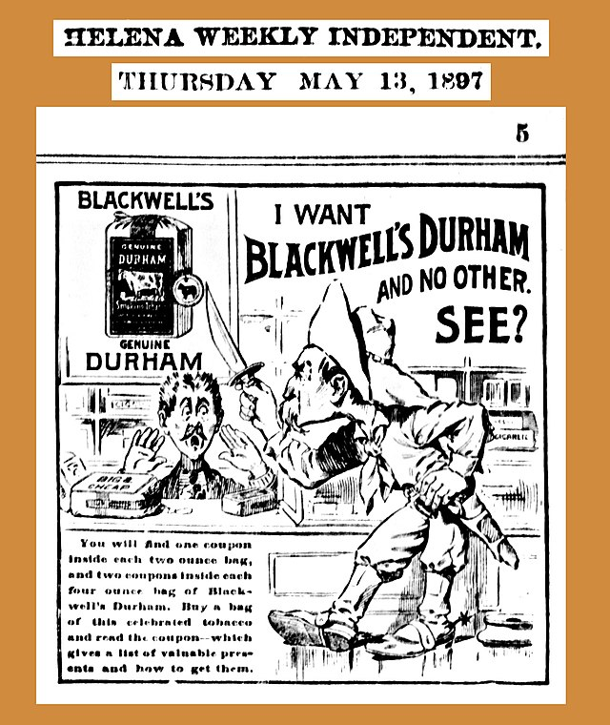

**Appeal to Peer Influence:** Studies show that exposure to tobacco advertising and promotion is associated with an increased likelihood that adolescents will start smoking, with evidence of a dose-response relationship7.

**Use of Symbols and Metaphors:** Tobacco companies have used imagery and themes that appeal to adolescents' desire for independence, nonconformity, and social acceptance7.

**Minimization of Risks:** Historically, tobacco companies used doctor endorsements to reduce public health concerns about smoking risks, using slogans like "Just What the Doctor Ordered"8.

**Creating Brand Loyalty:** Tobacco marketing, including advertising and promotion, aims to associate products with psychological and social needs that consumers want to fulfill7.

Overall, cigarette advertising is designed to appeal to people's emotions, aspirations, and social influences. Longitudinal studies consistently suggest that exposure to tobacco advertising and promotion is associated with the likelihood that adolescents will start to smoke7.

### **History of Smoking in Advertising: From Aspirational to Shameful**

The eternal question about smoking: Is it cool or is it gross? Look at any photo of James Dean and you can’t argue against the former, but check out the sobering statistics on lung cancer, or the image of a blackened lung, and you’ll inevitably land on “gross.”

The divide between how cigarettes are–and have been–perceived is explored in the following online exhibit from Yale University's Harvey Cushing/John Hay Whitney Medical Library on the history of advertising and cigarettes. “Selling Smoke: Tobacco Advertising and Anti-Smoking Campaigns” details the history of smoking in advertising from the early days of pro-cigarette ads (where ads declared "You're Safer Smoking Phillip Morris") to the early days of anti-smoking campaigns (the American Cancer Society featuring a pregnant woman with a cigarette and asking, "Why Start Life Under a Cloud").

The vintage ads are hard to take seriously by today’s standards, if only because they depict smoking as something so essential to personhood–it’s hard to imagine that sort of shamelessness in today’s market. Cigarettes turn women into desirable, stylish ladies and make men irresistible, and increase your chances of looking like Bob Hope or Lucille Ball and Dezi Arnaz. Victory over the Germans and/or the Commies comes from smoking Chesterfields, and smoking enough Raleigh’s can earn your prizes including a new blender. Looked back on through the lens of today’s cynical media-savvy environment, the pro-smoking campaigns seem to take on an air of desperation–which, given that the anti-smoking campaigns of the early ’80s would kick off a generational backlash, seems all the more appropriate in hindsight9.

* Online Exhibit: **Selling Smoke: Tobacco Advertising and Anti-Smoking Campaigns**, Yale University Library Online Exhibitions, 2023.
  + **Look at the following campaigns:**
    - Selling a Lifestyle: Men, Women, and Gender in Cigarette Advertising
    - Celebrities and “Ordinary” People Sell Smoke
    - Selling Patriotism with Every Pack!
    - Selling Cigarettes with Medical Science
    - Prizes and Promotions
    - The Rise of Anti-Smoking Movements
    - Advertisements in the Van Dyn Collection
      * More Doctors Smoke Camels
      * 20,6769 Physicians Say
      * Selling Smoke Exhibition Image, Drawn from Lucky Strike Advertisement
      * Juul E-Cigarette Advertisement

### **Marketing for Youth**

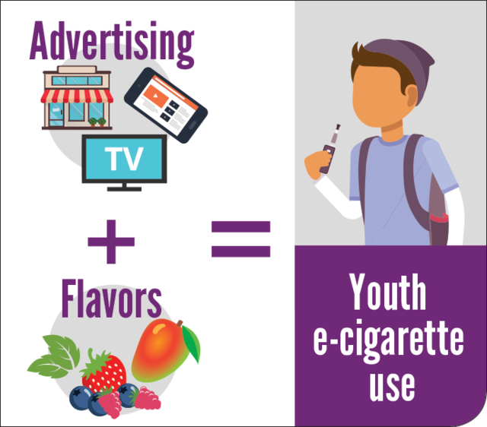

The most common themes in tobacco advertising that appeal to youth include:

* Popularity and peer acceptance
* Fun, rebelliousness, and risk-taking
* Independence and autonomy
* Social acceptance and admiration
* Maturity and nonconformity
* Satisfaction and taste
* Association with desirable social characteristics
* "Coolness" and youthfulness
* Outdoor activities and adventure
* Success (social and sexual)
* Individualism and self-image

These themes are designed to connect with unique adolescent needs and motivations. Tobacco companies use various tactics to convey these themes, such as:

- Using young models in advertisements

- Featuring high-tech designs and aesthetics

- Referencing social media and popular culture

- Employing humor and themes of rebellion

- Associating smoking with nightlife and socializing

Additionally, tobacco marketing often includes price incentives like coupons and discounts, which can make tobacco products more accessible to price-sensitive youth. These marketing strategies are carefully crafted to appeal to adolescents' psychological and social needs, potentially influencing their attitudes towards smoking and increasing the likelihood of tobacco use initiation10,11.

Peer-reviewed studies have examined the impact of tobacco marketing on youth smoking behavior.

Exposure to tobacco advertising and promotion is associated with an increased likelihood that adolescents will start smoking12.

Tobacco marketing targets key adolescent psychological needs such as social approval, peer bonding, autonomy, and self-image. This approach aims to influence behavior by suggesting benefits to using tobacco products12.

Digital tobacco marketing (DTM) on social media is often not effectively age-restricted, allowing youth exposure. Studies indicate that youth report frequent exposure to DTM via the internet13.

A systematic review and meta-analysis found that exposure to tobacco content on social media was associated with increased odds of lifetime tobacco use, past 30-day tobacco use, and susceptibility to use tobacco among never users14.

A recent study found that youth with no prior tobacco use, who used social media daily were 67% more likely to begin smoking after one year compared to less frequent users. Engagement with tobacco marketing on social media, such as liking or following tobacco brands, was associated with a 34% higher likelihood of first-time tobacco use and a 60% higher likelihood of using multiple tobacco products15.

* [Social Media Use Linked to Tobacco Initiation Among Youth](https://www.bu.edu/sph/news/articles/2024/social-media-use-linked-to-tobacco-initiation-among-youth/), Boston University School of Public Health

### **Flora Design and Youth**

Tobacco companies use flora imagery as an effective tactic to attract youth and increase receptiveness to cigarette advertising among adolescents and young adults. Key findings include:

* The presence of flora imagery (e.g., plants, flowers) in cigarette ads significantly increases advertising receptivity among both adolescents and young adults.
* Adolescents exposed to ads with flora imagery had 55% higher odds of being receptive to the advertisement compared to ads without this feature.
* Young adults were 43% more likely to be receptive to ads containing flora imagery.
* Flora imagery is used to create positive associations with cigarette brands, appealing to adolescents' psychological and social needs.

This tactic is part of a broader strategy to use images rather than information in tobacco marketing, portraying the attractiveness and perceived benefits of smoking.

The use of flora imagery in tobacco advertising is particularly concerning because increased receptivity to cigarette advertising is a documented step in the pathway between advertising exposure and product use among youth. This evidence suggests that restrictions on the use of flora imagery in tobacco advertising should be considered as part of comprehensive tobacco control policies aimed at protecting youth from the influence of tobacco marketing10.

These studies highlight the significant impact of tobacco marketing, particularly through digital channels, on youth smoking initiation and behavior.

### **Things As They Really Are**

As Disciples of Jesus Christ, we need to look at everything coming at us from the world with more perspective. There are a lot of negative and positive things in the world and discernment is important to agency and where we are pointing our focus.

Read/Watch the following devotional addresses by Elder David A Bednar

* Talk: **Things as They Really Are**, Church Educational System fireside address delivered at Brigham Young University–Idaho on May 3, 2009.
  + Video: [Things As They Really Are Message](https://www.churchofjesuschrist.org/media/video/2011-10-0006-things-as-they-really-are?lang=eng) (3:27 min)
* Watch**: Things as They Really Are**, Church Educational System fireside address delivered at Brigham Young University–Idaho on May 3, 2009.

Look at what Elder Bednar asks:

* **Does "IT" (you can place whatever you want as the "it") invite or impede the Holy Ghost in our lives?**
* **Does "IT" enlarge or restrict your capacity to live, to love, and to serve in meaningful ways?**

How does "action" versus being "acted upon" affect our interactions with the world's influence both positively and negatively? Can we use our agency to be proactive?

### Lecture Material: Tobacco II - Advertising & Marketing Resources

**Embedded Resources:**

·         Video Library**: Doctors Smoking.** Stanford University Research into the Impact of Tobacco Advertising, 2024.

o   LINK: <https://tobacco.stanford.edu/video/doctors-smoking/>

·         Video: 1962 T.V. Commercial Raleigh Cigarettes (1:01 min) Real Time 1960’s, 2022

o   LINK: [https://www.youtube.com/watch?v=ZWwu_Di1_oU&t=6s](https://www.youtube.com/watch?v=ZWwu_Di1_oU&amp;t=6s)

·         Video: **3 Flintstones Winston Cigarettes Commercials** (2:56 min) Vintage TV Commercials, 2009.

o   LINK: [https://www.youtube.com/watch?v=Bvt8skgm2l8&t=16s](https://www.youtube.com/watch?v=Bvt8skgm2l8&amp;t=16s)

·          Video: **Vintage 1948 Marlboro Flip-Top Box TV Commercial** (1:12 min) Quasar Kosmis, 2023

o   LINK: [https://www.youtube.com/watch?v=ljcoMhXwm_o&t=26s](https://www.youtube.com/watch?v=ljcoMhXwm_o&amp;t=26s)

·         Video: The Magnificent Seven (5:12 min) austinmillbarge22, 2007

o   LINK: <https://www.youtube.com/watch?v=t0vqQjaXLOU>

·         Video: Health Effects of Smoking Big Tobacco Ad (0:45 min) American Cancer Society Action Network, 2017.

o   LINK: [https://www.youtube.com/watch?v=O8I39Yb2a_I&t=5s](https://www.youtube.com/watch?v=O8I39Yb2a_I&amp;t=5s)

·         Video: Big Tobacco’s Anti-Smoking Ads to Debut on TV (2:29 min) Associated Press, 2017

o   LINK: <https://www.youtube.com/watch?v=828cmKfEz4Y>

## References:

1. Applied Social Psychology: Understanding and Addressing Social and Practical Problems, Schneider, F. W., Grumann, J. A., & Coutts, L. M., 2012
2. Marketing Management II - Social Influence Marketing. LinkedIn, Agarwal, A., 2023
3. The Strategic Marketing Group, n.d.
4. What is Social Influence, Coursera, 2024
5. Truth Initiative, 2021
6. Shadel et al., 2008
7. Lovato et al., 2011
8. Tobacco Stops with Me, n.d.
9. Solomon, 2014
10. Evidence of Youth-Appealing Cigarette Advertising Tactics from a Randomized, Controlled Experiment, Oxford Journals: Nicotine & Tobacco Research, Moran, M., Weiger, C., Czaplicki, L., & Heley, K., 2022
11. Mailed tobacco ads relay on price discounts and youth-appealing themes, Truth Initiative, 2022
12. Impact of Tobacco Advertising and Promotion on Increasing Adolescent Smoking Behaviors, Cochrane Tobacco Addiction Group, Lovato, C., Watts, A., & Stead, L., 2011
13. U.S. Digital Tobacco Marketing and Youth: A Narrative Review, Preventing Medical Rep., Venrick, S., et al., 2022
14. Association Between Exposure to Tobacco Content on Social Media and Tobacco Use, JAMA, Donaldson, S., Dormanesh, A., & Perez, C., 2022
15. Social Media Use, Brand Engagement, and Tobacco Production Initiation Among Youth: Evidence from A Prospective Cohort Study, Addictive Behaviors, Ranker, L., et al, 2024

## Images:

Figure 1: Tobacco Advertising via Wikimedia Commons <https://commons.wikimedia.org/wiki/File:1910_Christy_Mathewson_Tuxedo_Tobacco_Trolley_Car_Advertising_Sign.jpg>

Figure 2: Creating Brand Loyalty via Wikimedia Commons <https://commons.wikimedia.org/wiki/File:18970513_Tobacco_ad_-_The_Weekly_Independent_(Helena,_Montana).jpg>

Figure 3: Tobacco Advertising Youth via Wikimedia Commons <https://commons.wikimedia.org/wiki/File:Youth_E-cigarette_Use.png>

Read this online at <https://books.byui.edu/drugs_use_and_abuse/132_tobacco_advertising>