SCAT 6

Sport Concussion Assessment Tool
For adolescents (13 years +) & Adults

What is the SCAT6?
The SCAT6 is a standardised tool for evaluating concussions designed for use by Health Care Professionals (HCPs). The SCAT6 cannot be performed correctly in less than 10-15 minutes. Except for the symptoms scale, the SCAT6 is intended to be used in the acute phase, ideally within 72 hours (3 days), and up to 7 days, following injury. If greater than 7 days post-injury, consider using the SCOAT6/Child SCOAT6.
The SCAT6 is used for evaluating athletes aged 13 years and older. For children aged 12 years or younger, please
use the Child SCAT6.
If you are not an HCP, please use the Concussion Recognition Tool 6 (CRT6).

Preseason baseline testing with the SCAT6 can be helpful for interpreting post-injury test scores but is not required for that purpose. Detailed instructions for use of the SCAT6 are provided as a supplement. Please read through these instructions carefully before testing the athlete. Brief verbal instructions for each test are given in blue italics. The only equipment required for the examiner is athletic tape and a watch or timer.
This tool may be freely copied in its current form for distribution to individuals, teams, groups, and organizations.

Any alteration (including translations and digital reformatting), re-branding, or sale for commercial gain is not permissible without the expressed written consent of BMJ.

Recognise and Remove
A head impact by either a direct blow or indirect transmission of force to the head can be associated with serious and potentially fatal consequences. If there are significant concerns, which may include any of the Red Flags listed in Box 1, the athlete requires urgent medical attention, and if a qualified medical practitioner is not available for immediate assessment, then activation of emergency procedures and urgent transport to the nearest hospital or medical facility should be arranged.

Completion Guide
Key Points
- Any athlete with suspected concussion should be REMOVED FROM PLAY, medically assessed, and monitored for injury- related signs and symptoms, including deterioration of their clinical condition.
- No athlete diagnosed with concussion should return to play on the day of injury.
- If an athlete is suspected of having a concussion and medical personnel are not immediately available, the athlete should be referred (or transported if needed) to a medical facility for assessment.
- Athletes with suspected or diagnosed concussion should not take medications such as aspirin or other anti-inflammatories, sedatives or opiates, drink alcohol or use recreational drugs and should not drive a motor vehicle until cleared to do so by a medical professional.
- Concussion signs and symptoms may evolve over time; it is important to monitor the athlete for ongoing, worsening, or the development of additional concussion-related symptoms.
- The diagnosis of concussion is a clinical determination made by an HCP.
- The SCAT6 should NOT be used by itself to make, or exclude, the diagnosis of concussion. It is important to note that an athlete may have a concussion even if their SCAT6 assessment is within normal limits.

Remember
- The basic principles of first aid should be followed: assess danger at the scene, athlete responsiveness, airway, breathing, and circulation.
- Do not attempt to move an unconscious/unresponsive athlete (other than what is required for airway management) unless trained to do so.
- Assessment for a spinal and/or spinal cord injury is a critical part of the initial on-field evaluation. Do not attempt to assess the spine unless trained to do so.
- Do not remove a helmet or any other equipment unless trained to do so safely.
Sport Concussion Assessment Tool 6 - SCAT6

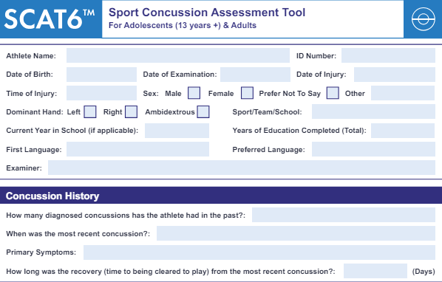

Immediate Assessment/Neuro Screen (Not Required at Baseline)

The following elements should be used in the evaluation of all athletes who are suspected of having a concussion prior to proceeding to
the cognitive assessment, and ideally should be completed “on-field” after the first aid/emergency care priorities are completed.
If any of the observable signs of concussion are noted after a direct or indirect blow to the head, the athlete should be immediately and safely removed from participation and evaluated by an HCP.
The Glasgow Coma Scale is important as a standard measure for all patients and can be repeated over time to monitor deterioration of consciousness. The Maddocks questions and cervical spine exam are also critical steps of the immediate assessment.

Off-Field Assessment
Please note that the cognitive assessment should be done in a distraction-free environment with the athlete in a resting state after
completion of the Immediate Assessment/Neuro Screen.

Read this online at https://books.byui.edu/ess_349_lab_manual/scat_6

