# Chapter 23: Plan Research (the Research Process and Basic Research Methodology)

### Spiritual Thought Box



[D&C 69:3](https://www.churchofjesuschrist.org/study/scriptures/dc-testament/dc/69?lang=eng)

And also that he shall continue in [writing](https://www.churchofjesuschrist.org/#note3a) and making a [history](https://www.churchofjesuschrist.org/#note3b) of all the important things which he shall observe and know concerning my church [family];

Think of ways you can "continue in writing and making a history of all the important things concerning your family.

## Overview

### Study Questions

1. What is considered “known” or “background information”?
2. What should a good Research Plan include?
3. What is the purpose of a Research Log?

### Vocabulary

* **Pedigree Chart:** Chart to show the recorded ancestry of a person or family.
* **Documented:** Written proof.
* **Credibility:** Quality of being trusted or believed in.
* **Objective:** A thing aimed at or sought; a goal.
* **Prioritize:** Treat as more important than other things.
* **Generic:** A class or group of things not specific.
* **Due Diligence:** Reasonable steps taken by a person in order to satisfy a legal requirement.
* **Overarching:** All-encompassing.

## The Research Process and Basic Research Methodology

Remember that in a previous section, we learned that the steps in the Research Process are:

1. Define the Problem
2. Find and Analyze Known Information
3. Develop a Plan
4. Gather Information
5. Analyze Information
6. Record Conclusions

In this section, we are going to go into a little more detail about these steps, and especially Step 3, Develop a Plan. In order to develop a plan, you need to first, Define the Problem (Step 1) and Find and Analyze Known Information (Step 2). Below is a review of these basic steps:

### Step 1 of the Research Process is to Define the Problem.

**To review:** A research objective is an overarching goal of a project, such as to "Find the ancestors of Joseph Smith who was born 1805 at Vermont and married Emma Hale."

A research question is a smaller goal often nested within a larger project's "research objective" such as "Where in Vermont was Joseph Smith born in 1805?" You may have an unlimited number of research questions within a research project.

A well-defined research problem focuses your research and helps you track your progress. Due to the easily accessible and time-saving genealogical resources available through the Internet, the average researcher has not maintained the motivation to define a problem. However, without a well-defined problem, you may waste time looking for additional records that are not needed to solve the problem you have been given.

To effectively define a research problem, remember to include specific facts and hypotheses about who you are researching, what you want to know, and where and when it happened. Every problem in genealogy essentially centers on establishing two types of information: relationships and events. State which type of information you will research to solve the problem. As you define the research problem, be specific and include pertinent details. For example, “Find the marriage” is not as effective as “Find the marriage of Paul Renz and Matha Kroll, who, based on their censuses, were most likely married in Youngstown, Mahoning, Ohio, in about 1914.”

No matter your level of expertise, you can write a well-defined research problem to focus your research. With experience, you will learn additional information that could further define the problem. For example, by learning when vital records for an area began to be recorded at a state level instead of a county level, you could add this detail to your research problem: “Find the marriage of Paul Renz and Matha Kroll, who, based on their censuses were most likely married in Youngstown, Mahoning, Ohio, in about 1914. This would have been recorded at the county level.”

Before beginning research, a genealogist should identify the specific problem he or she is trying to solve. Starting research without a clearly defined problem wastes time and resources. In the research process, a pedigree analysis is one method for defining your problem. This week, you will learn how to find problems in existing pedigree charts and client information and write a clearly defined problem in order to provide the focus for a research project.

#### Evaluate Information and Detect Errors With a Pedigree Analysis

A pedigree analysis evaluates the information and detects errors in a pedigree chart. Some errors are obvious, while others require careful study.

The following is an example of a blank Pedigree Chart:

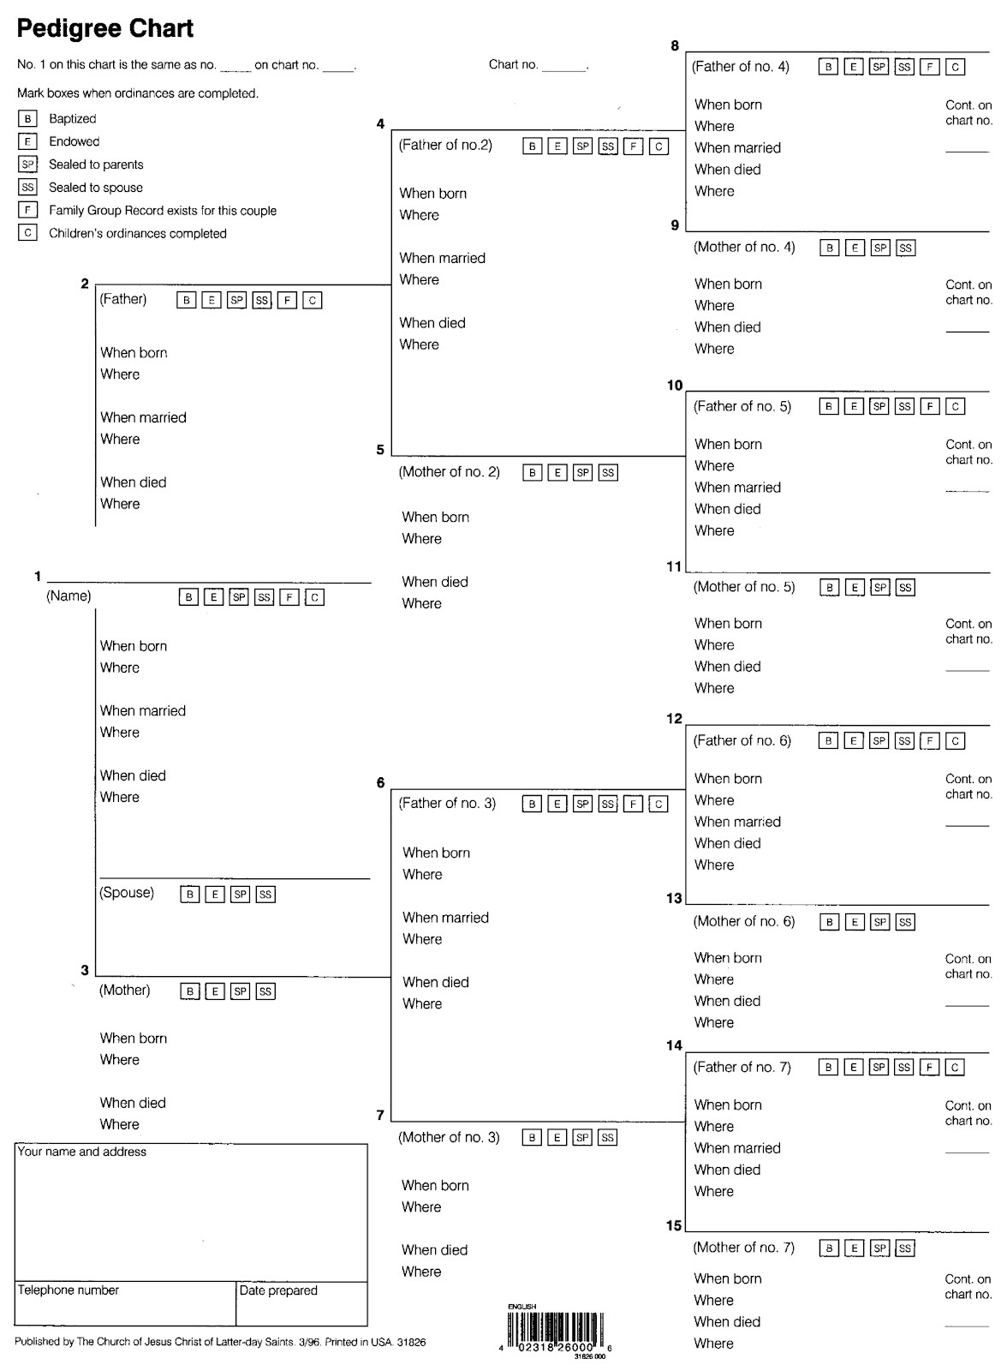

It’s basically a map of your subject person or family. This would be filled in as far as possible, or desirable for your current research question.

Flag obvious errors and evaluate the sources used to obtain the information. If a pedigree chart is riddled with errors, stop and verify the information before advancing it. Val Greenwood explains, “Just as you do not build a house separately from its foundation, genealogical evidence also requires a foundation. This means that you must begin your research on ancestors about whom you already know something” (The Researcher’s Guide to American Genealogy, 49). Start your work where the information is verified.

The following are pedigree analysis considerations:

* Successful research requires at least a name, a specific date, and a reasonably specific place. (You might need to accept an approximate date.) Ask the following questions:
  1. Does the pedigree contain at least this much information?
  2. Which individuals or families lack this critical information?
* Consider the significance of dates and places. Ask the following questions:
  1. What was happening during this time in this/these area(s)?
  2. Was there a war, and did your ancestors serve?
  3. Did the ancestor or his wife die young, and did the surviving spouse remarry?
  4. Is the ancestor found in any census records?
* Look for obvious errors or questionable information. Ask the following questions:
  1. Are the birth, marriage, and death dates logical?
  2. Did the ancestor remain in the same place, or did he move? If he moved, does his migration route make sense for the time frame?
  3. Are the age differences between the husband, wife, and their children logical?
  4. When and where did the parents marry? Does this match with the children’s birth dates and birthplaces?
  5. Did the localities exist when the ancestor(s) lived there? For example, part of the Northwest Territory became the state of Ohio in 1803. Ancestors' vital events in the Ohio area before 1803 should be named the Northwest Territory, not Ohio. Vital events after 1803 named the location Ohio (the state).
* Analyze sources to detect less obvious errors. Ask the following questions:
  1. Is the information well-documented?
  2. What sources were used?
  3. Are the sources credible?
  4. How reliable are the sources?
  5. Do several sources provide the same information or do they conflict?

#### Problems in a Pedigree

A clearly defined research problem includes a name or names and date information and a reasonably specific place or locality. Do not confuse pedigree analysis questions such as those in the above paragraph with clearly defined research problems. These are two different types of questions with different purposes. The analysis questions are numerous and exemplify the sort of questions you should be asking yourself when analyzing a pedigree. In contrast, a well-written specific research problem is an objective or focusing question from which effective research may begin.

The following is an example of a well-defined problem, "Identify the maiden name of Jane, mother of Matthew Charlton (c. 6 June 1842 at Easington parish, Durham, England), and determine the names of her parents."

Step 1 of the Research Process (reviewed above) also provides important guidance on writing a clearly defined research problem. It stated, "To effectively define a research problem, remember to include specific facts and hypotheses about who you are researching, what you want to know, and where and when it happened." That reading gave this example, "Find the marriage of Paul Renz and Matha Kroll, who, based on their censuses, were most likely married in Youngstown, Mahoning, Ohio, in about 1914." Notice that the question includes a research focus (finding the marriage) as well as name, date, and location information. The date and location information should clearly identify the individual being researched so that there cannot be any confusion with any other person who might have the same name. Even better, the date and location information chosen to be included was not arbitrary. It literally gives the researcher a place and time period within which to begin their search.

### TRY IT OUT

Using the example above as a guide, create a clearly defined research problem. Include the person’s name, along with specific known facts, and what you want to find out.

### Step 2 of the Research Process is to Find and Analyze Known Information.

To review: Finding and analyzing known information will save a great deal of time. However, you should never accept any previous research without first analyzing it and confirming its conclusions. There are many resources that you can use to find previous research, such as:

* FamilySearch Family Tree or Genealogies
* Ancestry.com Public Member Trees
* MyHeritage
* Other online trees, found through an Internet search
* Biographies, local histories, or compiled research books - Digital or print copies may be found through an Internet search, in the FamilySearch catalog, Google Books, archive.org, and other societies, archives, or libraries.
* Other online sources are found through Internet searches - blogs, Wikipedia articles, etc.

Once you find potential known information, ask yourself the following questions as part of your analysis:

* Is there enough information contained in the record to confirm that the individuals involved are those you are researching?
* Does the information solve your research problem?
* Does the information appear accurate, or are there unexpected locations or dates?
* Is the information thoroughly sourced?
* Does the existing material include high-quality images of original documents?

If the answer to any of the questions above is “no” you may need to choose one of the following options: obtain original records to validate the information, use the information as hints that could narrow your search, or simply start from nothing. Ask yourself these questions each time you find known information. As you gain more experience, you will more quickly discover additional sources of known information and automatically analyze the information.

Known information is what you already have, or the background information a client gives you about a person (subject of the research). You need to review and analyze this information to determine credibility. Then you have a starting point for your research. At this point, you have a research problem or question to solve, based on the known information. **The key to the answer to the research question is somewhere in the known information. Use the known information to guide your next research steps.** Here is where you need to apply your knowledge and common sense. For instance, you wouldn’t search for a birth certificate for a person in a time or area where none exists.

### TRY IT OUT

Select a grandparent or parent and make a list of the known information and documents you have about them. If you already have a lot of known information for that person, select someone a generation further back, or an aunt or uncle you have less information about. Think of a simple research question about that person, for instance, “When did my grandfather, who was born in Paisley, Scotland, in 1920, arrive in the United States?” Now think of the best piece of known information you have that would lead you to your next research step. This is the start of developing a plan.

### Step 3 of the Research Process is to Develop a Plan.

**To review:** A plan transforms the research problem into specific steps you will take to conduct new research and solve the research problem. Developing a plan will orient your research and provide you with contingency plans that you can quickly use if your initial plan fails. Your plan should include the location(s) you will search for as well as the types of records you would like to locate.

No matter your level of expertise, you can carefully think through your problem and develop a specific research plan. As you become more experienced, you will learn which types of records tend to solve which types of research problems. You will also learn which records are available in the area where you are conducting your research. Until you gain this knowledge, you can write a more generic research plan, such as the example written below.

Remember, your plan should include the specific information you are seeking, record types you believe will solve your problem (if known), and any details that could aid your research, such as names, dates, and locations. Notice in the example that most of these details would have been written as part of your well-defined research problem.

**Example Research Plan:**

I plan to obtain the marriage dates of Louis Gershon and Jessie Greenwall by finding their marriage license, certificate, or return. The information may also be located on a Church record and I suspect that they were Jewish. They were likely married in South Africa but could have been married in the eastern part of Germany or Poland. He was born in Wreschen, Posen, Germany in 1860 (in modern-day Poland) and she was born in Turek, Poland in 1865. To find information, I will:

* Check FamilySearch, Ancestry, and other major online databases, beginning with a few global searches, and then drilling down into specific collections.
* Conduct an Internet search for records.
* Check CyndisList for sites that may contain the needed information.
* Check the FamilySearch catalog:
  + Search each jurisdictional level for information that may solve my problem.
  + Create a list of microfilm numbers and any other needed information that may help me locate the information on the microfilm.
  + Order the list in terms of what will most likely solve the problem, ensuring to include any preliminary steps, such as searching a microfilmed index first. I will skip any records that I know will not solve my problem. Otherwise, I will include it in the list.
* Conduct an Internet search for religious or government archives that I could contact. Depending on time and cost, insert these archives into the list I created from the FamilySearch.org catalog. If I do not have easy access to the Family History Library, paying an agency the fee for a document may be cheaper than ordering multiple microfilms.

Breaking it further down into detailed action, to create a research plan, you will do the following:

1. Study and analyze known information.
2. Determine a focused question you need to answer. This is called a research objective.
3. List and prioritize sources that might answer your research question.
4. Note where the sources are located and how to access them.

Notice that sometimes the examples of research steps in research plans are generic. However, to develop an effective research plan, you need to know what specific collections exist, which repositories hold them, and the format (offline or online) of the collections. A focused research step in a research plan is better than a generic one.

For example, a research plan might include the overly generic step—Search for marriage records in Missouri. To focus on that step, include a specific collection to search. For example, “Search marriage records from 1870 to 1876 in 'Missouri, County Marriage, Naturalization, and Court Records, 1800–1991.' Database with images. FamilySearch. http://FamilySearch.org: 1 December 2016. Citing Recorder of Deeds. Missouri State Archives, Jefferson City.”

Keep in mind that research plans are to guide your research only. They are not rigid; they are flexible. If you complete the first step(s) of your research plan and find information that makes you think of a better strategy or record collection to use to answer the research question, then modify your plan. As an analogy, think of the trails animals make through vegetation as they travel to a certain food and water source. The number and direction of trails may vary, but the trails all lead to the same food and water source. Your research strategies and record collections used may vary, but they should all lead you to the same conclusion.

##### Identify Sources

What sources should you include in your research plan? Seasoned genealogists use reference books and websites to identify available records for a specific time and place to address the specific research goal or objective, for instance, the FamilySearch Wiki. Never assume that you know what records exist for the time and place you are researching, unless you actually do from prior research and experience. Conduct a locality survey in reference materials to find out specifically what records actually do exist. Do not promise clients that you will be able to procure any specific record without first ascertaining whether that record is likely to exist. Assuming there is a record “out there” that will resolve all conflicting information or answer the research objective perfectly is a rookie mistake. Failure to conduct a proper locality search may also result in overlooking unexpected records that actually do exist. Doing your due diligence is a sign of a true professional.

#### Common Errors to Avoid When Identifying Resources

A common error is to assume that all the information a genealogist needs is found in census and vital records. These records are valuable and informative, but do not reflect all the records necessary for reasonably exhaustive research. Remember, conducting reasonably exhaustive research means searching all available and relevant records.

#### Below is a sample Research Plan Chart:

#### Partial Research Plan

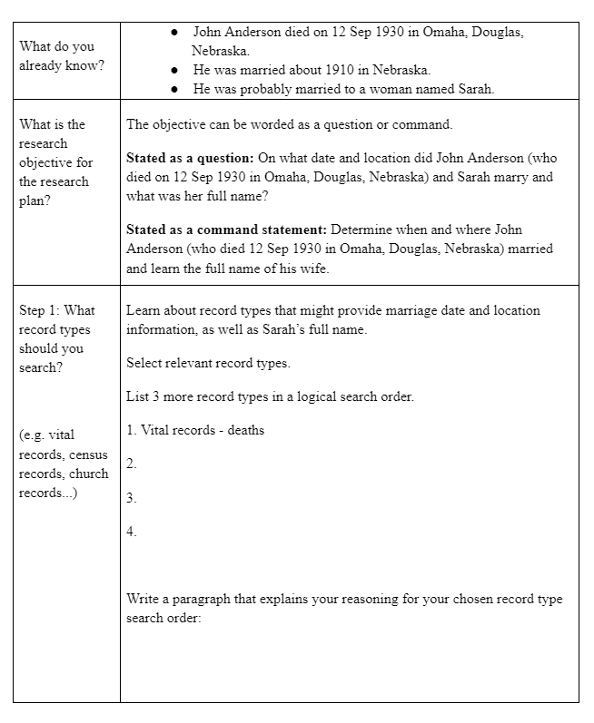

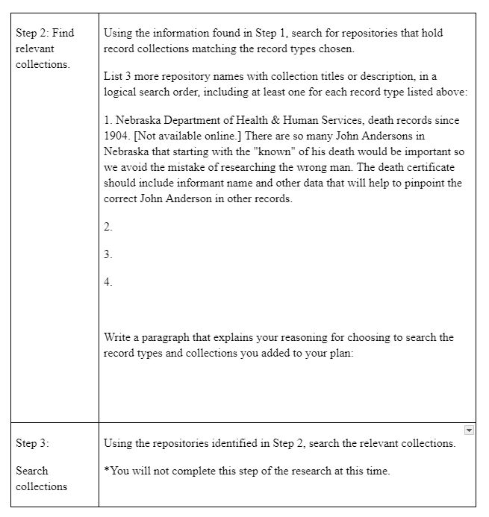

### TRY IT OUT

If you know your grandfather was born in Paisley, Scotland in 1882, how would you determine whether a birth record might exist for him? (Clue: where would you look to see what records are available for Paisley, Scotland?) Do a quick search. Do they exist? What information does this give you for your research plan? What will be your next step?

### Step 4 of the Research Process is to Gather Information.

To review: Once you have developed a plan, execute it to find the information you need. No matter your level of expertise, you will have questions as you conduct your research. You can find help articles in order to locate and read the records you seek. Such help articles could include:

* The Help or Learning Centers on FamilySearch, Ancestry, or other major websites
* The FamilySearch Research Wiki, or the Ancestry.com Wiki
* Finding aids for libraries or archives, which help you navigate their collections. For example, the National Archives has many guides and finding aids.

In this course and throughout the BYU-Idaho Family History program, you will develop many fundamental research skills and discover valuable genealogical resources. Some of these skills include using FamilySearch and its partner sites, locating historical records in a variety of databases, and reading difficult handwriting to help you decipher historical records. With continued practice, you will be able to perform these steps faster and with greater confidence.

Now that we come to the point of conducting research, we turn our attention to the Genealogical Proof Standard (GPS).

The five GPS elements are as follows:

1. Conduct reasonably exhaustive research.
2. Use complete and accurate source citations.
3. Conduct thorough analysis and correlation.
4. Resolve any conflicting evidence.
5. Write a soundly written conclusion based on the strongest evidence.

#### Conducting Research

Conducting research is the main focus of the GPS. Conducting “reasonably exhaustive research” means searching all available and relevant sources that have been listed in the research plan and recording them in a research log.

#### Research Logs

After you, as a researcher, have defined a research goal and developed a well-structured research plan, then, and only then, may research begin. As you research, you must record the results of the planned research in a research log. Your completed research log shows that you followed and completed your planned research. You may need to follow up on the research problem if it wasn't solved, but you would use a new plan and research log (or extend your first plan and log, according to your preference).

A research log should be very specific and detailed so that anyone can recreate the same research session simply by following the research log. The format and elements of a research log can vary, but there are some basic elements that must be included in every research log.

It is likely the information you need to include will exceed the space available on a single-page research log. You can establish a numbering system to organize the additional pages. A computer spreadsheet is also a valuable way to keep a research log.

#### Basic Elements of a Research Log

1. Name of researcher
2. Date of research
3. Name of person being researched
4. Specific research goal
   * Example: Identify the parents of Charlotte Wells who was born in May 1911 in Camden County, New Jersey.
5. Specific details for each source searched
6. Description of the source as a whole (book, database of images, and so on). This is recorded before researching the source
7. Description of how each source was searched (search terms used, filters applied, spelling variations searched, etc.)
8. Description of the results (information not found, information found, analysis of information)
9. Full citation of any found documents (page number, document number, and so on) This is recorded after searching the source.

#### Sample Research Log

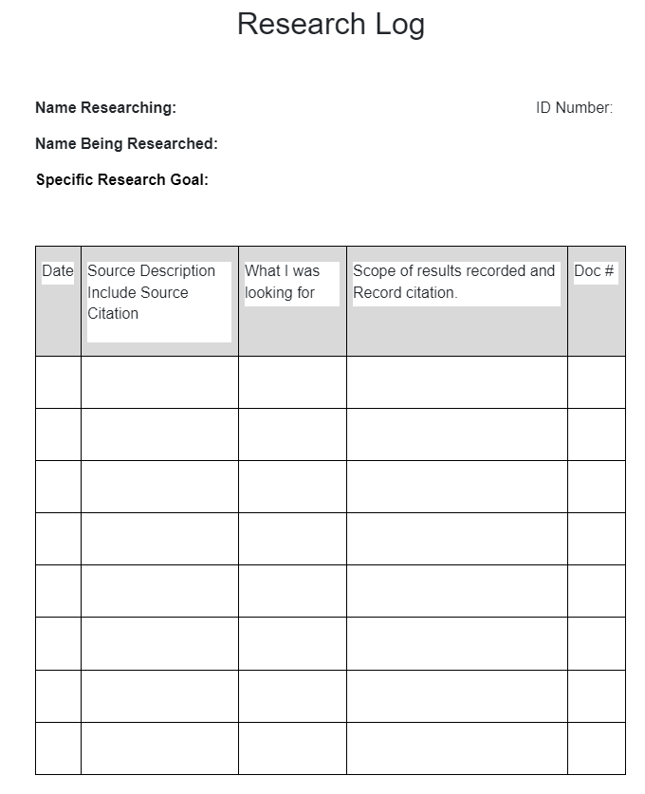

## Optional Resource

How to Ascertain Whether Research Is Reasonably Exhaustive

After creating a research plan, conducting research, and logging the results in a research log, how do you know when the research is complete, or reasonably exhaustive? The researcher should ask himself or herself the following questions:

1. Have I answered my research question?
2. Have I searched across a breadth of records, not just the ones that are easily available? Have I searched many different record types? Have I looked in all relevant sources?
3. Have I used relevant methods and strategies to help me find less obvious evidence that could strengthen my conclusion?
4. As much as possible, have I replaced information found in derivative records with information found in original documents?
5. Have I found enough information to resolve any conflicts?

### Step 5 in the Research Process is to Analyze Information.

To review: Once you find information, you must analyze it instead of immediately accepting it as fact. To analyze the information you find, ask yourself questions like:

* Is this an original document, or is it an index or transcription? For example, a birth record is more reliable than a birth index because indexing or transcribing could introduce (additional) errors.
* Did the person who reported or recorded the information have firsthand information about the event? For example, a birth date reported by a person’s parent is more reliable than one reported by a person’s spouse because the parent was present for the event while the spouse was not.
* Does the information in the document directly state a fact or is it only inferred? For example, in determining where a person lived, a census record would be more reliable than a death record that lists their place of death. While you can infer that they died near their home, their residence can only be inferred from the death record, while the census states it directly.
* Was the record created near the time of the event or much later? For example, in determining a birth date, a birth record would be more reliable than birth information listed on a death record because the birth record was created nearer to the time of the birth.
* Does the document contain other noticeable errors? For example, if you know that a death record lists the wrong birth information and the names of their parents, the rest of the information is somewhat more likely to be wrong as well.
* Would the person who gave the information have a stronger motive to lie or to be accurate? For example, many people could lie about their marriage date in order to cover up a child born out of wedlock, but someone who is applying for a pension would choose to be extremely accurate in their application to ensure they receive the pension.

Asking yourself these questions is vital to conducting accurate genealogical research. As you become more experienced, you will analyze evidence automatically.

Step 5 will be covered in detail in the next course.

### Step 6 of the Research Process is to Record Conclusions.

To review: After you analyze the evidence, you are ready to record the information. In recording information, remember the following principles:

* A female’s maiden name should be recorded.
* Dates should be in the order of day-month-year, and the year should be recorded as four dits. For example, 16 May 1864.
* Places should be recorded from smallest geographical area to largest, such as City, County, State, and Country. For example, Rexburg, Madison, Idaho, United States.
* Jurisdictions on a city, county, state, and county level should be recorded as they existed at the time of the event.

At first, you may not always notice and record every piece of pertinent information included in each record you find, but with practice, you will quickly improve your ability to notice the subtle details contained in a record.

Along with recording the information you find, you should also:

* Cite your sources. This means you must state where you found your information. There are general rules you should follow when citing a source, and there are style guides you can refer to for assistance. At the minimum, your citation must include enough information for someone else to quickly find the source.
* Track your research through well-organized notes or a research log. If your research plan is written in a document with space for additional notes, that would be an excellent location to record your results. Additionally, your research log should include some of the information you will need for your citations.

Always track your research through a basic research log and cite your sources with enough information to locate the document again. If you wish to use formal genealogical citations, most professional genealogists use Evidence Explained by Elizabeth Shown Mills. The final decision of what style to use depends on your preference and the preferences of your client. For the purposes of the BYU-Idaho FHGEN courses, we have created the FHGEN Guide to Citing Sources, which you will be expected to follow. It is available in your course materials.

Step 6 will be covered in detail in the next course.

### Answers to Study Questions

1. What is considered “known” or “background information”? (Known information is your starting point. It is what is already proven or accepted research or the validated background information a client provides about their family.)
2. What should a good Research Plan include? (A research plan should include specific information you are seeking, record types you think will solve your problem, and any known details to aid your search.)
3. What is the purpose of a Research Log? (To document and record the results of your research plan. To show that you followed your plan. It becomes a roadmap of your plan and traces your steps and results.)

Read this online at <https://books.byui.edu/fhgen_110_textbook_/chapter_23_plan_research_the_research_process_and_basic_research_methodology>