# Homeostasis

One of the defining features of warm-blooded animals, like humans, is the ability to maintain a core body temperature that is different from the environmental temperature. The average human body temperature is 98.6°F (37°C), and the body exerts a fair amount of energy ensuring that this temperature stays relatively constant; we call this temperature (98.6°F) the **set point** for body temperature. Different set points for different systems are found throughout the body. For instance, the set point for glucose (blood sugar) is 85 mg/dl, and the set point for sodium is 142 mmol/L. The body uses a variety of organs and organ systems to help ensure that certain **variables** remain as close to their set point value as possible, or at least within a **normal range**. For example, without the assistance of clothing, the human body has a remarkable capacity for keeping the variable of body temperature between 98°F and 100°F, even when placed in environmental conditions that range from 68°F to 130°F. How does the body stay warm at 68°F and cool at 130°F?

To stay warm, the body can increase metabolism, divert blood flow away from the surface, or cause muscles to shiver. All of these mechanisms generate heat. Of course, we could also use our higher cognitive abilities and put some clothes on. Conversely, to stay cool, the body releases water droplets on the surface of the skin, forming sweat, which acts to dissipate heat as the water evaporates. Perhaps most interesting is that sweating, shivering, and blood flow diversions happen automatically; in other words, we do not consciously control them; they just seem to happen. This automatic property of the human body to regulate variables was observed and defined by Claude Bernard in 1854. Then, in 1926, Walter Cannon named this process **homeostasis**. Homeostasis, like many scientific words, is of Greek origin were homeo means "similar or same," and stasis means "standing still or remaining the same." Homeostasis then, by definition, is the ability of the body to maintain relatively stable internal conditions (internal environment) even though the outside world (external environment) is changing. The internal environment is defined as the fluid that surrounds the cells.

As will be explained, the human body undergoes a multitude of highly complex interactions to maintain homeostasis by ensuring that systems function to hold different variables within their normal ranges. These interactions are essential to the survival of the body. An inability to maintain homeostasis may lead to death or diseases such as: diabetes, dehydration, hyperthermia, and even allergic reactions.

In order to explain how homeostasis works, let's revisit changes that occur to maintain body temperature. How does the body know when to shiver or sweat? The body first needs to detect a temperature change. In the body, this function is attributed to a **receptor**, which is a type of sensor that monitors the environment and detects changes in variables. When conditions cause a change in a variable, we call those conditions **stimuli**. Once a receptor detects a change, it then communicates this change to a **control center**. Control centers are located throughout the body, often in the brain, and are responsible for determining the set point and the appropriate course of action to correct deviations from the set point. Control centers dictate a course of action by communicating with **effectors**. An effector provides the means to correct the deviation. In terms of temperature regulation, the control center is located in the hypothalamus, a small region in the brain, and the effectors would include skeletal muscles (shivering), sweat glands (sweating), and blood vessels (constriction and dilation). It is also interesting that the human body can change a set point for a particular variable. This change is generally temporary and beneficial. For example, the set point for body temperature can change to a higher value in response to infections, called a fever. This increase in temperature aids the immune system in eliminating the pathogen. Consider this critical thinking question: does the set point change observed during a fever represent a negative or positive feedback response? The answer is negative, but why?

An essential component of homeostasis is communication. Communication in the body occurs primarily through two systems: the nervous system and the endocrine system. Regardless of the system used, if communication flows toward the control center from the receptor, it is termed an **afferent** pathway. If information flows from the control center to the effector, it is termed an **efferent** pathway. Collectively, the receptor, afferent pathway, control center, efferent pathway, and effector comprise a **homeostatic control system**. Essentially, all organs and tissues of the body are part of homeostatic control systems and perform functions that help maintain the body's internal environment.

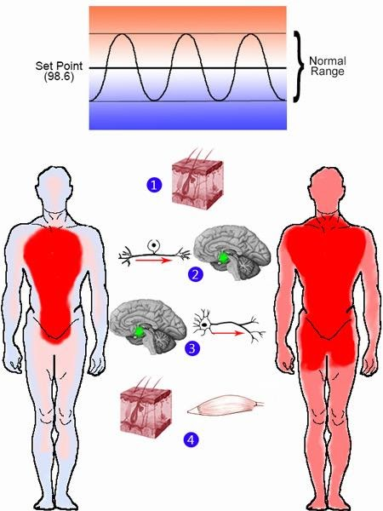

Image modified from public domain images of brain and skin. Other elements freehand by JS at BYU-I 2013.

**\*The numbers below explain the numbers in the picture above**

**1.**Receptors in the skin and the brain can sense temperature.

**2.**Information about the temperature travels through afferent neurons to the control center. The control center in this story is the hypothalamus (green dot in the brain picture above).

**3.**The hypothalamus assesses where the temperature is in relationship to set point (98.6°F). The hypothalamus then sends a signal through efferent neurons to the skin and the muscle tissues.

**4.**The skin and the muscle tissues are effectors. If the control center determines that the temperature of the body is above the set point, then blood vessels in the skin dilate to divert some of the blood closer to the surface of the body, thus releasing heat in sweat and cooling down the body. Sweat glands can draw water from the blood, trapping heat and releasing it as the sweat (water) is evaporated at the surface of the skin. If the control center determines that the temperature of the body is below the set point, then the blood vessels of the skin constrict to decrease the amount of blood moving to the skin, so the warmer blood instead moves toward the core of the body. Also, sweat glands cease producing sweat. Muscles are another effector that can shiver when it is cold to produce heat in the body.

Homeostatic control systems, such as temperature regulation, operate through feedback response loops. These loops start with a stimulus that changes a variable and end with an effector that adjusts the variable. If the change in the variable brings it back toward a set point, this is known as a negative feedback loop. The term “negative” is used because the resulting change in the variable is opposite to the initial change. For example, if a stimulus raises body temperature to 99°F, sweating acts to lower it back to 98.6°F. Since the initial stimulus caused an increase and the response resulted in a decrease, this is a negative feedback loop. This process helps maintain the constancy of the internal environment. Other examples of negative feedback loops include the replenishment of oxygen by the lungs, the regulation of blood pH at 7.4, and blood glucose control by insulin. These mechanisms are essential to maintaining homeostasis.

Positive feedback loops, on the other hand, occur when the response to a stimulus increases the deviation from the set point. This often happens when a negative feedback system fails to adequately address a problem because one or more effectors is broken or unable to function effectively. For example, in response to a significant loss of blood, the body's negative feedback response would increase heart rate to restore blood pressure. However, if the blood loss is too severe, the increased heart rate may not be enough to raise blood pressure. As a result, less blood reaches the heart, depriving it of oxygen and nutrients. This weakens the heart's ability to pump blood, creating a downward spiral where the heart receives even less blood, leading to worsening conditions. In this case, the body has shifted into a positive feedback loop, where the deviation from normal blood pressure continues to increase. Without medical intervention, this can lead to critical failure.

Positive feedback can also have beneficial roles in specific situations. For example, during childbirth, labor contractions are enhanced through positive feedback. The hormone oxytocin, released from the brain, travels through the bloodstream to the uterus, causing stronger contractions. These contractions push the baby’s head downward, stretching the cervix. Stretch receptors in the cervix send signals to the brain to release more oxytocin, intensifying contractions until the baby is born. A synthetic form of oxytocin, known as Pitocin, can be administered to induce or assist labor when the natural system is insufficient.

In addition to feedback loops, some systems utilize feedforward control mechanisms that anticipate changes. For instance, humans in warm environments with low sweat rates can be induced to sweat almost immediately after drinking water. Similarly, the sight, smell, or even thought of food can trigger salivation and stomach acid secretion before food is consumed, a common example of feedforward control. Another interesting example involves the consumption of diet soda. Although diet soda does not contain "sugar" the sweetness comes from chemicals that mimic the sugar taste. Thus, in response, the digestive system "thinks" it is getting a big load of sugar so it adapts by adding more structures that help to absorb sugar. The result of this feed forward mechanism is that any sugar consumed after a diet soda is absorbed much quicker than it would have been with out the diet soda priming.

Feedback loops rarely operate in isolation; instead, they are part of complex networks that interact with each other. Some loops may compete, making treatment more challenging. A hierarchy also exists among feedback systems, with brain function being prioritized over other systems. For example, the body will sacrifice bone calcium to maintain proper brain function.

In medicine, the goal is to help individuals return to homeostasis when their own systems become inadequate. Medical interventions use physiological parameters as reference points and aim to restore balance when deviations occur.

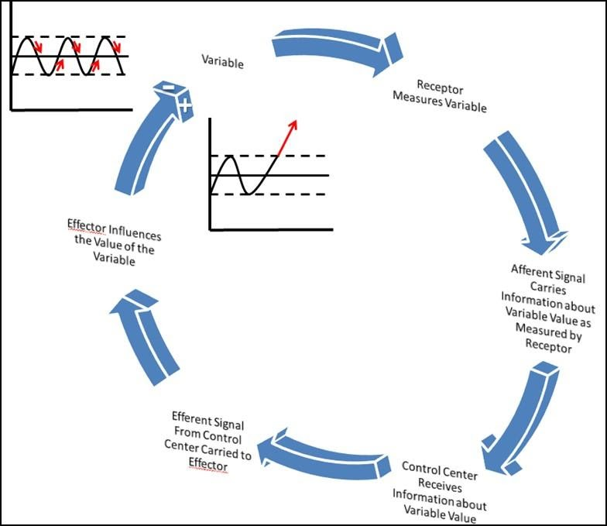

Image created by JS at BYU-I 2013.

Above is an image representation of a Feedback Response Loop. Notice that feedback loops can result in Negative or Positive Feedback. The red arrows in the top left graph show what would happen if the effector(s) caused the variable to come back to set point (Negative Feedback). The red arrow in the right-hand graph (inside the cycle) shows what would happen if the effector(s) caused the variable to go further and further from the set point (Positive Feedback).

Read this online at <https://books.byui.edu/bio_264_anat_phys_I/jzvvdcetci>