# Headings

This skill is taught in FAML 100.

## Job Skills: Professional Writing Using APA Headings

In FAML 160 you learned the basics of formatting in APA Style (American Psychological Association Style). In FAML 100 you will be expected to continue using the basic formatting but you will also start using headings and page numbers in APA style.

Headings are used to show sections of a paper. Headings can help you organize your thoughts improving the quality of your academic paper and other written communications. They also allow your readers to quickly find the information they are looking for. APA headings are organized like an outline: levels nest under each other. For example, if you have one main point and 2 sub points you would use Level 1 and Level 2 headings to represent the main point and the sub points respectively. There are 5 levels of headings in APA, but you will only need to use Level 1 and Level 2 in this course. You will notice that rubrics measuring your use of APA style will include APA headings from now on.

Page numbers simply indicate the length and sequence of pages of a paper. In addition to headings, page numbers allow your readers to quickly know the length of your paper and locate specific sections. From now on, you will also notice that page numbers will be required when APA style is being evaluated.

### Level 1 Headings

This level is the main level heading of a paper. If only one level is needed use Level 1. Level 1 headings are centered, bolded, and in title case. Title case means the first letter of each word is capitalized. There is no colon (:) at the end of the heading. The text following a level 1 heading is treated like a normal paragraph.

### Level 2 Headings

This is the secondary level used to designate a subsection in a paper. Level 2 headings are used to note a subtopic within the Level 1 topic. You should avoid using Level 2 headings if you don't have more than 1 subtopic under the Level 1 heading. You don't need to number your headings with numbers or letters — you show the level heading by the placement and formatting of the heading. Level 2 headings are flush to the left margin (not indented like your paragraph), bolded, and in title case. The text following a level 2 paragraph starts on the next line, and is treated like a normal paragraph.

### Other Levels of Headings

While we are only explaining Level 1 and Level 2 headings here, there may be times in your academic work when will make sense for you to include other levels of headings. You should make sure to understand the formatting of these levels and incorporate these into your writing appropriately.

## Common Errors

Below are examples of common mistakes students make. The red text indicates what kind of mistake was made.

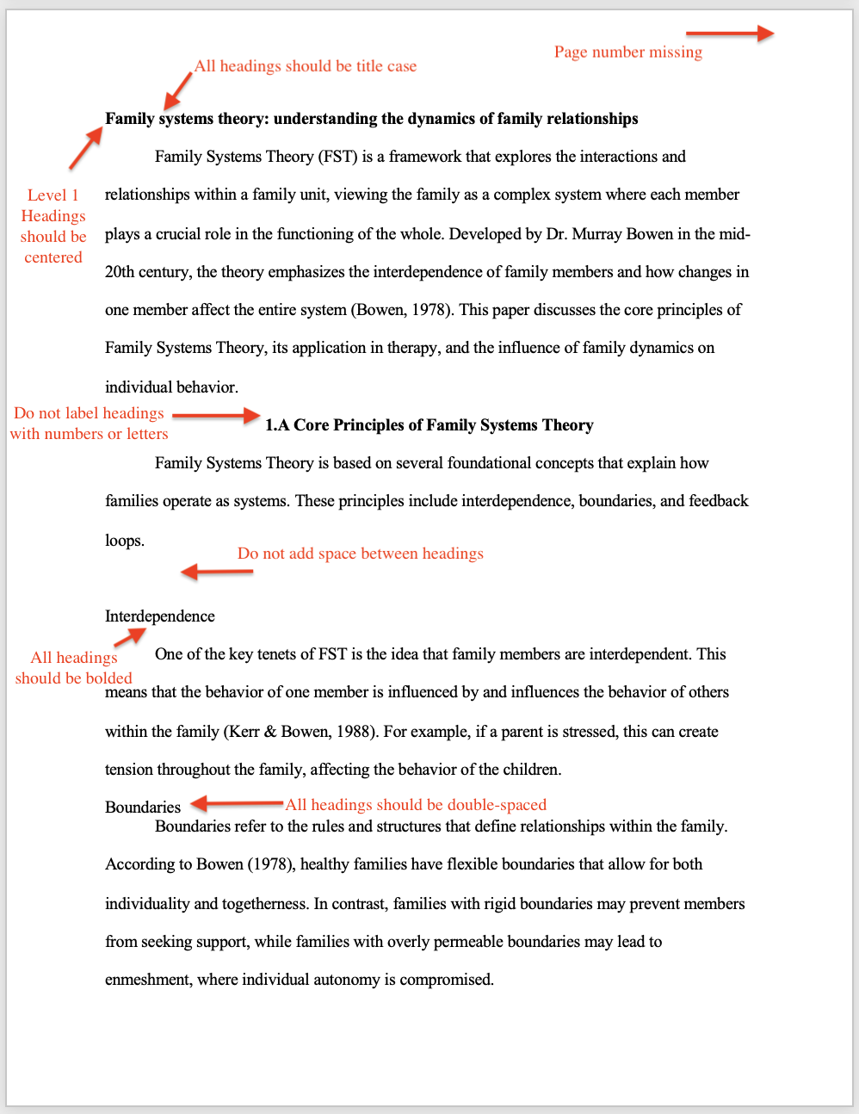

## Correctly Formatted Paper

Below is an example of a paper with correctly formatted headings.

### Additional Optional Resources:

For a more detailed look at the parts of an APA paper, please reference the Annotated APA Template.[05_document_APA_Annotated_Template.pdf (byui.edu)](https://content.byui.edu/file/39b84406-3eb0-4922-88c9-9b4b08b3dd19/2/05/05_document_APA_Annotated_Template.pdf)

If you want a[detailed explanation of APA Headings](https://apastyle.apa.org/style-grammar-guidelines/paper-format/headings), follow this link to the APA Style guide.

Read this online at <https://books.byui.edu/BYU-Idaho_FHS/bervcshnth>