Section 1: Evolutionary Milestones in Embryonic Development

Symmetry
Symmetry is one of the earliest and most influential evolutionary developments, setting the framework for how organisms interact with their environments. In invertebrates, symmetry can be classified into two main types—radial and bilateral symmetry—each associated with distinct ecological roles, movement patterns, and evolutionary paths.
- Radial Symmetry and the Radiata: Radial symmetry (Latin “radius,” meaning “ray”) describes body plans organized around a central axis, allowing an organism to interact with its surroundings uniformly from all sides. Organisms with radial symmetry belong primarily to the group Radiata, an early evolutionary branch that includes phyla such as Cnidaria (jellyfish, sea anemones, corals) and Ctenophora (comb jellies). Radiata represents an ancient lineage on the evolutionary tree, where body simplicity and radial organization support a lifestyle adapted to stationary or slow-moving existence in aquatic environments. Radially symmetrical animals often have sensory structures evenly distributed around the body, as seen in cnidarians’ tentacles, which detect prey or danger from any direction. This form of symmetry likely reflects one of the earliest structural adaptations among multicellular animals, evolving before the emergence of more complex, directional body plans.
- Bilateral Symmetry and Bilateria: Bilateral symmetry (Latin “bi-,” meaning “two,” and “latus,” meaning “side”) evolved later and is associated with more advanced body plans and behaviors. In bilaterally symmetrical animals, the body is divided into distinct left and right halves, which supports directional movement and specialized sensory structures at the head (a phenomenon known as cephalization). Bilateria encompasses the majority of invertebrate diversity, including groups like annelids, mollusks, and arthropods, and shows the evolutionary shift toward complexity. The evolutionary advantage of bilateral symmetry is its role in enabling focused, forward movement and environmental awareness, allowing bilaterians to become active hunters, foragers, and explorers.
- 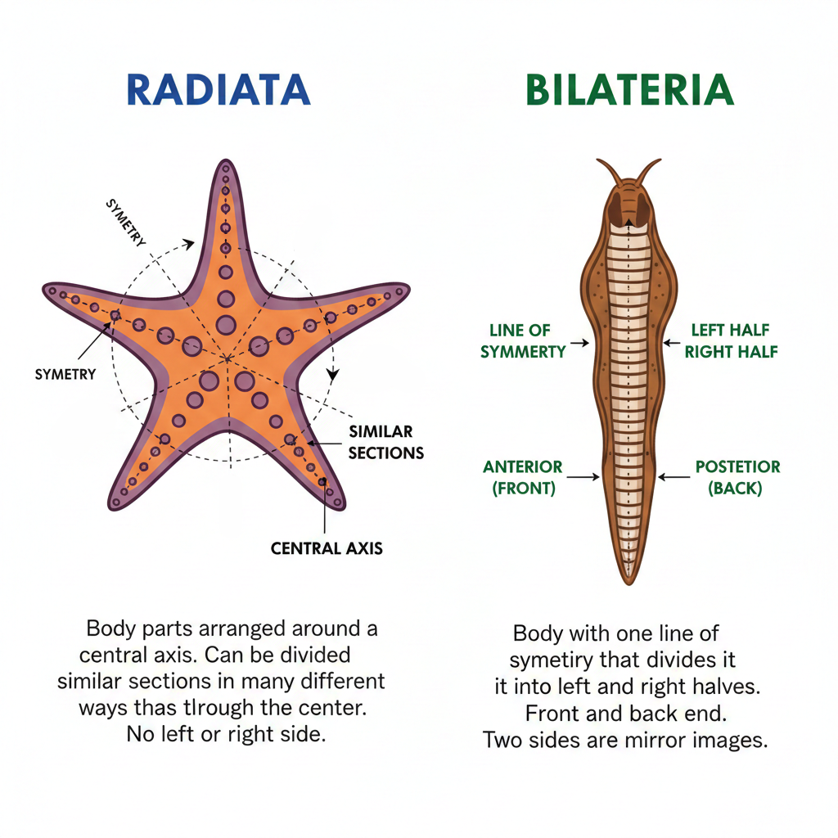
The divergence between radial and bilateral symmetry represents a significant branching point on the evolutionary tree. While the Radiata are adapted for static or slow lifestyles in environments where a multi-directional body plan is beneficial, Bilateria evolved more complex nervous systems, sensory structures, and specialized organs to support highly active, varied lifestyles. This transition from radial to bilateral symmetry marks an essential advancement in evolutionary history, one that paved the way for the specialized and adaptive behaviors seen in bilaterian animals.

Germ Layers
The evolution of germ layers in embryonic development allowed for the emergence of increasingly complex and specialized body structures. Germ layers are embryonic tissues that give rise to all major body systems, and they represent an essential milestone in the evolution of invertebrates. In invertebrates, germ layer organization falls into two categories: diploblastic and triploblastic organization.
- Diploblastic Organization: Found in more primitive invertebrates like cnidarians and ctenophores, diploblastic animals develop two main germ layers: the ectoderm (outer layer) and the endoderm (inner layer). Between these layers, diploblastic animals typically have a mesoglea (from Greek “meso,” meaning “middle,” and “glea,” meaning “jelly”), a non-living gelatinous layer that separates the ectoderm and endoderm. The ectoderm forms structures like the outer epidermis and simple sensory cells, while the endoderm develops into the lining of the gut and digestive tissues. This diploblastic structure is efficient for simple, soft-bodied organisms that rely on diffusion for gas exchange and nutrient distribution, a trait well-suited to their aquatic environments.
- Triploblastic Organization: Triploblastic animals, which include nearly all bilaterians, develop three germ layers: the ectoderm, mesoderm, and endoderm. This additional layer, the mesoderm, provides the cellular basis for more complex organ systems and bodily functions. Each layer contributes to the formation of distinct body structures:
  - Ectoderm: Forms the outer protective layer of the body, as well as the nervous system, including sensory structures and the brain. In arthropods and other ecdysozoans, the ectoderm also produces the exoskeleton.
  - Mesoderm: Gives rise to muscles, connective tissues, and in many species, a coelom (body cavity) that houses and supports internal organs. The mesoderm enables the development of circulatory, excretory, and reproductive systems, supporting larger body sizes and more active lifestyles.
  - Endoderm: Develops into the lining of the digestive tract and associated structures, such as the liver and lungs in more derived animals. The endoderm supports nutrient absorption and plays a critical role in digestion and internal homeostasis.
The evolution of a third germ layer in triploblastic animals enabled the development of diverse body plans and complex organ systems. This additional cellular layer facilitates greater specialization and compartmentalization of body functions, allowing invertebrates to evolve in response to varied ecological pressures. Triploblasty is a major driver of evolutionary diversity within Bilateria, enabling invertebrates to adapt to terrestrial and aquatic environments with specialized physiological functions.

Read this online at https://books.byui.edu/Invertebrate_Life/lcojlrrknl

